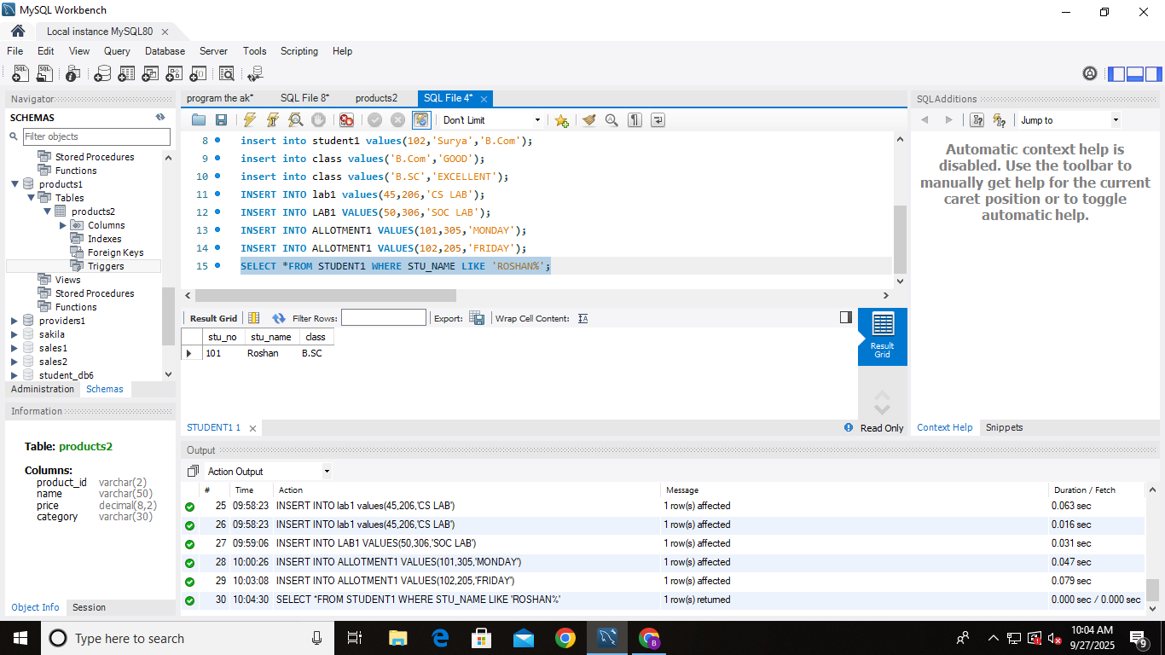**ASSIGNMENT-14**

1. Find the names of all students whose name ‘roshan’.
2. 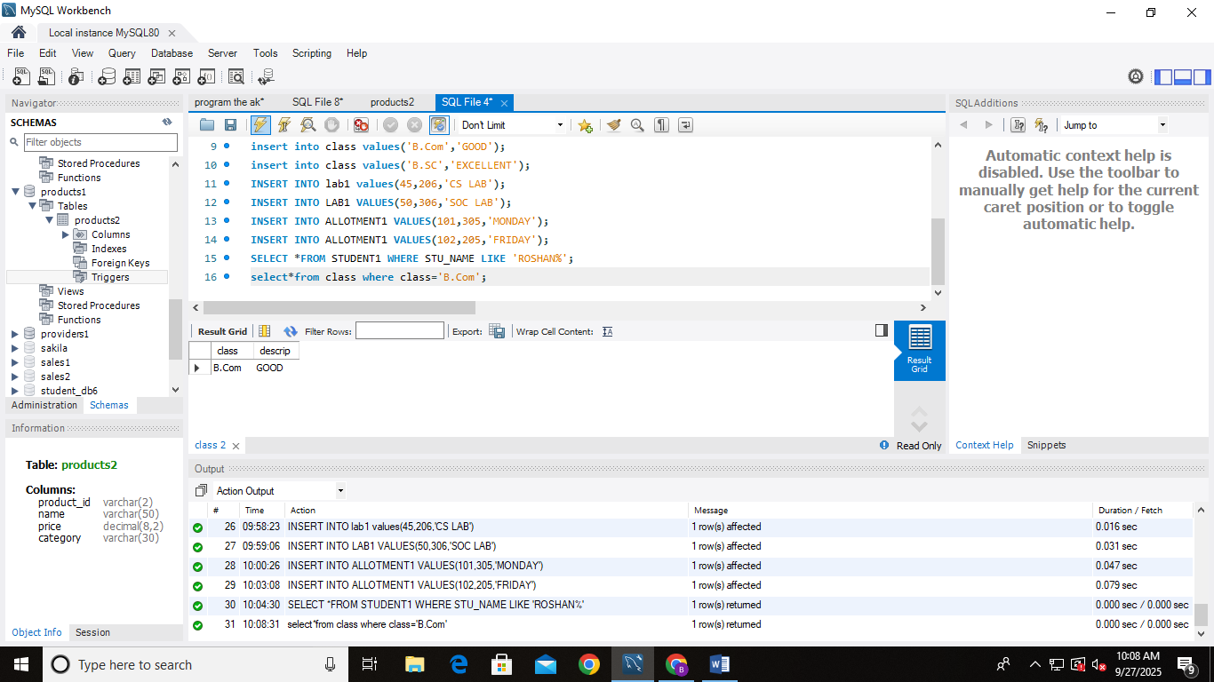Fetch the class where class=’B.Com’
3. 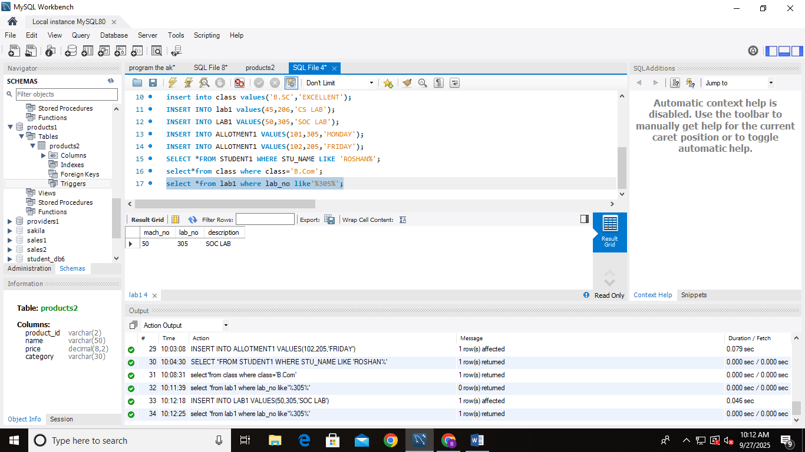Find all lab started “305” in its lab.
4. list all student in alphabetic order of their names.
5. 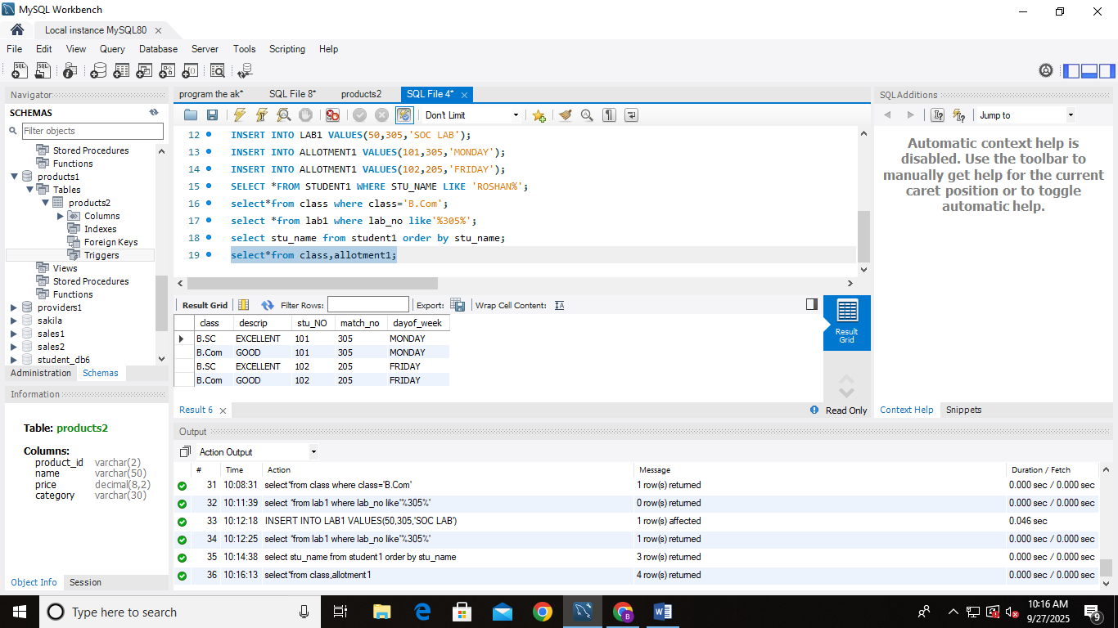Fetch the all fields of class and allotment relation