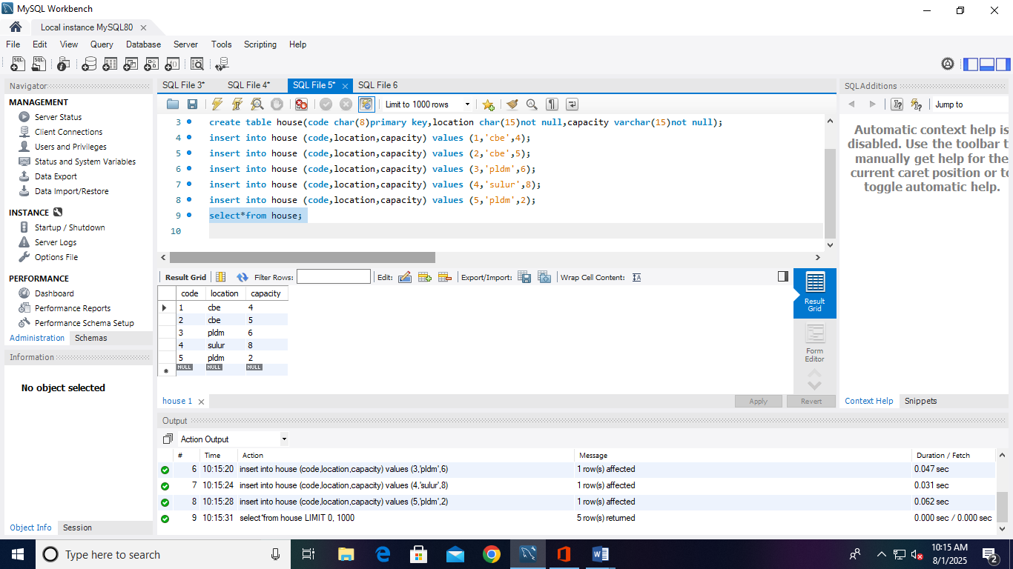

create database book;
use book;
create table house(code char(8)primary key,location char(15)not null,capacity varchar(15)not null);
insert into house (code,location,capacity) values (1,'cbe',4);
insert into house (code,location,capacity) values (2,'cbe',5);
insert into house (code,location,capacity) values (3,'pldm',6);
insert into house (code,location,capacity) values (4,'sulur',8);
insert into house (code,location,capacity) values (5,'pldm',2);
select*from house;

