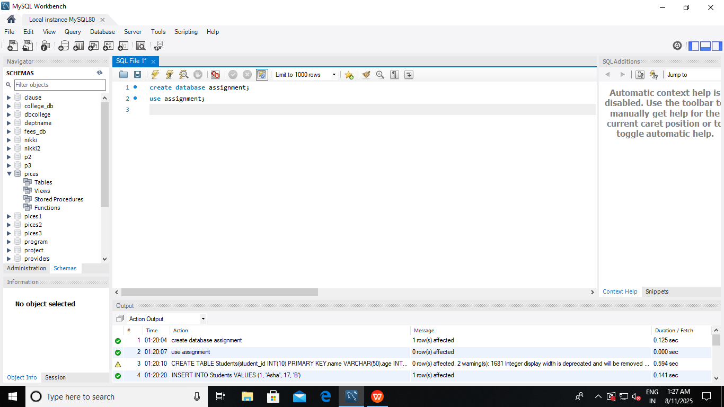

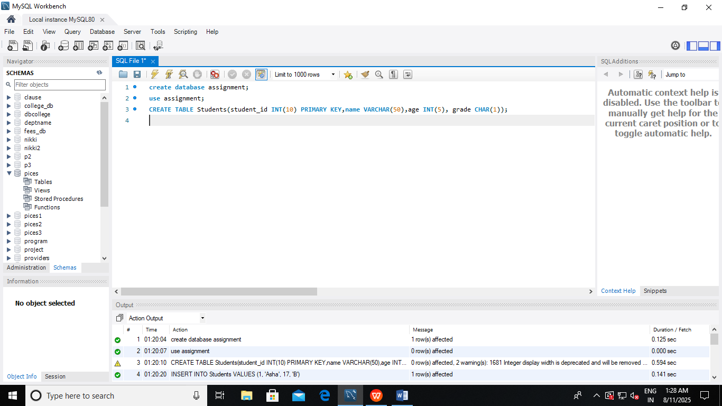

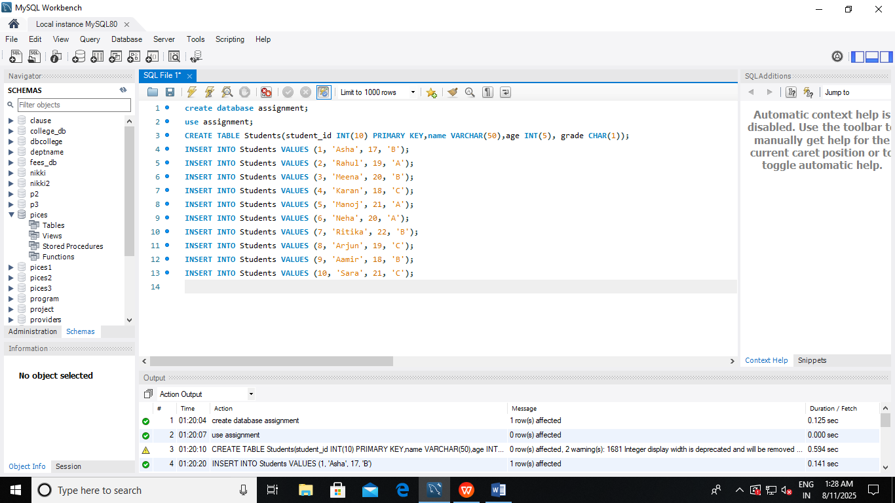

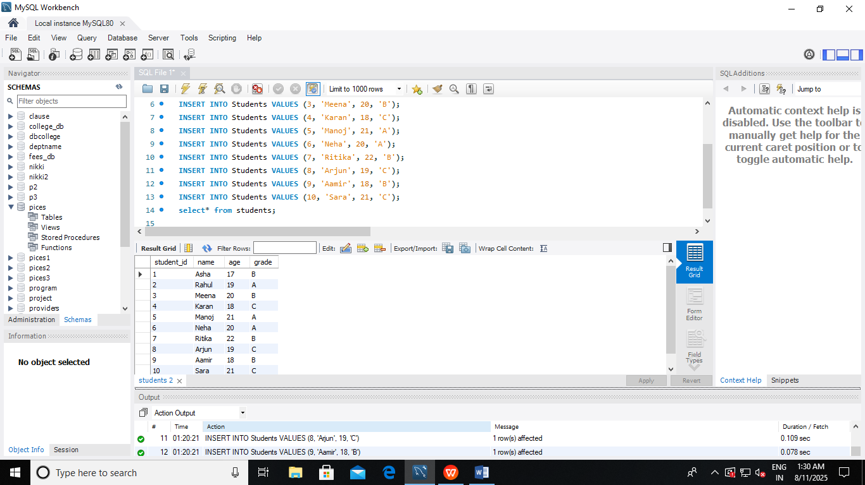

create database assignment;
use assignment;
CREATE TABLE Students(student_id INT(10) PRIMARY KEY,name VARCHAR(50),age INT(5), grade CHAR(1));
INSERT INTO Students VALUES (1, 'Asha', 17, 'B');
INSERT INTO Students VALUES (2, 'Rahul', 19, 'A');
INSERT INTO Students VALUES (3, 'Meena', 20, 'B');
INSERT INTO Students VALUES (4, 'Karan', 18, 'C');
INSERT INTO Students VALUES (5, 'Manoj', 21, 'A');
INSERT INTO Students VALUES (6, 'Neha', 20, 'A');
INSERT INTO Students VALUES (7, 'Ritika', 22, 'B');
INSERT INTO Students VALUES (8, 'Arjun', 19, 'C');
INSERT INTO Students VALUES (9, 'Aamir', 18, 'B');
INSERT INTO Students VALUES (10, 'Sara', 21, 'C');
select* from students;
ALTER TABLE Students RENAME TO StudentDetails;
SELECT Students.name, Students.age FROM StudentDetails AS Students WHERE Students.grade ='B';
