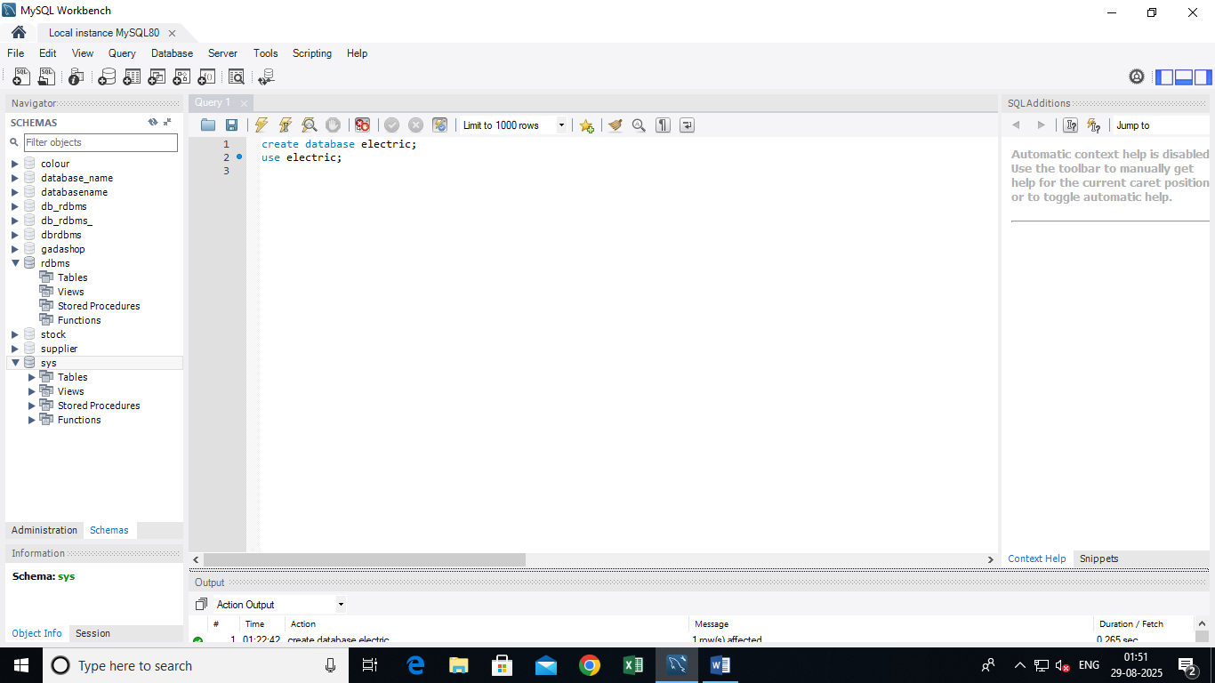

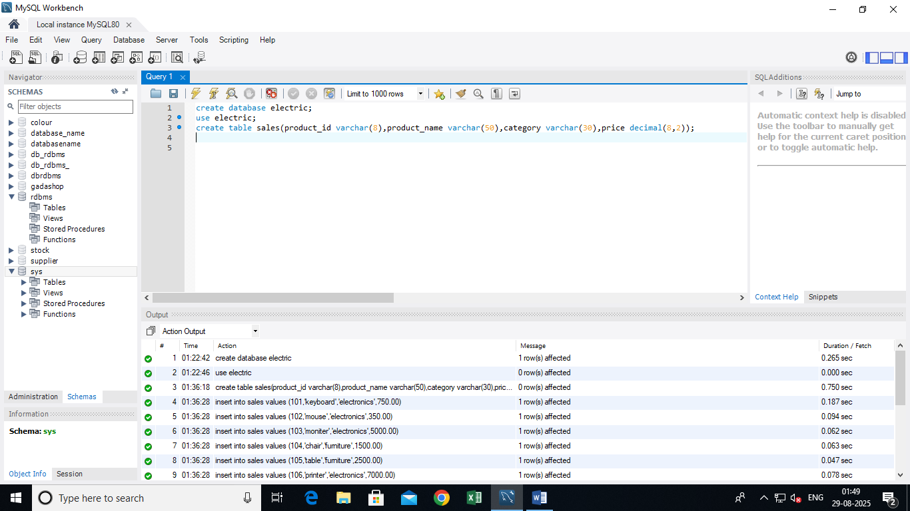
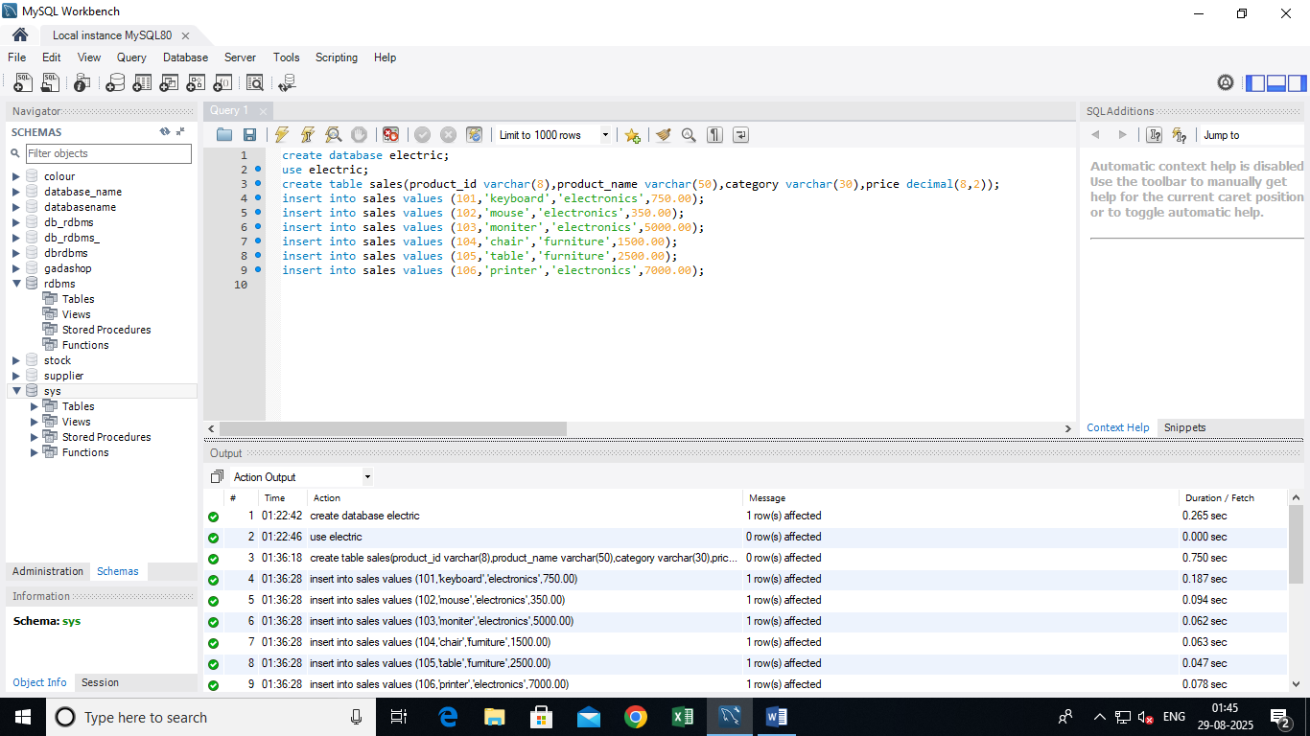
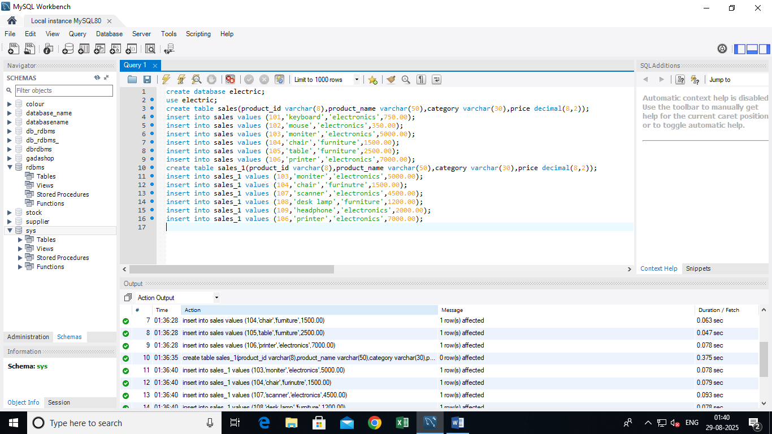
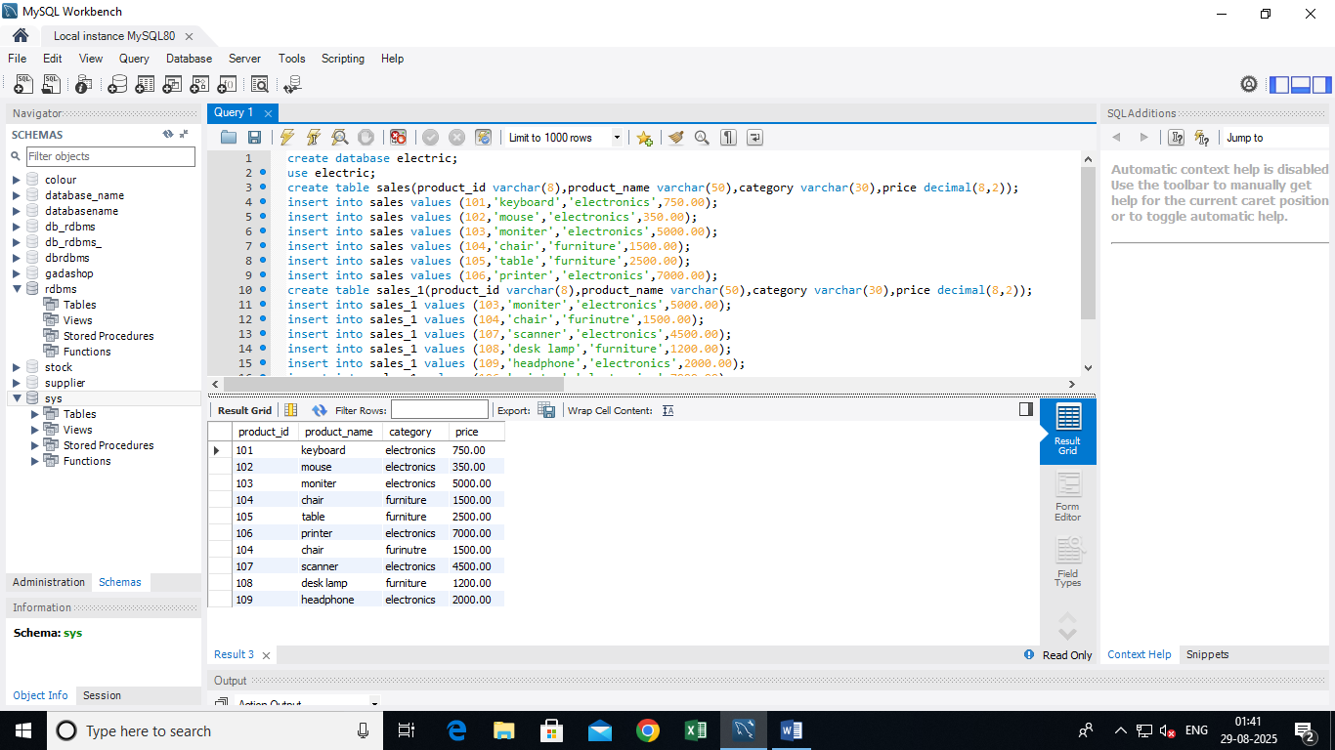
create database electric;
use electric;
create table sales(product_id varchar(8),product_name varchar(50),category varchar(30),price decimal(8,2));
insert into sales values (101,'keyboard','electronics',750.00);
insert into sales values (102,'mouse','electronics',350.00);
insert into sales values (103,'moniter','electronics',5000.00);
insert into sales values (104,'chair','furniture',1500.00);
insert into sales values (105,'table','furniture',2500.00);
insert into sales values (106,'printer','electronics',7000.00);
create table sales_1(product_id varchar(8),product_name varchar(50),category varchar(30),price decimal(8,2));
insert into sales_1 values (103,'moniter','electronics',5000.00);
insert into sales_1 values (104,'chair','furinutre',1500.00);
insert into sales_1 values (107,'scanner','electronics',4500.00);
insert into sales_1 values (108,'desk lamp','furniture',1200.00);
insert into sales_1 values (109,'headphone','electronics',2000.00);
insert into sales_1 values (106,'printer','electronics',7000.00);
select*from sales
union select*from sales_1;

