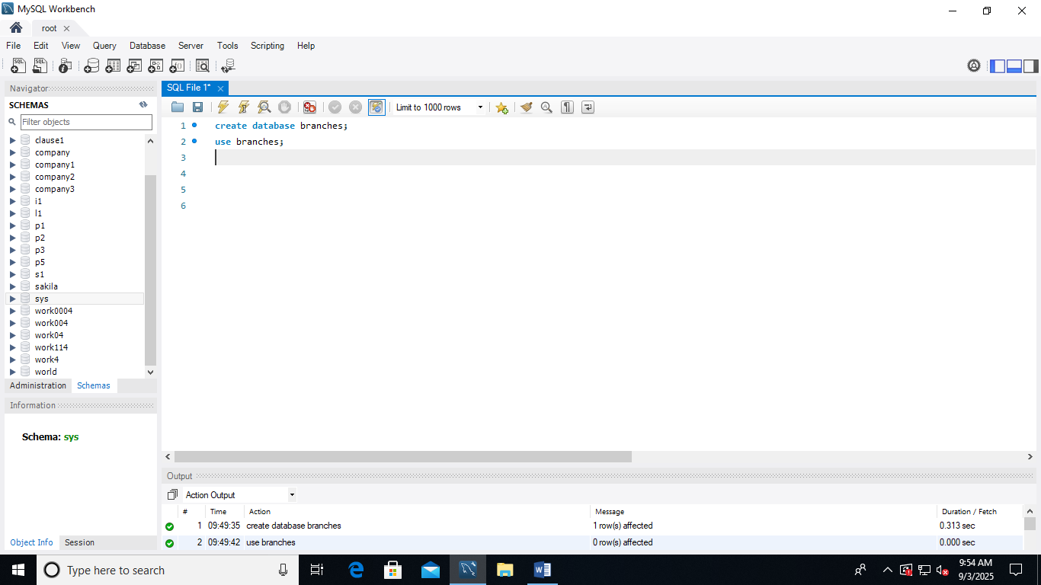

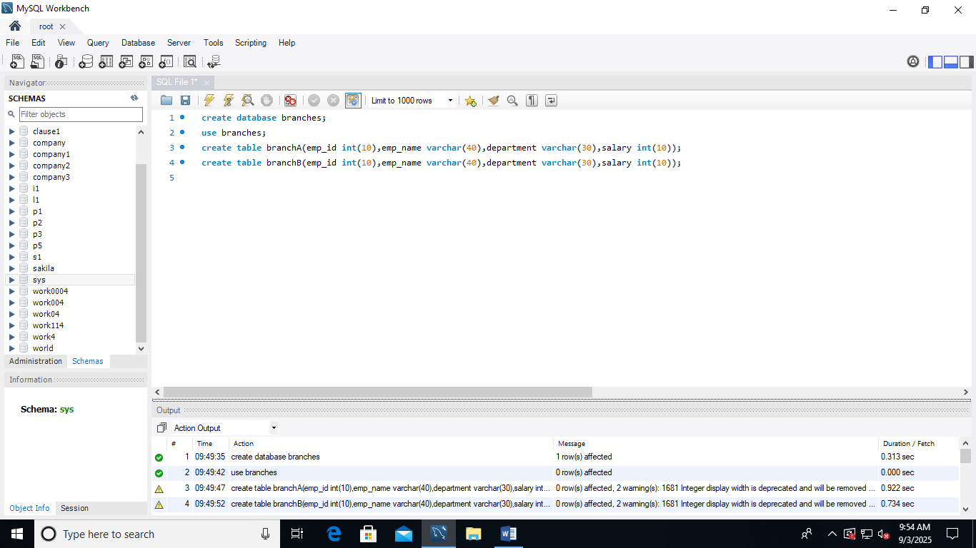

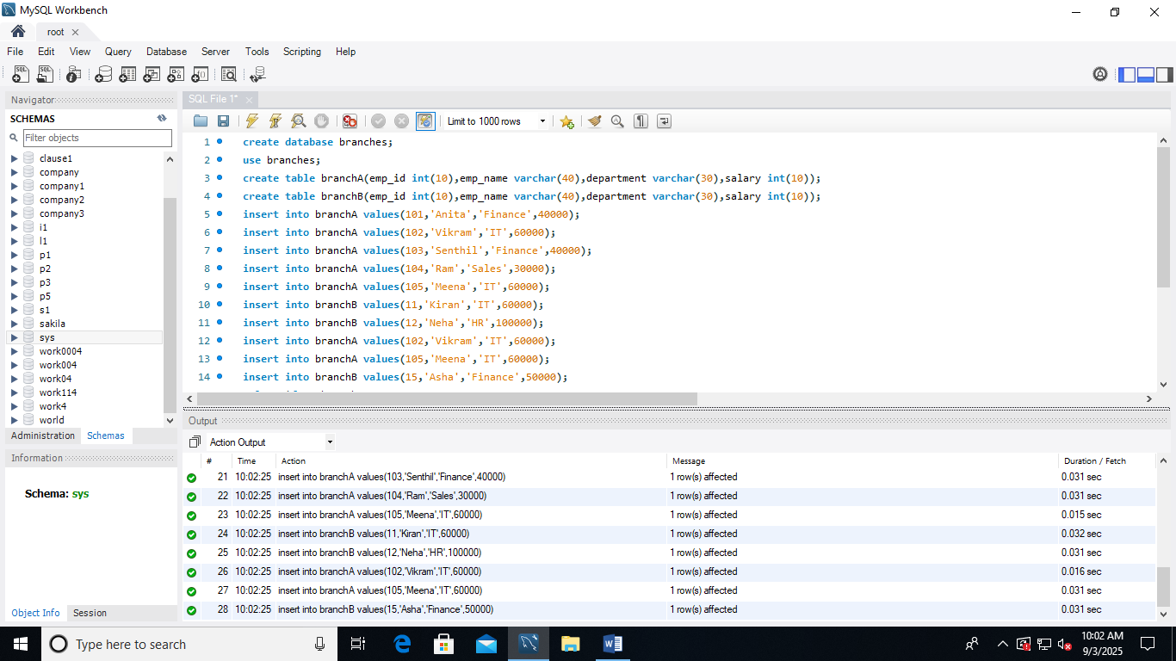

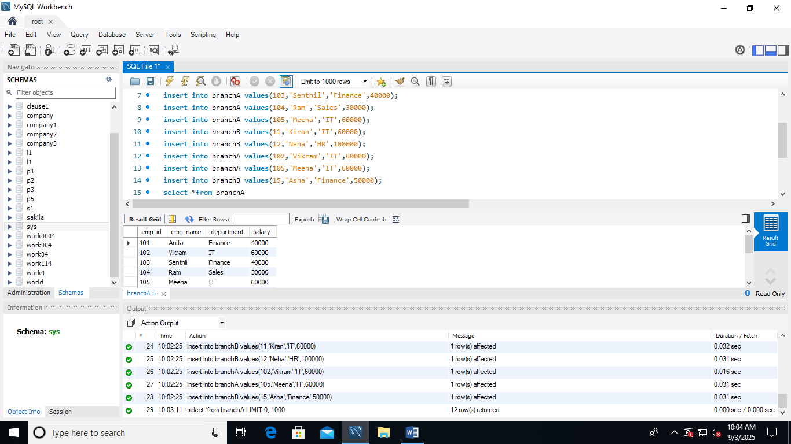
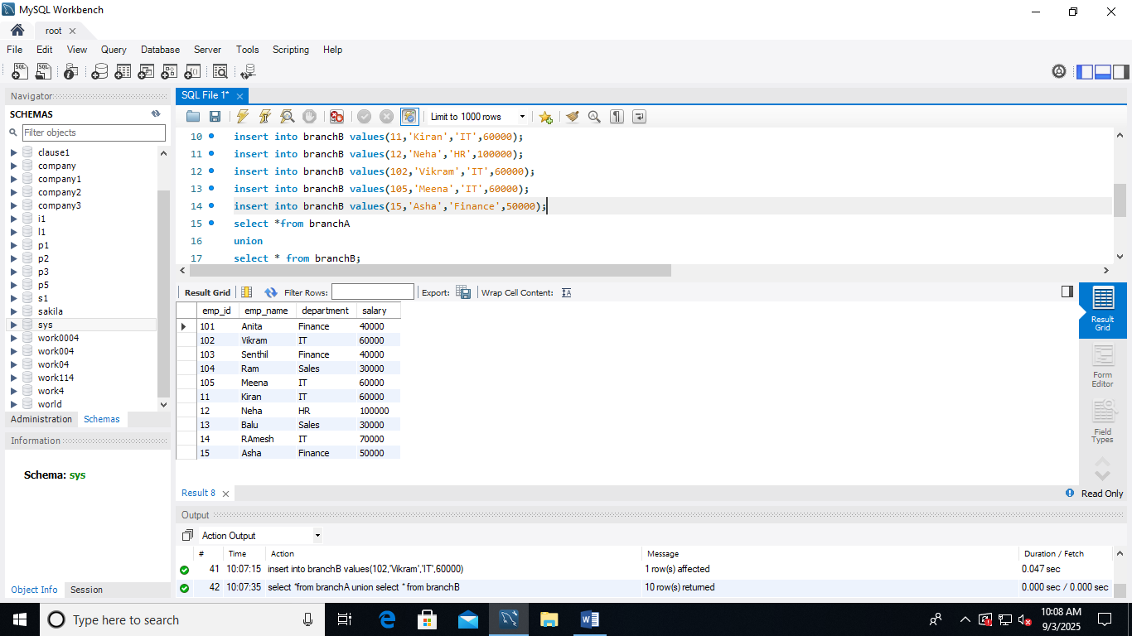
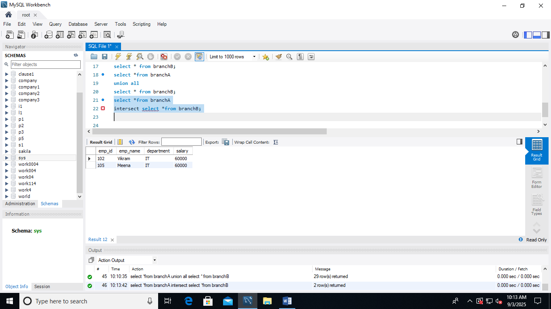
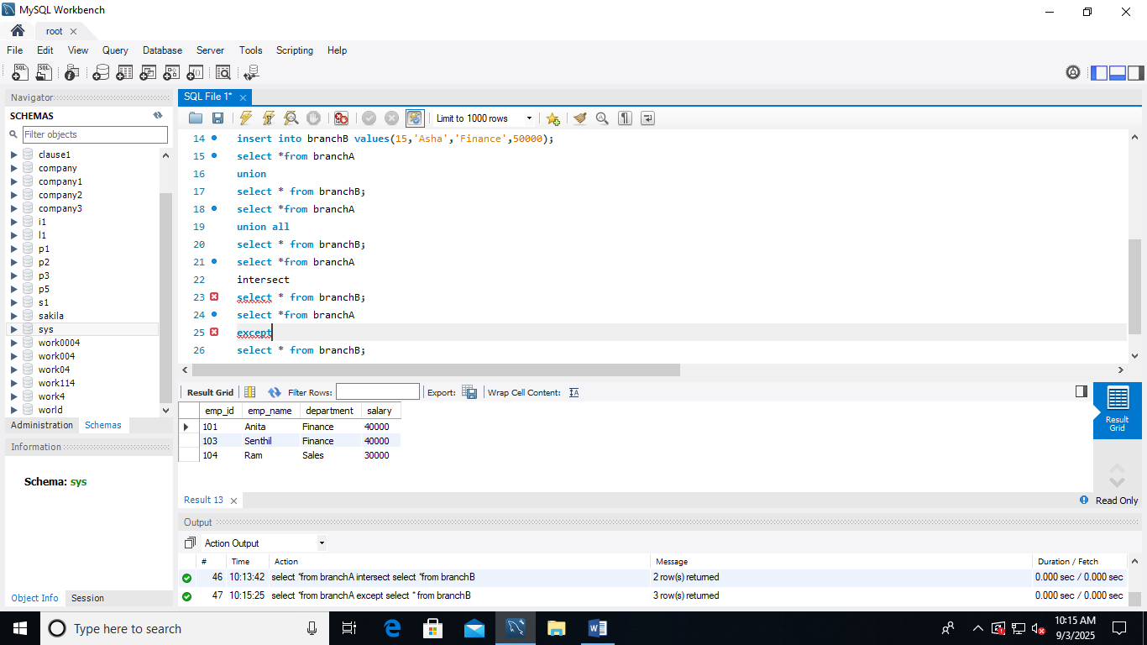

create database branches;
use branches;
create table branchA(emp_id int(10),emp_name varchar(40),department varchar(30),salary int(10));
create table branch(emp_id int(10),emp_name varchar(40),department varchar(30),salary int(10));
insert into branchA values(101,'Anita','Finance',40000);
insert into branchA values(102,'Vikram','IT',60000);
insert into branchA values(103,'Senthil','Finance',40000);
insert into branchA values(104,'Ram','Sales',30000);
insert into branchA values(105,'Meena','IT',60000);
insert into branchB values(11,'Kiran','IT',60000);
insert into branchB values(12,'Neha','HR',100000);
insert into branchB values(102,'Vikram','IT',60000);
insert into branchB values(105,'Meena','IT',60000);
insert into branchB values(15,'Asha','Finance',50000);
select *from branchA
union
select * from branchB;
select *from branchA
union all
select * from branchB;
select *from branchA
intersect
select * from branchB;
select *from branchA
except
select * from branchB;

