UNIX ASSIGNMENT-1

NAME:Rathod Premdas

Unit: Digital Delivery

TASK1

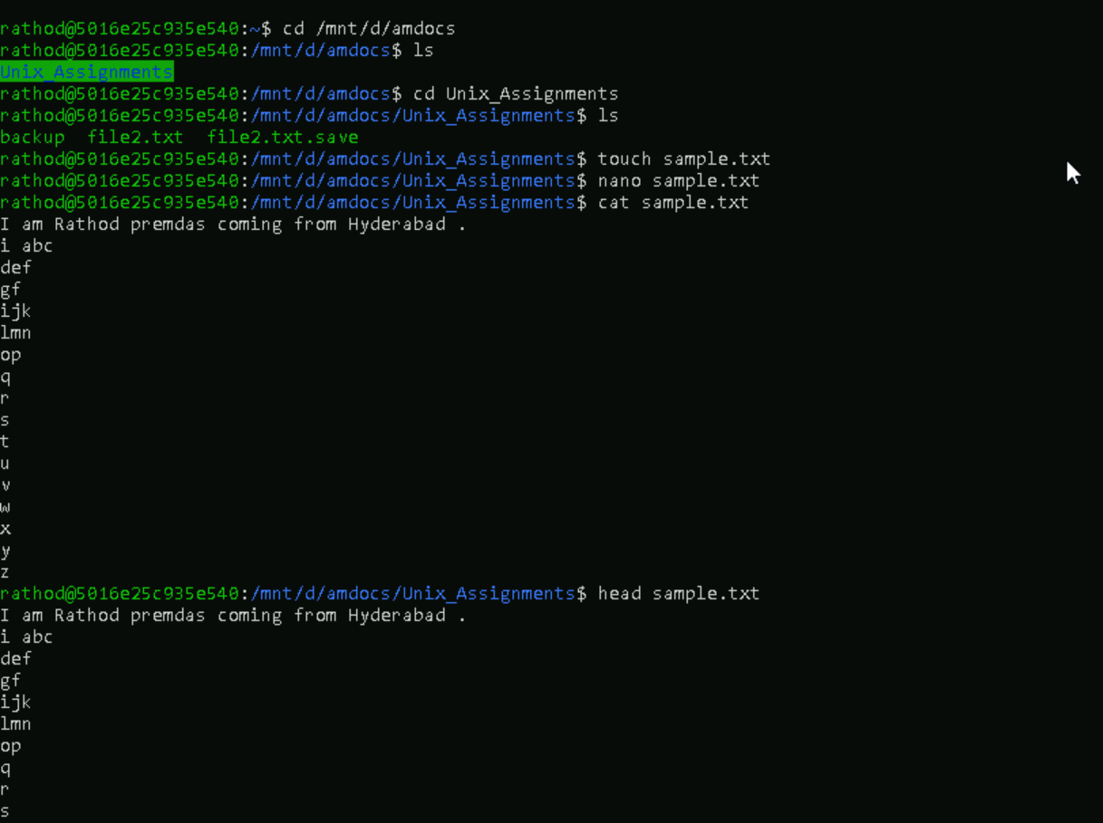







Review;

I have learnt the various unix commands and importance of unix operating system in in the industry