CREDIT CARD CUSTOMER CHURN ANALYSIS
Retention Insights from Customer Behavior and Transaction Data

PROJECT REPORT
Submitted as part of the Internship Project

Prepared by
R.Keerthi
B.Tech – Electrical and Electronics Engineering
G. Narayanamma Institute of Technology and Science
Academic Year: 2026–2027

1. Abstract
This project is based on the analysis of credit card customer data to understand customer attrition. The dataset contains information about customers such as their age, income category, credit details, inactivity, contacts and transaction activity. I cleaned the dataset and performed exploratory data analysis to compare existing customers with attrited customers. I mainly studied transaction behavior, credit utilization, inactivity and customer contacts. The results were then presented using charts and an interactive Streamlit dashboard. The analysis helped identify some noticeable differences between existing and attrited customers and provided useful insights for further customer retention analysis.

2. Introduction
Customer churn is an important issue for businesses that depend on maintaining long-term customers. When customers stop using a service or leave, it can affect the business and its customer relationships. Therefore, studying customer behavior can help in understanding the patterns related to customer attrition.
In this project, I analyzed a credit card customer dataset containing information about customer demographics, account details, transaction activity, credit information and customer engagement. I used Python to clean and analyze the data and compared existing customers with attrited customers. The analysis was also presented through a Streamlit dashboard so that the main findings could be viewed more easily.

3. Problem Statement
The main purpose of this project is to study customer attrition in a credit card customer dataset. The project focuses on understanding how existing and attrited customers differ based on their transaction activity, credit utilization, inactivity, number of contacts and other customer details. The analysis is used to identify patterns in the available data that may be useful for understanding customer retention.

4. Objectives
- To understand the credit card customer dataset and its different attributes.
- To clean and prepare the data before performing the analysis.
- To compare existing customers and attrited customers.
- To study customer transaction activity and transaction amounts.
- To examine customer inactivity and contact patterns.
- To compare credit utilization between the two customer groups.
- To explore demographic and income-related customer information.
- To create an interactive dashboard to present the analysis results.
- To identify useful observations that can support further customer retention analysis.

5. Dataset Description
For this project, I used the Credit Card Customers dataset available on Kaggle. The dataset contains 10,127 customer records and information about their demographics, credit details, account relationships, activity and transactions. The main column used to identify customer status is Attrition_Flag, which indicates whether the customer is an existing customer or an attrited customer.
The original dataset contained 23 columns. During the data preparation process, two columns related to the Naive Bayes classifier output were removed because they were not required for the customer behavior analysis. After this step, the cleaned dataset contained 21 columns. CLIENTNUM was kept as a customer identifier but was not used as a variable for business analysis.

Dataset Information | Details
Number of records | 10,127
Original number of columns | 23
Cleaned number of columns | 21
Target/Status variable | Attrition_Flag
Customer identifier | CLIENTNUM
Main analysis areas | Demographics, activity, credit, contacts and transactions

6. Tools and Technologies
- Python – used for data cleaning and analysis.
- Pandas – used for loading, cleaning and analyzing the dataset.
- Matplotlib – used to create charts during the analysis.
- Plotly – used for interactive visualizations in the dashboard.
- Streamlit – used to build the interactive dashboard.
- Google Colab – used for developing and running the analysis notebook.
- Visual Studio Code – used to work with the project files and run the dashboard.

7. Data Cleaning and Preparation
Before starting the analysis, I checked the dataset to understand its structure and make sure it was suitable for analysis. I checked the records, columns, missing values and duplicate rows. I also reviewed the columns related to the Naive Bayes classifier and removed them because they were not needed for this analysis.
- The dataset contains 10,127 customer records.
- No missing values were found in the dataset.
- No duplicate rows were found.
- Two Naive Bayes classifier-related columns were removed.
- The cleaned dataset contains 21 columns.
- CLIENTNUM was treated as an identifier and was not used to draw business conclusions.
- The cleaned dataset was saved as credit_card_customer_churn_cleaned.csv.

8. Exploratory Data Analysis
After cleaning the dataset, I performed exploratory data analysis to compare existing customers and attrited customers. I looked at different customer and account-related variables to understand the patterns in the data. The main areas considered were customer status, transaction activity, credit utilization, months of inactivity, customer contacts, income category, age, gender, education level and credit limit.

8.1 Customer Status
The dataset contains 10,127 customers in total. Among them, 8,500 are existing customers and 1,627 are attrited customers. This means that 83.93% of the customers are existing customers and 16.07% are attrited customers. This gives an overall view of the customer distribution in the dataset.

8.2 Transaction Behavior
I compared the transaction activity of existing and attrited customers using transaction count and transaction amount. Existing customers had an average transaction count of 68.67, while attrited customers had an average of 44.93. The average transaction amount was also higher for existing customers at 4,654.66 compared with 3,095.03 for attrited customers.

8.3 Credit Utilization
The average credit utilization ratio was also compared between the two groups. Existing customers had an average utilization ratio of about 0.296, while attrited customers had an average of about 0.162. This shows a difference in the credit utilization values observed for the two groups.

8.4 Months of Inactivity
I also checked the number of months customers were inactive during the previous 12 months. The attrition rate was different for different inactivity levels. For example, the observed attrition rate was 29.89% for customers with 4 months of inactivity. The 0-month group showed an attrition rate of 51.72%. However, the groups should be considered along with their customer counts, so these values alone should not be treated as proof that inactivity causes attrition.

8.5 Customer Contacts
The number of contacts made with customers during the previous 12 months was another variable included in the analysis. The observed attrition rate was 1.75% for customers with 0 contacts and increased to 33.52% for customers with 5 contacts. The 6-contact group showed 100% attrition in the dataset, but this value should be interpreted carefully because the number of customers in that group may be small.

8.6 Income Category
I compared attrition across different income categories to check whether there were noticeable differences. The observed attrition rates were 17.33% for customers earning $120K+, 17.19% for Less than $40K, 15.77% for $80K–$120K, 15.14% for $40K–$60K and 13.48% for $60K–$80K. The differences between the main income groups were relatively small.

8.7 Age and Demographic Characteristics
Age, gender and education level were also included in the analysis. The average age of attrited customers was 46.66 years, while the average age of existing customers was 46.26 years. I also compared the customer groups based on gender and education level to understand the distribution of attrition across these categories.

8.8 Credit Limit
Credit limit was another variable considered during the analysis. The average credit limit was 8,136.04 for attrited customers and 8,726.88 for existing customers. This shows a difference in the average credit limit between the two groups, although the overall distribution of the values also needs to be considered.

9. Interactive Dashboard
After completing the analysis, I created an interactive dashboard using Streamlit. The dashboard was developed to make the main results easier to understand without going through the complete analysis code. It contains summary values and charts related to customer status, transactions, credit utilization, inactivity and customer contacts. An income category filter was also added to view the data for different income groups.
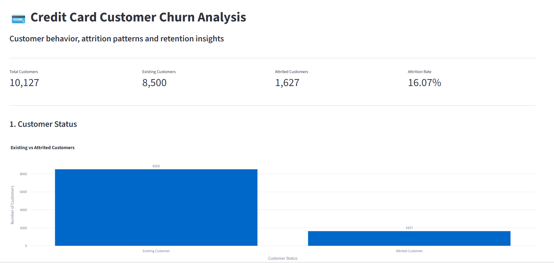
Figure 1: Streamlit dashboard overview and customer status
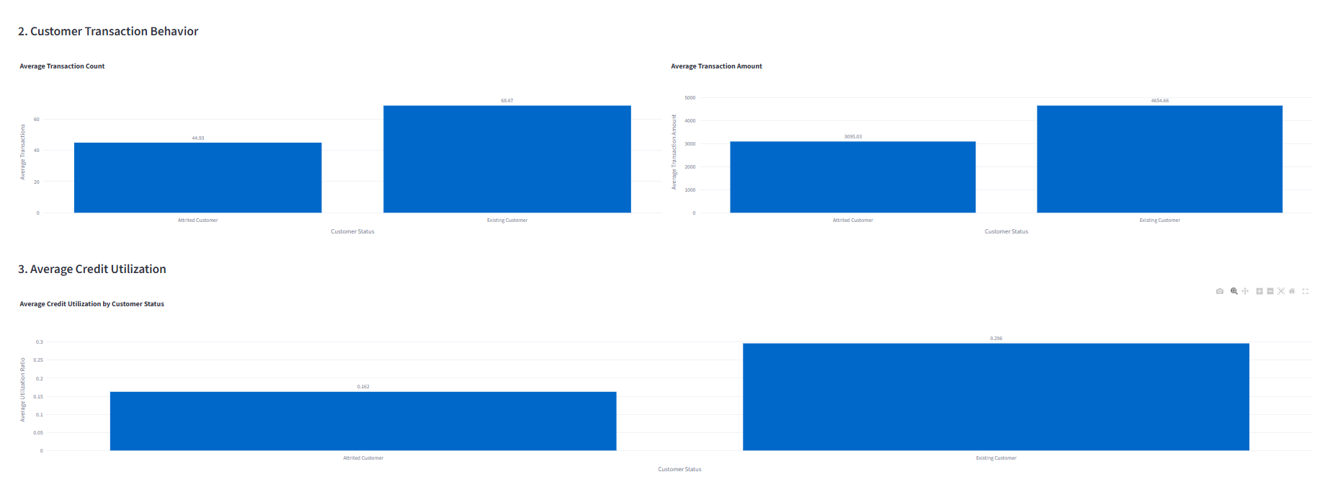
Figure 2: Transaction behavior and average credit utilization
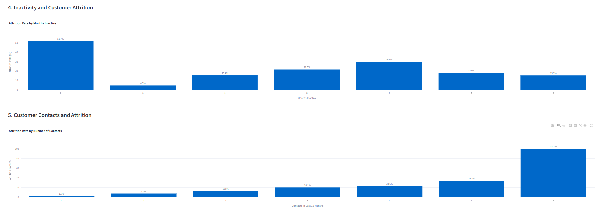
Figure 3: Customer inactivity and contact-related attrition analysis
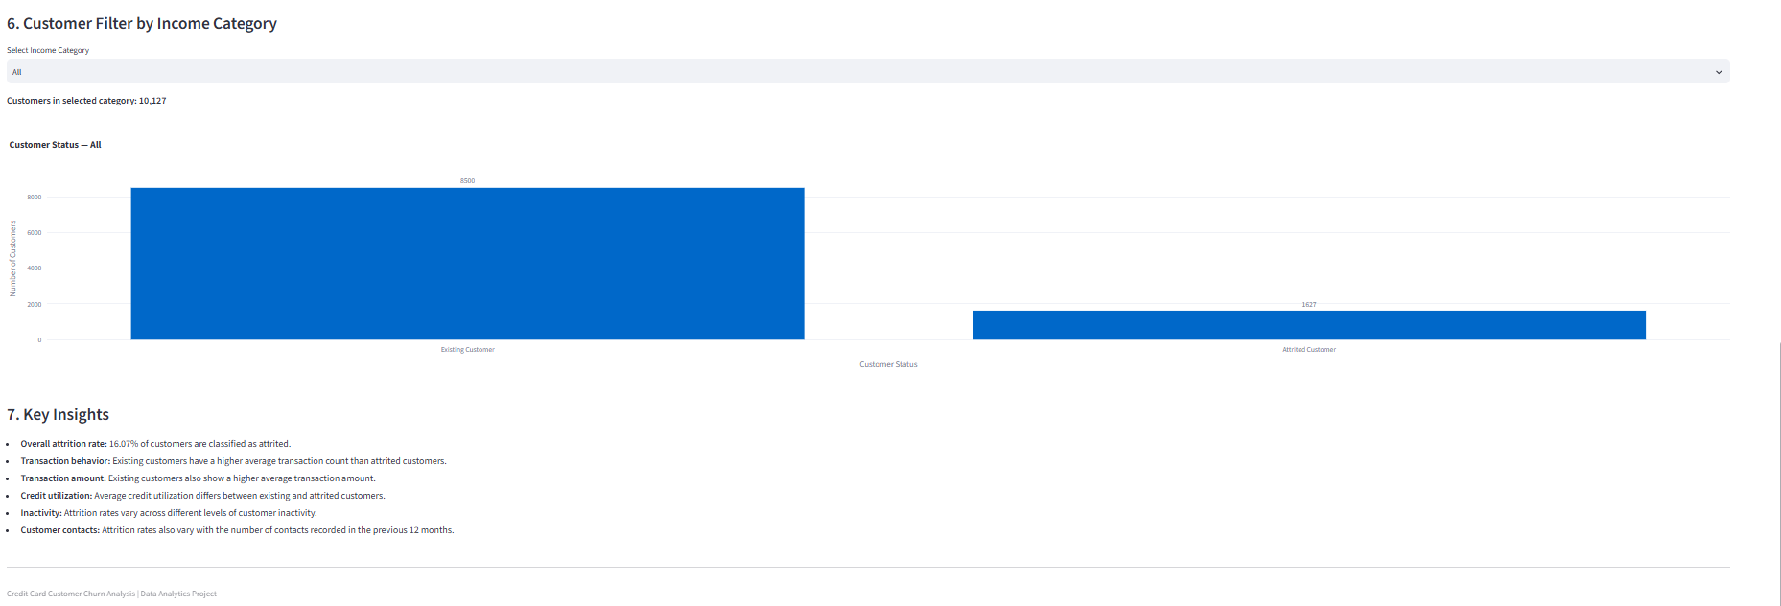
Figure 4: Income category filter and key insights
- Total number of customers
- Existing and attrited customer counts
- Overall attrition rate
- Average transaction count
- Average transaction amount
- Average credit utilization
- Attrition by months of inactivity
- Attrition by number of customer contacts
- Income category filter
- Key observations from the analysis

10. Key Findings
- The dataset contains 10,127 customers.
- 8,500 customers are existing customers and 1,627 customers are attrited.
- The overall observed attrition rate is 16.07%.
- Existing customers have a higher average transaction count (68.67) than attrited customers (44.93).
- Existing customers also have a higher average transaction amount (4,654.66) than attrited customers (3,095.03).
- The average credit utilization ratio is about 0.296 for existing customers and 0.162 for attrited customers.
- Attrition rates vary across different months of inactivity.
- Attrition rates also vary according to the number of customer contacts.
- The main income categories have relatively similar attrition rates.
- The average age of existing and attrited customers is quite similar.

11. Retention Insights
The analysis gives some useful areas that can be considered when studying customer retention. Customers with lower transaction activity, different inactivity levels and repeated contacts showed different patterns of attrition in the dataset. These areas can therefore be used for further customer-level analysis. However, the results from this project are based on observed data patterns and should not be treated as direct proof of the reasons for customer attrition.
- Customers with lower transaction activity can be studied further as a separate group.
- Customers showing inactivity can be monitored for changes in their activity.
- Customers with repeated contacts can be examined to understand their account or service-related situations.
- Customer segments can be created using the available demographic, transaction and account information.
- A predictive model can be developed in future work if prediction is required.

12. Conclusion
In this project, I analyzed credit card customer data to understand the differences between existing and attrited customers. The data was cleaned and explored using different customer, transaction and account-related variables. The analysis showed noticeable differences in transaction activity, transaction amount and credit utilization between the two customer groups. I also studied inactivity, customer contacts, income category and demographic information. Finally, I created a Streamlit dashboard to present the main results in an easier way. Overall, the project helped me understand how data analysis can be used to study customer behavior and identify areas for further retention analysis.

13. Future Scope
- A machine learning model can be developed to predict customer attrition.
- Different machine learning algorithms can be compared based on their performance.
- Important features for predicting attrition can be studied using feature-importance techniques.
- More customer segmentation options can be added to the dashboard.
- Additional filters and visualizations can be added to make the dashboard more interactive.
- Future customer data can be used to evaluate whether retention strategies are effective.

14. References
1. Kaggle – Credit Card Customers dataset:
https://www.kaggle.com/sakshigoyal7/credit-card-customers/activity
2. Python, Pandas, Matplotlib, Plotly and Streamlit documentation used during project development.

