**Problem Statement:**

We will implement a solution that utilizes lambdas to:

1. Sort a list of integers in ascending and descending order.

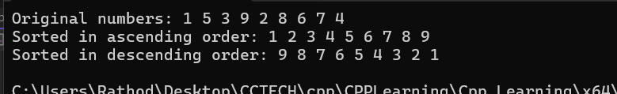

**Use Cases**: Lambdas are often used for short, inline functions passed to algorithms like sort, accumulate, or copy_if, making code concise and readable.