Crime Analysis and Visualization of Police Department Data

**Created By:**

Mayur Suresh Rathod

Vishwakarma Institute of Technology, Pune

[mayur.rathod19@vit.edu](mailto:mayur.rathod19@vit.edu)

Gr No. 11910509

<https://github.com/Rathodsaheb/Crime-Analysis-and-Visualization-of-Police-Department-Data.git>

## Introduction

The dataset provided is from the San Francisco Police Department and contains information about crimes in the city. We need to find insights here to improve the city's overall safety. To accomplish this, we conducted a thorough analysis of the provided dataset using Python and PowerBI. First, we look for features that add value to the city's safety by lowering the crime rate. We can plot the relationship between the features using data visualization techniques. We can draw some conclusions from this.

## Analysis

First of all, we need to see the total number of incidents recorded under a single crime category.

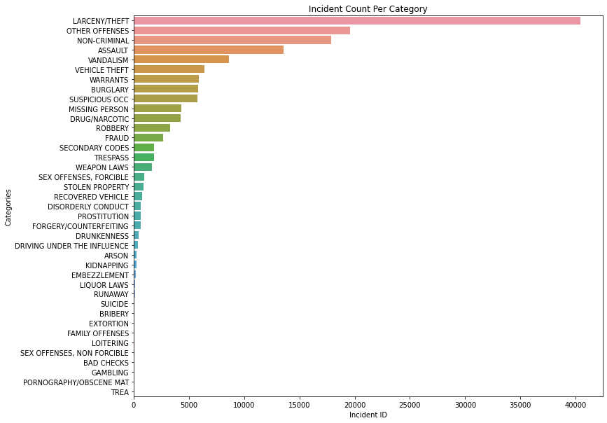

From the above bar plot, we see that the categories of which maximum incidents recorded are Larceny/Theft, Other Offences, Non-Criminal, Assault and Vandalism. Here department need to focus in order to reduce this type of crimes.

Let us check the proportion of incident per district to get clear idea about the incidents recorded in a district.

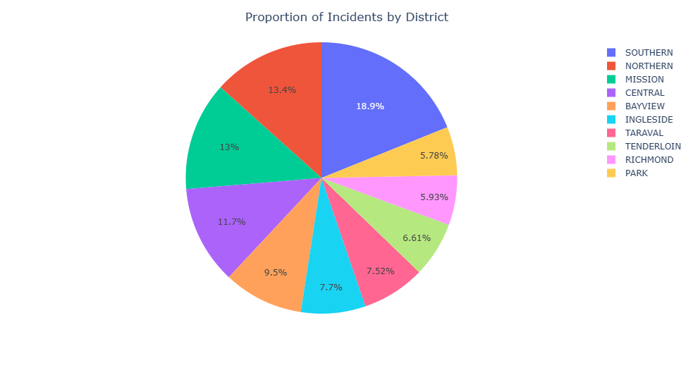

From the above visuals, we get the maximum crimes happens in southern district.

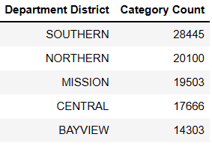

Above are the top 5 criminalize district on the basis of incident counts.

Now we need to check the type of crimes happens in specific district to look at the seriousness of crime.

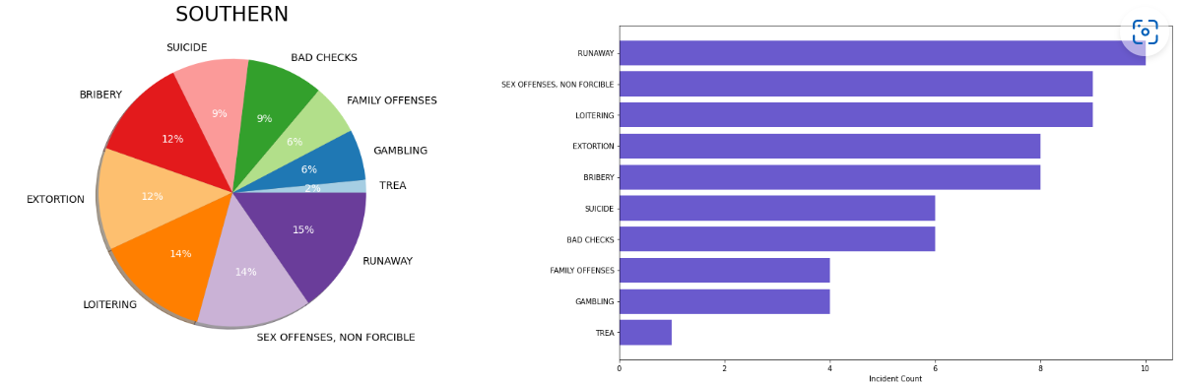

Southern district contains serious type of crimes like runaway, sex offences-non forcible, loitering and extortion.

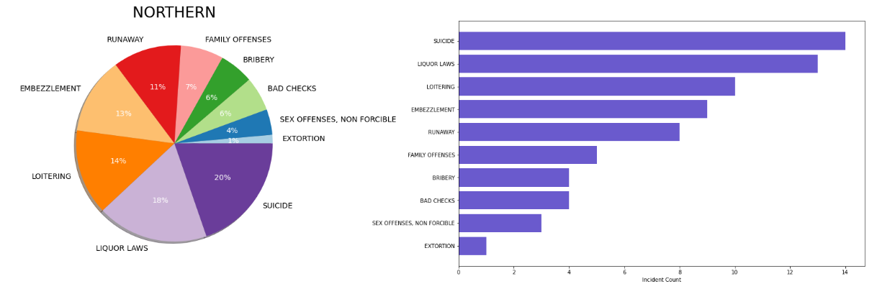

In Northern district include crimes like suicide, liquor laws, loitering, bribery and embezzlement. Here most of the crime occur due to violation of government laws may be because of lack of governance.

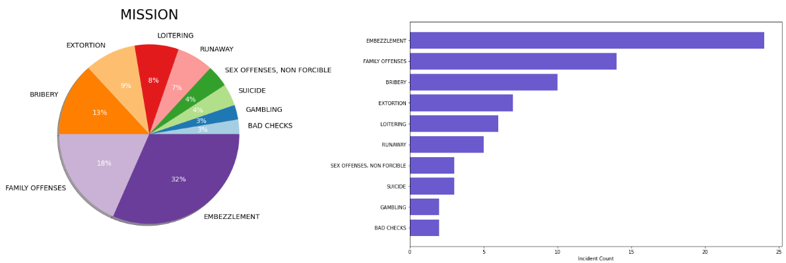

Mission district include crimes like Embezzlement, family offenses and bribery, which are not as serious as southern district but it requires defensive approach to resolve those crimes.

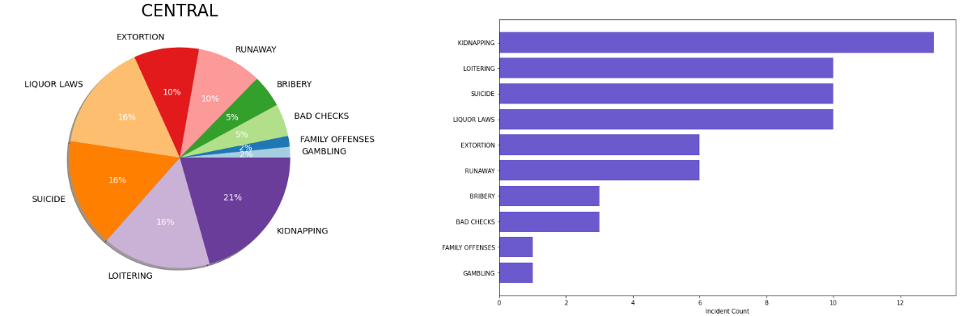

Central District has many types of incidents with more or less proportions.

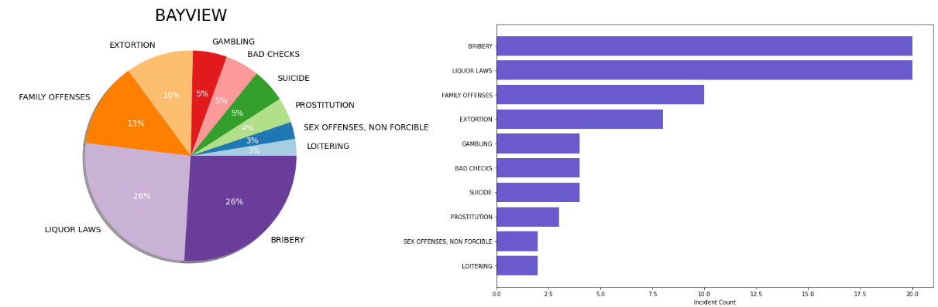

Bayview has most crime registered under categories like bribery, liquor laws, family offenses which is more than 10 incidents.

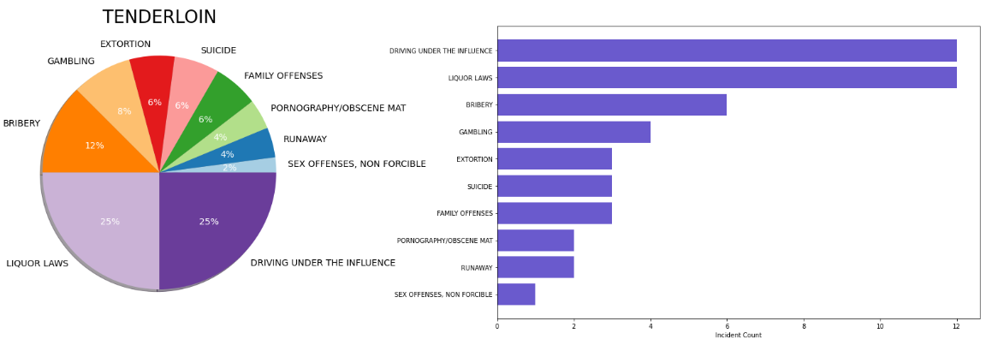

Tenderloin district has underground art spaces, classic concert venues such as the Great American Music Hall and historic theaters staging Broadway and indie shows. It is funky, colorful streets feature a mix of upscale, trendy and casual restaurants. Nightlife ranges from dark dives slinging beer and shots to speakeasy-style bars mixing craft cocktails. Because of this the crimes like driving under the influence, liquor laws, bribery and gambling occur most.

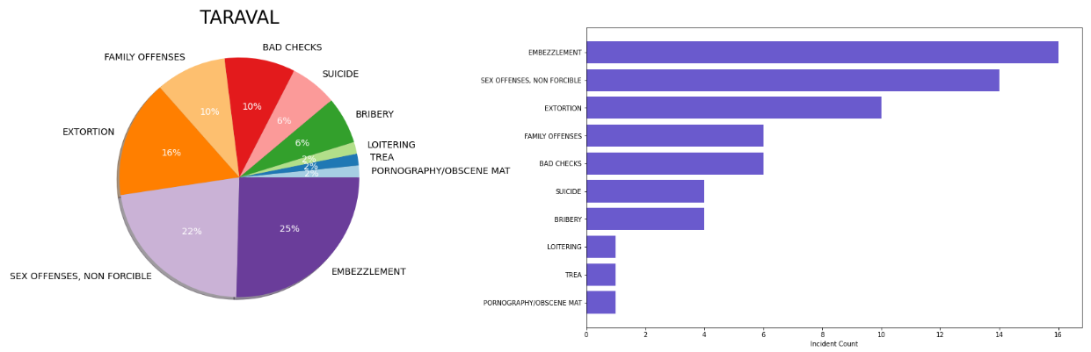

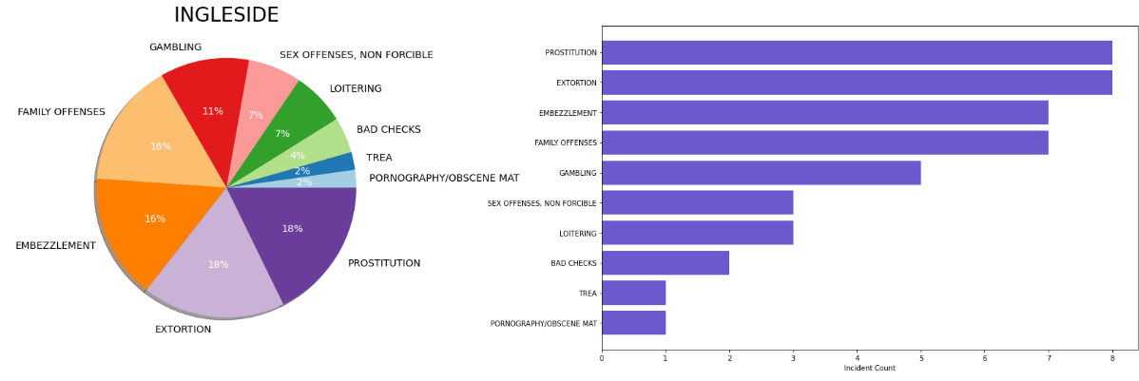

Ingleside is wealthy area which contains residential parks, bars and inn. Because of the crime occur is of the categories like prostitution, extortion, embezzlement, gambling.

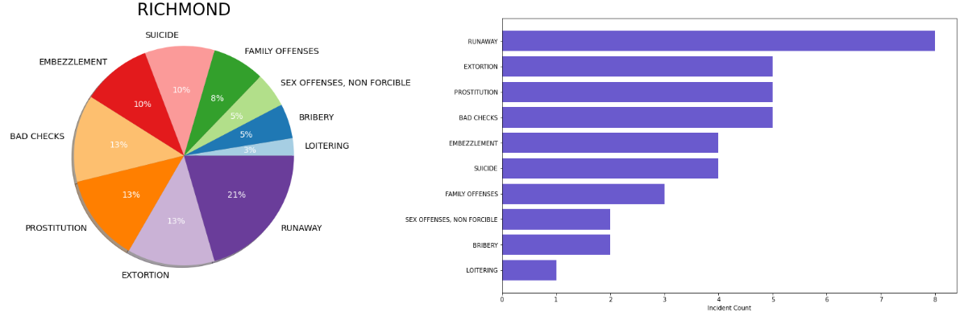

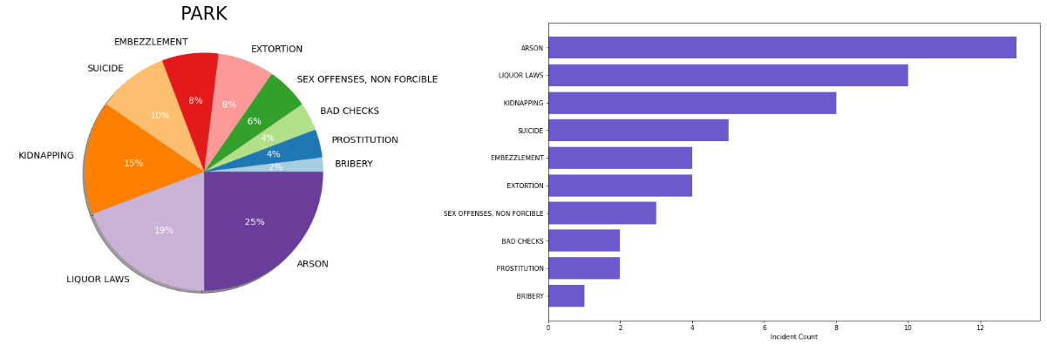

Up till now we have seen the crimes happen in district and type of crimes per district.

Now we need to check whether that crime is resolved or not. As per the data given there are 14 categories in which crime resolution done like Arrest-Booked, Arrest-Cited, Juvenile Booked, Juvenile Diverted, Juvenile Cited, Exceptional Clearance, Complainant Refuses to Prosecute, Cleared-contact juvenile for more info, Not Prosecuted, Located, Psychopathic Case, Prosecuted by Outside Agency, Unfounded and None.

Now, let us check percentage rate of resolution categories with respect to crime category on the basis on incidents resolved.

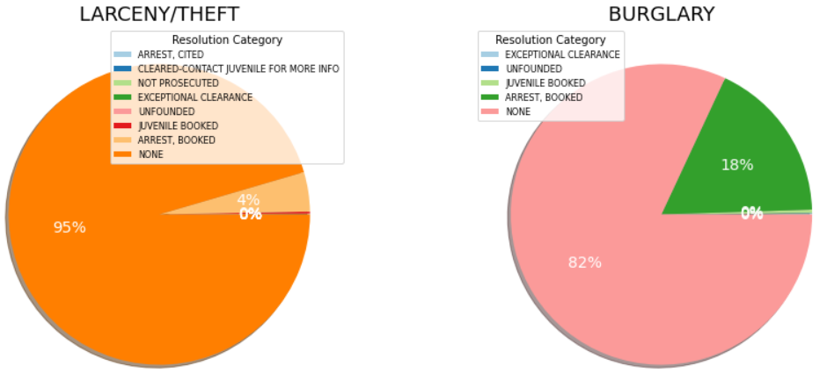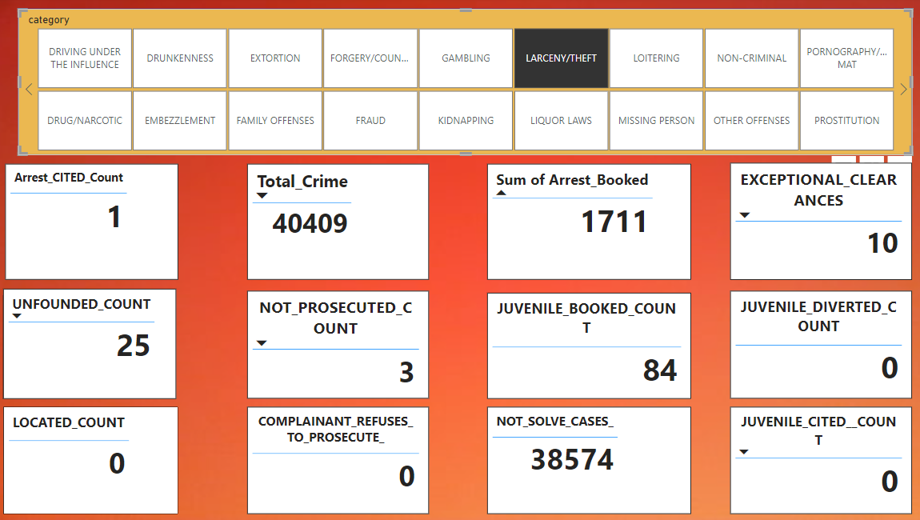

Larceny/Theft is the top most crime category out of which most of the crime are not yet resolve. This may

be the reason because of which this crime is increasing.

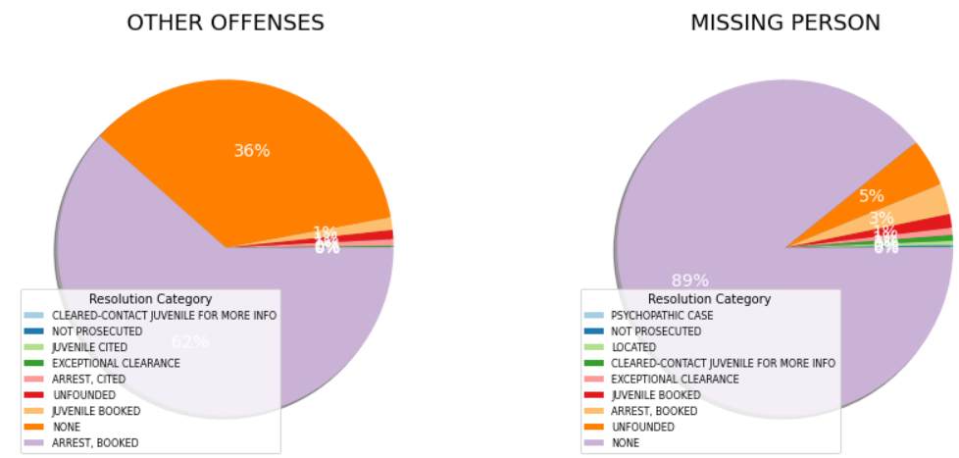 

In Other offences, out of total 19,599 incidents in 12061 cases criminal are arrest-booked, 238 cases where juvenile booked and 31 exceptional clearances. Here more than 200 juveniles discovered which indicate the need to do preventive actions to stop juveniles to attempt crime. In other offenses crime we see positive information about the cases resolved.

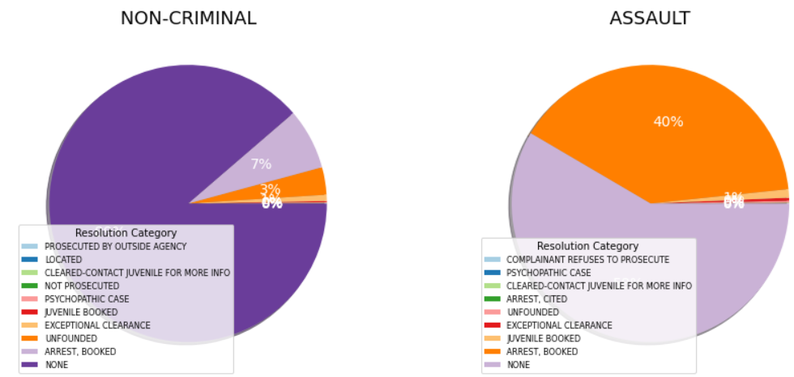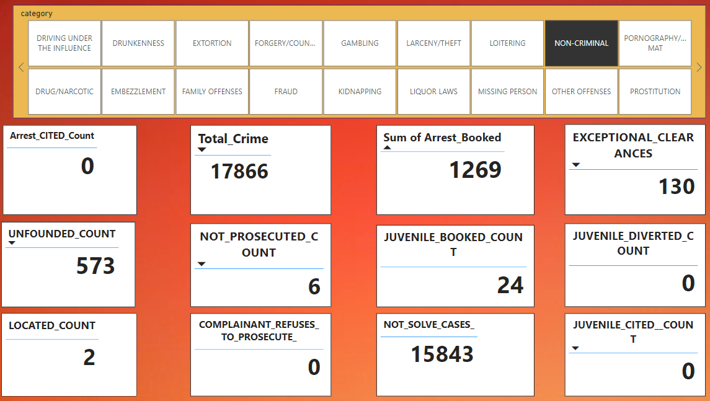

Non-criminal has most of the cases not solve and unfounded cases are around 3%. The arrest-booked count is 1269 which is around 7%. The number of unfounded cases is greater than 500.

 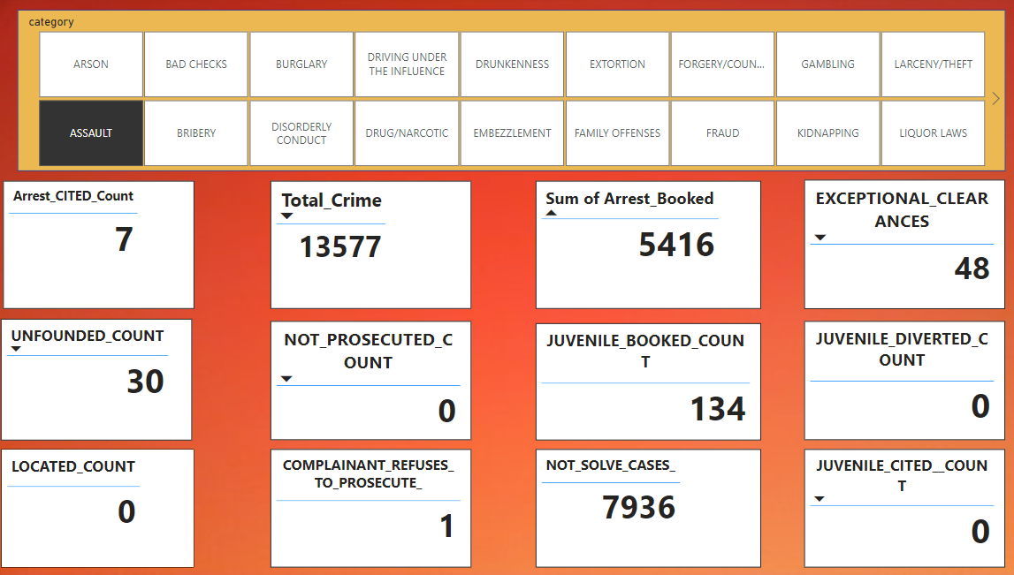

In Assault, around 58% cases are not solved, 40% cases are arrest-booked which is still good and in 134 cases juvenile-booked type of resolution done.

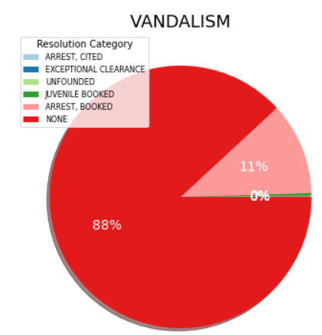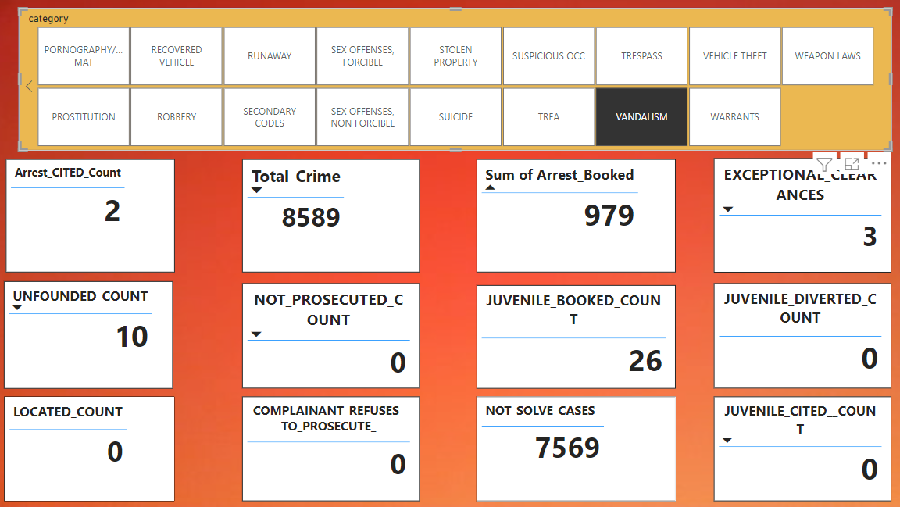

In Vandalism, again most cases are still pending which is around 88% there are only in 11 cases criminal is arrest-booked.

From the above proportion of resolution categories of top 5 most criminal category we clearly see that most of the cases are not solved which is the biggest concern and need to resolve as soon as possible. After plotting rest of the categories results are quite positive but department need to take respective action to solve almost all cases.

Now we’ll check the relation between months and crime rate to check the seasonality of the data.

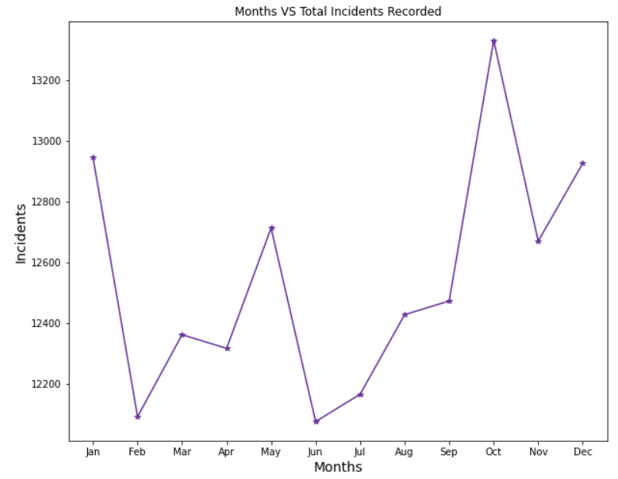

Here we clearly see that most crimes happen in January, May, October, November and December. But from June to October crime rate continuously increasing. As this is the best time to visit San Francisco and tourist visits is at its peak.

Along with this, we can also find at what time maximum crime happens.

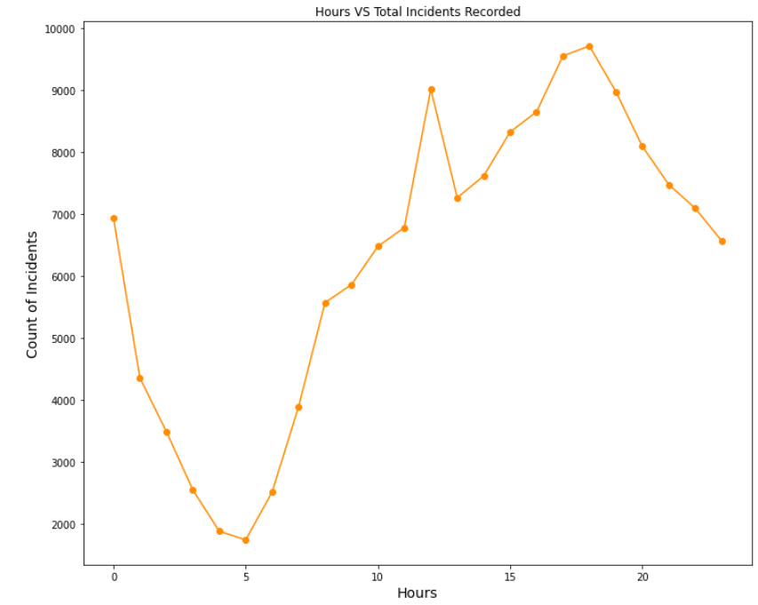

Here we see the maximum incidents happens between 17 pm to 19 pm. Incidents are decreasing from 1 am to 5 am may be because this is the midnight and morning time. And incidents increasing from 5 am to 18pm as its day time. So, most the incidents happens when people are awake.

Let’s check whether monthly crime incidents are increasing or decreasing in a department district.

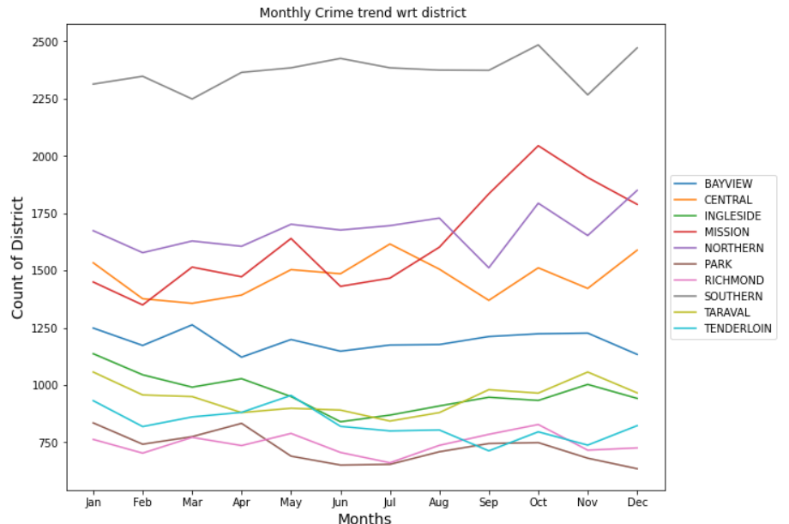

From the above plot, we can see Ingleside, Taraval, Tenderloin, Park districts has a decreasing trend which means criminal incidents in these districts are decreasing per months. On the other side, in mission district criminal incidents are increasing and rest district is somewhat stable.

Let’s try to plot the incident categories with the help of latitude and longitude.

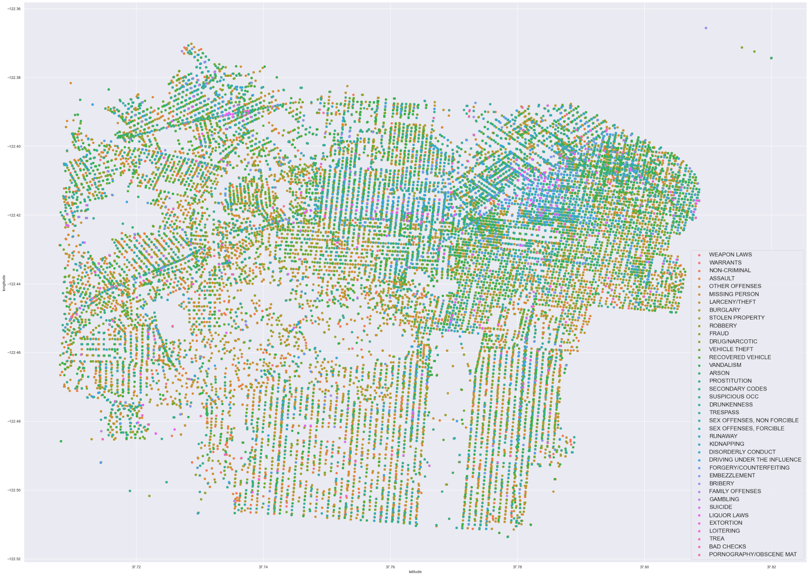

If we came the above plot with actual San Francisco map we came to know that maximum crime happens in the southern region as we stated at start.

## Results

* Categories of which maximum incidents recorded are Larceny/Theft, Other Offences, Non-Criminal, Assault and Vandalism.
* Top 5 criminalize districts are Southern, Northern, Mission, Central, Bayview.
* Most of the districts have serious crime categories, few district contains minor offenses.
* Most of the criminal cases are not solved.
* Most crimes occur in January, May, October, November, and December according to the relationship between months and crime rate. But the crime rate has been steadily rising since June to October.
* Maximum incidents happen between 17 pm to 19 pm. Incidents are decreasing from 1 am to 5 am may be because this is the midnight and morning time. And incidents increasing from 5 am to 18 pm as its day time.
* Districts like ingleside, taraval, tenderloin, park has criminal incidents are decreasing per months. On the other side, in mission district criminal incidents are increasing.

## Conclusion

* Analysis is done to extract actionable insights form the given dataset in order to improve overall safety of city.
* Different type of relation between the variables are taken into consideration to draw conclusions.
* Maximum incidents recorded are of larceny/theft, non-criminal, other offence and assault category and in order to reduce crime, police department must take necessary action against these violations.
* Highly criminalize district is affected by incidents like loitering, assault, extortion and liquor laws. Here department may take defensive actions to capture these criminals.
* There are some incidents like suicide which resolve by organizing awareness campaign.
* Certain crimes like weapon laws, vandalism are done by juvenile, this is a serious issue which has to solve on immediate basis.
* Most of the incidents are not solve which inspires criminals to do it again and again, and this may be the reason of increasing count of these type of crimes like larceny/theft.
* Mostly crimes happen in tourist season and festivals, so police department has to put extra force at that time.

--Thank You--