*Estimation of Energy Performance of Residential Buildings*

***Wireframe Documentation***

Homepage

We have divided Energy efficiency prediction Homepage into one Section: -

1. First thing anyone will see is a pop-up window on Homepage which will ask for User Inputs like building details for example Relative Compactness, Surface Area, Wall Area, Roof Area, Overall Height, Orientation, Glazing Area, Glazing Area Distribution.

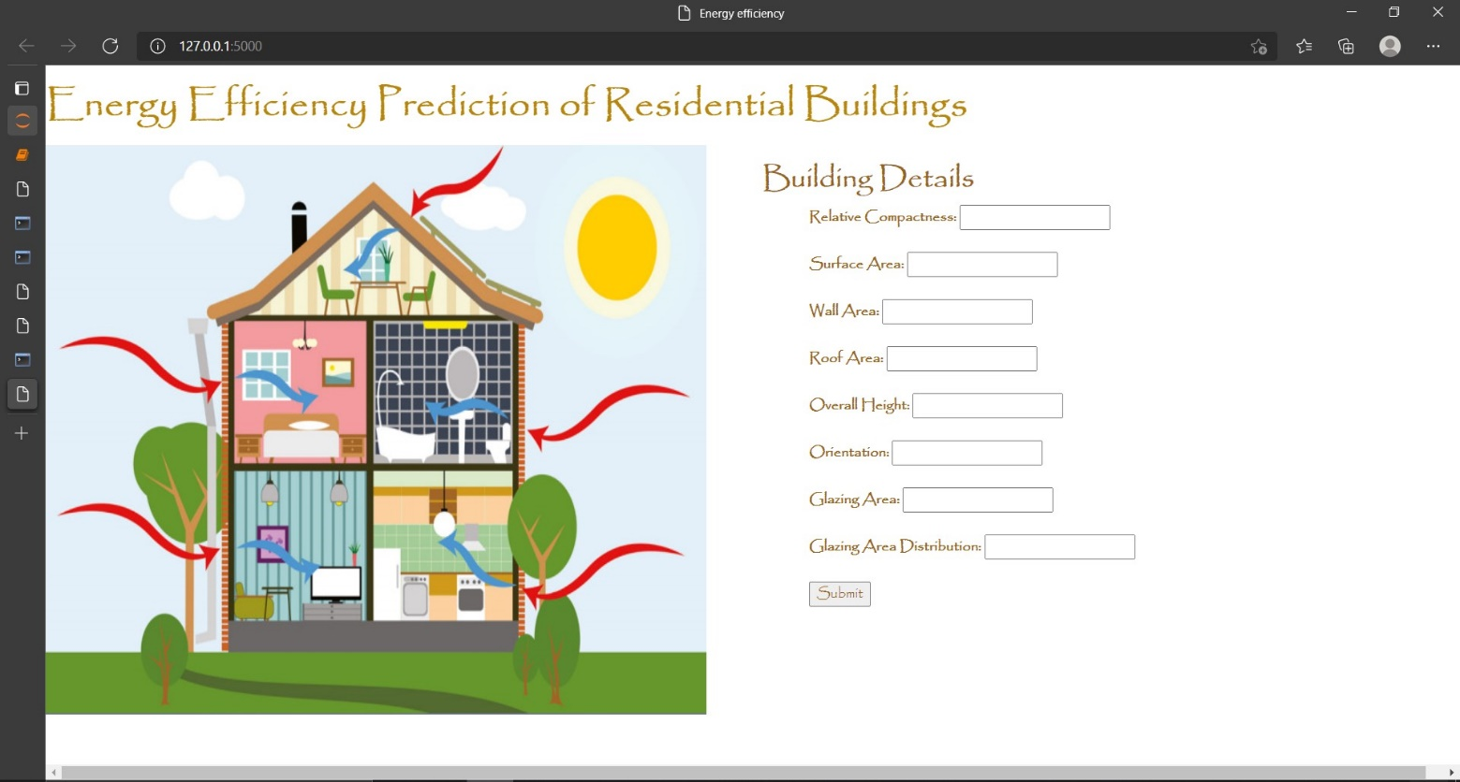

Based on User’s input, our Energy Efficiency Prediction System will recommend values of heating load and cooling load to user on Homepage itself. A sample view of Homepage showing results is below:

