

**Instituto Politécnico Nacional**

*Unidad Profesional Interdisciplinaria en Ingeniería y Tecnologías Avanzadas*

Dispositivos programables

**Tarea**

Filtros FIR e IIR

**Alumno**

Alvarado Balbuena Jorge Anselmo

**Grupo**

4TV1

**Profesor**

Juan Manuel Madrigal Bravo

10/10/2018

**Filtro IIR Pasa-bajas chebyshev tipo 1**

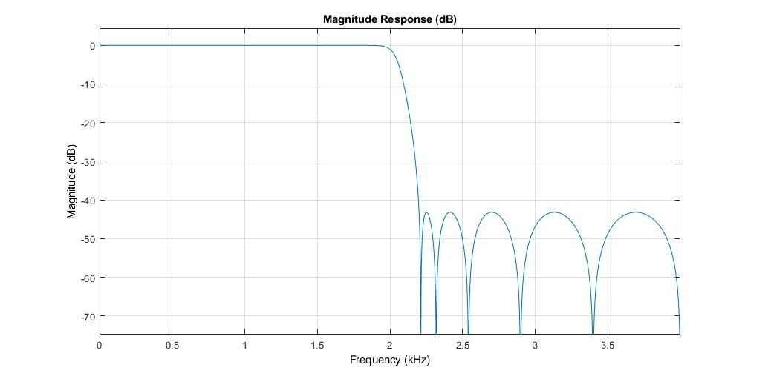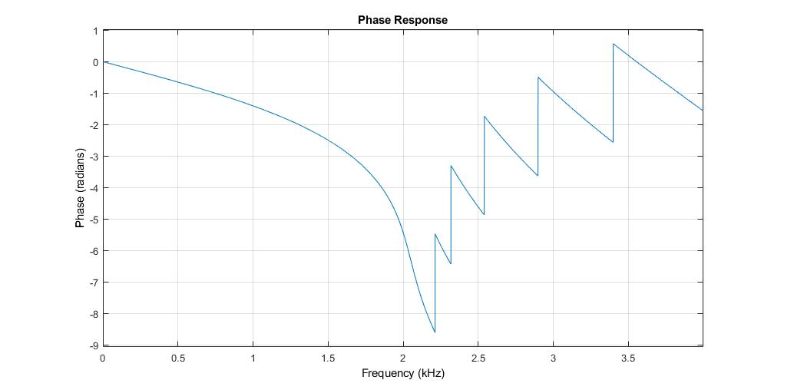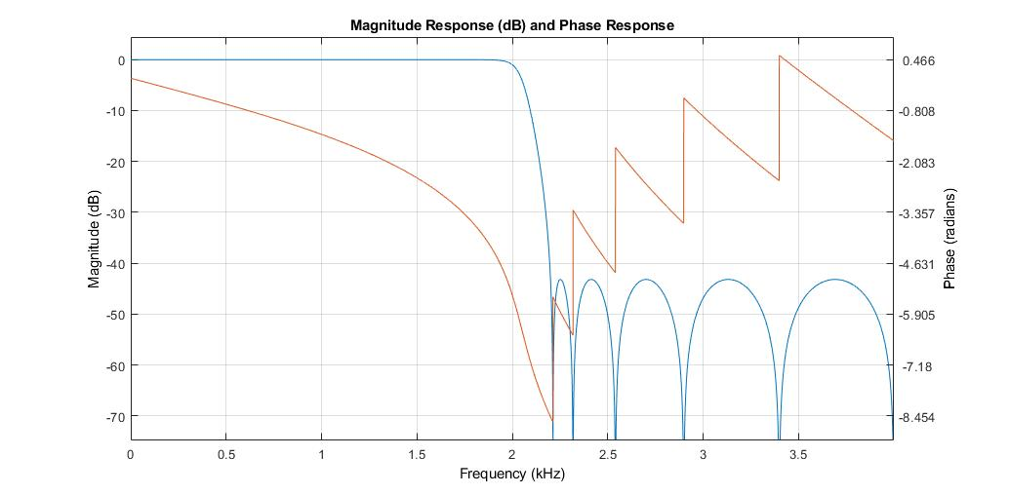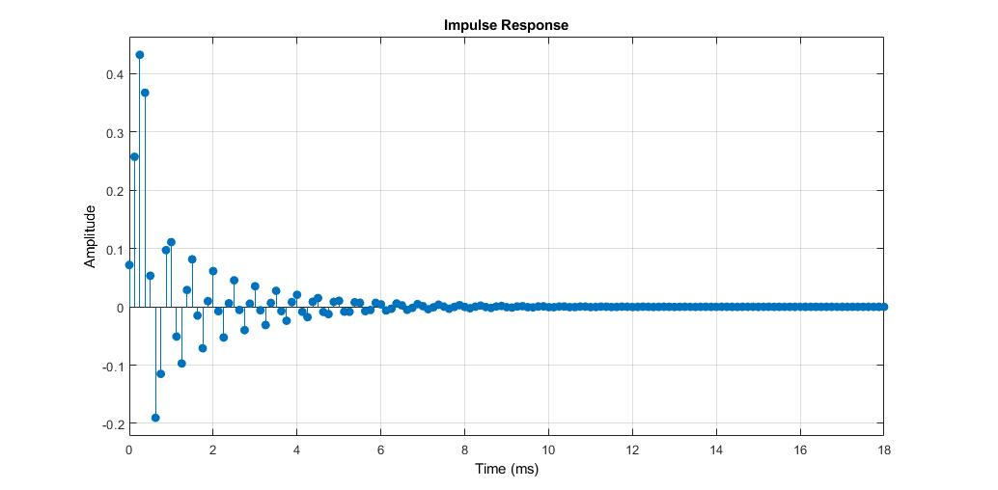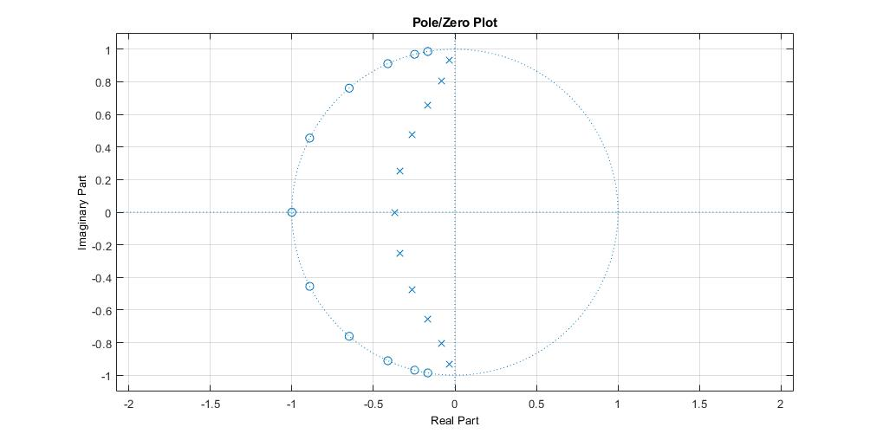

**Coeficientes**

b = 0.0719 0.4119 1.2916 2.7826 4.4969 5.6705 5.6705 4.4969 2.7826 1.2916 0.4119 0.0719

a = 1.0000 2.1475 4.2583 5.4232 5.7907 4.8008 3.2573 1.7522 0.7374 0.2300 0.0481 0.0052

**Parámetros**

|  |  |  |  |  |
| --- | --- | --- | --- | --- |
| Fs [muestras/seg] | Ap [dB] | As [dB] | Fp [Hz] | Fr [Hz] |
| 8000 | 1 | 40 | 2000 | 2200 |

**Filtro IIR Pasa-altas chebyshev tipo 2**

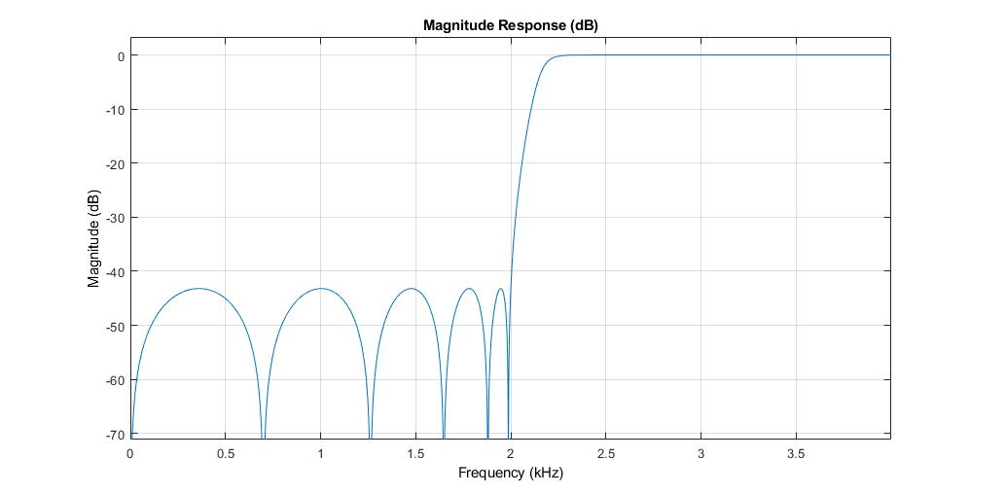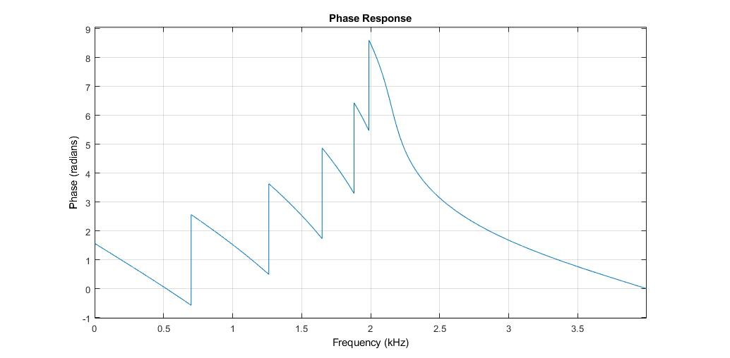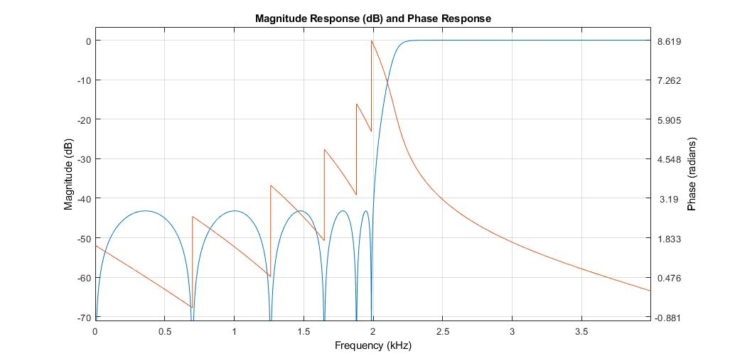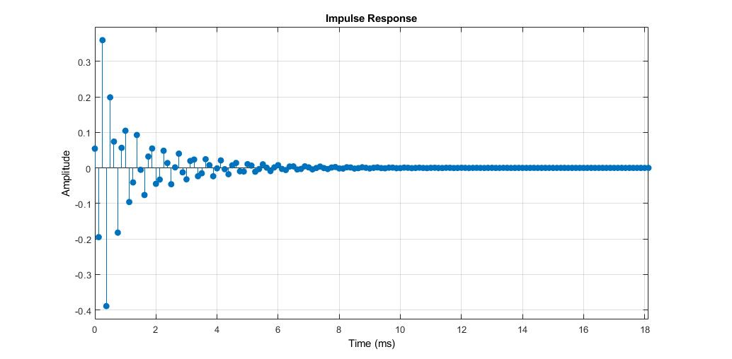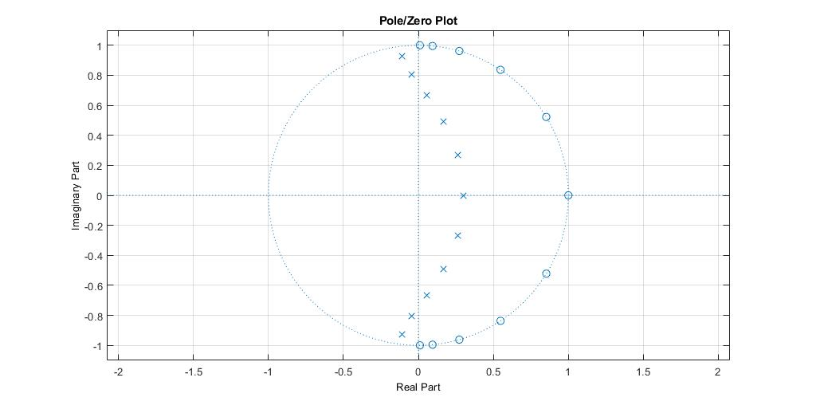

**Coeficientes**

b = 0.0541 -0.2466 0.6852 -1.3571 2.0841 -2.5638 2.5638 -2.0841 1.3571 -0.6852 0.2466 -0.0541

a = 1.0000 -0.9565 2.5703 -2.2733 2.6918 -1.9449 1.3729 -0.7227 0.3184 -0.1044 0.0239 -0.0029

**Parámetros**

|  |  |  |  |  |
| --- | --- | --- | --- | --- |
| Fs [muestras/seg] | Ap [dB] | As [dB] | Fp [Hz] | Fr [Hz] |
| 8000 | 1 | 40 | 2200 | 2000 |

**Filtro IIR Pasa-bandas chebyshev tipo 2**

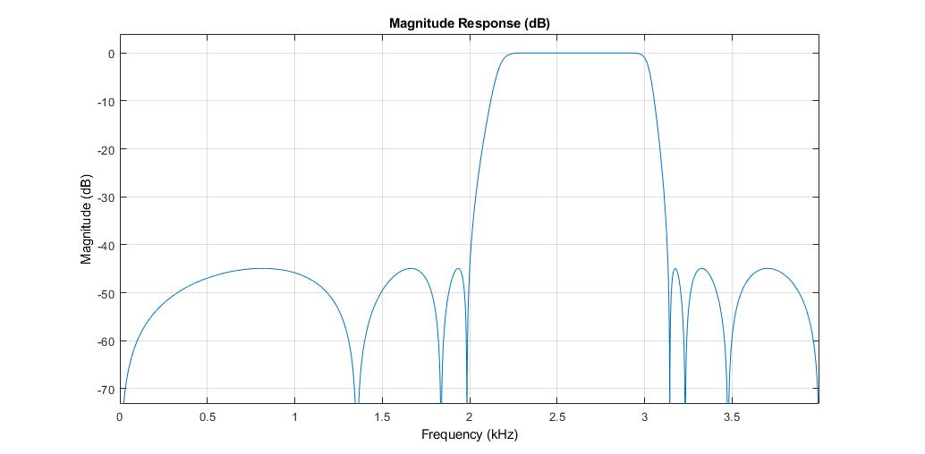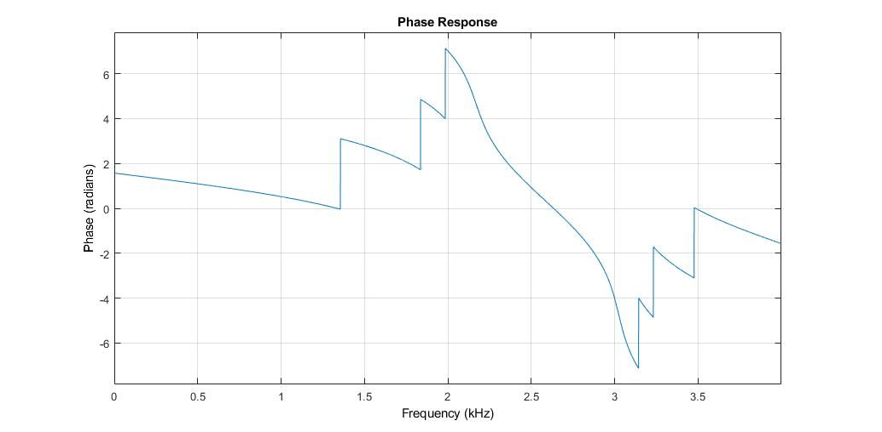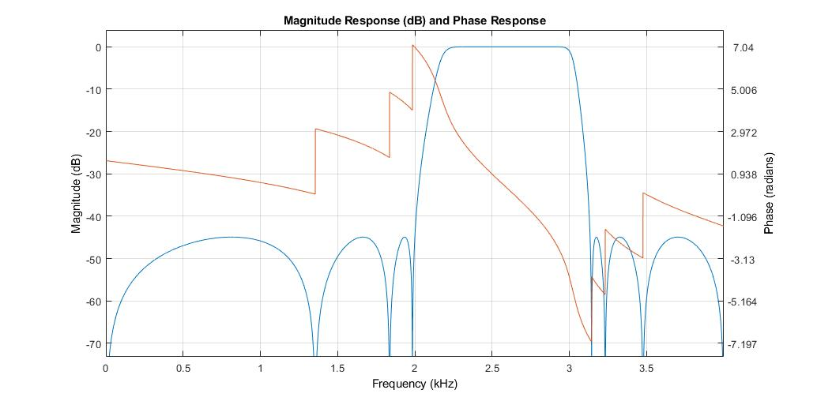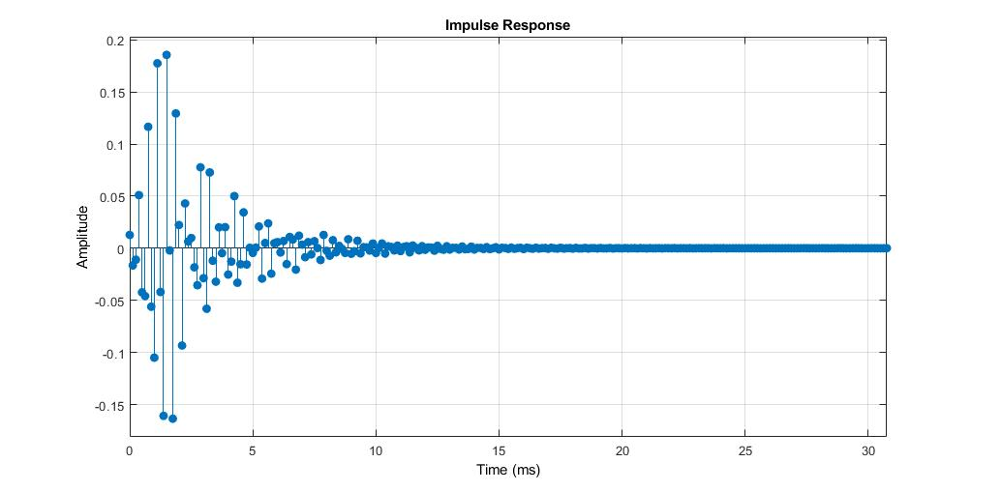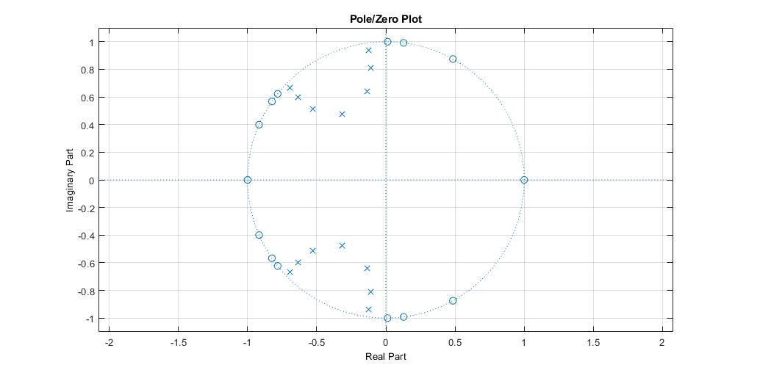

**Coeficientes**

b = 0.0128 0.0485 0.0950 0.1369 0.1625 0.1445 0.0800 0 -0.0800 -0.1445 -0.1625 -0.1369 -0.0950 -0.0485 -0.0128

a = 1.0000 5.0868 14.8652 30.2934 47.6215 59.9373 62.0433 53.2777 38.1697 22.6549 11.0340 4.2864 1.2796 0.2647 0.0319

**Parámetros**

|  |  |  |  |  |  |  |  |
| --- | --- | --- | --- | --- | --- | --- | --- |
| Fs [muestras/seg] | Ap [dB] | As1 [dB] | As2 [dN] | Fp1 [Hz] | Fp2 [Hz] | Fr1 [Hz] | Fr2 [Hz] |
| 8000 | 1 | 40 | 40 | 2200 | 3000 | 2000 | 3200 |

**Filtro IIR Rechaza-bandas chebyshev tipo 2**

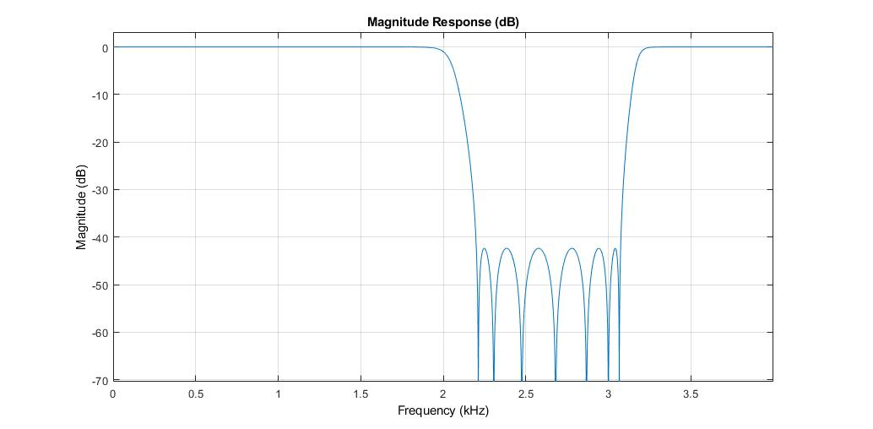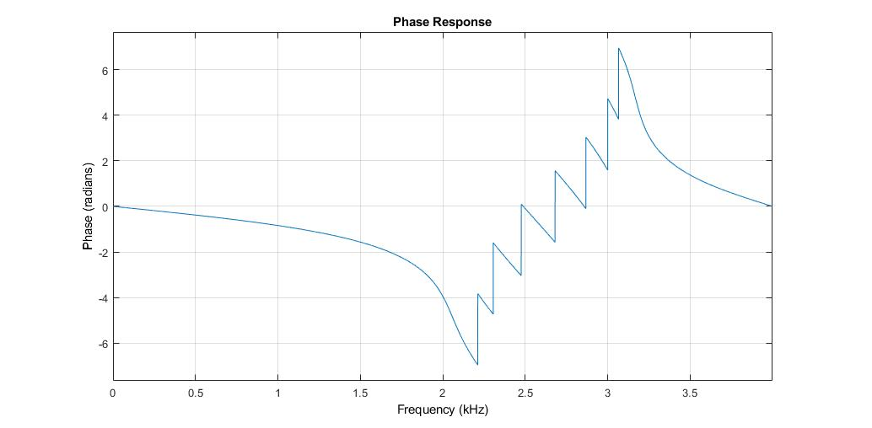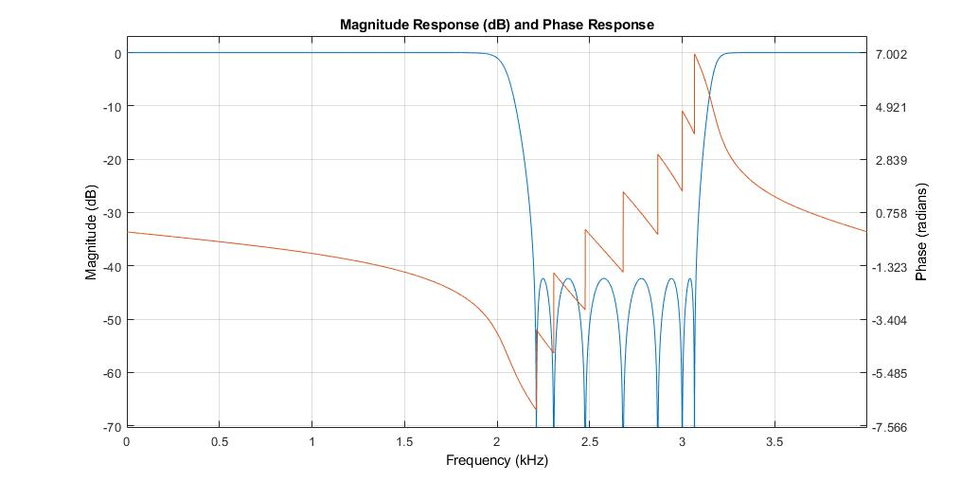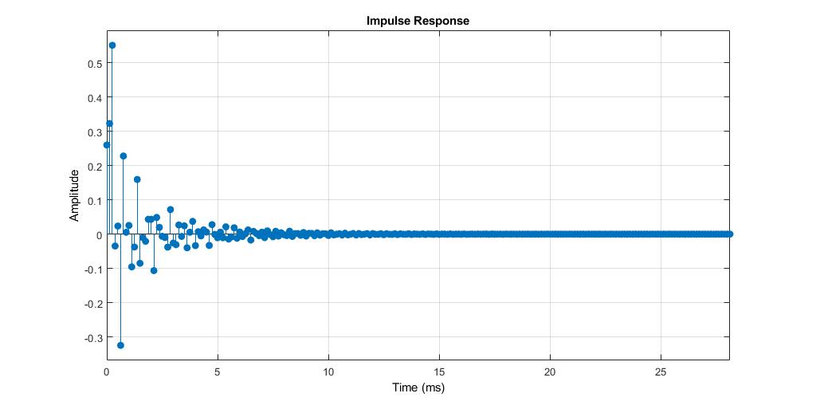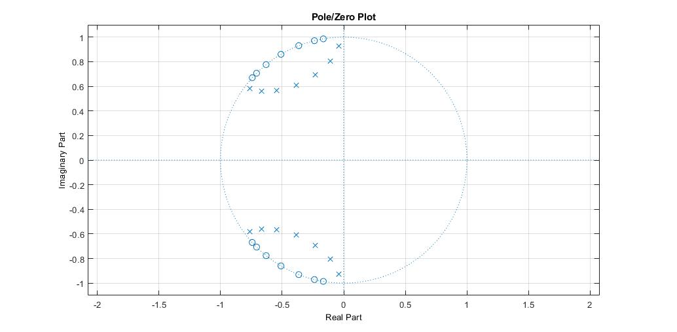

**Coeficientes**

b = 0.2601 1.7468 6.6853 17.7288 35.9909 58.2284 77.1463 84.5735 77.1463 58.2284 35.9909 17.7288 6.6853 1.7468 0.2601

a = 1.0000 5.4761 16.7937 35.8669 58.9529 77.7589 84.4793 76.3712 57.7168 36.2491 18.7093 7.7211 2.4455 0.5382 0.0676

**Parámetros**

|  |  |  |  |  |  |  |  |
| --- | --- | --- | --- | --- | --- | --- | --- |
| Fs [muestras/seg] | As [dB] | Ap1 [dB] | Ap2 [dN] | Fp1 [Hz] | Fp2 [Hz] | Fr1 [Hz] | Fr2 [Hz] |
| 8000 | 40 | 1 | 1 | 2000 | 3200 | 2200 | 3000 |

**Filtro FIR pasa-bajas equiripple**

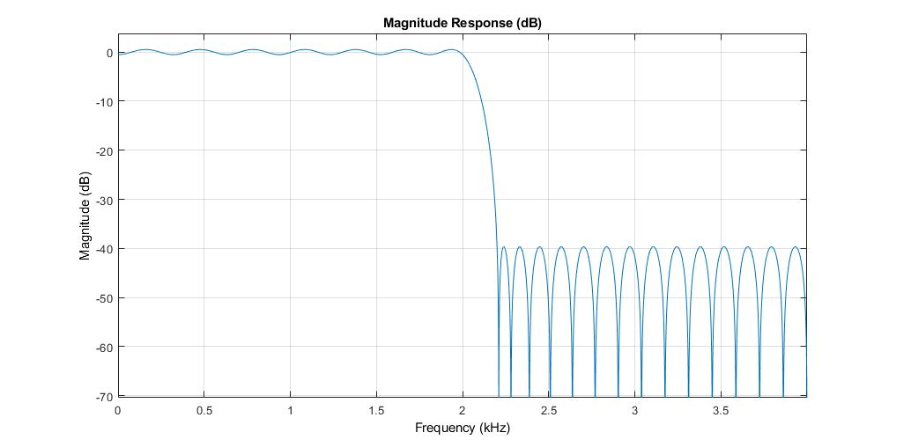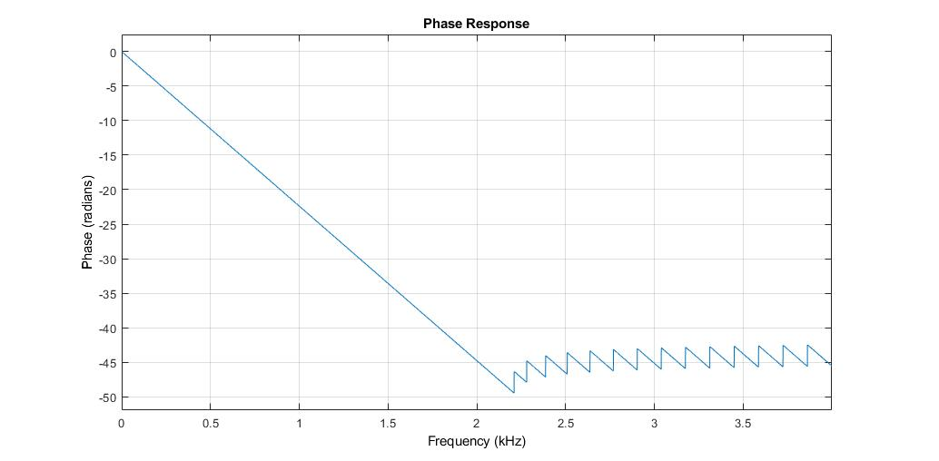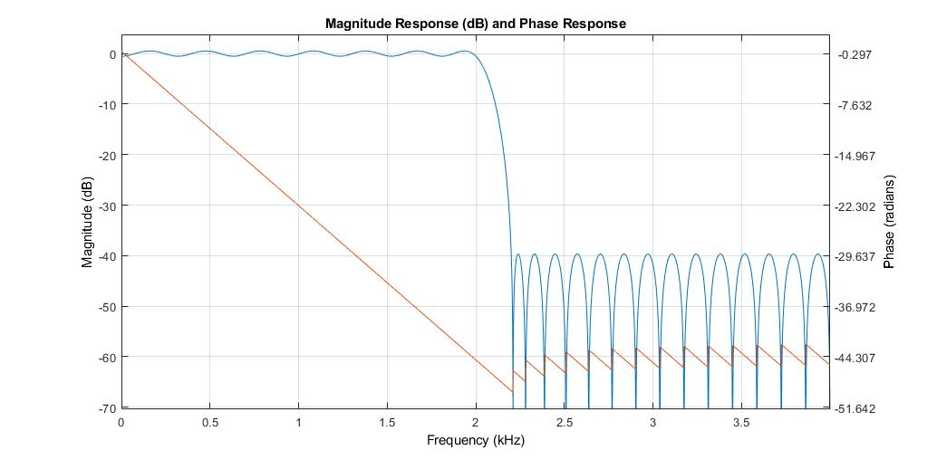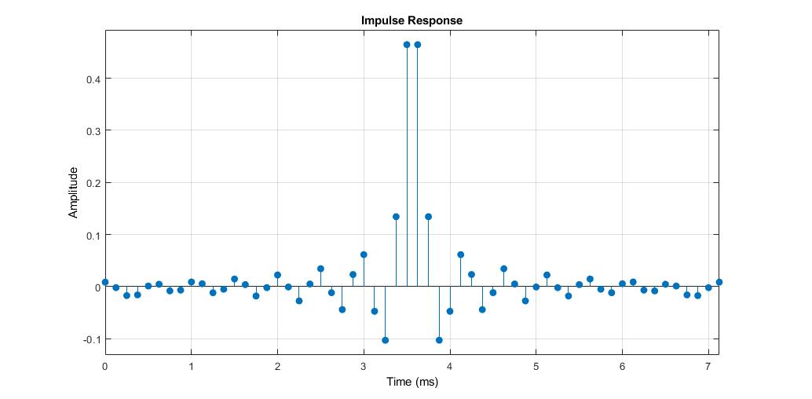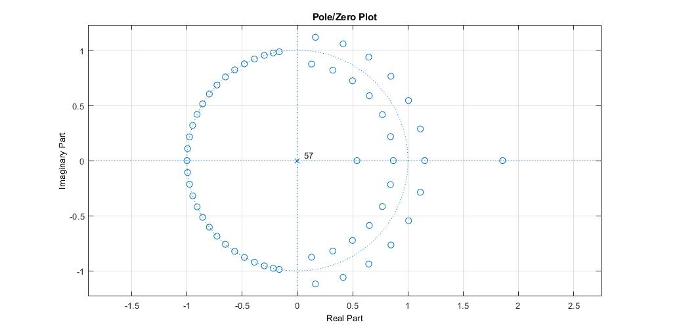

**Coeficientes**

Num = 0.0085 -0.0020 -0.0173 -0.0160 0.0011 0.0045 -0.0082 -0.0068 0.0089 0.0055 -0.0118 -0.0050 0.0146 0.0038 -0.0181 -0.0020 0.0223 -0.0008 -0.0275 0.0050 0.0343 -0.0117 -0.0442 0.0232 0.0614 -0.0474 -0.1030 0.1343 0.4646 0.4646 0.1343 -0.1030 -0.0474 0.0614 0.0232 -0.0442 -0.0117 0.0343 0.0050 -0.0275 -0.0008 0.0223 -0.0020 -0.0181 0.0038 0.0146 -0.0050 -0.0118 0.0055 0.0089 -0.0068 -0.0082 0.0045 0.0011 -0.0160 -0.0173 -0.0020 0.0085

**Parámetros**

|  |  |  |  |  |
| --- | --- | --- | --- | --- |
| Fs [muestras/seg] | Ap [dB] | As [dB] | Fp [Hz] | Fr [Hz] |
| 8000 | 1 | 40 | 2000 | 2200 |

**Filtro FIR pasa-altas equiripple**

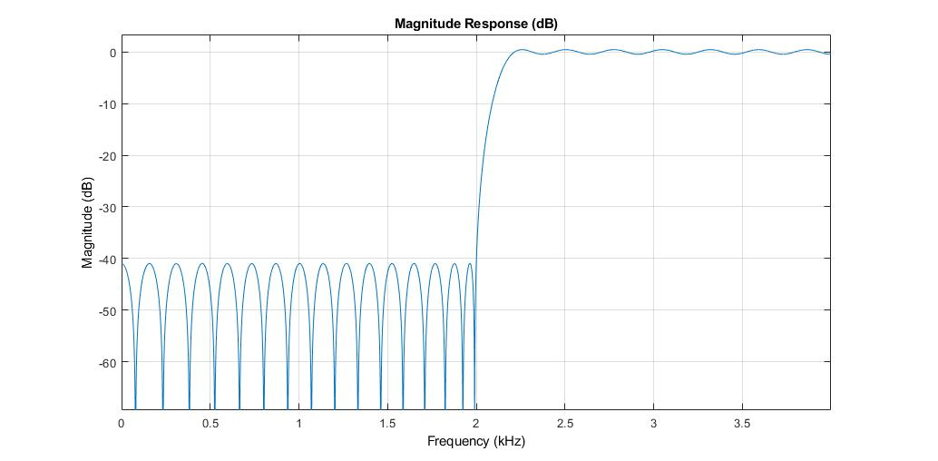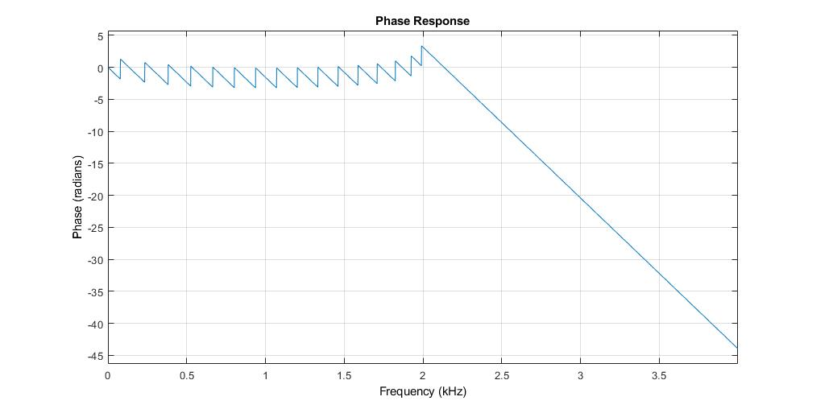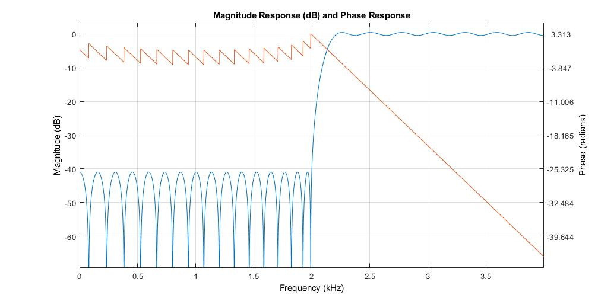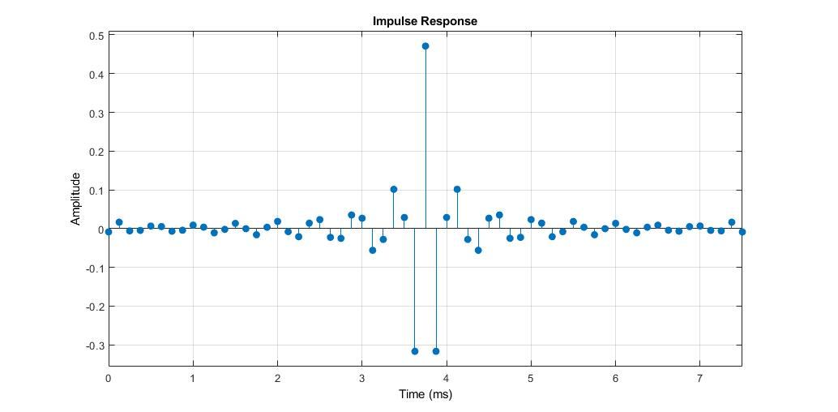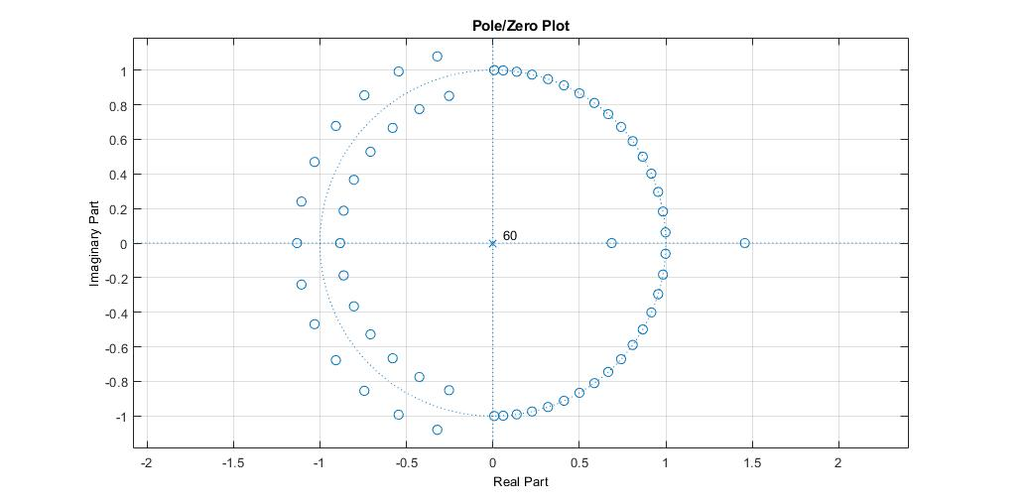

**Coeficientes**

Num = -0.0086 0.0165 -0.0060 -0.0046 0.0066 0.0052 -0.0067 -0.0042 0.0089 0.0036 -0.0110 -0.0020 0.0135 -0.0002 -0.0159 0.0035 0.0185 -0.0080 -0.0209 0.0141 0.0232 -0.0226 -0.0251 0.0351 0.0268 -0.0560 -0.0280 0.1014 0.0287 -0.3167 0.4710 -0.3167 0.0287 0.1014 -0.0280 -0.0560 0.0268 0.0351 -0.0251 -0.0226 0.0232 0.0141 -0.0209 -0.0080 0.0185 0.0035 -0.0159 -0.0002 0.0135 -0.0020 -0.0110 0.0036 0.0089 -0.0042 -0.0067 0.0052 0.0066 -0.0046 -0.0060 0.0165 -0.0086

**Parámetros**

|  |  |  |  |  |
| --- | --- | --- | --- | --- |
| Fs [muestras/seg] | Ap [dB] | As [dB] | Fp [Hz] | Fr [Hz] |
| 8000 | 1 | 40 | 2200 | 2000 |

**Filtro FIR pasa-bandas equiripple**

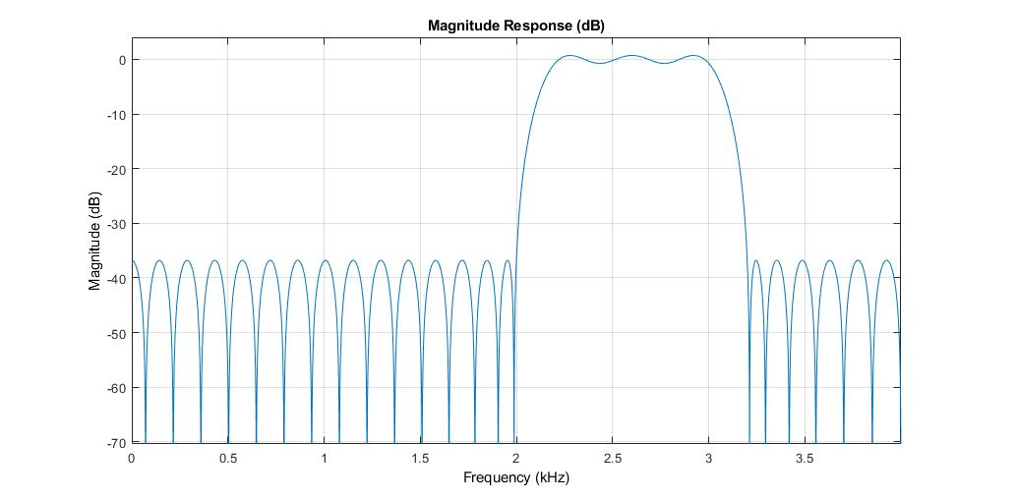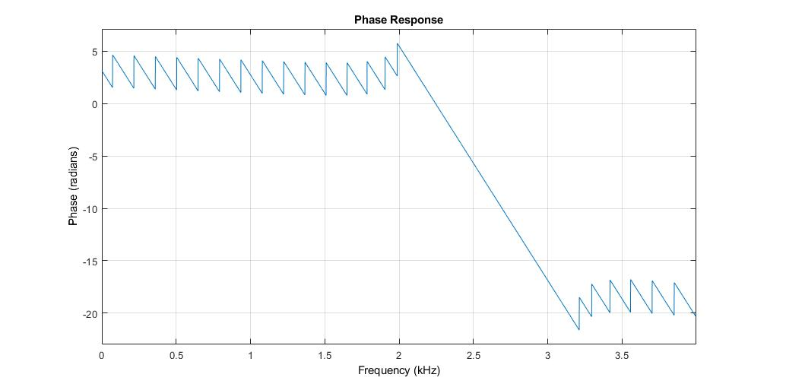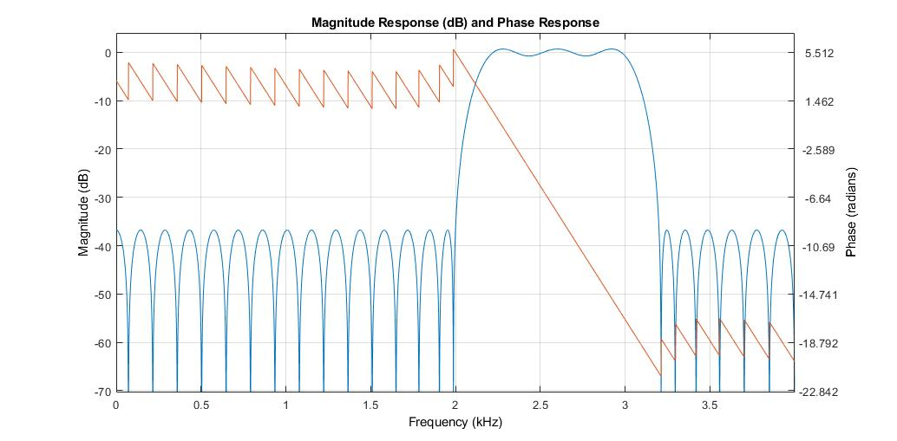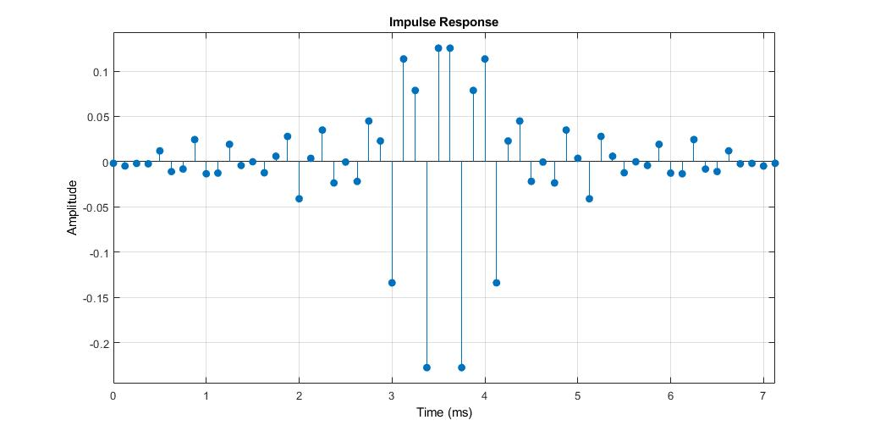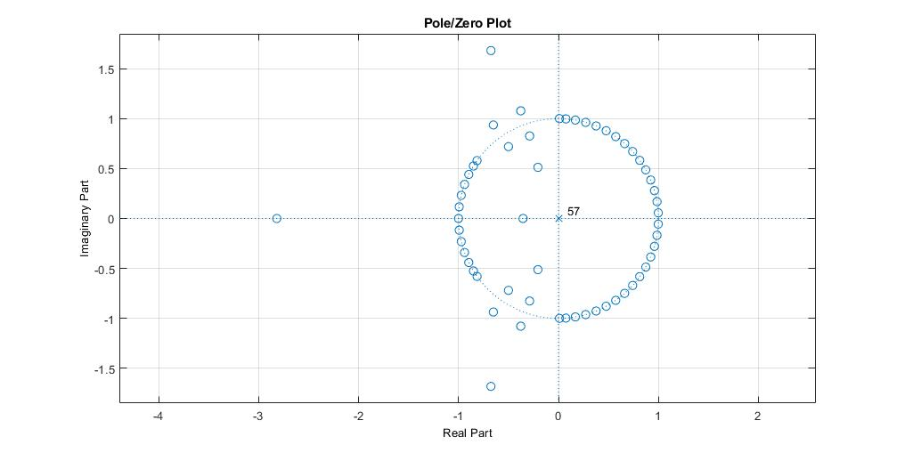

**Coeficientes**

Num = -0.0018 -0.0048 -0.0019 -0.0023 0.0119 -0.0109 -0.0081 0.0244 -0.0134 -0.0126 0.0192 -0.0042 -0.0001 -0.0123 0.0060 0.0279 -0.0410 0.0037 0.0349 -0.0235 -0.0004 -0.0218 0.0449 0.0228 -0.1339 0.1135 0.0787 -0.2275 0.1254 0.1254 -0.2275 0.0787 0.1135 -0.1339 0.0228 0.0449 -0.0218 -0.0004 -0.0235 0.0349 0.0037 -0.0410 0.0279 0.0060 -0.0123 -0.0001 -0.0042 0.0192 -0.0126 -0.0134 0.0244 -0.0081 -0.0109 0.0119 -0.0023 -0.0019 -0.0048 -0.0018

**Parámetros**

|  |  |  |  |  |  |  |  |
| --- | --- | --- | --- | --- | --- | --- | --- |
| Fs [muestras/seg] | Ap [dB] | As1 [dB] | As2 [dN] | Fp1 [Hz] | Fp2 [Hz] | Fr1 [Hz] | Fr2 [Hz] |
| 8000 | 1 | 40 | 40 | 2200 | 3000 | 2000 | 3200 |

**Filtro FIR rechaza-bandas equiripple**

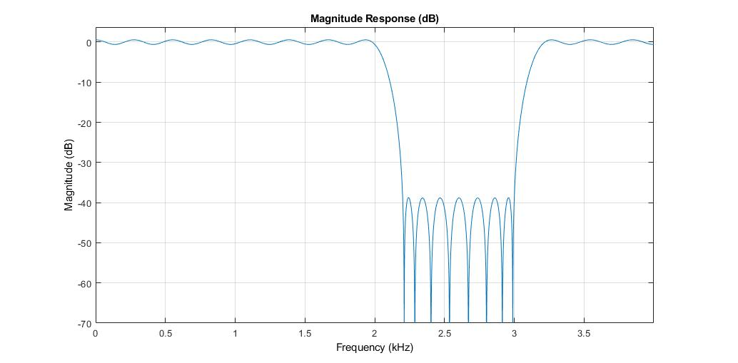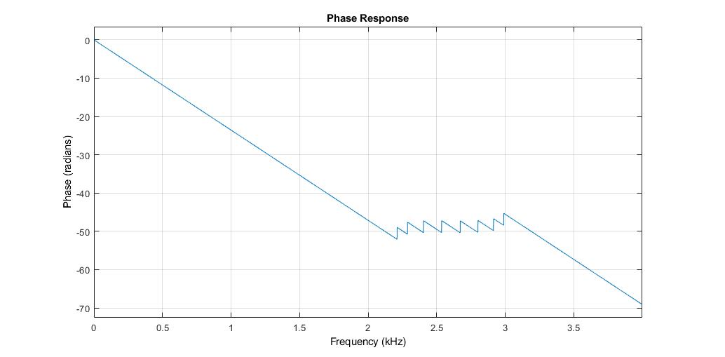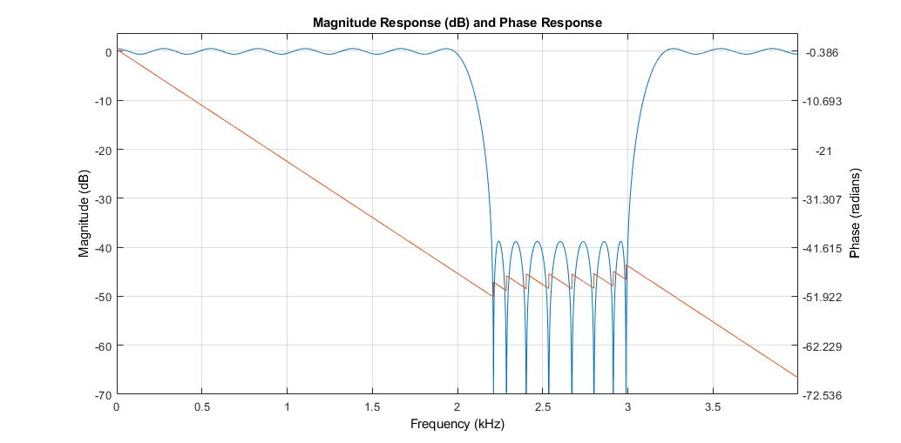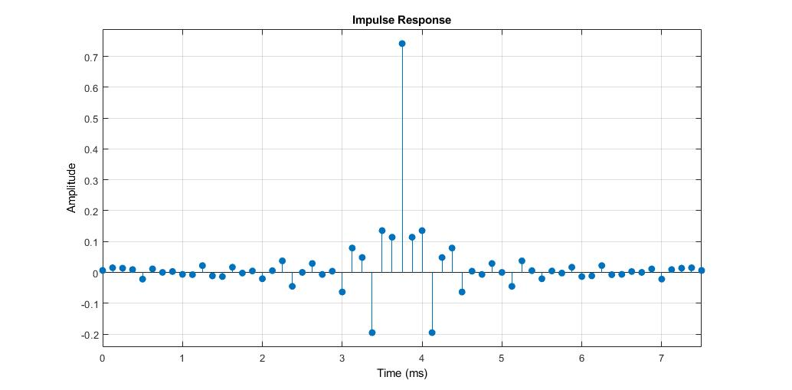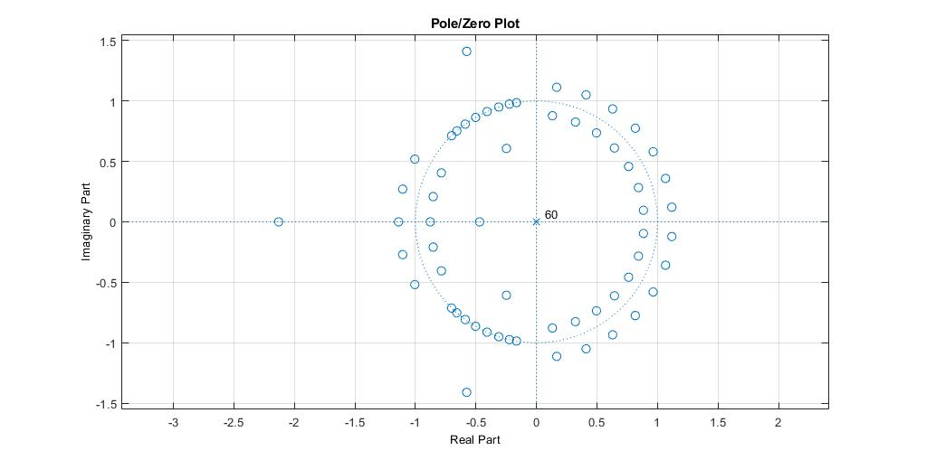

**Coeficientes**

Num = 0.0063 0.0151 0.0137 0.0092 -0.0217 0.0114 0.0001 0.0029 -0.0063 -0.0073 0.0220 -0.0112 -0.0134 0.0168 -0.0021 0.0046 -0.0205 0.0057 0.0374 -0.0452 0.0001 0.0289 -0.0065 0.0040 -0.0634 0.0791 0.0483 -0.1952 0.1354 0.1140 0.7416 0.1140 0.1354 -0.1952 0.0483 0.0791 -0.0634 0.0040 -0.0065 0.0289 0.0001 -0.0452 0.0374 0.0057 -0.0205 0.0046 -0.0021 0.0168 -0.0134 -0.0112 0.0220 -0.0073 -0.0063 0.0029 0.0001 0.0114 -0.0217 0.0092 0.0137 0.0151 0.0063

**Parámetros**

|  |  |  |  |  |  |  |  |
| --- | --- | --- | --- | --- | --- | --- | --- |
| Fs [muestras/seg] | As [dB] | Ap1 [dB] | Ap2 [dN] | Fp1 [Hz] | Fp2 [Hz] | Fr1 [Hz] | Fr2 [Hz] |
| 8000 | 40 | 1 | 1 | 2000 | 3200 | 2200 | 3000 |