INFOSYS SPRINGBOARD VIRTUAL INTERNSHIP 7.0
Workflow Report On
AI-Assisted Threat Detection Dashboard Using AWS Cloud and Machine Learning

Submitted in Partial Fulfillment of the Requirements
for the
Infosys Springboard Internship 7.0

Submitted By
Name: Ratish Vaishnav
Department: MBA CMAT
College: Dept. of Management Studies, Jai Narain Vyas University, Jodhpur

Team: A (GROUP 2)

ARCHITECTURE DESCRIPTION
The proposed system follows a serverless AWS architecture to provide automated threat detection and visualization. Security logs are uploaded through the dashboard and stored in Amazon S3. An S3 event automatically invokes AWS Lambda, which preprocesses the log data and loads the trained Random Forest model to classify threats. The prediction results and calculated risk scores are stored in Amazon DynamoDB. If a critical threat is detected, Amazon SNS immediately sends an email notification to the administrator. Finally, the dashboard retrieves data from DynamoDB and displays real-time security analytics, including threat summaries, risk scores, attack timelines, and downloadable reports.

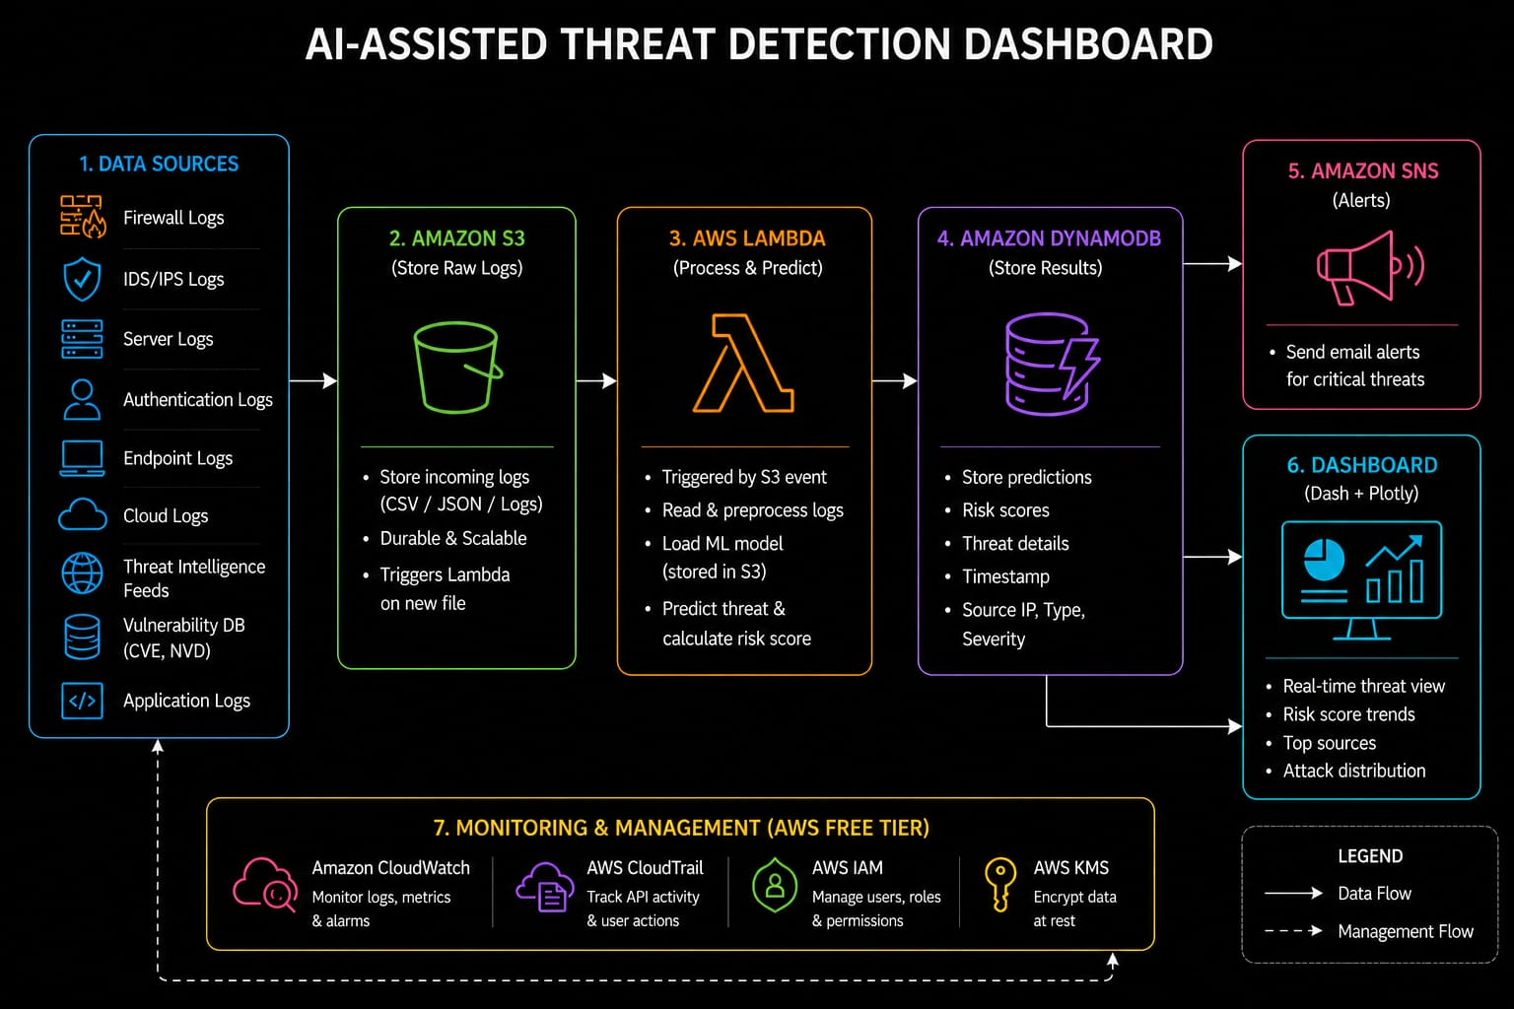

Workflow Steps
START
│
User Login to Dashboard
│
Upload Security Log File
│
Amazon S3 (Raw Log Storage)
│
AWS Lambda Triggered Automatically
│
Data Preprocessing
│
Machine Learning Prediction
│
Risk Score Calculation
│
┌────────┴─────────┐
Store Results Critical Threat?
in DynamoDB
│ Yes

Amazon SNS Alert
│
└────────┬─────────┘
Dashboard Visualization
│
Generate Reports
│
END
Step 1: User Authentication
The user logs into the AI-Assisted Threat Detection Dashboard using valid credentials. After successful authentication, the user is redirected to the main dashboard.
Input:
- Username
- Password
Output:
- Dashboard Access
Step 2: Security Log Upload
The administrator uploads cybersecurity log files in CSV or JSON format through the dashboard. These logs may contain firewall events, authentication records, server logs, or network traffic data.
Input:
- CSV Log File
- JSON Log File
AWS Service Used:
- Amazon S3
Output:
- Raw logs stored securely in Amazon S3.
Step 3: Automatic Trigger
Whenever a new log file is uploaded to Amazon S3, AWS Lambda is automatically triggered using an S3 event notification.
AWS Service Used:
- AWS Lambda
Purpose:
- Start the threat detection process automatically.
Step 4: Data Preprocessing
AWS Lambda reads the uploaded log file and performs preprocessing before sending it to the Machine Learning model.
Operations Performed
- Remove missing values
- Validate log format
- Extract required features
- Convert categorical values
- Normalize data
Output:
- Cleaned security data ready for prediction.
Step 5: AI-Based Threat Detection
The pre-processed data is passed to the trained Machine Learning model developed using Scikit-learn.
Model Responsibilities
- Analyse login attempts
- Detect abnormal behaviour
- Classify suspicious activities
- Predict cyber threats
Algorithm Used
- Random Forest Classifier
Output
- Normal Activity
- Malicious Activity
Step 6: Risk Score Generation
Based on the prediction, a risk level is assigned to every security event.
Risk Levels
Risk Score | Severity
0–25 | Low
26–50 | Medium
51–75 | High
76–100 | Critical
The risk score helps prioritize security incidents for investigation.

Step 7: Store Results
Prediction results, threat categories, and risk scores are stored in Amazon DynamoDB.
Stored Information
- Log ID
- Timestamp
- Source IP
- Threat Prediction
- Risk Score
- Threat Severity
AWS Service Used
- Amazon DynamoDB

Step 8: Alert Generation
If a threat is classified as Critical, AWS Lambda sends an alert notification to the administrator using Amazon SNS.
Alert Information
- Threat Type
- Risk Score
- Timestamp
- Recommended Action
AWS Service Used
- Amazon SNS

Step 9: Dashboard Visualization
The dashboard retrieves the latest prediction results from Amazon DynamoDB and displays them using interactive charts and tables.
Dashboard Components
- Total Threats
- Critical Alerts
- Risk Score
- Live Threat Table
- Threat Timeline
- Threat Distribution
- Recent Alerts
- Download Reports
Technology Used
- Dash (Python)
- Plotly

