**Intra Stock Transport Order**

* Stock transfer within the same Company code

**Configuration:**

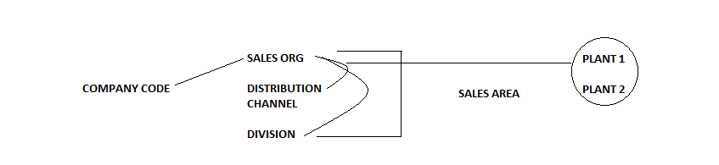

**Sales Organization:**

**Path:** Enterprise Structure -Definition -Sales and Distribution -Define, copy, delete, check sales organization

* Copy Standard 0001 to DLSO – Delphi sales org

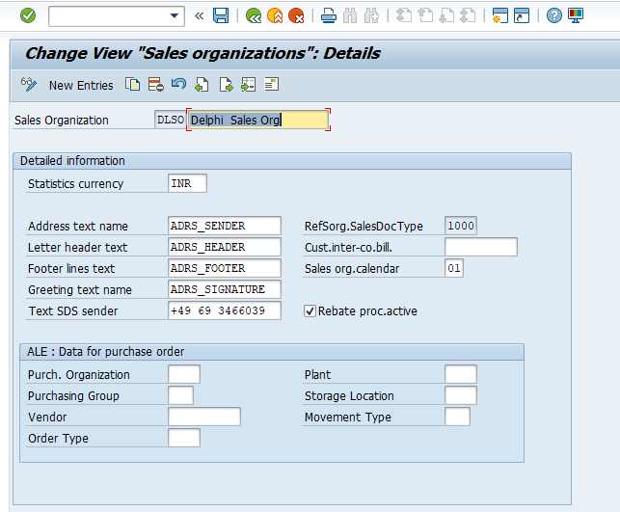

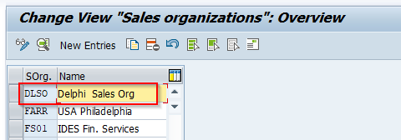

**Distribution Channel:**

**Path:** Enterprise Structure -Definition -Sales and Distribution- Define, copy, delete, check distribution channel

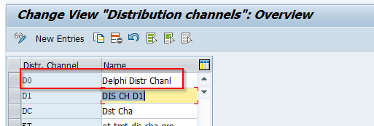

**Division:**

**Path:** Enterprise Structure -Definition -Logistics - General -Define, copy, delete, check division

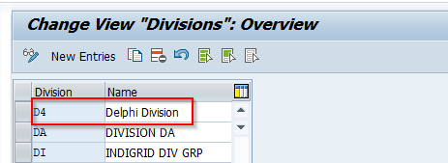

**Assign Sales Organization to Company Code:**

**Path:** Enterprise Structure -Assignment -Sales and Distribution -Assign sales organization to company code

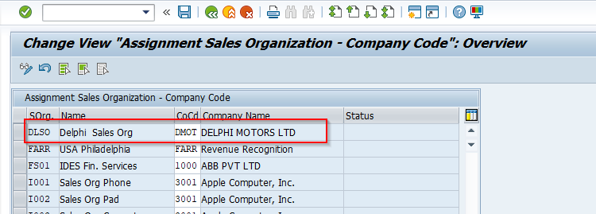

**Assign distribution channel to sales organization:**

**Path:** Enterprise Structure -Assignment -Sales and Distribution - Assign sales organization to company code

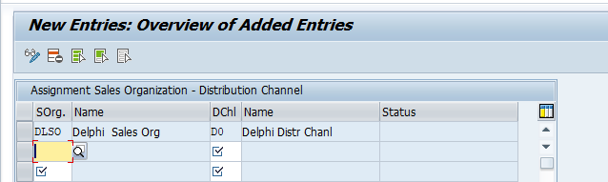

**Assign division to sales organization**

**Path:** Enterprise Structure -Assignment -Sales and Distribution - Assign division to sales organization

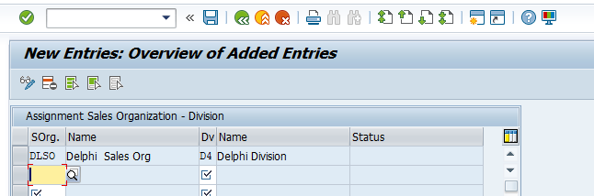

**Setup Sales Area:**

**Path:** Enterprise Structure -Assignment -Sales and Distribution -Setup Sales Area

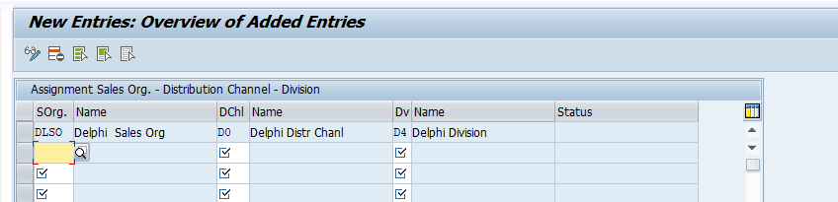

**Assign sales organization - distribution channel – plant:**

**Path:** Enterprise Structure -Assignment -Sales and Distribution -Assign sales organization - distribution channel – plant

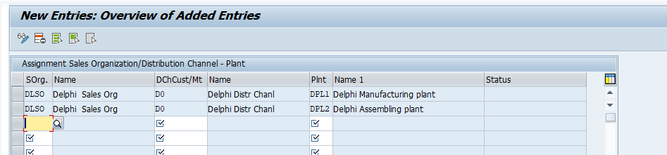

**Material Master Data:**

* Maintain sales views

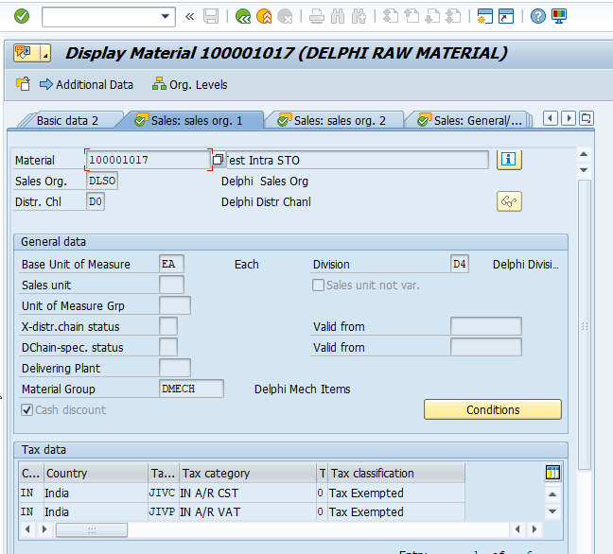

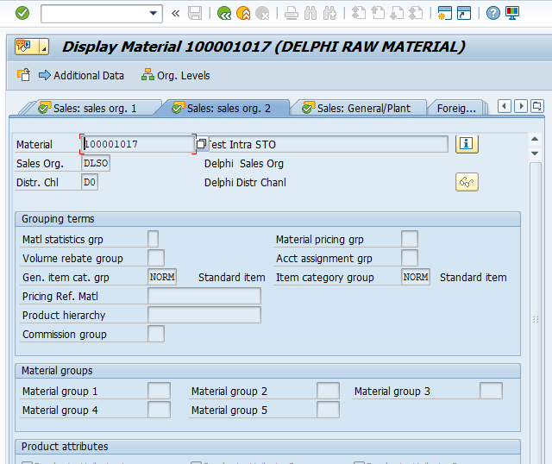

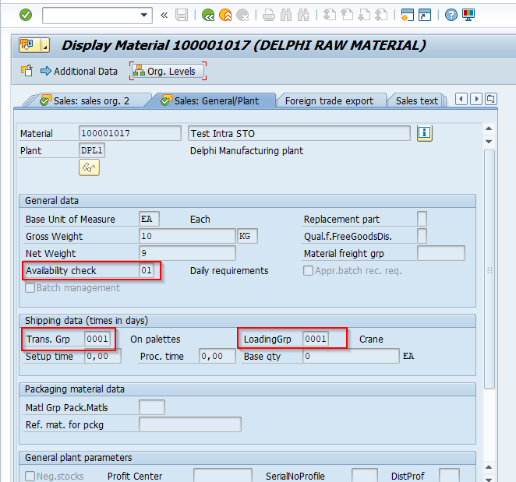

* Create a Material in supplying plant and extend to Receiving plant

**Assign Supplying Plant to Vendor Master Data:**

* Go to extras- Add purchasing data

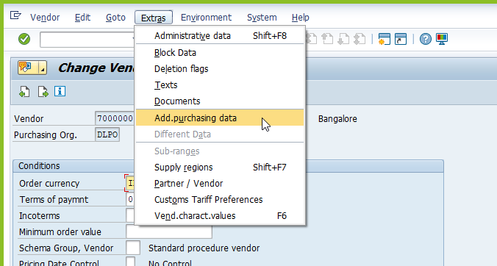

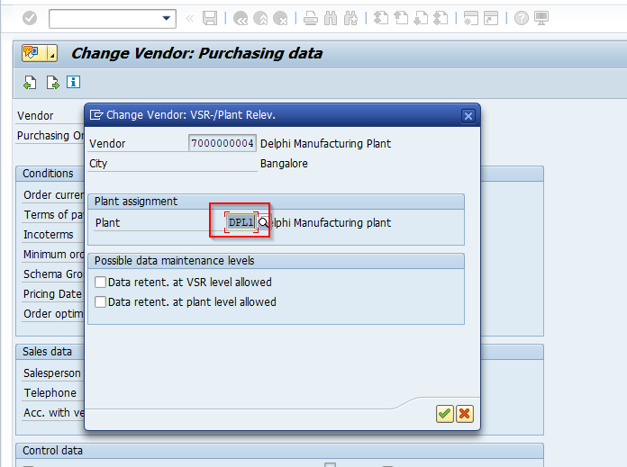

**Create Customer Master Data:**

* **T-code:** XD01

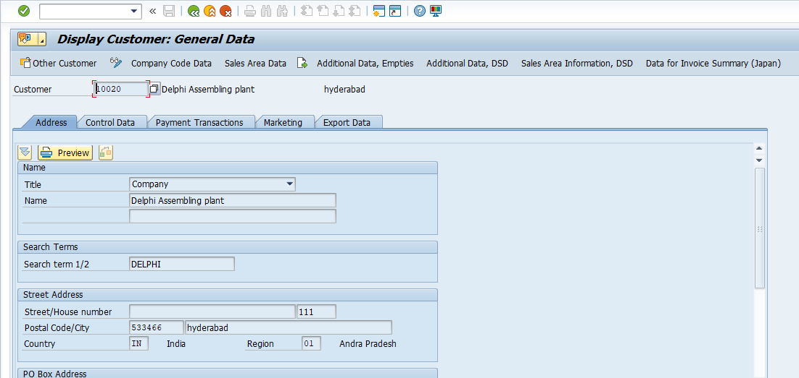

* Assign shipping condition in shipping tab

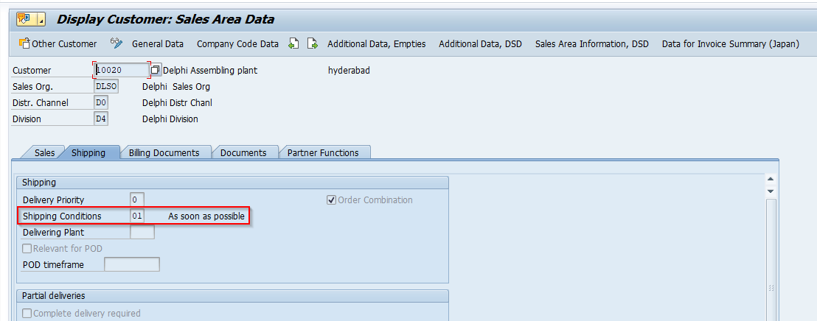

**Set up Stock Transport Order :**

**Define Shipping Data for Plants:**

Path: Materials Management -Purchasing -Purchase Order -Set up Stock Transport Order -Define Shipping Data for Plants

* For Supplying plant, assign Sales area

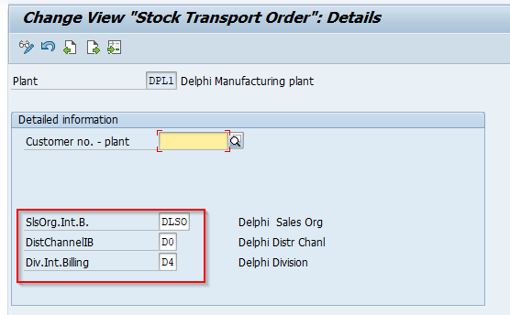

* For Receiving plant, assign Customer and sales area

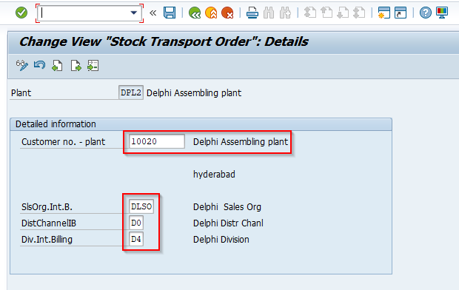

**Assign Delivery Type and Checking Rule:**

**Path:** Materials Management -Purchasing -Purchase Order -Set up Stock Transport Order - Assign Delivery Type and Checking Rule

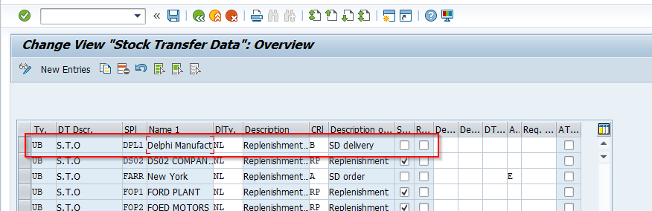

**Assign Document Type, One-Step Procedure, Under-delivery Tolerance:**

**Path:** Materials Management -Purchasing -Purchase Order -Set up Stock Transport Order - Assign Document Type, One-Step Procedure, Under delivery Tolerance

* Check box will control the one step or two step process

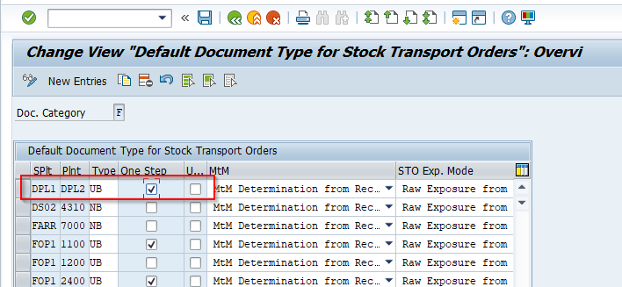

**Shipping Points:**

**Define Shipping Point:**

**Path:** Enterprise Structure-Definition -Logistics Execution -Define, copy, delete, check shipping point – Define Shipping point

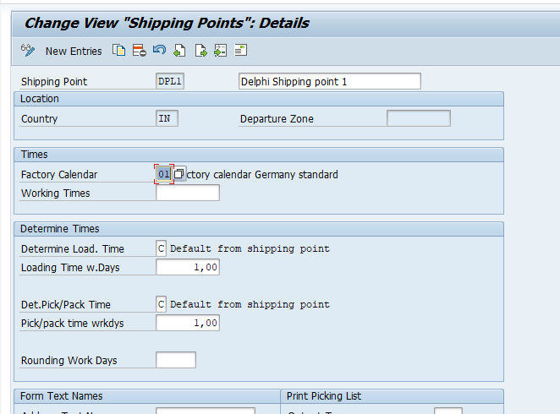

**Assign Shipping Point to Supplying plant:**

**Path:** Enterprise Structure -Assignment -Logistics Execution -Assign shipping point to plant

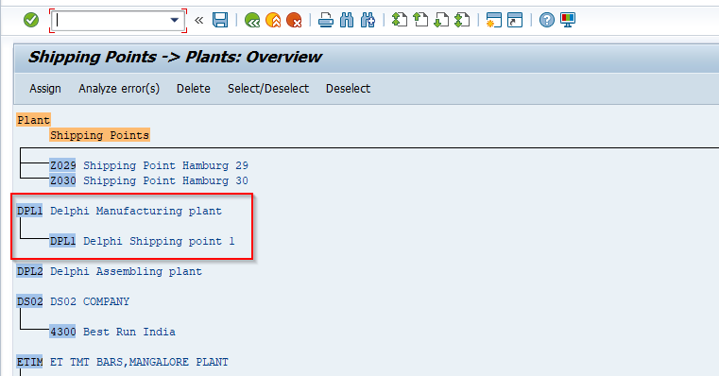

**Shipping Point Determination:**

**Path:** Logistics Execution -Shipping -Basic Shipping Functions -Shipping Point and Goods Receiving Point Determination -Assign Shipping Points

* Shipping condition from customer master data
* Loading group from material master data
* shipping point of Supplying plant

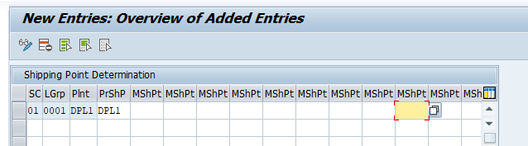

**Process Flow: One Step Method**

**Create Stock Transport order:**

* **T-code:** ME21N

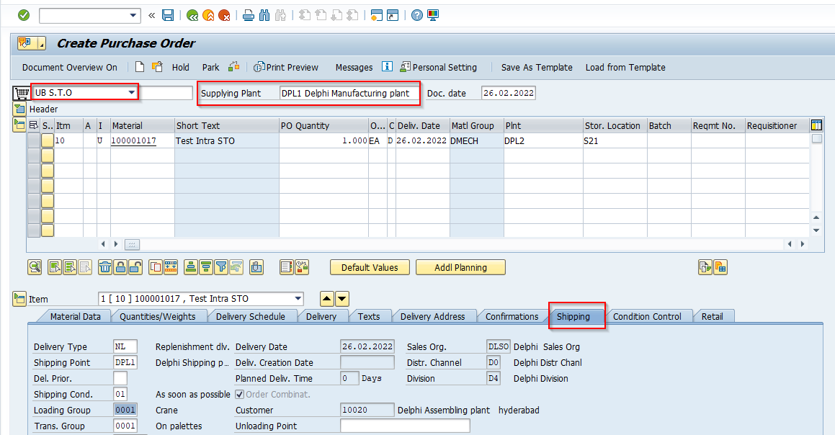



**Create Outbound Delivery:**

* **T-code: VL10D**
* Maintain shipping point and STO number
* Click on execute

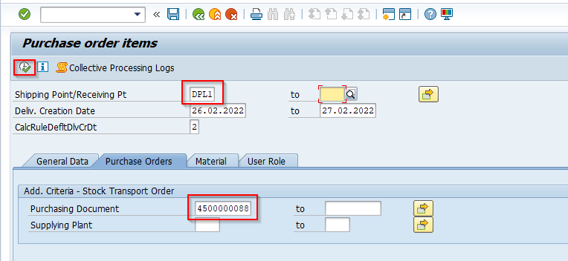

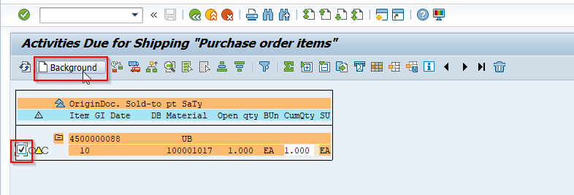

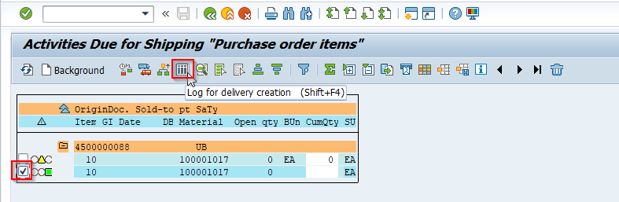

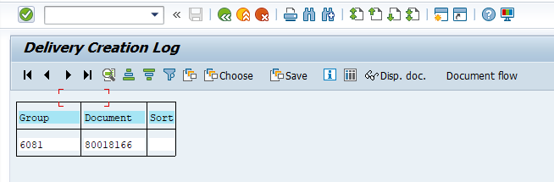

**Post Goods Issue:**

* **T-code:** VL02N

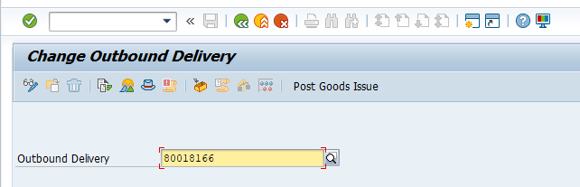

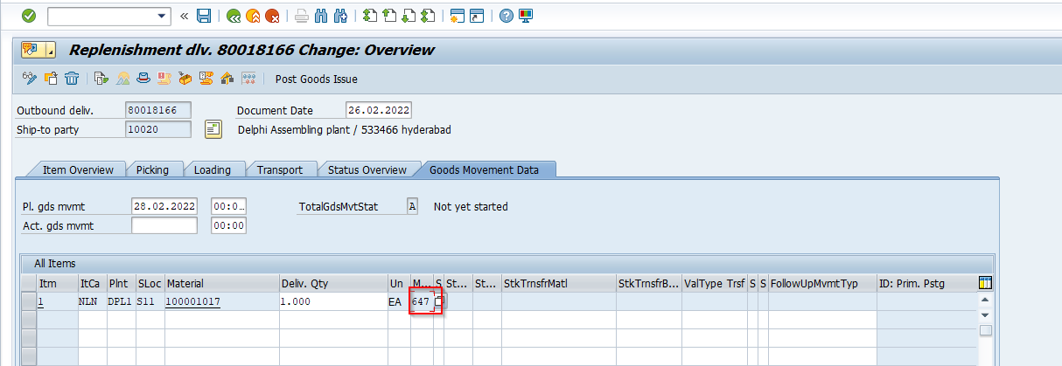

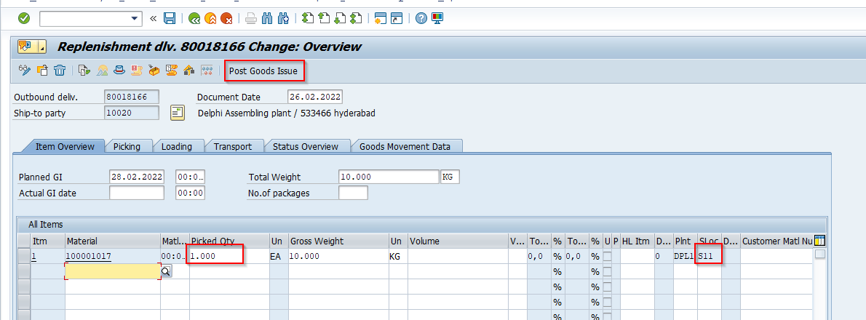



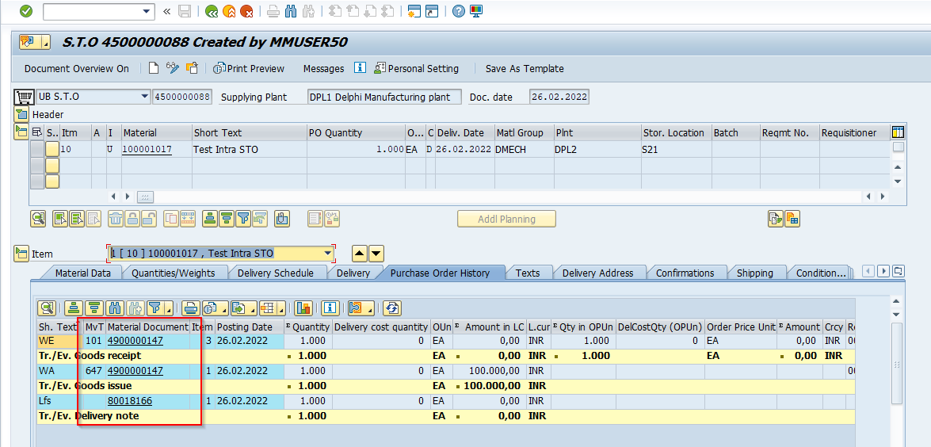

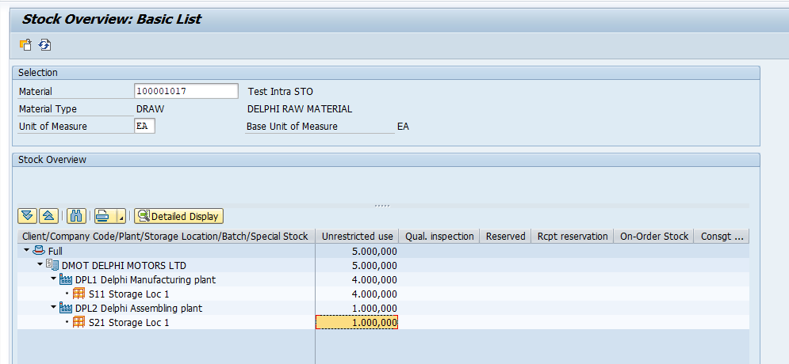

**Process Flow: Two Step Method**

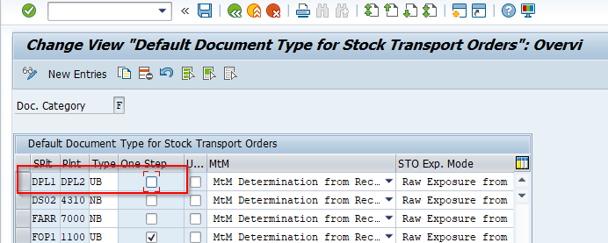

**Create Stock transport order:**

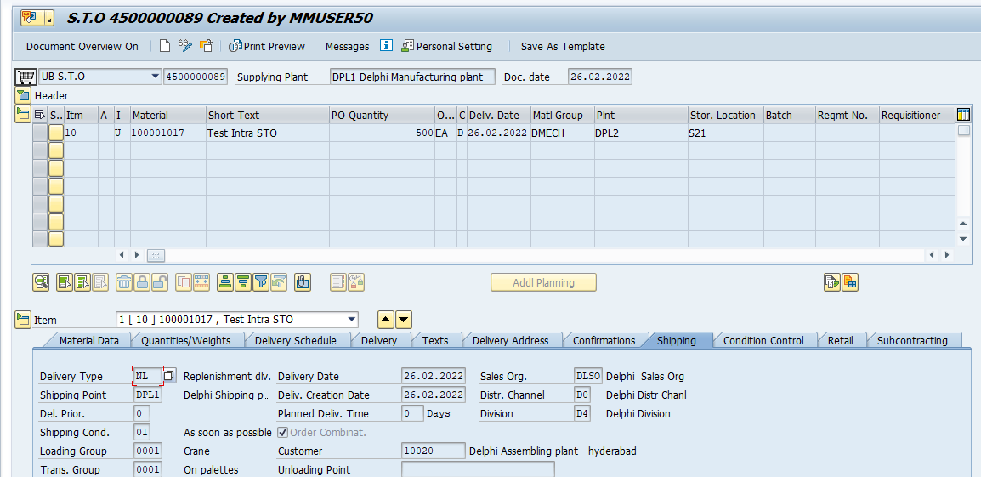

**Create Outbound Delivery:**

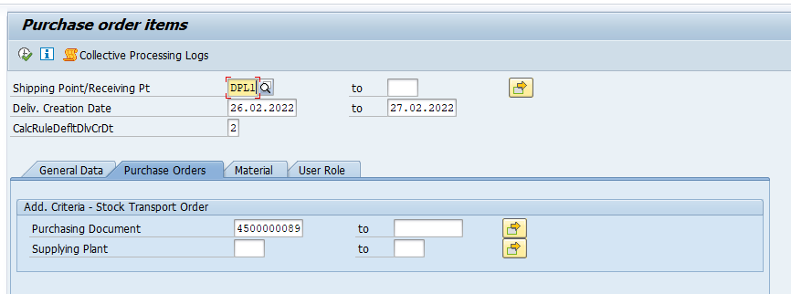

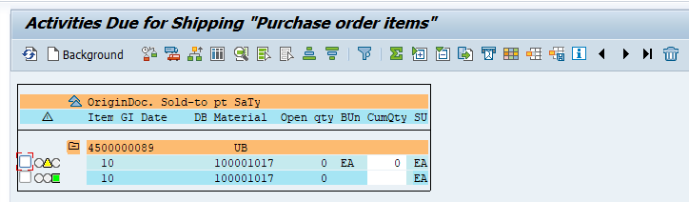

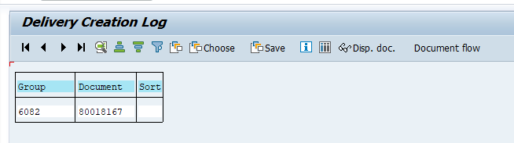

**Post Goods Issue:**

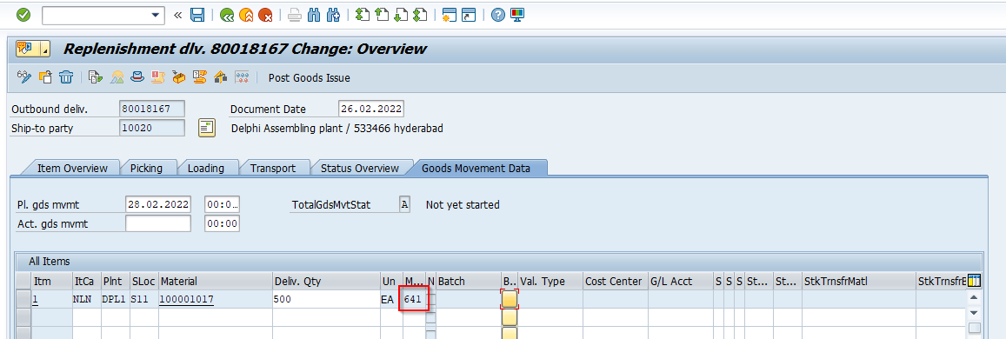

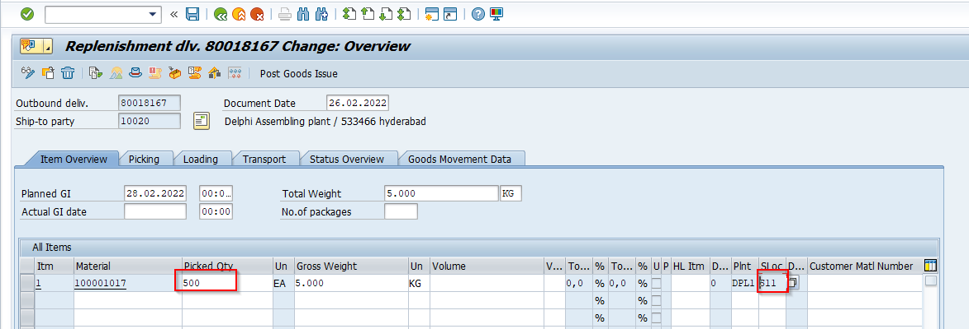



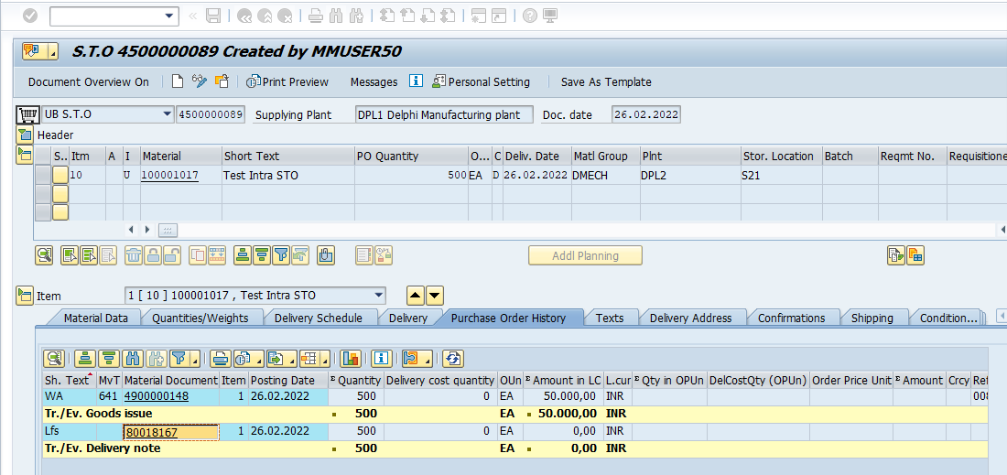

**Goods Receipt:**

* **T-code:** MIGO

