**Scheduling Agreement**

**Define Number Ranges:**

**Path:** SPRO-IMG- Materials Management -Purchasing -Scheduling Agreement -Define Number Ranges

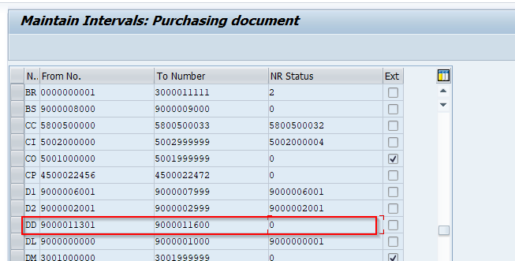

**Define Document type:**

**Path:** SPRO-IMG- Materials Management -Purchasing -Scheduling Agreement -Define Document types

* Define LP and LPA document types and assign number range to it

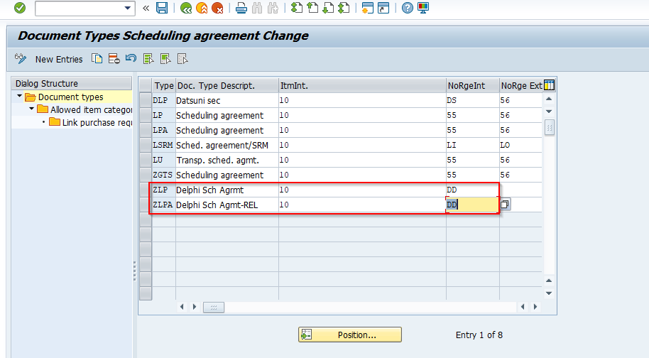

**Without Release document**

**Create Scheduling Agreement:**

* T-code: ME31L

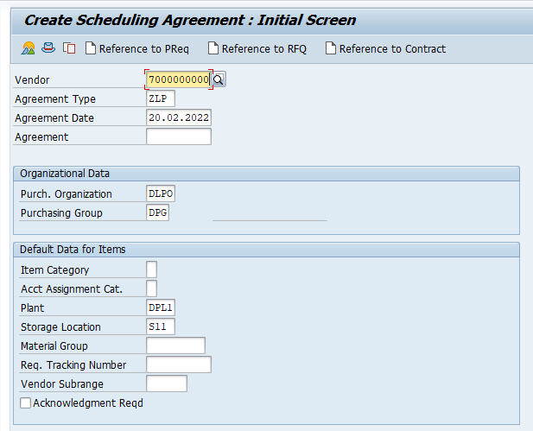

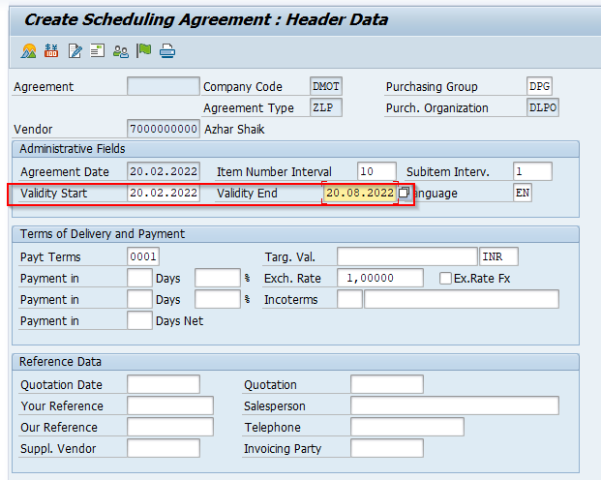

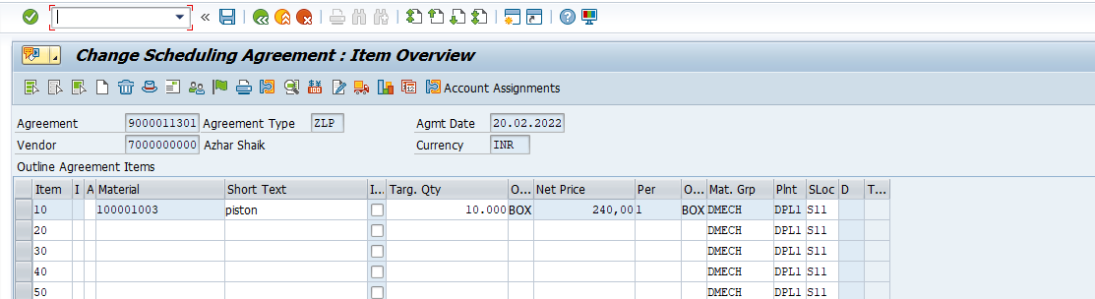

* Select the line item and go to item details and maintain confirmation control key

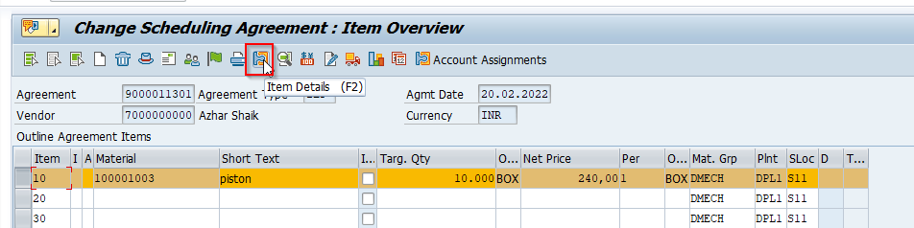

* Maintain confirmation control key as inbound delivery - ANLI

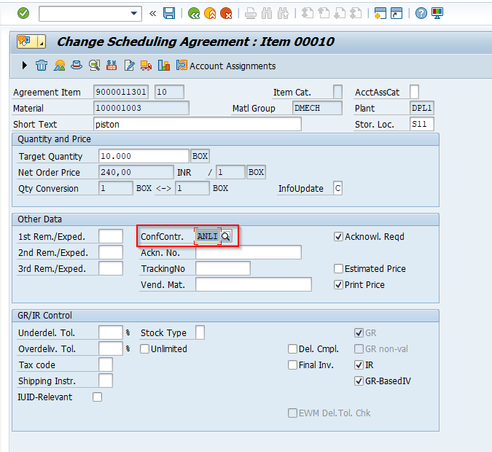

* Scheduling agreement created – 9000011301

**Maintain Delivery Schedules:**

* **T-code:**ME38

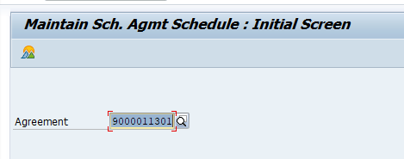

* Select the line item and go to Item – Delivery Schedule

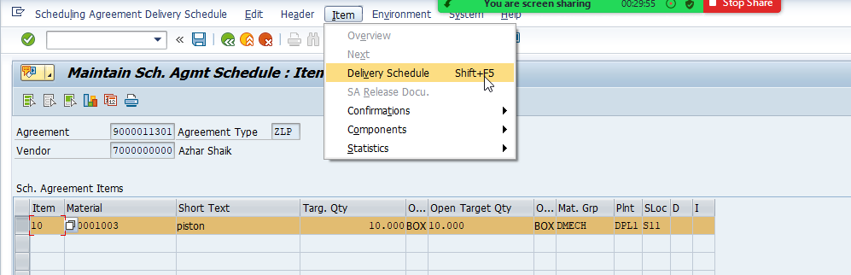

* Maintain Delivery date and Schedules quantity and click on save.

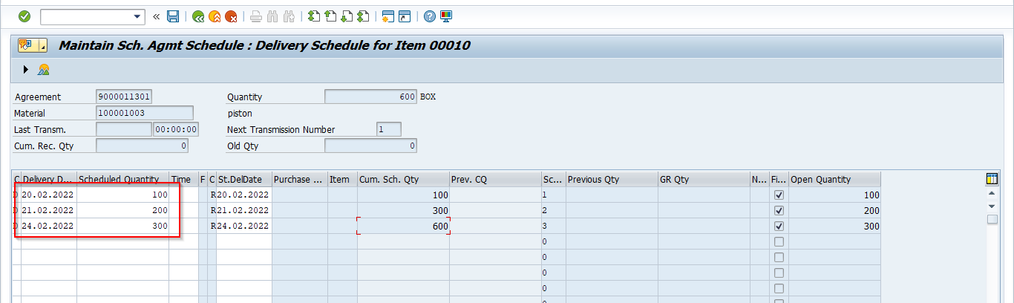

**Create Inbound Delivery:**

* **T-code:** VL31N

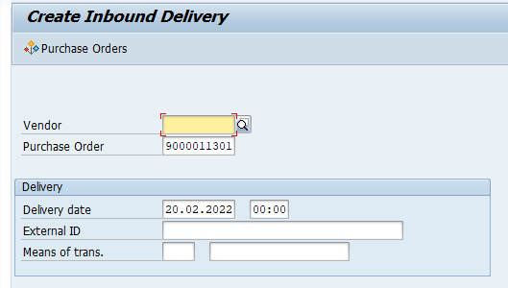

* Maintain Put away quantity and save the document

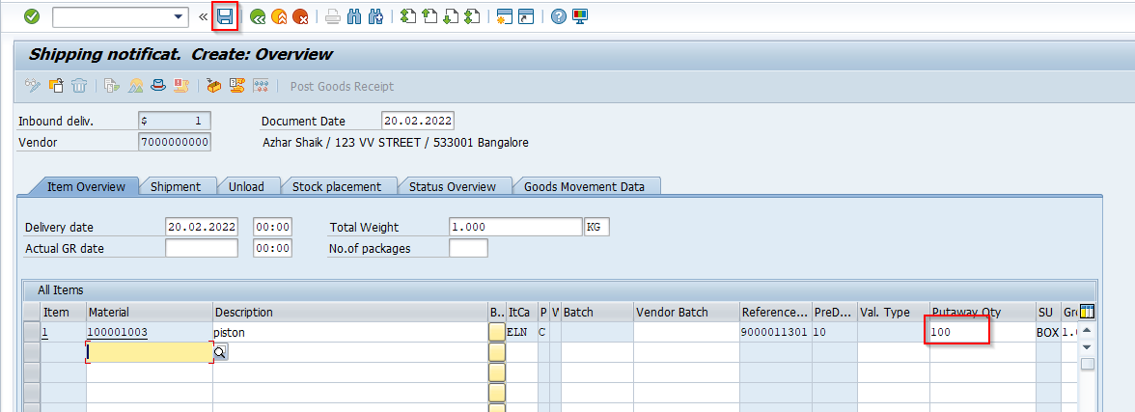



**Post Goods Receipt:**

* **T-code: VL32N**

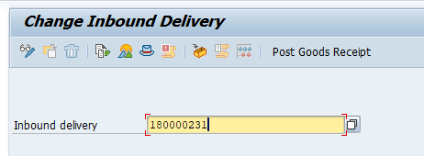

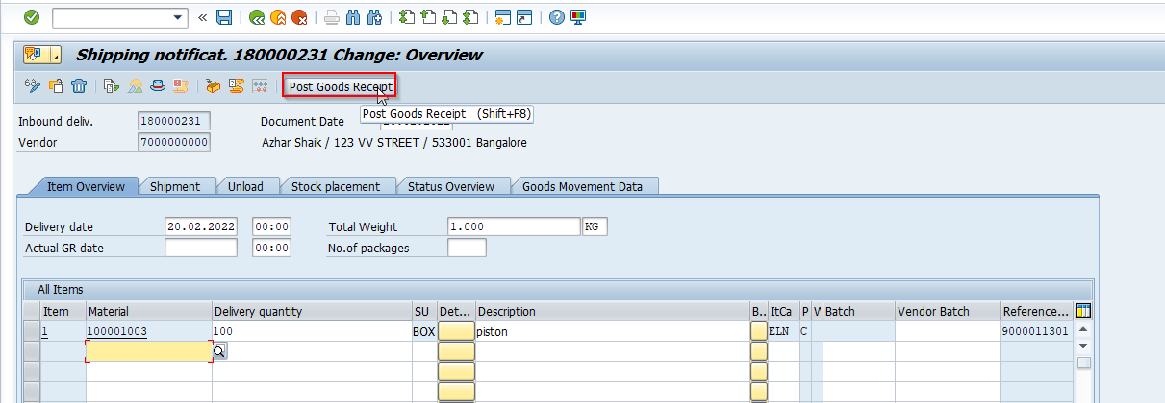



**With Release document**

**Maintain Release Creation profile**

**Path:** Materials Management -Purchasing -Scheduling Agreement -Maint. Rel. Creation Profile for Sched. Agmt. w. Rel. Docu.

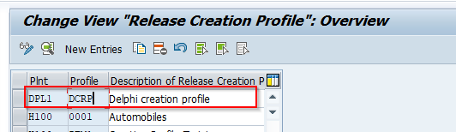

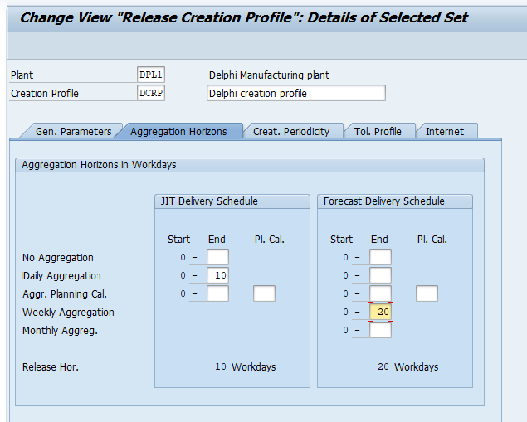

* Activate JIT indicator in Material master data

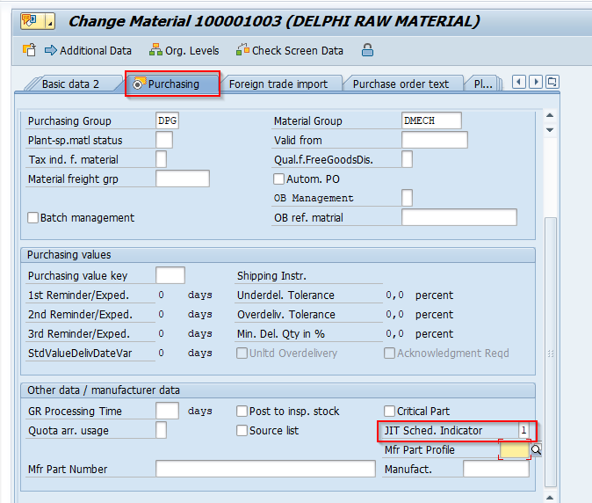

**Maintain release creation profile in vendor master data:**

* Open purchasing data in vendor master
* Go to extras – Add Purchasing data and maintain plant

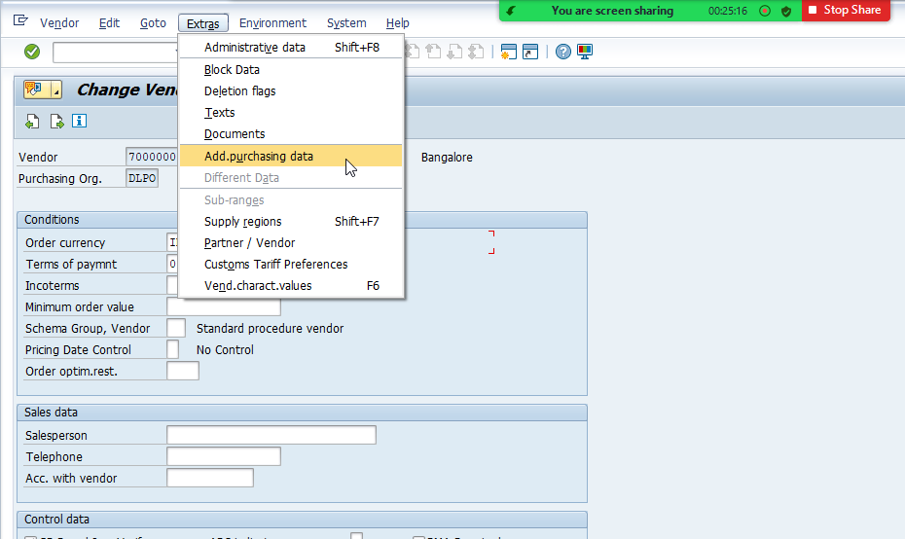

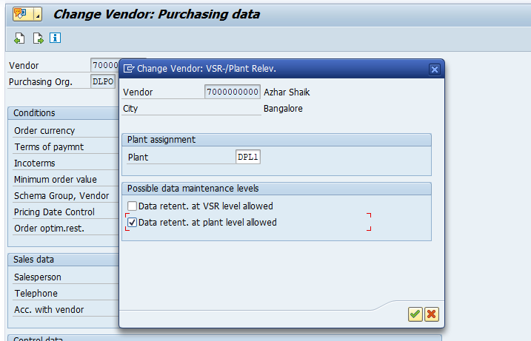

* Click on Different data button and maintain plant and check purchasing data
* Then creation profile field is enabled

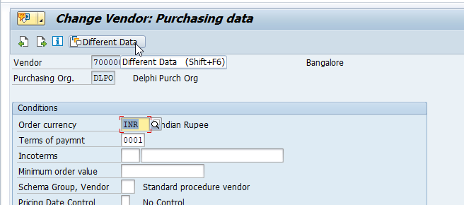

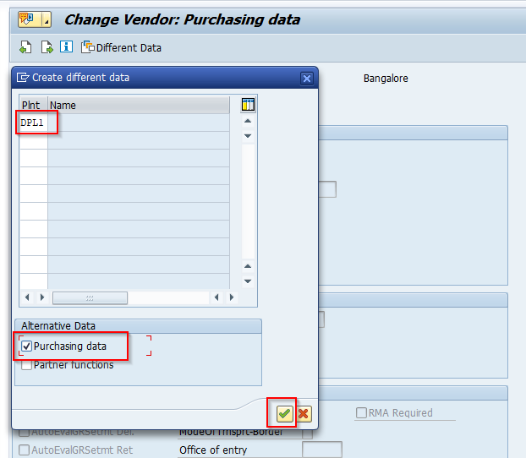

* Assign our creation profile and save it

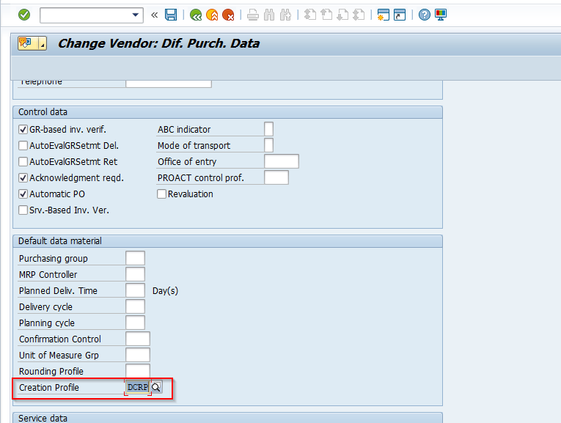

* Remove plant assignment in purchasing data
* Go to Extras- Add purchasing data

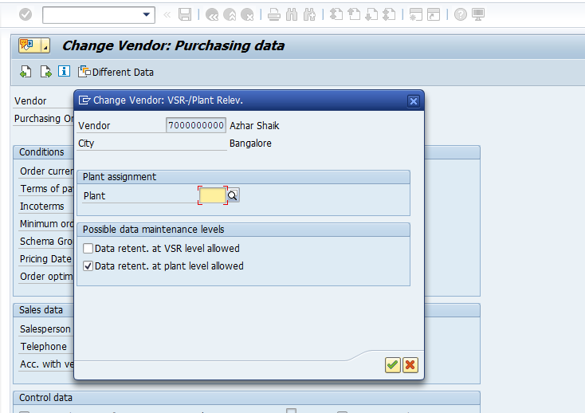

**JIT delivery Schedule:**

**Create Scheduling Agreement:**

* T-code: ME31L

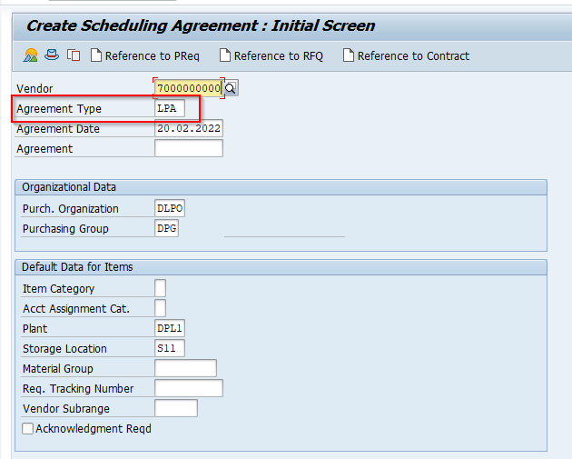

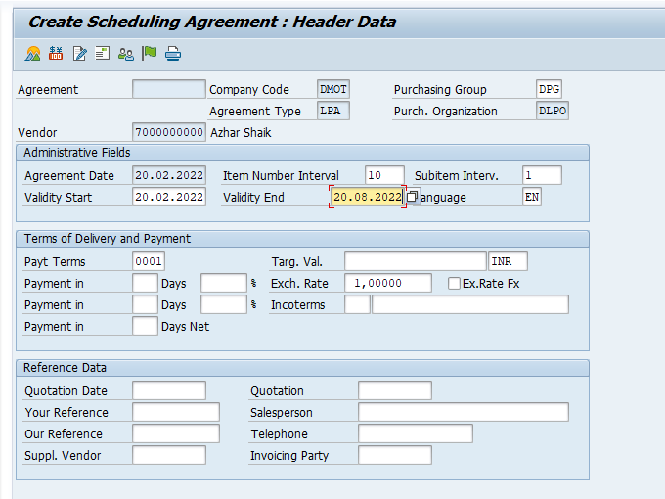

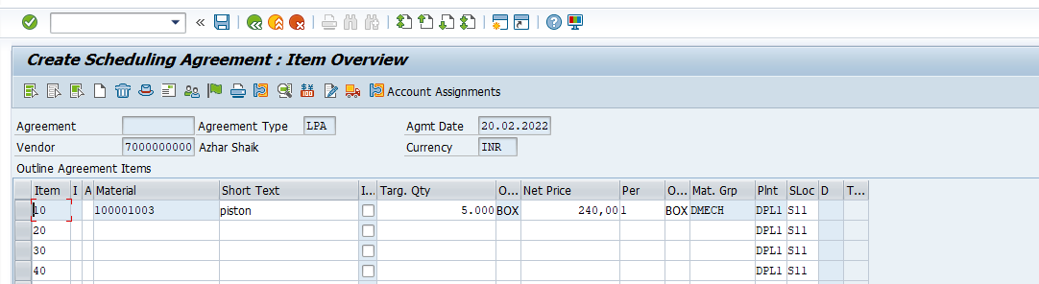



**Maintain Delivery Schedules:**

* **T-code:**ME38
* Maintain schedule delivery dates and save it

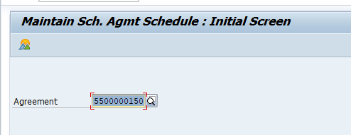

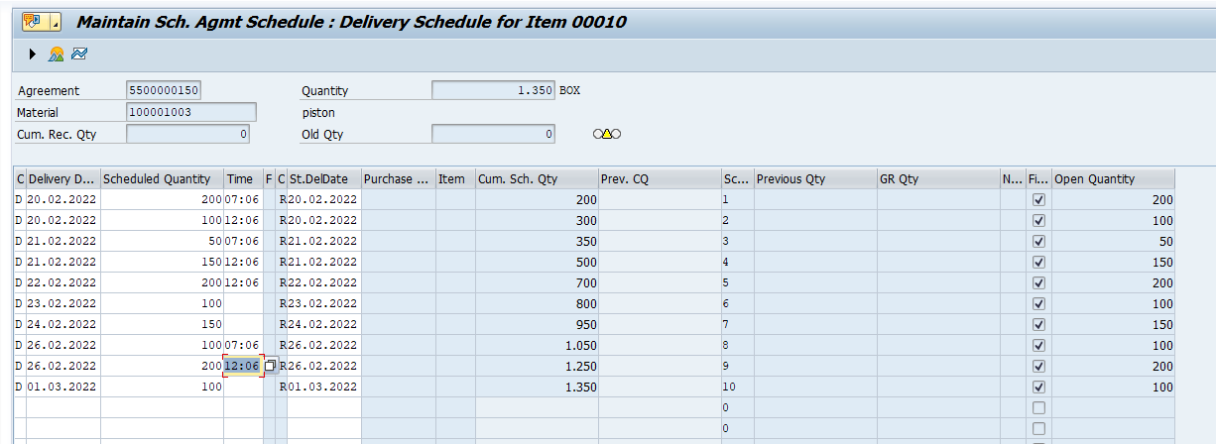

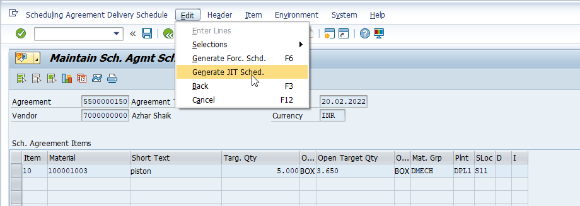



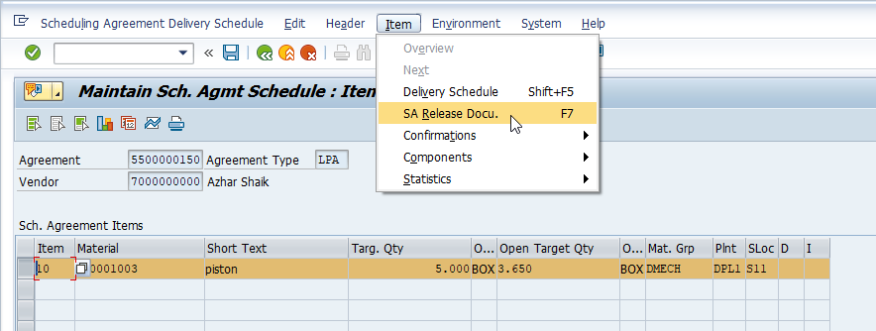

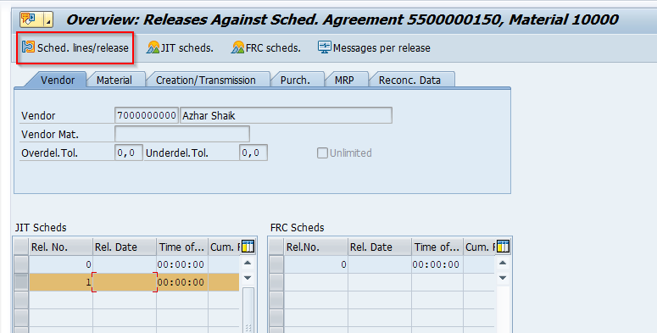

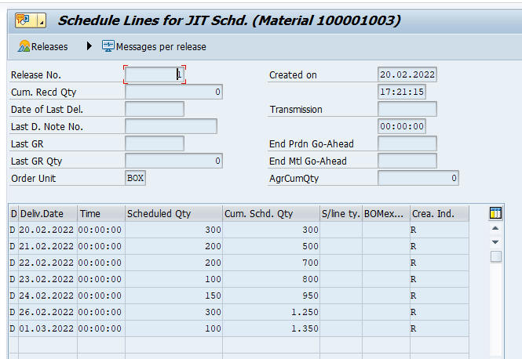

* Go back and save it
* DO create inbound delivery and Goods receipt

**Forecast Schedules:**

**Create scheduling agreement:**

* **T-code:** ME31L

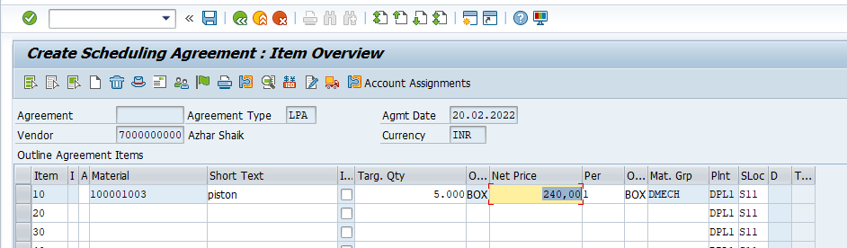

**Maintain Schedule lines:**

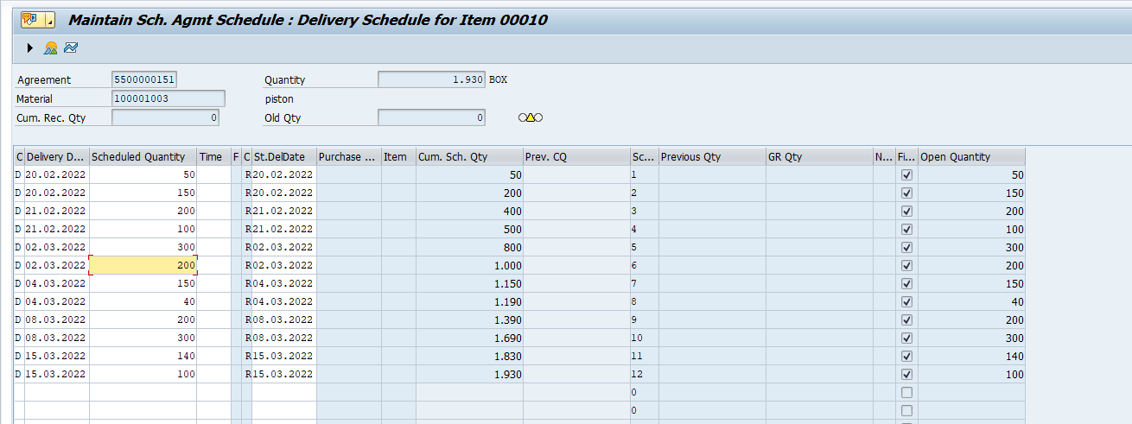

**Generate Forecast schedules**

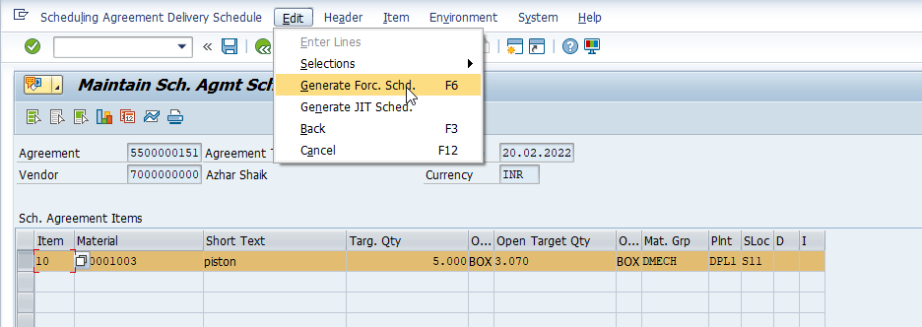



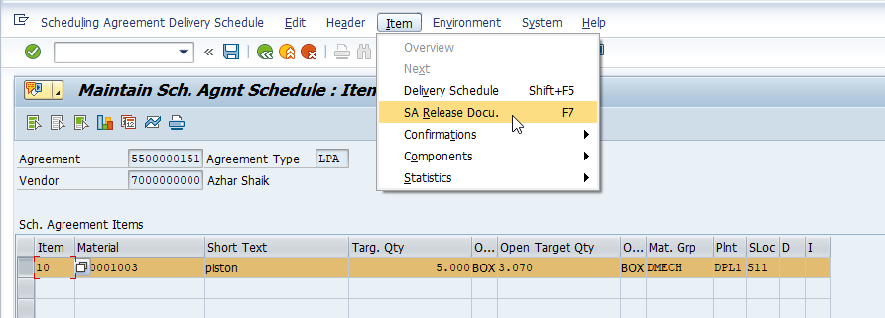

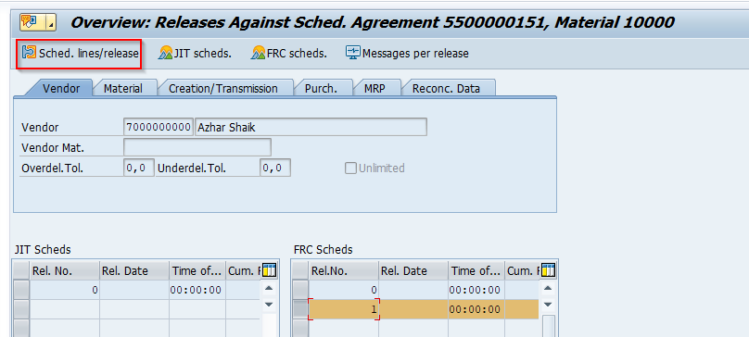

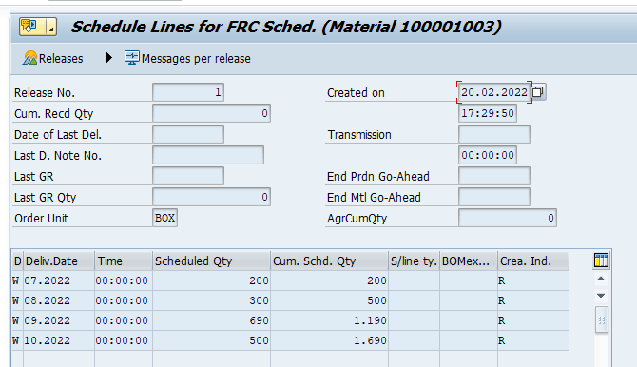

* Go back and save it
* DO create inbound delivery and Goods receipt