Load Profile
The load profile was designed to gradually increase concurrency while keeping the traffic light and practical. The test starts with a 1-user smoke test to validate the script and application flow, followed by load tests with 5, 10, and 25 concurrent users.
For the 5-user test, a 30-second ramp-up is used, followed by a 10-minute steady-state duration. The 10-user test uses a 60-second ramp-up and 10-minute duration, while the 25-user test uses a 120-second ramp-up and 10-minute duration. A pacing delay of approximately 5 seconds is introduced between business transactions to avoid generating an unrealistic burst of requests.
The traffic is intentionally kept moderate rather than aggressive. Users are gradually introduced into the system, allowing the application to reach a stable state at each load level. This approach helps identify how response time, throughput, and error rate change as concurrency increases without unnecessarily stressing the environment.
Load Profile Table
Test | Users | Ramp-up | Duration | Pacing | Traffic Intensity
Load 1 | 5 | 30 sec | 5 min | 5 sec | Low
Load 2 | 10 | 60 sec | 5 min | 5 sec | Moderate
Load 3 | 25 | 120 sec | 10 min | 5 sec | Moderate
Load 4 | 25 | 120 sec | 10 min | 1 sec | Moderate

Scenario setup:
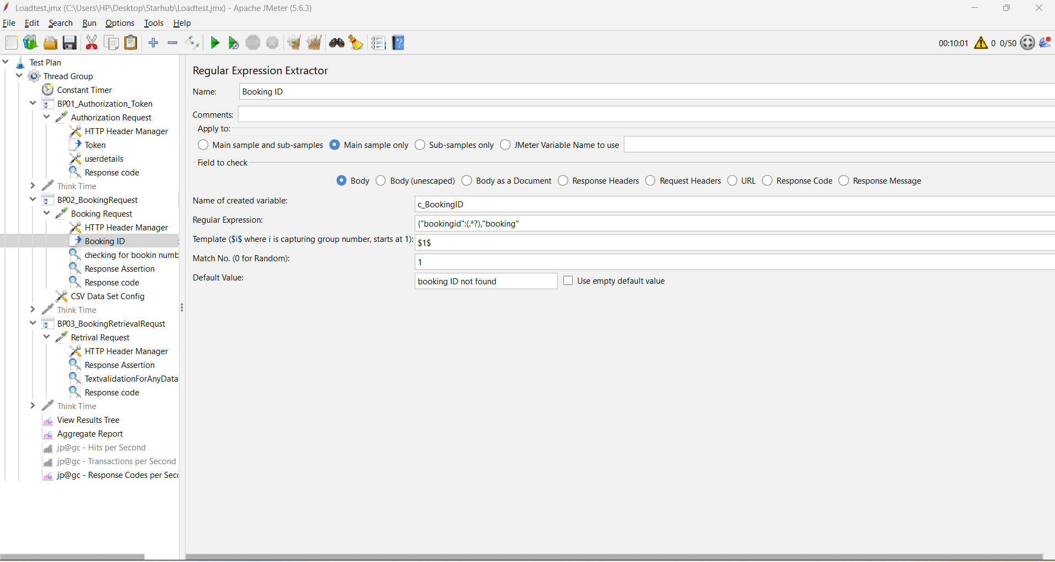
Test Details
Scenario 1: Load test with 5 users
Ramp up: 30 seconds
Steady state: 10 minutes
Think time is 5 seconds
Observations:
- Response times: At the 95th percentile, the system consistently met targets across all three services: • Authorization Token – 1.2 seconds • Booking Request – 0.3 seconds • Booking Retrieval Request – 0.3 seconds
- Error observations: A 1.2% error rate was recorded, primarily due to “not found” responses in the Booking Retrieval service.
- Throughput efficiency: Each service maintained steady throughput throughout the 10-minute execution, demonstrating reliable transaction handling under concurrent load.
- Scalability potential: The platform successfully supported 5 concurrent users without performance degradation. The next recommended step is to scale testing to 10 users to further evaluate service resilience and capacity thresholds.

Scenario 2: Load test with 10 users
Ramp up: 60 seconds
Steady state: 10 minutes
Think time: 5 seconds
Observations:
- Response times: At the 95th percentile, the system maintained consistent performance across all three services: • Authorization Token – 1.5 seconds • Booking Request – 0.3 seconds • Booking Retrieval Request – 0.3 seconds
- Error observations: A 1.6% error rate was recorded, primarily due to “not found” responses in the Booking Retrieval service.
- Throughput efficiency: Each service sustained steady throughput throughout the execution, confirming reliable transaction handling under increased load.
- Scalability potential: The platform successfully supported 10 concurrent users without degradation. The next recommended step is to scale testing to 25 users to further evaluate service resilience and performance thresholds.
Scenario 3: Load test with 25 users
Ramp up: 120 seconds
Steady state: 10 minutes
Think time : 5 seconds
Observations:
- Response times: At the 95th percentile, the system maintained consistent performance across all three services: • Authorization Token – 1.3 seconds • Booking Request – 0.3 seconds • Booking Retrieval Request – 0.3 seconds
- Error observations: A 0.87% error rate was recorded, primarily due to “not found” responses in the Booking Retrieval service.
- Throughput efficiency: Each service sustained stable throughput throughout the test, demonstrating reliable transaction handling under increased load.
- Scalability potential: The platform successfully supported 25 concurrent users without performance degradation, with response times remaining in line with previous runs.

Scenario 4: Load test with 25 users with 1 second as thinktime.
Ramp up: 120 seconds
Steady state: 10 minutes
Think time : 1 second (Reduced think time)
Observations:
- Response times: Service response times showed degradation under the 25-user load with reduced think time (1 second): • Authorization Token – 3.6 seconds • Booking Request – 0.9 seconds • Booking Retrieval Request – 0.9 seconds
- Error observations: A 0.08% error rate was recorded, primarily due to “not found” responses in the Booking Retrieval service. Importantly, no server-side errors were observed in the logs.

