Definition 2
Architecture 2
Challenges 5
Spring Cloud 5
Advantages of MicroServices 6
MicroService Environments 7
Creating Limits-Service and Spring Cloud Config Server 8
Limits-Service 8
SpringCloud Config Server and Connecting to Git 9
Spring Cloud Config Server Connecting to Limits Service 12
Providing Profiles for Limits Service 13
Currency Exchange Service 14
Currency Conversion Service 15
Using Feign REST client for Service Invocation 16
Client Side LoadBalancing With Ribbon 17
Need of Naming Server 20
Creating a naming server 20
Connecting Currency Conversion Service with Eureka Service 21
Connecting currency-exchange- service to eureka 22
Connecting Limits Service to Eureka Service 23
Distributing Calls Using Eureka and Ribbon 24
API GateWays 26
Setting up Zuul API Gateway 26
Spring Cloud Sleuth For Distributed Tracing 27
RabbitMQ and ZipKin Distributed Tracing 27
Installing RabbitMQ 28
Installing ZIPKIN Server 28
Connecting microservices to Zipkin 29
Spring Cloud Bus 29
Fault Tolerance with Hystrix 29

Definition
Although there are so many definitions for Microservices a simple one is listed here

- Small autonomous services that work together - Sam Newman

Architecture
MicroServices are services basically

- REST Services
- Small Deployable Units
- Cloud Enabled

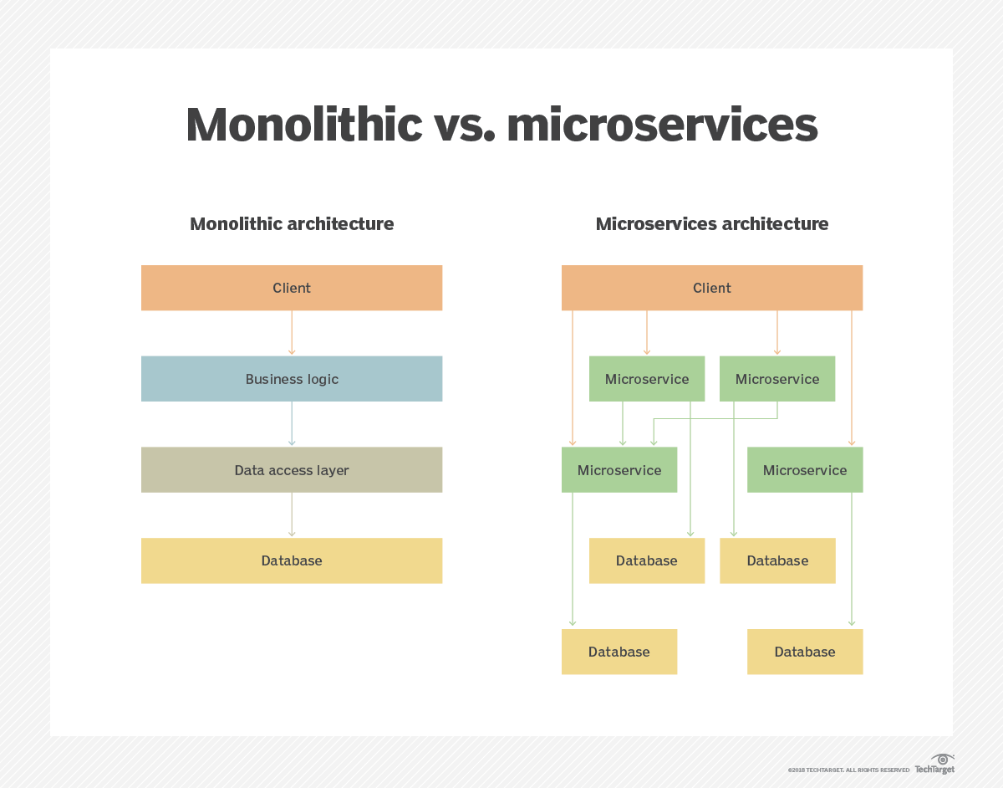

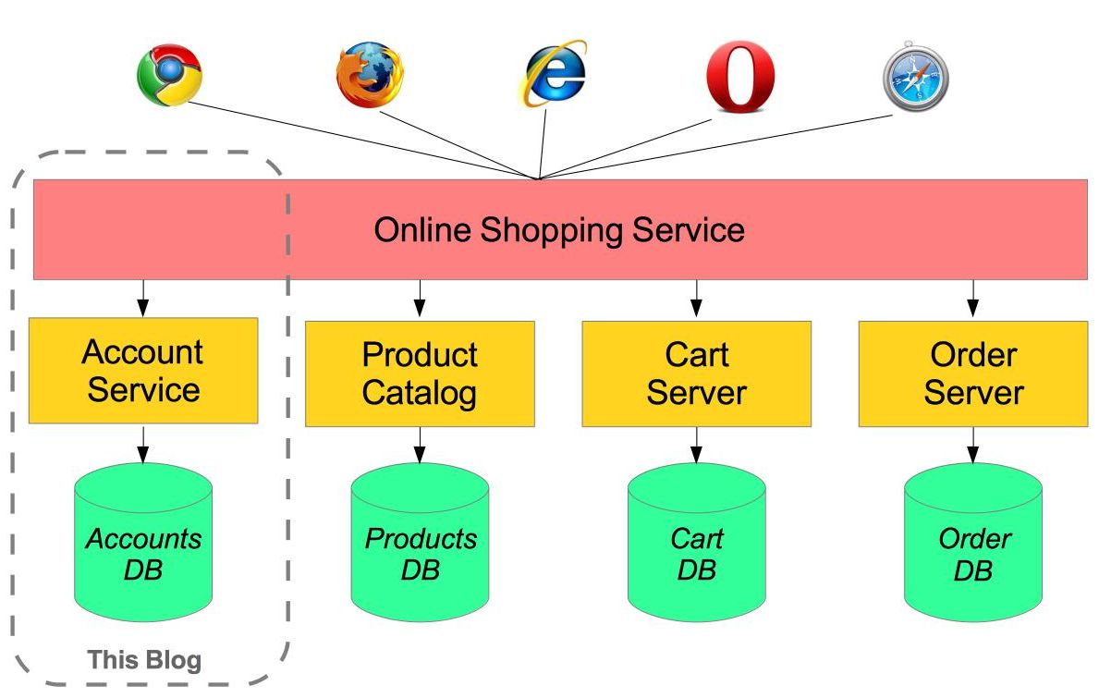

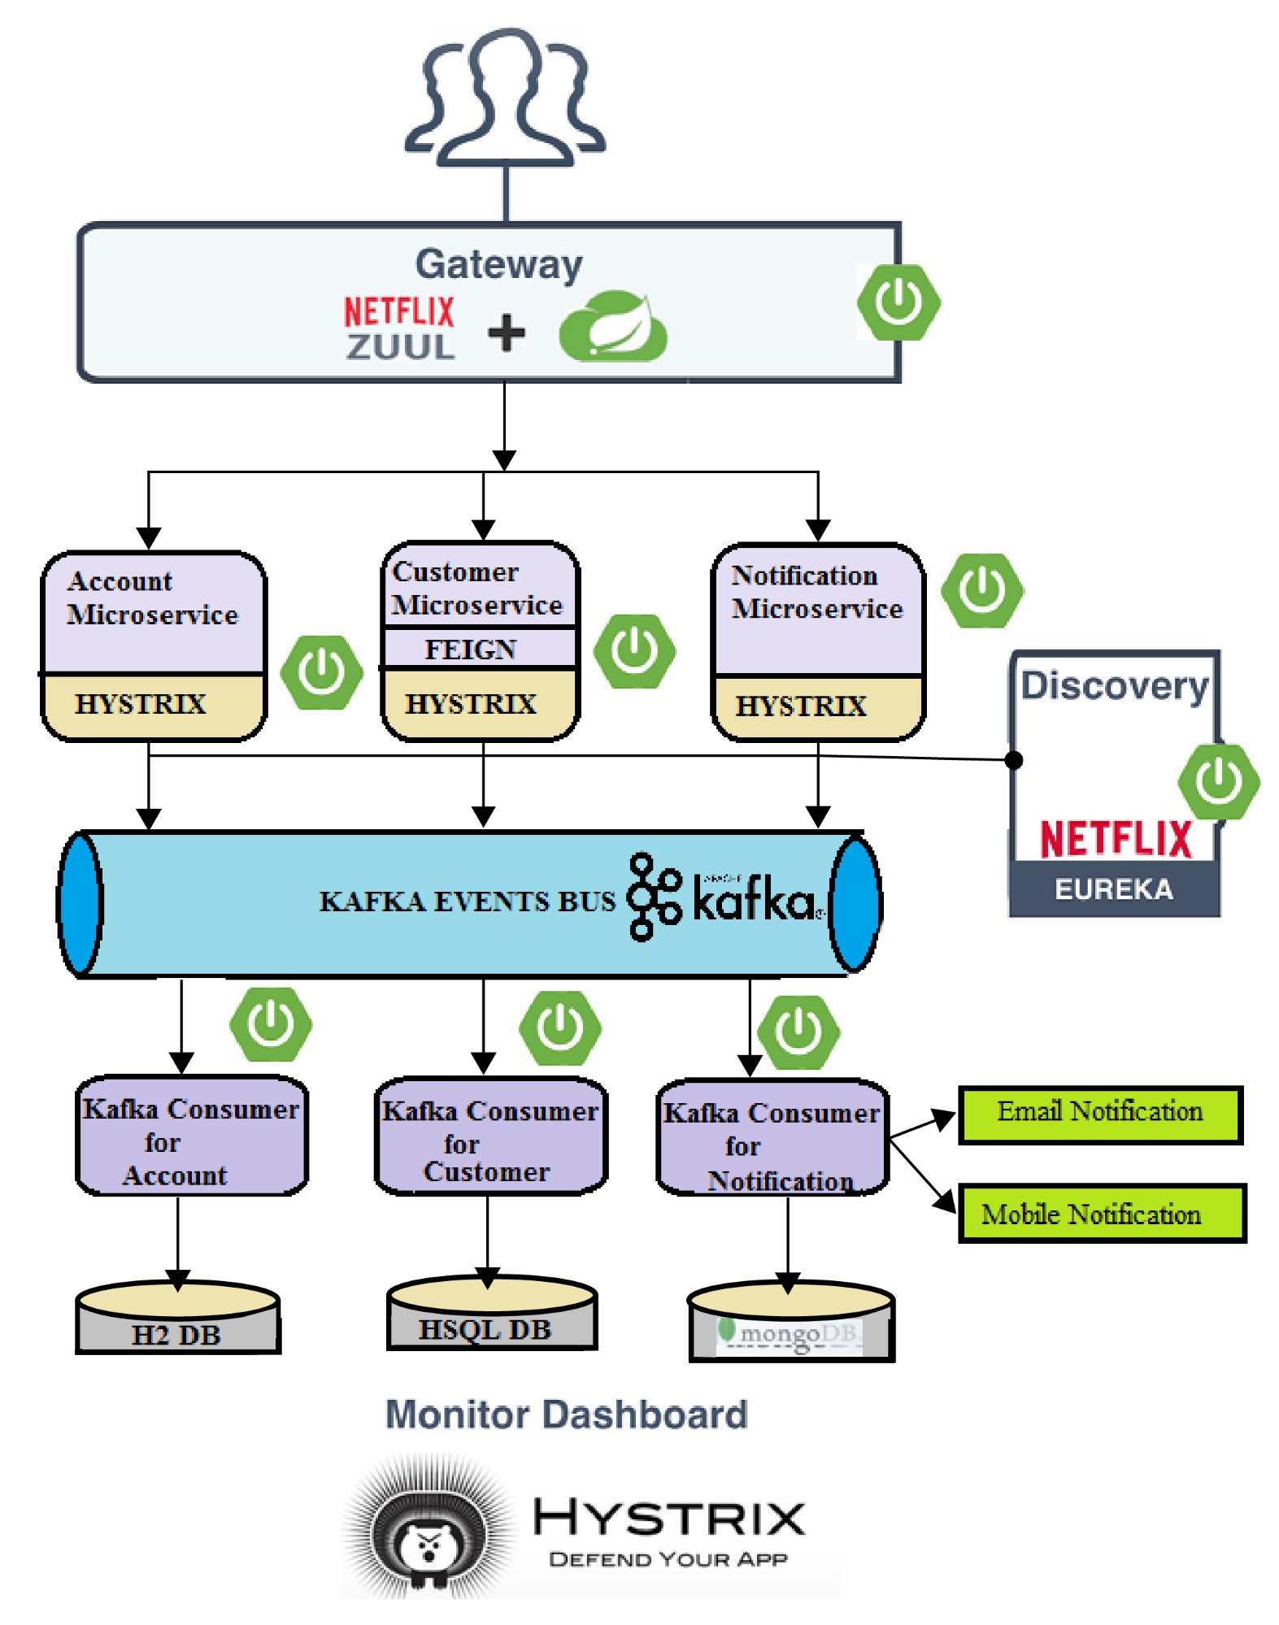

Challenges

- Configuration Management
- Dynamic Scale up and ScaleDown
- Visibility
- Pack of cards

Spring Cloud
Spring Cloud provides Solutions to the above challenges.

Spring Cloud Config Server Manages all the Configuration Management by keeping all Microservices configurations in one place.
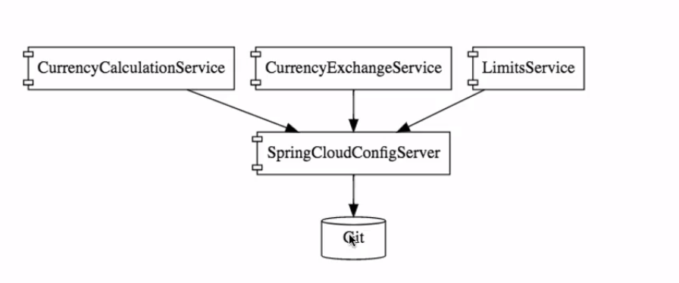

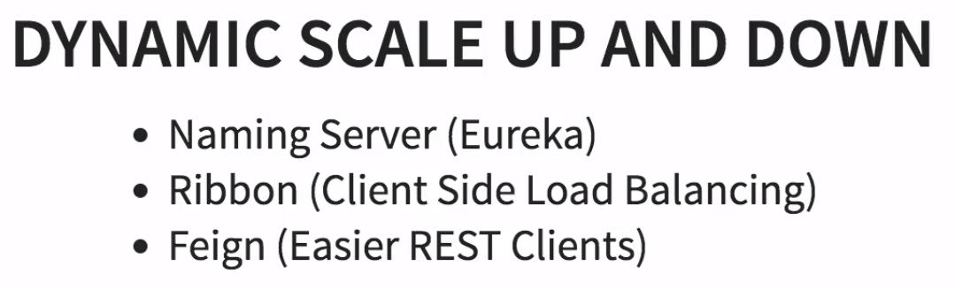
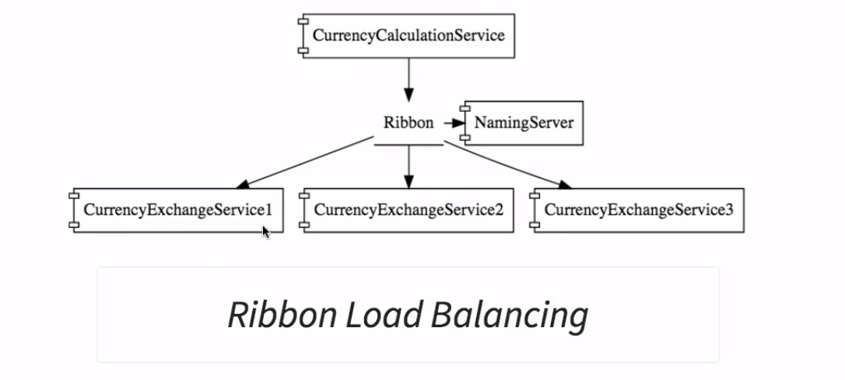





Advantages of MicroServices
- MicroService can be of any technology (Ex java,kotlin,php)
- Dynamic Scaling
- Faster Release Compare to Monolithic

MicroService Environments

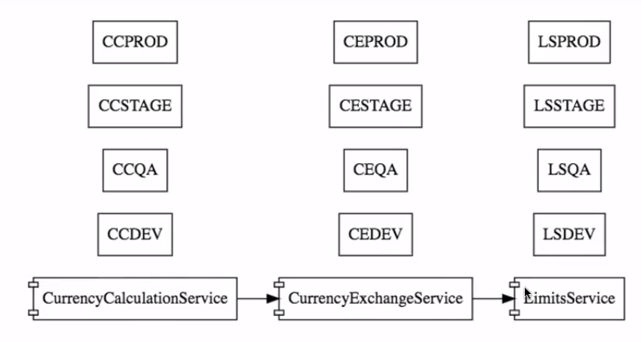

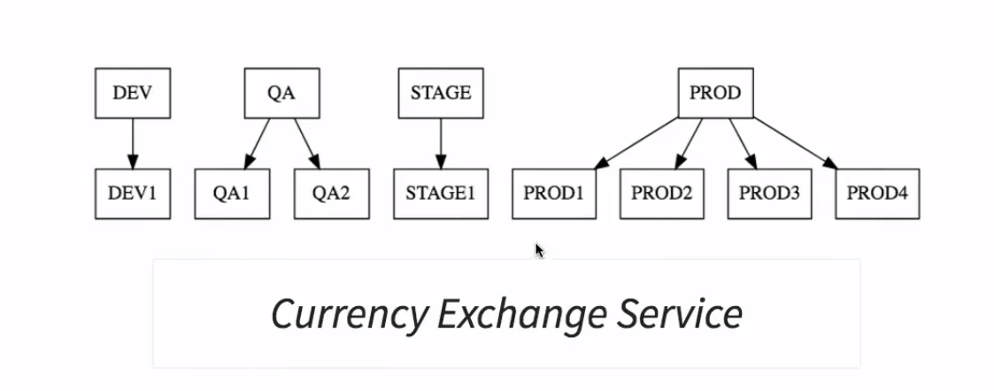

Spring Cloud Config Server takes care of all the environments of micro service as a centralized repository.

But we need to keep all the configurations of Microservices in git repository from there Spring Cloud Config Server comes into picture for managing all configurations.
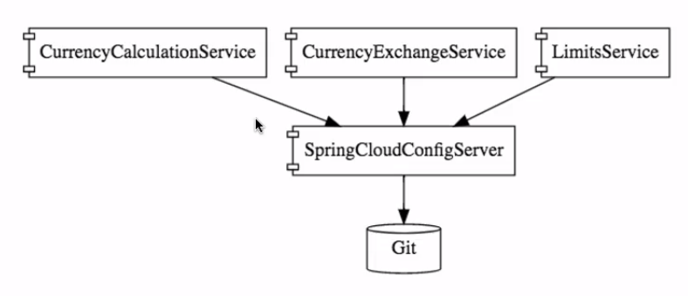

Creating Limits-Service and Spring Cloud Config Server

Limits-Service

Expose a service by configuring the dependencies using
- spring-boot-starter-actuator
- spring-boot-starter-web
- spring-cloud-starter-config

http://localhost:8080/limits-service

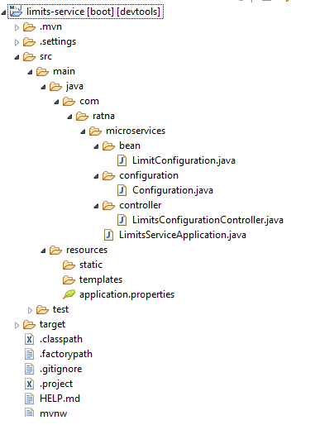

SpringCloud Config Server and Connecting to Git
Some tricky steps involved here to make a boot project as Spring Cloud Config Server.
We will discuss step by step
Step1: create a project with following dependencies
- spring-cloud-config-server
- spring-starter-web

Step2: change the port to any other here i made it to 8888 and add @EnableConfigServer along with @SpringBootApplication

Step3:create a local git repository folder and link it the spring cloud config server
Navigate to any folder in local and create folder for git repo
Example : E:\cognizant\internal-interviews\microservices\springboot-micro-services\git-localconfig-repo
And do git init

Step4:Add a properties file named with the microservice and commit it to local repository

limits-service.properties in our case remember it is case insensitive

git add -A
git commit -m “first commit”

Step5: specify the location of file in spring-cloud-server-config projects application.properties file with following value
spring.cloud.config.server.git.uri=file:///E:/cognizant/internal-interviews/microservices/springboot-micro-services/git-localconfig-repo
Note:We have to specify “ file://” infront of our path to the local repo.

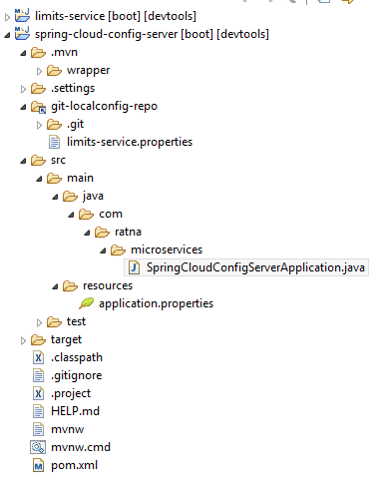

Step6: run following url http://localhost:8888/limits-service/default to check everything is ok you will get a following response

{
"name": "limits-service",
"profiles": [
"default"
],
"label": null,
"version": "d5b4246453693ac10fa83b12c7b3e9ae50028f0d",
"state": null,
"propertySources": [
{
"name": "file:///E:/cognizant/internal-interviews/microservices/springboot-micro-services/git-localconfig-repo/limits-service.properties",
"source": {
"limits-service.minimum": "88",
"limits-service.maximum": "8888"
}
}
]
}

Step7: If you want your files based on environment specific create files limits-service-dev.properties and limits-service-qa.properties and push them to local repository
To access them
http://localhost:8888/limits-service/dev
http://localhost:8888/limits-service/qa

{
"name": "limits-service",
"profiles": [
"dev"
],
"label": null,
"version": "b2325938b460b0967b353c95233849e9ea1e4c82",
"state": null,
"propertySources": [
{
"name": "file:///E:/cognizant/internal-interviews/microservices/springboot-micro-services/git-localconfig-repo/limits-service-dev.properties",
"source": {
"limits-service.minimum": "11",
"limits-service.maximum": "1111"
}
},
{
"name": "file:///E:/cognizant/internal-interviews/microservices/springboot-micro-services/git-localconfig-repo/limits-service.properties",
"source": {
"limits-service.minimum": "88",
"limits-service.maximum": "8888"
}
}
]
}

Spring Cloud Config Server Connecting to Limits Service
Step1 : change the application.properties file to bootstrap.properties and remove local properties
Step2: Add following value in bootstrap.properties file spring.cloud.config.uri=http://localhost:8888

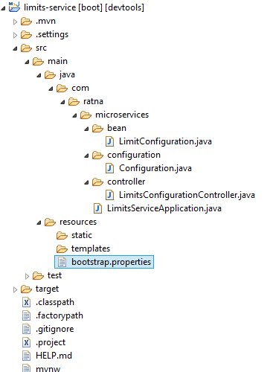

Step3: when you access the following url http://localhost:8080/limits
You will get response from default limits-service.properties file as we not configured any profile

{
- "maximum": 5555,
- "minimum": 55
}

Providing Profiles for Limits Service
Step1 : Open bootstrap.properties file and enter the following value based on which you want to choose the profile
spring.profiles.active=stage
When we enter the url http://localhost:8080/limits
We will get response from stage
{
- "maximum": 3333,
- "minimum": 33
}

Currency Exchange Service
We are now dealing with another microservice that is a currency exchange service where it will deal with databases and in our previous service we dealt with only configuration.
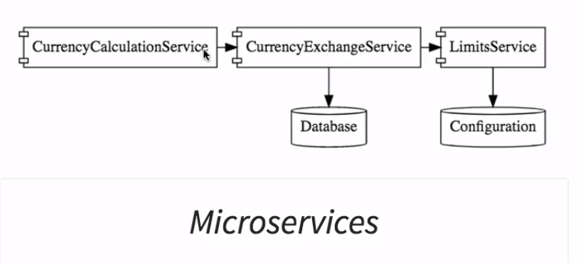

Step1 : Expose a service by configuring the dependencies using
spring-boot-starter-actuator
spring-boot-starter-web
spring-cloud-starter-config
Spring-boot-starter-data-jpa
h2

http://localhost:8000/currency-exchange/from/USD/to/INR
Use the above service to check the data

prop.getProperty("local.server.port") to get port value Dynamically
{
- "from": "USD",
- "to": "INR",
- "id": 1000,
- "conversionMultiple": 65,
- "port": 8000
}

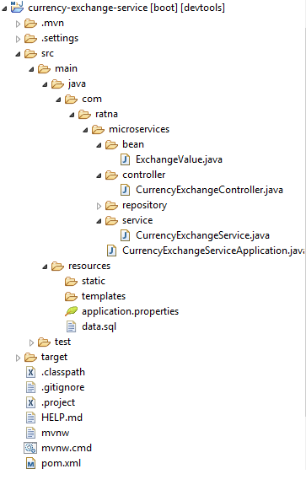

Currency Conversion Service

We are now dealing with another microservice that is a currency conversion service where it will get information from currency exchange service.

Step1 : Expose a service by configuring the dependencies using
- spring-boot-starter-actuator
- spring-boot-starter-web
- spring-cloud-starter-config
- spring-cloud-starter-feign

http://localhost:8100/currency-converter/from/USD/to/INR/quantity/5000

{
- "from": "USD",
- "to": "INR",
- "id": 10000,
- "conversionMultiple": 65,
- "quantity": 5000,
- "totalAmount": 325000,
- "port": 8100
}

Using Feign REST client for Service Invocation
Step1: Add the dependency spring-cloud-starter-feign

Step2: Enable the feign at @SpringBootApplication by using annotation
@EnableFeignClients("com.ratna.microservices") and passing the package to scan

Step3: create a proxy of the service in current service to access it and specify the return type

@FeignClient(name = "currency-exchange-service", url = "localhost:8000")
public interface CurrencyExchangeServiceProxy {

@GetMapping("/currency-exchange/from/{from}/to/{to}")
public CurrencyConversionBean retrieveExchangeValue(@PathVariable("from") String from, @PathVariable("to") String to);

}

Method in CurrencyConversionController accessing the proxy

@Autowired
private CurrencyExchangeServiceProxy proxy;

@GetMapping("/currency-converter-feign/from/{from}/to/{to}/quantity/{quantity}")
public CurrencyConversionBean convertCurrencyUsingFeign(@PathVariable String from, @PathVariable String to,
@PathVariable BigDecimal quantity) {

CurrencyConversionBean response = proxy.retrieveExchangeValue(from, to);
response.setQuantity(quantity);
response.setTotalAmount(response.getConversionMultiple().multiply(quantity));

return response;
}

Client Side LoadBalancing With Ribbon

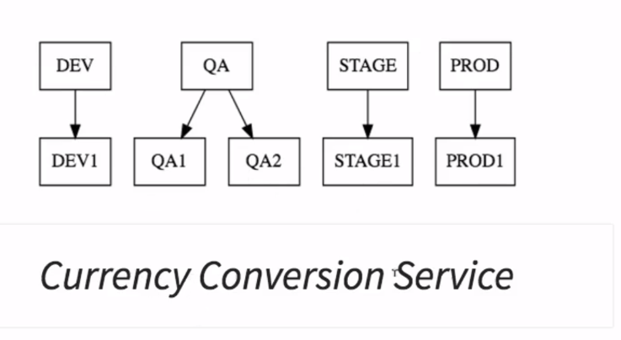

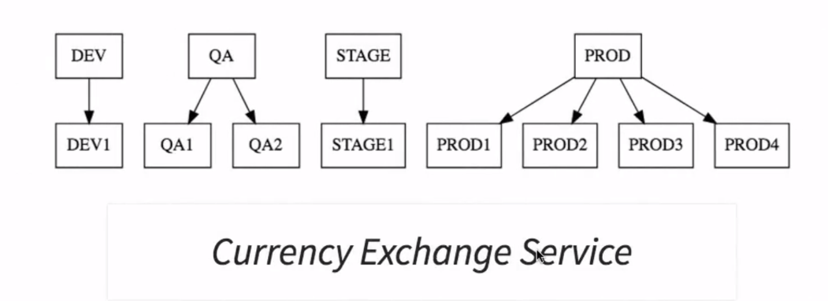
Let us assume a scenario where our currency conversion service is having one instance in production and currency exchange service having 4 instances in production.

But our proxy above we created has been hard coded to the one instance let’s say localhost:8000 lets say one instance currency conversion service will interact with any one instance of prod1 or 3 or 2 or 4 of currency exchange service even though we kept host in the property file instead of hardcoded.

Suppose if you want to make your currency conversion service to talk with all instances of currency exchange service and distribute equal load here Ribbon comes into picture

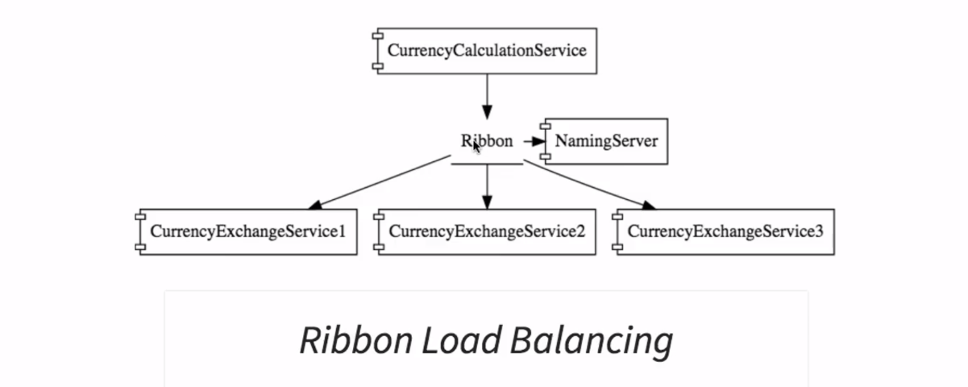

Ribbon uses feign configuration and distributes the load equally among the services so we have to enable Ribbon on our proxy service..

Update the existing currency-conversion-service with ribbon starter dependency

Add the @RibbonClients() on the proxy since we are dealing with multiple instances remove the port in the proxy and updated proxy will be as shown below

//@FeignClient(name = "currency-exchange-service", url = "localhost:8000")
@FeignClient(name = "currency-exchange-service")
@RibbonClient(name="currency-exchange-service")
public interface CurrencyExchangeServiceProxy {

@GetMapping("/currency-exchange/from/{from}/to/{to}")
public CurrencyConversionBean retrieveExchangeValue(@PathVariable("from") String from, @PathVariable("to") String to);

}

Add the list of ports in currency conversion service properties file
currency-exchange-service.ribbon.listOfServers=http://localhost:8000,http://localhost:8001

http://localhost:8100/currency-converter-feign/from/USD/to/INR/quantity/50000

When after successfully configuring then we will get response from the two instances of currency-exchange-service

{
- "from": "USD",
- "to": "INR",
- "id": 10001,
- "conversionMultiple": 65.00,
- "quantity": 50000,
- "totalAmount": 3250000.00,
- "port": 8001
}

{
- "from": "USD",
- "to": "INR",
- "id": 10001,
- "conversionMultiple": 65.00,
- "quantity": 50000,
- "totalAmount": 3250000.00,
- "port": 8000
}

Need of Naming Server
For dynamically increase or decrease the services instead of configuring them in properties file we should use Naming Server

The two important features of Naming Server are
- service registry and
- service discovery

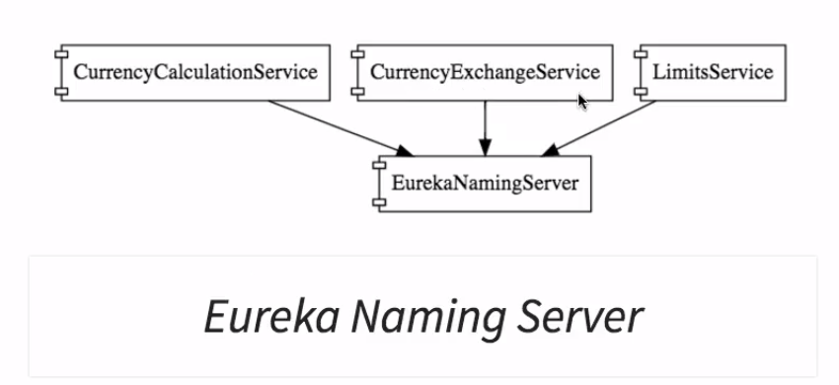

Creating a naming server
Step 1:
Create a new service with following dependencies
- spring-cloud-starter-netflix-eureka-server
- spring-cloud-starter-config
- spring-boot-starter-actuator

Step 2
Enable the eureka server by adding @EnableEurekaServer on spring boot starter class

Step 3
Add the following in application.properties

spring.application.name=netfix-eureka-naming-server
server.port=8761
eureka.client.register-with-eureka=false
eureka.client.fetch-registry=false

Step 4
Access url http://localhost:8761/ then you will see a html page with ureka

Connecting Currency Conversion Service with Eureka Service
Step 1
Add eureka dependency in pom.xml of currency-conversion-service
- spring-cloud-starter-eureka

Step 2
Add annotation @EnableDiscoveryClient to the spring boot starter class

Step3
Configure eureka url in currency-conversion-service properties as shown below
eureka.client.service-url.default-zone=http://localhost:8761/eureka

Step4
After completing the above steps once you started conversion service it will be available in naming service as shown below.

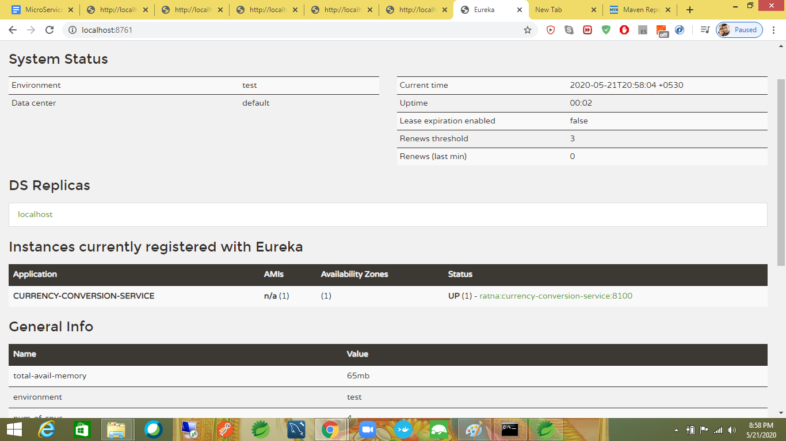

Connecting currency-exchange- service to eureka
Follow the same steps as specified in above

If everything is properly connected and as we are running currency-exchange in two instances we will be able to see each of them and conversion service in eureka service
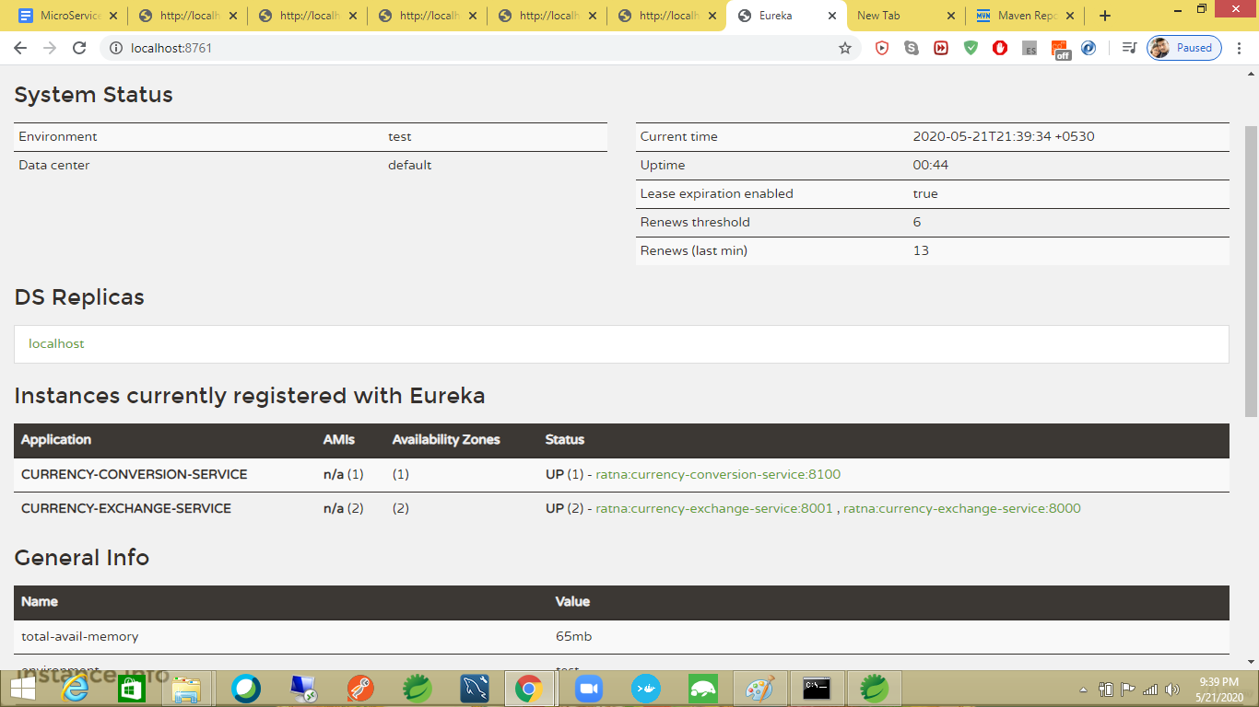

Connecting Limits Service to Eureka Service
We need to follow same steps as above but here instead of placing the naming url in application.properties we need to place it in bootstrap.properties

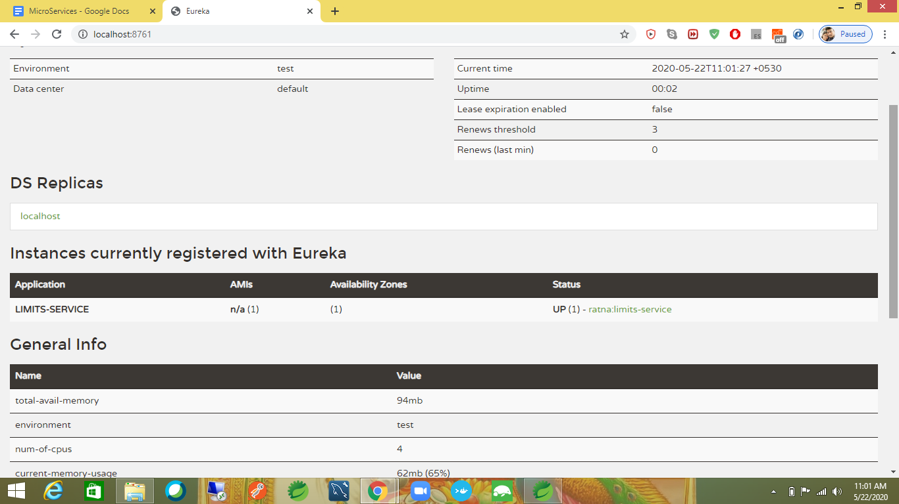

Distributing Calls Using Eureka and Ribbon

We have to disable the list of servers we have specified in the conversion service as we are using the eureka naming server
Hence disable it in properties

spring.application.name=currency-conversion-service
server.port=8100
eureka.client.service-url.default-zone=http://localhost:8761/eureka
#currency-exchange-service.ribbon.listOfServers=http://localhost:8000,http://localhost:8001

When you access url http://localhost:8100/currency-converter-feign/from/USD/to/INR/quantity/50000
Then we will get response from two instances and naming server is performing the load balance

{
- "from": "USD",
- "to": "INR",
- "id": 10001,
- "conversionMultiple": 65.00,
- "quantity": 50000,
- "totalAmount": 3250000.00,
- "port": 8000
}

{
- "from": "USD",
- "to": "INR",
- "id": 10001,
- "conversionMultiple": 65.00,
- "quantity": 50000,
- "totalAmount": 3250000.00,
- "port": 8001
}

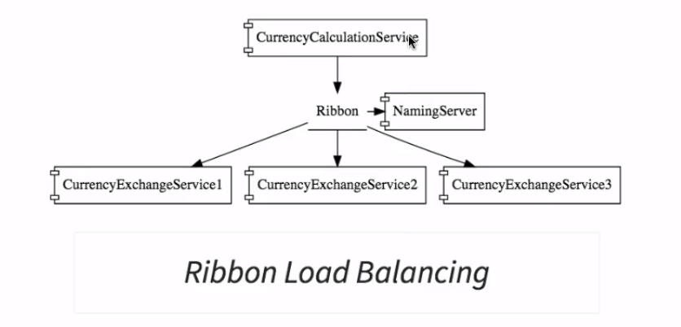

API GateWays
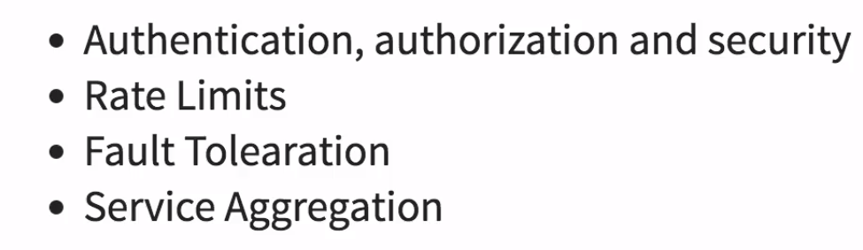

Instead of allowing microservices to talk to each other we should allow them to pass between a common API Gateway where all above features will cover.

Setting up Zuul API Gateway
Step1: create a service by having following dependencies
- spring-boot-starter-actuator
- spring-cloud-starter-netflix-eureka-client
- spring-cloud-starter-netflix-zuul
- spring-boot-devtools

Step2:Add two annotations on spring boot starter class @EnableZuulProxy
@EnableDiscoveryClient

Step3: Add following properties in application.properties file
spring.application.name=netfix-zuul-api-gateway-server
server.port=8765
eureka.client.service-url.default-zone=http://localhost:8761/eureka

Step4: Just create a logging class to check functionality of gateway by extending ZuulFilter

Step5: To execute a request through ZuuLApi we have to do the following
Normal Request : http://localhost:8100/currency-converter-feign/from/USD/to/INR/quantity/50000
Zuul Request:
http://localhost:8765/{applicationName}/{uriofservice}

http://localhost:8765/currency-conversion-service/currency-converter-feign/from/USD/to/INR/quantity/50000

{
- "from": "USD",
- "to": "INR",
- "id": 10001,
- "conversionMultiple": 65.00,
- "quantity": 50000,
- "totalAmount": 3250000.00,
- "port": 8000
}

Spring Cloud Sleuth For Distributed Tracing
Step1 : Add the dependency in required services here I am adding for currency-conversion,currency-exchange,netflix-zuul-api-gateway server
- spring-cloud-starter-sleuth

Step2:Add Sampler class in spring bootstrap class
@Bean

public Sampler defaultSampler() {
return Sampler.ALWAYS_SAMPLE;
}

We will get a log with an id but it is distributed in all consoles to make all the logs available in one place we will use zipkin

RabbitMQ and ZipKin Distributed Tracing
We use RabbitMQ for taking all the log messages from the microservices and use ZipkinDistributed Tracing will listen from MQ

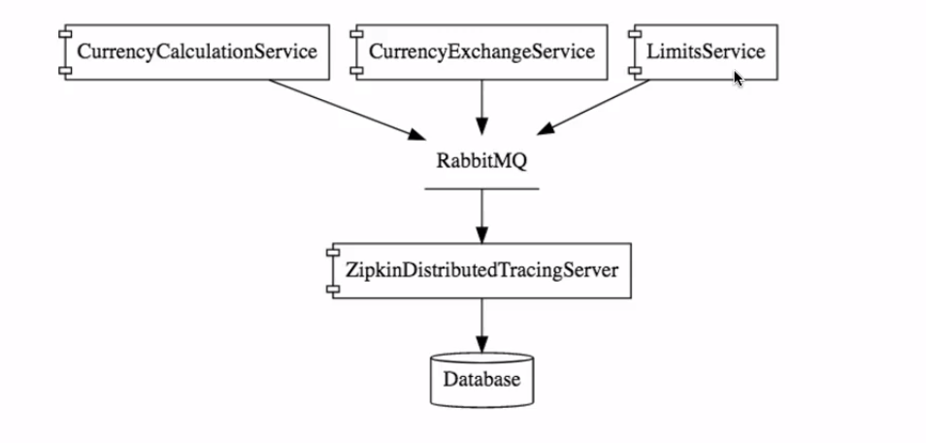

Installing RabbitMQ

Step1 Go to Following website https://www.rabbitmq.com/install-windows.html
Step2 Install ErLang before installing RabbitMQ https://www.erlang-solutions.com/resources/download.html

Installing ZIPKIN Server
Download Zipkin executable jar from https://search.maven.org/search?q=g:io.zipkin.java%20AND%20a:zipkin-server&core=gav
And run it using java -jar zipkin-server-2.12.9-exec.jar
Launch the index page using http://localhost:9411/zipkin/

To make ZIPKIN know about rabbit use below command
SET RABBIT_URI=amqp://localhost
java -jar zipkin-server-2.12.9-exec.jar

Connecting microservices to Zipkin
Step 1:
Add the following dependencies in the services
- spring-cloud-sleuth-zipkin
- Spring-cloud-starter-bus-amqp

Spring Cloud Bus
- In general when we are changing the configuration in springcloudconfig server it doesn’t reflect immediately unless we run a refresh server url
- Here in my case I changed the property of minimum limits to 3 from 33 and I pushed it to local git repository when I accessed the url I am getting limit as 33 but not 3

- And add following property in bootstrap.properties
management.security.enabled=false it will be refreshed automatically whenever there is a change

Fault Tolerance with Hystrix
There may be a chance where our microservices get failed and the other microservices that are depending on it may be failed but we have to make sure a service failure shouldn’t affect other services.

In this scenario we should use Hystrix to return a dummy response or something to make service available we are using in limit-service.

Step 1 use following dependency to install it
Spring-cloud-starter-hystrix

Step 2 Add @EnableHystrix at bootstrap class

Step 3: Use @HystrixCommand(fallbackMethod = "fallBackMethodHandler") on the service then in case of any failure we will get response from the fallbackmethod

http://localhost:8080/limits-error-callback
@GetMapping("/limits-error-callback")
@HystrixCommand(fallbackMethod = "fallBackMethodHandler")
public LimitConfiguration callback() {
throw new RuntimeException("Not Available");
}

public LimitConfiguration fallBackMethodHandler() {
return new LimitConfiguration(10000, 100);
}

