**Program-7)Suite-level execution ( instead of giving mail id , we are passing ‘x ‘ and ‘y’)**

** in ‘x’ place normally we use “vinu@gmail.com”**

** in ‘y’ place normally we use “**[**mathi@gmail.com**](mailto:mathi@gmail.com)**”**

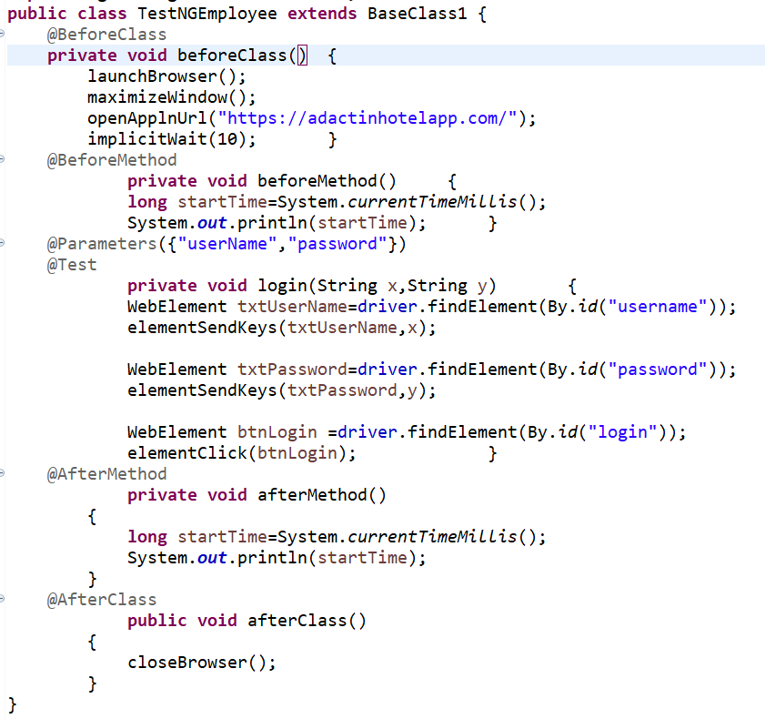

**testing.xml**

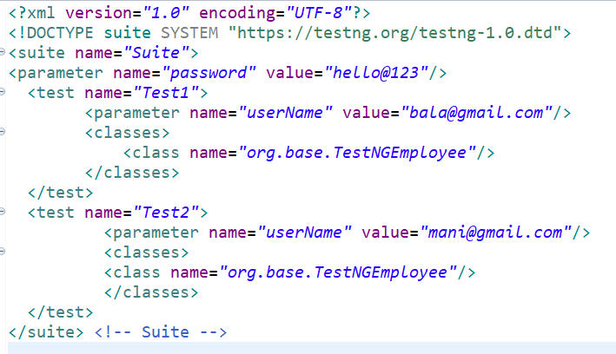

**To run a program, right click on the test.xml coding window and click Run As 🡪 (TestNG Suite)**

**, then it will open hotel login with username and password, and test case output shown.**

**Output:**

