testNG

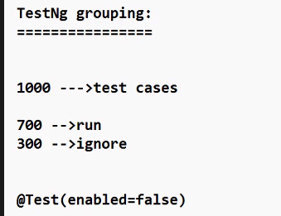

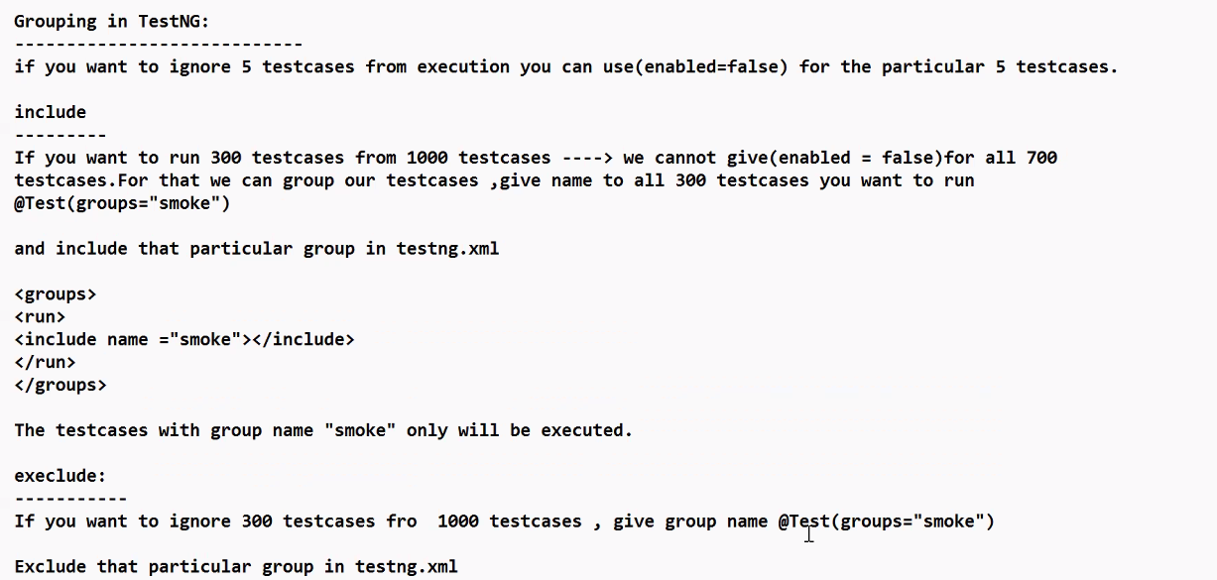

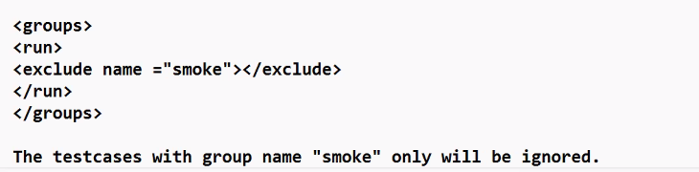

**Example program for grouping the testcases:**

**Include the particular test cases (include name=”reg”)**

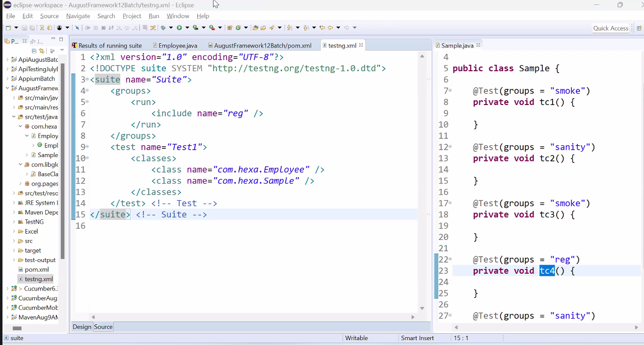

Continuation of Sample.java (given above)

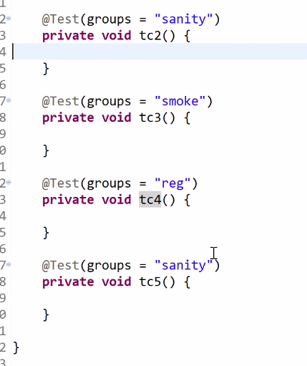

**Exclude the particular test case:**

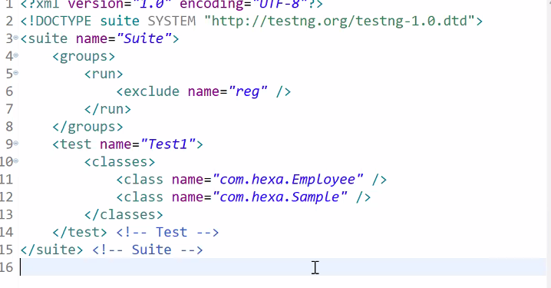

Employee.java , for this proceed the same Sample.java file.

After executing the program, refresh the project name and open the test-output folder and check the emailable-report.html.(you can see the detailed reports)

