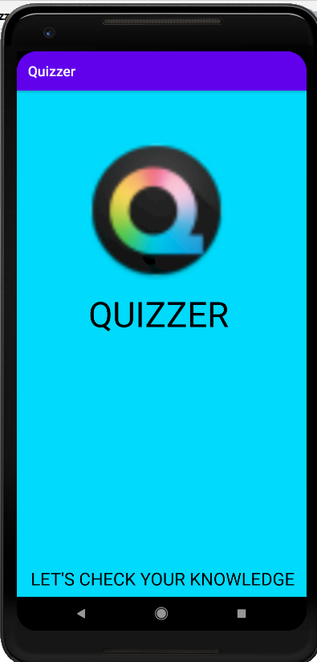

Fig1: SPLASH SCREEN

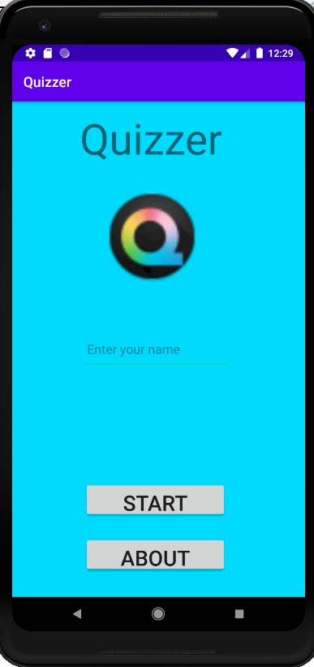

Fig 2: MAINACTIVITY SCREEN

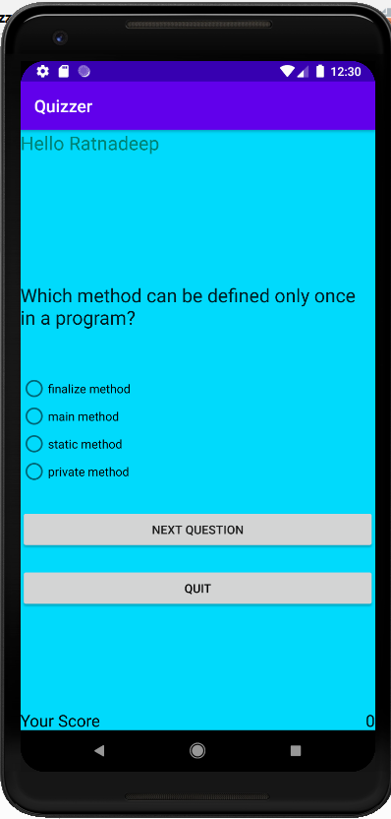

Fig 3: QUESTIONACTIVITY SCREEN

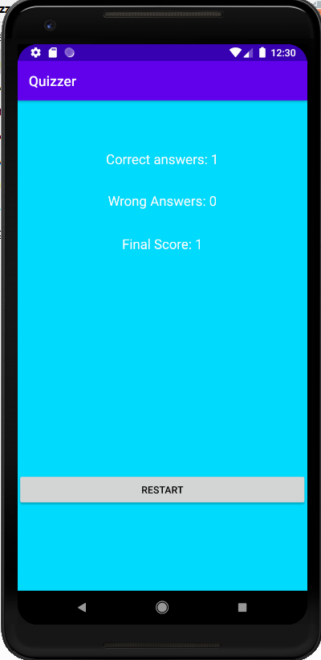

Fig 4:RESULTACTIVITY SCREEN

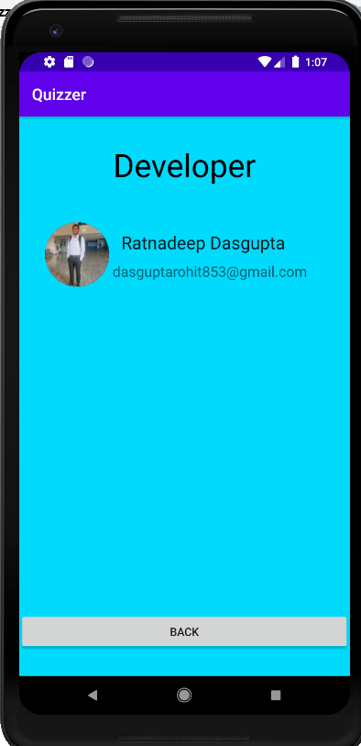

Fig 5: DEVELOPERACTIVITY SCREEN