**Student Name: Patil Ratnakar Netaji**

**Student Roll no.: 322050**

**Class: TY- B**

**Batch: B2**

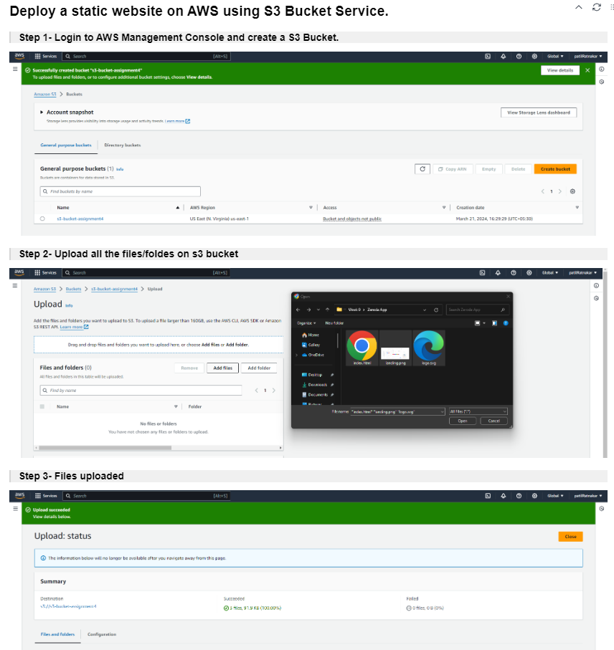

**ASSIGNMENT 4**

