1(madhu) 2(nirupama)

wish list track order
crafts villa brand kurthis nd more
payment gatewats social media buttons(follows)
cart search

3(gautam) 4(rathna)

contact us appDownload
sarees salvar suit
our company support
download App
food Authentication modul

5(sangeetha)
style trends
lehanga
policies nd info
useful info
hpme pg

suns7425
sunshine99

track order
kurthis nd more
social media buttons(follows)
search

1. track order

1.1 Track order button should be present in side menu
1.2 when clicked on track order button, window popup should appear.
1.3 Track order window popup should contain two social media bittons (facebook , google)
1.3.1 when clicked on facebook button, it should take you to facebook signin page
1.3.2 when clicked on google button, it should take you to google signin page.

1.4 should contain e-mailid text field and continue button.
1.4.1 when clicked on continue button without entering mail address, it should throw error message (mail id is required).
1.4.2 after entering valid mail-id, it should ask for password
1.4.3 on valid credential, should be able to login.
1.4.4 on invalid credential, when clicked on login button should throw error message(invalid e-mail id or password!).
1.4.5 if you are a new user / if you want to resister, enter mailid, password and click on register button
1.4.6 after registering you should be able to see the user name on top right corner

1.5 track order wondow popup should contain cancel botton on top right corner, when clicked on it, it should close the popup.

2. Kurthis and More
2.1 kurthis and more is the LINK on top menu bar
2.2 when mouse hovered on it, should display the options like
2.2.1 kurthis
2.2.1.1 all links under kurthis should be clickable
2.2.1.2 should contain link see all at the end

2.2.2 skirts
2.2.2.1 all links under skirts should be clickable
2.2.2.2 should contain link see all at the end

2.2.3 fusion wear
2.2.3.1 all links under fusion wear should be clickable
2.2.3.2 should contain link new at the end

2.2.4 bottom wear with link new
2.2.4.1 all links under fusion wear should be clickable

2.2.5 Islamic wear
2.2.5.1 all links under fusion wear should be clickable

2.3 when clicked on kurthis and more link, kurthis and more page is displayed\

2.4 kurthis page should contain FilterBy on left navigation bar

2.5 page should contain Bread Crumb on top navigation bar to see the navigation

2.6 page should contain sort By on top of the oage

2.7 page should contain Show option to zoom the images

2.8 page should have footer which contains payment options, follow us, support, our company, top categories, useful info, policies and info, for sellers.

2.9 page should contain side menu with options wish list, track order, contact us, app download, style trends.

2.10 page should contain pagination in the bottom to clicl on next page.

2.11 page should contain main menu(top menu)

2.12 page should contain search bar

2.13 cart should be displayed

2.14 user name should be displayed, and when mousehovered on it, should display the options
2.14.1 my orders,
2.14.2 wish list,
2.14.3 my address,
2.14.4 bankl details,
2.14.5 account settings
2.14.6 logout.

1.2 Track order popup should look like this.
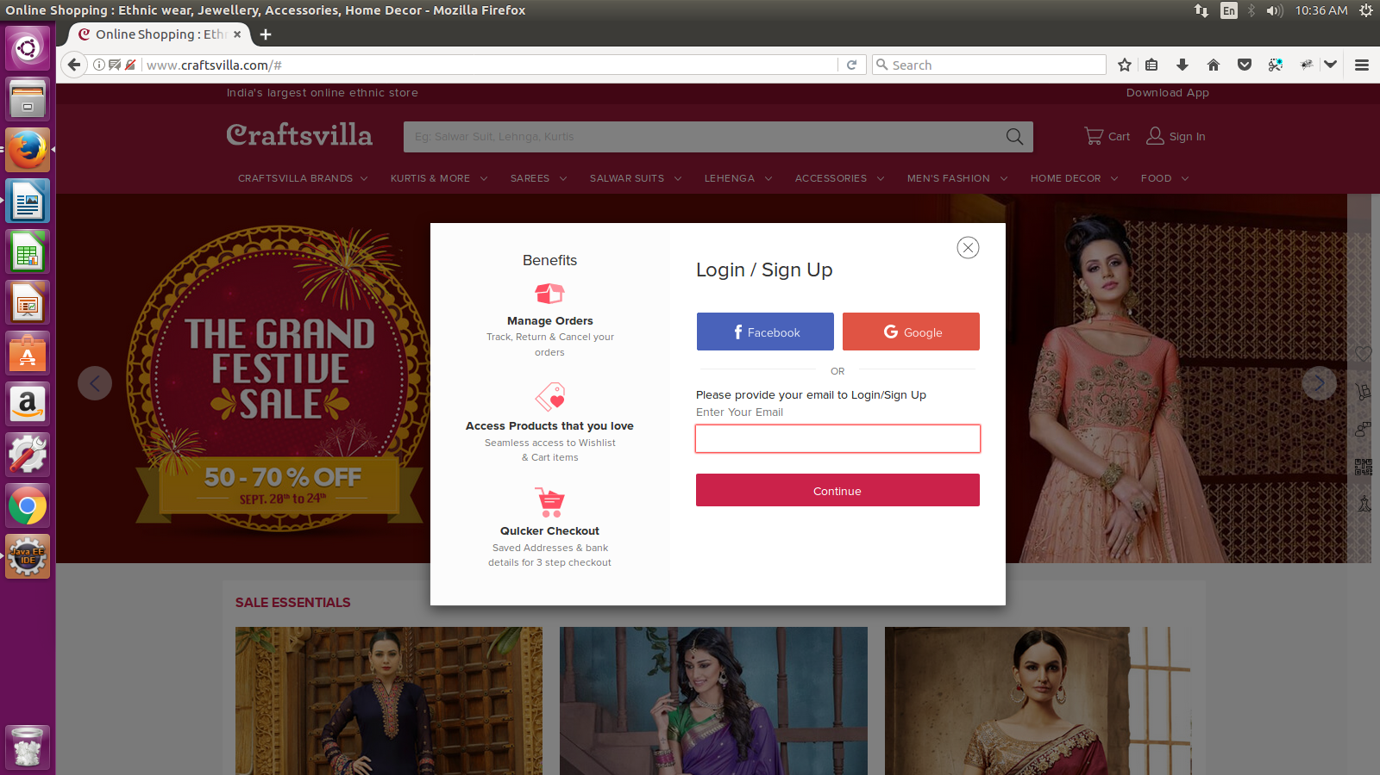
1.4.2 Enetr mail id and click on continue, should ask of password

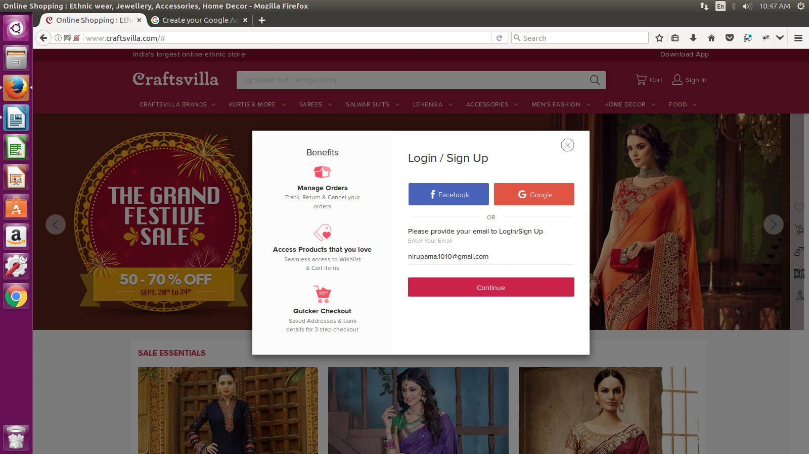

1.4.5 if you are new user, you can enter mailid, password and click on register button

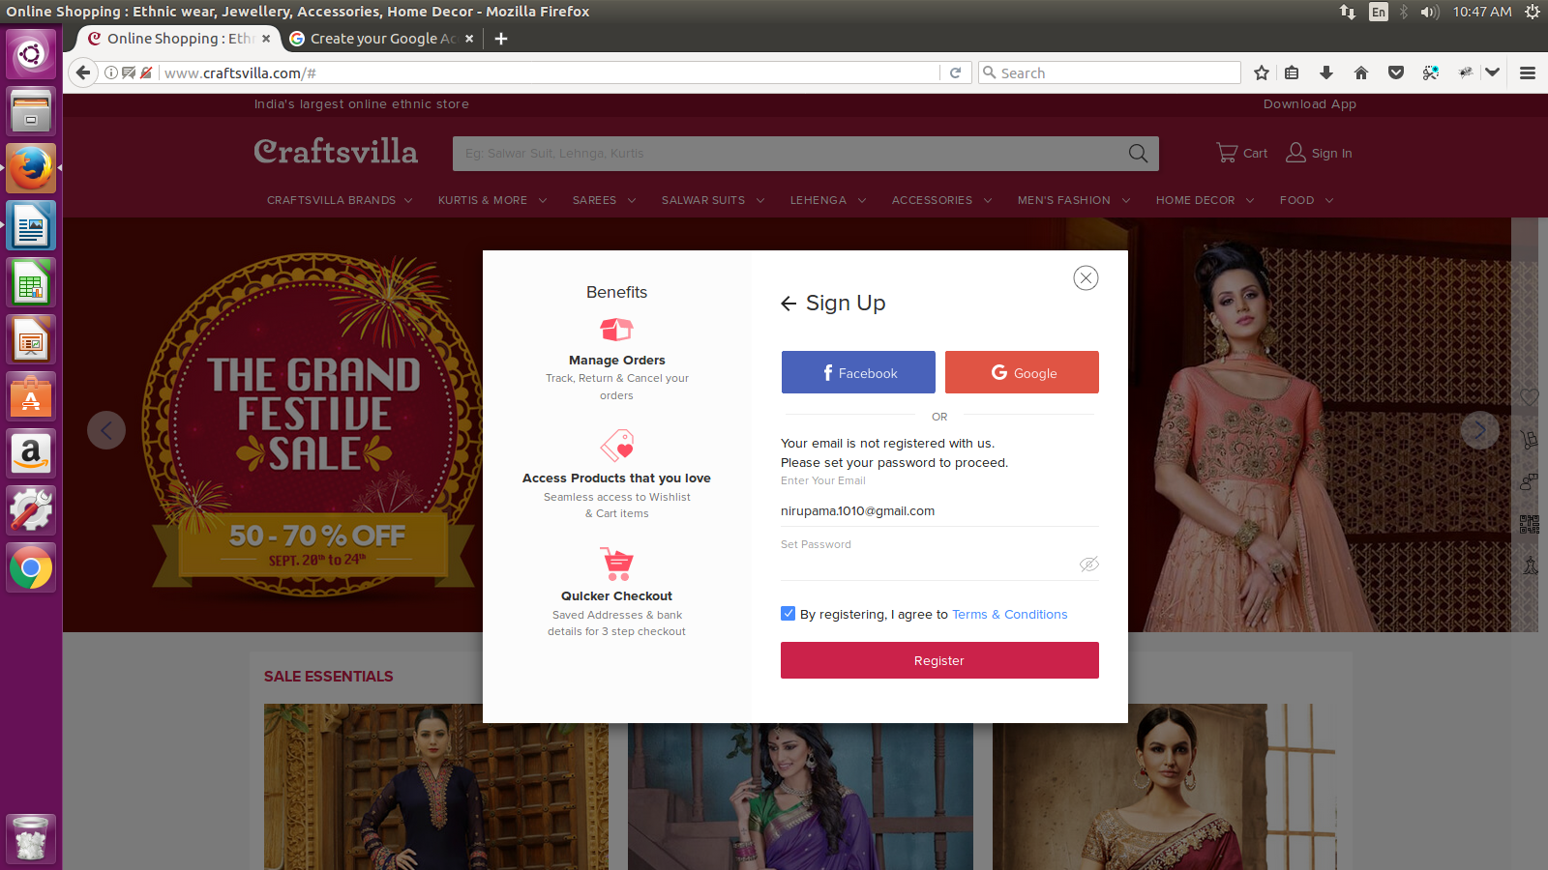
1.4.6 after registering you should be able to see the user name on top right corner

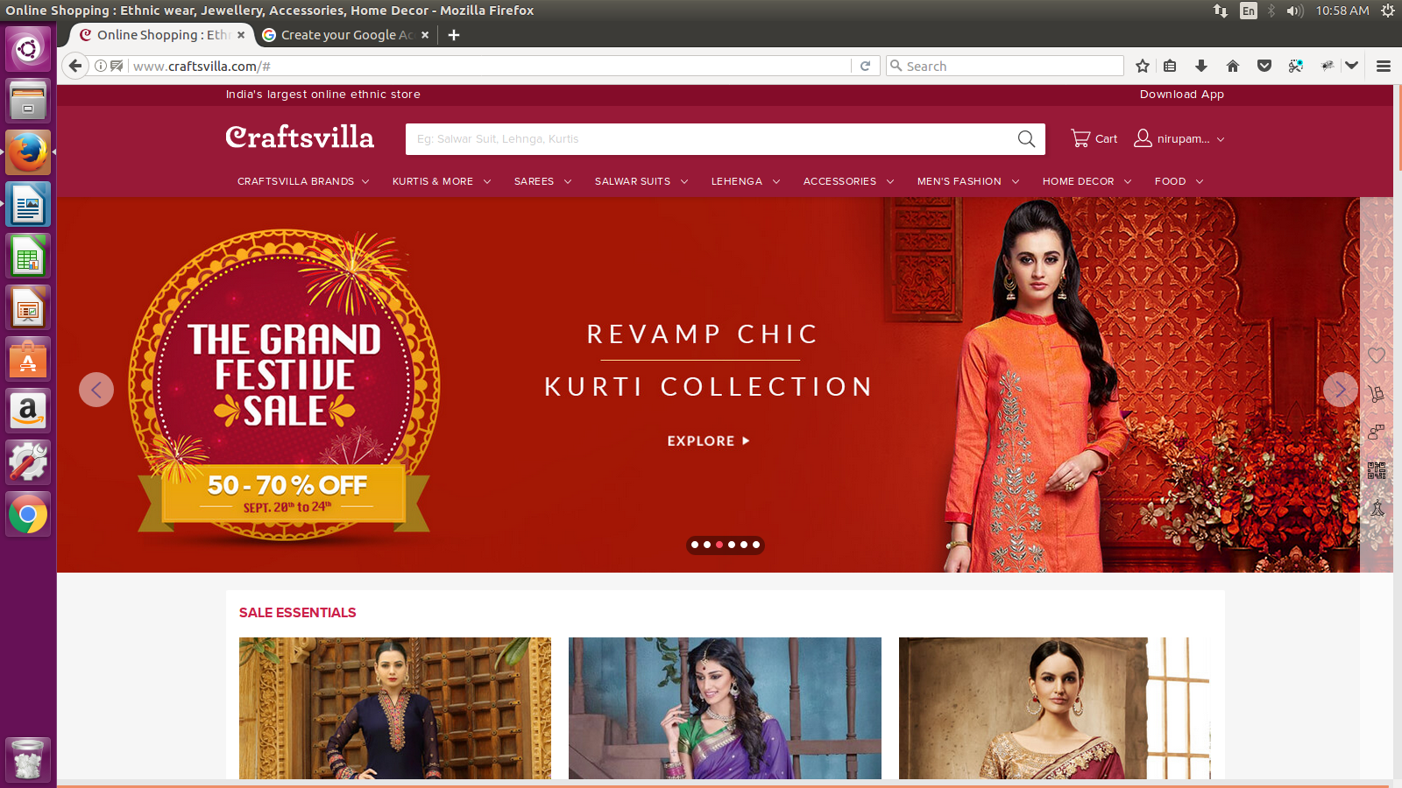

2.2 when mouse hovered on it, should display the options

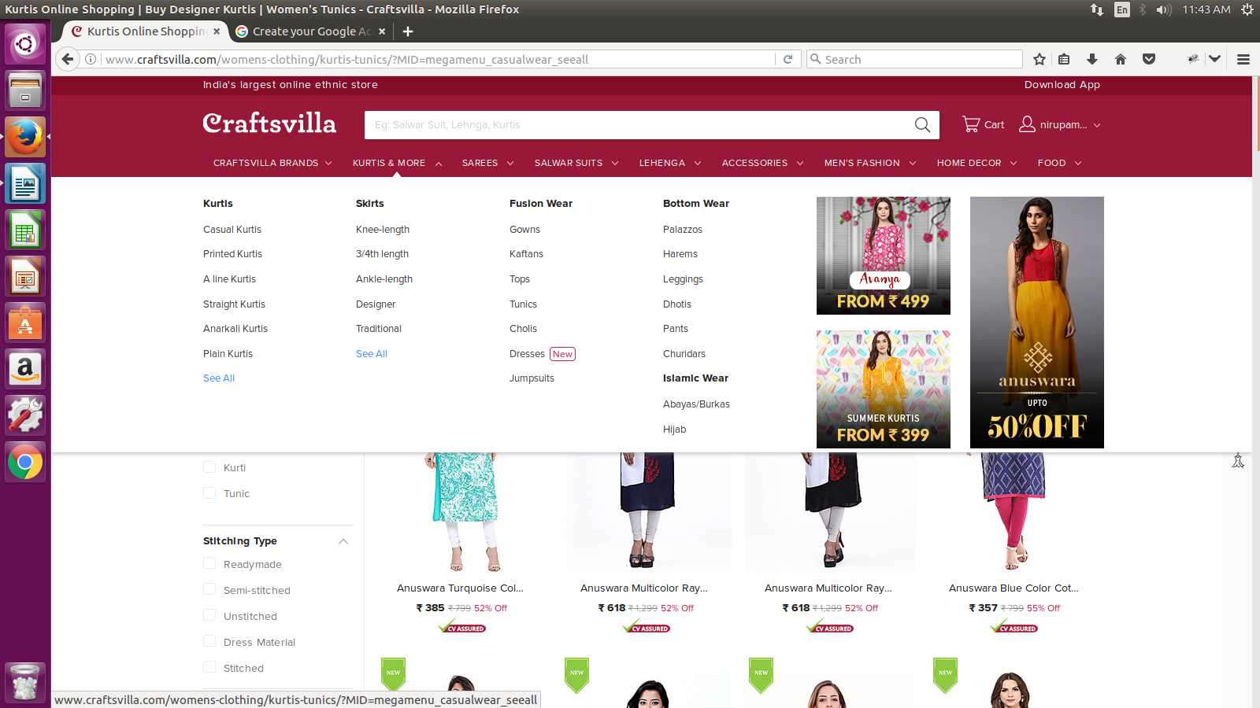

2.3 when clicked on kurthis and more link, kurthis and more page is displayed



