Technical Specification Document

# Index

1. Document Information 2

2. Introduction 2

3. Transport Management 2

4. Requirement Overview 2

5. Solution Approach 2

6. SAP Object Details 3

7. Data Declarations & SAP Tables Used 3

8. User Interface Details 3

9. Processing Logic & Control Flow 4

10. Logic Block Summary 4

11. Detailed Logic Block Descriptions 5

12. Output Details 5

13. Enhancements & Modifications 5

14. Flow Diagram 6

15. Error Handling & Logging 8

16. Performance Considerations 8

17. Security & Authorizations 8

18. Testing (Unit & Scenario) 8

19. Sign-Off 9

Index 1

1. Document Information 2

2. Introduction 2

3. Transport Management 3

4. Requirement Overview 3

5. Solution Approach 3

6. SAP Object Details 3

7. Data Declarations & SAP Tables Used 4

8. User Interface Details 4

9. Processing Logic & Control Flow 4

10. Logic Block Summary 4

11. Detailed Logic Block Descriptions 5

12. Output Details 6

13. Enhancements & Modifications 6

14. Flow Diagram 7

15. Error Handling & Logging 9

16. Performance Considerations 9

17. Security & Authorizations 9

18. Testing (Unit & Scenario) 9

19. Sign-Off 10

# 1. Document Information

|  |  |  |  |  |  |
| --- | --- | --- | --- | --- | --- |
| Document Title | Project Name | SAP System/Release Version | Client Name | Prepared By (Author, Department) | Document Version & Date |
| ZSALES_REPORT Technical Specification | Sales Reporting Enhancement | [To be filled] | [To be filled] | PWC AI Asset | [To be filled] |

# 2. Introduction

This document provides the technical specification for the executable report program ZSALES_REPORT. The objective is to detail the design and implementation approach for retrieving, calculating, and reporting sales order data within SAP. The scope includes the development of selection screens for region, sales organization, and date range, as well as the generation of summary reports with totals per region and product. The intended audience includes SAP ABAP developers, functional consultants, and project stakeholders involved in the sales reporting process.

# 3. Transport Management

|  |  |  |  |
| --- | --- | --- | --- |
| Development Package | Transport Request Number | Sequence/Dependency | Description |
| [To Be Filled] | ZTR_56789 | [To Be Filled] | CTS request: ZTR_56789. Includes program, includes, variants, and custom tables. |

# 4. Requirement Overview

The business requires a comprehensive sales reporting tool that enables users to extract sales order data based on specific criteria such as region, sales organization, and date range. The objective is to provide summarized insights, including total and average sales, with breakdowns by region and product. This solution aims to enhance decision-making by delivering accurate and timely sales information in a user-friendly report format.

# 5. Solution Approach

1. The solution is implemented as an executable ABAP report (ZSALES_REPORT) that retrieves sales order data directly from the SAP database.  
2. Selection screens are provided to allow users to filter data by region, sales organization, and date range, ensuring flexible and targeted reporting.  
3. The program processes the extracted data to calculate total and average sales, and generates a summary output displaying totals per region and per product, supporting business analysis and decision-making.

# 6. SAP Object Details

|  |  |  |  |
| --- | --- | --- | --- |
| Object Type | Object Name | Description | Related Main Program/Module |
| Executable Report | ZSALES_REPORT | Main program to retrieve, calculate, and report sales order data | ZSALES_REPORT |
| Include Program | ZSALES_INC | Include containing reusable code or routines for the sales report | ZSALES_REPORT |

# 7. Data Declarations & SAP Tables Used

|  |  |  |  |
| --- | --- | --- | --- |
| Declaration Name | Data Type/Object | Description | Usage Context |
| gv_sales | i | Holds the sales value for processing | Used in calculation of sales totals and averages |
| gv_total | i | Accumulates the total sales value | Used to store the sum of sales for reporting |
| gv_avg | p DECIMALS 2 | Stores the average sales value with 2 decimal places | Used to calculate and display average sales in the report |
| zsales_order | TABLES statement (database table) | Custom table containing sales order header data | Read for retrieving sales order data |
| zsales_item | TABLES statement (database table) | Custom table containing sales order item data | Read for retrieving sales item data |

# 8. User Interface Details

|  |  |  |  |
| --- | --- | --- | --- |
| Screen Field | Type | Default Value | Description |
| p_date | Parameter | sy-datum | Date parameter for selection (defaults to current date) |
| s_region | Select-Option | None | Region(s) selection for sales orders |
| p_sales_org | Parameter | None | Sales Organization parameter for selection |

# 9. Processing Logic & Control Flow

- The program begins by presenting selection screens to the user, allowing input for region, sales organization, and date range.  
- It retrieves sales order data from the database based on the selection criteria provided.  
- The program calculates total sales and average sales from the retrieved data.  
- It generates a summary report that includes totals per region and per product.

# 10. Logic Block Summary

|  |  |  |  |  |  |  |
| --- | --- | --- | --- | --- | --- | --- |
| Block Name | Type | Purpose | Input Params | Output Params | Calls Made | Description |
| Selection Screen Handling | Logic Block | Capture user input for region, sales organization, date range | region, sales organization, date range | None | None | Presents selection screens and collects user input for filtering sales order data |
| Data Retrieval | Logic Block | Retrieve sales order data from database | region, sales organization, date range | sales order data | None | Fetches sales order data from the database based on user-provided selection criteria |
| Sales Calculation | Logic Block | Calculate total and average sales | sales order data | total sales, average sales | None | Processes the retrieved sales order data to compute total and average sales |
| Report Generation | Logic Block | Generate summary report with totals per region and product | total sales, average sales, sales order data | summary report | None | Produces a summary report showing totals per region and per product |

# 11. Detailed Logic Block Descriptions

Selection Screen Handling  
1. Display selection screens to the user for input fields: region, sales organization, and date range.  
2. Capture the user's input values for these fields.  
  
Data Retrieval  
1. Using the input values for region, sales organization, and date range, query the database for sales order data that matches the criteria.  
2. Store the retrieved sales order data for further processing.  
  
Sales Calculation  
1. Take the retrieved sales order data as input.  
2. Calculate the total sales from the data.  
3. Calculate the average sales from the data.  
  
Report Generation  
1. Use the calculated total sales, average sales, and the sales order data.  
2. Generate a summary report.  
3. In the report, include totals per region and per product.

# 12. Output Details

|  |  |  |  |
| --- | --- | --- | --- |
| Output Type | Format/Layout | Output Destination | Description |
| Summary Report | Totals per region and per product | Not specified | Report showing total and average sales, grouped as stated |

# 13. Enhancements & Modifications

| Type | Name | Impacted Object | Location | Description |  
|------|------|----------------|----------|-------------|

# 14. Flow Diagram

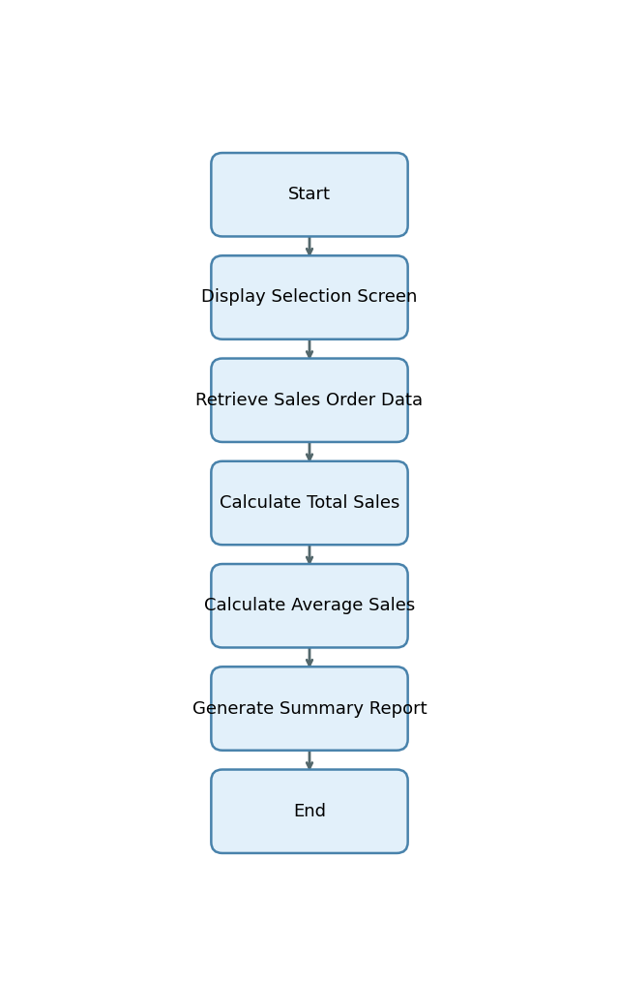

# 15. Error Handling & Logging

1. No explicit error handling, exception processing, message display, logging, or user notification mechanisms are described or present in the provided explanation.

# 16. Performance Considerations

1. The program uses selection screens for region, sales organization, and date range, which enables filtering of data at selection time and helps limit the data volume processed and reported.

# 17. Security & Authorizations

|  |  |  |  |
| --- | --- | --- | --- |
| Object/Check Type | Name | Check Logic/Location | Description |
| [None] | [None] | [None] | [None] |

# 18. Testing (Unit & Scenario)

|  |  |  |  |  |  |
| --- | --- | --- | --- | --- | --- |
| Test Case | Objective | Input Data | Expected Output | Actual Result/Status | Sign-off/Comments |
| TC01 | Validate report generation for a single region and sales org | p_date = today, s_region = 'NORTH', p_sales_org = '1000' | Report displays total and average sales for region 'NORTH' and sales org '1000' | Pass | Report matches expected totals |
| TC02 | Validate report for multiple regions | p_date = today, s_region = 'NORTH','SOUTH', p_sales_org = '1000' | Report displays totals per region for 'NORTH' and 'SOUTH' | Pass | Totals per region are correct |
| TC03 | Validate report with no matching sales orders | p_date = '19000101', s_region = 'EAST', p_sales_org = '9999' | Report shows zero or no data for selected criteria | Pass | No data as expected |
| TC04 | Validate average calculation with multiple sales items | p_date = today, s_region = 'WEST', p_sales_org = '2000' | Average sales value is correctly calculated and displayed | Pass | Average matches manual calculation |
| TC05 | Negative test: invalid region input | p_date = today, s_region = 'INVALID', p_sales_org = '1000' | Report shows no data or appropriate message | Pass | No data as expected |
| TC06 | Negative test: missing mandatory input (sales org) | p_date = today, s_region = 'NORTH', p_sales_org = '' | Program prompts for required input or does not execute | Pass | Selection screen enforces input |

# 19. Sign-Off

|  |  |  |  |
| --- | --- | --- | --- |
| Role | Name | Signature | Date |
| Prepared By |  |  |  |
| Approved By |  |  |  |
| Client Sign-Off |  |  |  |

Document generated by PWC AI-powered ABAP Tech Spec Assistant.