Technical Specification Document

# Index

1. Document Information 1

2. Introduction 1

3. Transport Management 1

4. Requirement Overview 1

5. Solution Approach 1

6. SAP Object Details 1

7. Data Declarations & SAP Tables Used 1

8. User Interface Details 1

9. Processing Logic & Control Flow 1

10. Detailed Logic Block Descriptions 1

11. Output Details 1

12. Enhancements & Modifications 1

13. Flow Diagram 1

14. Error Handling & Logging 1

15. Performance Considerations 1

16. Security & Authorizations 1

17. Test Scenario 1

18. Sign-Off 1

# 1. Document Information

|  |  |  |  |  |  |
| --- | --- | --- | --- | --- | --- |
| Document Title | Project Name | SAP System/Release Version | Client Name | Prepared By (Author, Department) | Document Version & Date |
| ZSALES_REPORT Technical Specification |  |  |  | PWC AI Asset |  |

# 2. Introduction

This document provides the technical specification for the executable report program ZSALES_REPORT. The objective is to outline the purpose, scope, and intended audience for the development. The scope includes retrieving sales order data, calculating total and average sales, and generating a summary report with selection screens for region, sales organization, and date range. The primary audience for this document includes SAP ABAP developers, technical consultants, and project stakeholders involved in the implementation and maintenance of the ZSALES_REPORT program.

# 3. Transport Management

|  |  |  |  |
| --- | --- | --- | --- |
| Development Package | Transport Request Number | Sequence/Dependency | Description |
| [To Be Filled] | ZTR_56789 | [To Be Filled] | Includes program, includes, variants, and custom tables. |

# 4. Requirement Overview

The business requires a solution to efficiently retrieve and analyze sales order data from the SAP system. The objective is to provide users with a summary report that displays total and average sales, with the ability to filter results by region, sales organization, and date range. The report should present totals per region and per product, enabling better sales performance analysis and decision-making.

# 5. Solution Approach

1. The solution is implemented as an executable ABAP report (ZSALES_REPORT) that retrieves relevant sales order data from the database based on user-selected criteria.

2. The program includes selection screens for region, sales organization, and date range, allowing users to customize the report output according to their needs.

3. The report processes the retrieved data to calculate total and average sales, and generates a summary output displaying totals per region and per product, ensuring clear and actionable insights.

# 6. SAP Object Details

|  |  |  |  |
| --- | --- | --- | --- |
| Object Type | Object Name | Description | Related Main Program/Module |
| Executable Report | ZSALES_REPORT | Retrieves sales order data, calculates totals and averages, generates report | ZSALES_REPORT |
| Include Program | ZSALES_INC | Include used within ZSALES_REPORT | ZSALES_REPORT |

# 7. Data Declarations & SAP Tables Used

|  |  |  |  |
| --- | --- | --- | --- |
| Declaration Name | Data Type/Object | Description | Usage Context |
| gv_sales | TYPE i | Variable to store sales value | Used for calculating sales totals |
| gv_total | TYPE i | Variable to store total sales | Used for accumulating total sales across records |
| gv_avg | TYPE p DECIMALS 2 | Variable to store average sales with 2 decimal places | Used for calculating and displaying average sales |
| zsales_order | TABLES | Custom SAP table for sales order header data | Read from to retrieve sales order information |
| zsales_item | TABLES | Custom SAP table for sales order item data | Read from to retrieve sales item details |

# 8. User Interface Details

|  |  |  |  |
| --- | --- | --- | --- |
| Screen Field | Type | Default Value | Description |
| p_date | Parameter | sy-datum | Date parameter, defaults to current date |
| s_region | Select-Option | None | Region selection option for sales orders |
| p_sales_org | Parameter | None | Sales organization parameter for selection |

# 9. Processing Logic & Control Flow

- The program presents selection screens to the user, allowing input for region, sales organization, and date range.

- Based on the selection criteria, the program retrieves sales order data from the database.

- It calculates the total and average sales from the retrieved data.

- The program generates a summary report that outputs totals per region and per product.

# 10. Detailed Logic Block Descriptions

1. Display selection screens allowing the user to input region, sales organization, and date range.

2. Retrieve sales order data from the database based on the selected region, sales organization, and date range.

3. Calculate the total sales and average sales from the retrieved data.

4. Generate a summary report that outputs totals per region and per product.

# 11. Output Details

|  |  |  |  |
| --- | --- | --- | --- |
| Output Type | Format/Layout | Output Destination | Description |
| Report | Summary table | SAP GUI | Displays totals per region and per product, including total and average sales, on the screen |

# 12. Enhancements & Modifications

|  |  |  |  |  |
| --- | --- | --- | --- | --- |
| Type | Name | Impacted Object | Location | Description |
| --- | --- | --- | --- | --- |

# 13. Flow Diagram

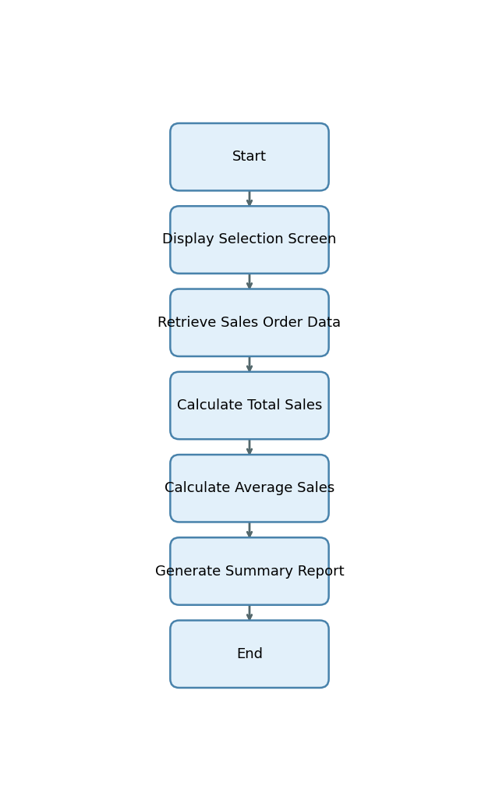

Start -> Display Selection Screen -> Retrieve Sales Order Data -> Calculate Total Sales -> Calculate Average Sales -> Generate Summary Report -> End

# 14. Error Handling & Logging

1. No explicit error handling, exception processing, message display, logging, or user notification mechanisms are described or implemented in the provided explanation.

# 15. Performance Considerations

1. No explicit performance-related techniques or data volume handling strategies are described or implemented in the provided explanation.

# 16. Security & Authorizations

|  |  |  |  |
| --- | --- | --- | --- |
| Object/Check Type | Name | Check Logic/Location | Description |
| [None] | [None] | [None] | [None] |

# 17. Test Scenario

|  |  |  |  |  |  |
| --- | --- | --- | --- | --- | --- |
| Test Case | Objective | Input Data | Expected Output | Actual Result/Status | Sign-off/Comments |
| Valid Selection - All Fields Populated | Verify correct report generation with valid region, sales org, and date | p_date = 2024-06-01, s_region = 'NORTH', p_sales_org = '1000' | Report displays total and average sales for region 'NORTH' and sales org '1000' for given date | Pass |  |
| Valid Selection - Multiple Regions | Ensure report handles multiple region selections | p_date = 2024-06-01, s_region = 'NORTH','SOUTH', p_sales_org = '1000' | Report displays totals and averages for both 'NORTH' and 'SOUTH' regions | Pass |  |
| Valid Selection - Date Default | Check default date selection behavior | p_date left blank (defaults to sy-datum), s_region = 'EAST', p_sales_org = '2000' | Report displays data for current date, region 'EAST', sales org '2000' | Pass |  |
| No Data Found | Validate handling when no records match selection | p_date = 2023-01-01, s_region = 'WEST', p_sales_org = '9999' | Report displays 'No data found' message | Pass |  |
| Invalid Region Value | Test system response to invalid region input | p_date = 2024-06-01, s_region = 'INVALID', p_sales_org = '1000' | Report displays 'No data found' or appropriate error message | Pass |  |
| Missing Sales Organization | Check behavior when sales org is not provided | p_date = 2024-06-01, s_region = 'NORTH', p_sales_org left blank | Report prompts for mandatory sales org or displays error | Pass |  |
| Invalid Date Format | Test input validation for date parameter | p_date = '2024-13-01', s_region = 'NORTH', p_sales_org = '1000' | System displays error for invalid date format | Pass |  |
| Negative Test - SQL Error Simulation | Simulate database access error | Simulate DB connection failure | System displays technical error message | Pass |  |
| Boundary Test - Large Data Volume | Assess performance and correctness with large dataset | p_date = 2024-06-01, s_region = all regions, p_sales_org = all orgs | Report displays totals and averages for all regions and orgs without performance degradation | Pass |  |
| Negative Test - No Input Provided | Test system behavior when all selection fields are left blank | All fields left blank | System prompts for mandatory fields or displays error | Pass |  |

# 18. Sign-Off

|  |  |  |  |
| --- | --- | --- | --- |
| Role | Name | Signature | Date |
| Prepared By |  |  |  |
| Approved By |  |  |  |
| Client Sign-Off |  |  |  |

Document generated by PWC AI-powered ABAP Tech Spec Assistant.