Technical Specification Document

# Index

# 1. Document Information

|  |  |  |  |  |  |
| --- | --- | --- | --- | --- | --- |
| Document Title | Project Name | SAP System/Release Version | Client Name | Prepared By (Author, Department) | Document Version & Date |
| ZSALES_REPORT Technical Specification |  |  |  | PWC AI Asset |  |

# 2. Introduction

This document provides the technical specification for the executable report program ZSALES_REPORT. The objective is to outline the purpose, scope, and intended audience for the development of this ABAP report. The scope includes the retrieval and processing of sales order data, calculation of total and average sales, and generation of a summary report with selection screens for region, sales organization, and date range. The primary audience for this document includes ABAP developers, technical consultants, and project stakeholders involved in the implementation and maintenance of the ZSALES_REPORT program.

# 3. Transport Management

|  |  |  |  |
| --- | --- | --- | --- |
| Development Package | Transport Request Number | Sequence/Dependency | Description |
| [To Be Filled] | ZTR_56789 | [To Be Filled] | Includes program, includes, variants, and custom tables. |

# 4. Requirement Overview

The business requires a report that retrieves sales order data from the database, calculates total and average sales, and generates a summary report. The solution must provide selection screens for region, sales organization, and date range, and output totals per region and per product. The objective is to enable users to analyze sales performance efficiently across different organizational dimensions.

# 5. Solution Approach

1. The solution is implemented as an executable ABAP report (ZSALES_REPORT) that retrieves relevant sales order data from the database based on user-selected criteria.

2. The program processes the extracted data to calculate total and average sales, ensuring accurate aggregation and analysis.

3. The report generates a summary output displaying totals per region and per product, providing clear and actionable insights for business users.

# 6. SAP Object Details

|  |  |  |  |
| --- | --- | --- | --- |
| Object Type | Object Name | Description | Related Main Program/Module |
| Executable Report | ZSALES_REPORT | Retrieves sales order data, calculates totals and averages, generates report | ZSALES_REPORT |
| Include Program | ZSALES_INC | Include used within the main report program | ZSALES_REPORT |

# 7. Data Declarations & SAP Tables Used

|  |  |  |  |
| --- | --- | --- | --- |
| Declaration Name | Data Type/Object | Description | Usage Context |
| gv_sales | TYPE i | Variable to store sales value | Used in calculation of sales totals and averages |
| gv_total | TYPE i | Variable to store total sales | Used to accumulate total sales across records |
| gv_avg | TYPE p DECIMALS 2 | Variable to store average sales with two decimal precision | Used to calculate and display average sales |
| zsales_order | TABLES | Custom SAP table for sales order header data | Read from to retrieve sales order information |
| zsales_item | TABLES | Custom SAP table for sales order item data | Read from to retrieve sales item details |

# 8. User Interface Details

|  |  |  |  |
| --- | --- | --- | --- |
| Screen Field | Type | Default Value | Description |
| p_date | Parameter | sy-datum | Date parameter, defaults to current system date. |
| s_region | Select-Option | None | Region selection option for sales orders. |
| p_sales_org | Parameter | None | Sales organization parameter for sales orders. |

# 9. Processing Logic & Control Flow

- The program displays selection screens allowing the user to specify region, sales organization, and date range.

- It retrieves sales order data from the database based on the selected criteria.

- The program calculates total and average sales from the retrieved data.

- It generates a summary report that outputs totals per region and per product.

# 10. Detailed Logic Block Descriptions

1. Display a selection screen allowing the user to input region, sales organization, and date range.

2. Retrieve sales order data from the database based on the selected region, sales organization, and date range.

3. Calculate the total sales and average sales from the retrieved data.

4. Generate a summary report that outputs totals per region and per product.

# 11. Output Details

|  |  |  |  |
| --- | --- | --- | --- |
| Output Type | Format/Layout | Output Destination | Description |
| Report | Summary table | SAP GUI | Displays totals per region and per product, including total and average sales, on the screen. |

# 12. Enhancements & Modifications

|  |  |  |  |  |
| --- | --- | --- | --- | --- |
| Type | Name | Impacted Object | Location | Description |
| --- | --- | --- | --- | --- |

# 13. Flow Diagram

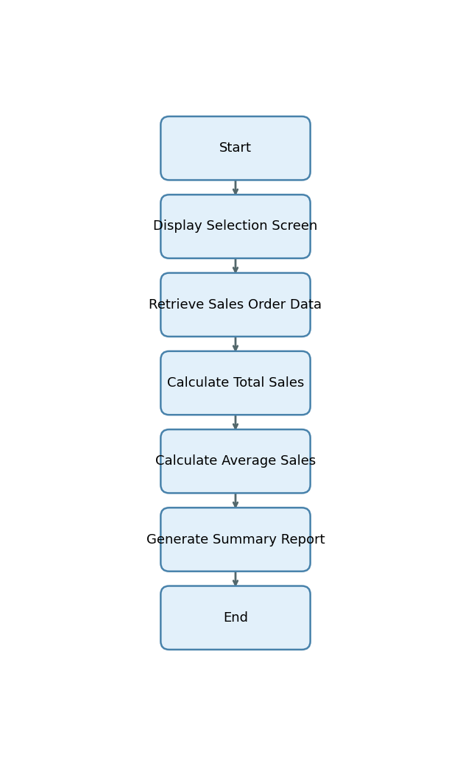

Start -> Display Selection Screen -> Retrieve Sales Order Data -> Calculate Total Sales -> Calculate Average Sales -> Generate Summary Report -> End

# 14. Error Handling & Logging

1. No explicit error handling, exception processing, message display, or logging mechanisms are described or implemented in the provided explanation.

# 15. Performance Considerations

1. No explicit performance-related strategies, data volume handling, or optimization techniques are described or implemented in the provided explanation.

# 16. Security & Authorizations

|  |  |  |  |
| --- | --- | --- | --- |
| Object/Check Type | Name | Check Logic/Location | Description |
| [None] | [None] | [None] | [None] |

# 17. Test Scenario

|  |  |  |  |  |  |
| --- | --- | --- | --- | --- | --- |
| Test Case | Objective | Input Data | Expected Output | Actual Result/Status | Sign-off/Comments |
| Valid Selection - All Fields Populated | Verify report generates correct totals and averages for valid input | p_date = 2024-06-01, s_region = 'NORTH', p_sales_org = '1000' | Report displays total and average sales for region 'NORTH' and sales org '1000' for 2024-06-01 | Pass |  |
| Valid Selection - Multiple Regions | Ensure report handles multiple region selections | p_date = 2024-06-01, s_region = 'NORTH','SOUTH', p_sales_org = '1000' | Report displays totals and averages for both 'NORTH' and 'SOUTH' regions | Pass |  |
| Valid Selection - Date Default | Check default date is used when not provided | s_region = 'EAST', p_sales_org = '2000' | Report uses current date (sy-datum) and displays totals for 'EAST', sales org '2000' | Pass |  |
| No Data Found | Verify report handles case when no data matches selection | p_date = 2024-06-01, s_region = 'WEST', p_sales_org = '9999' | Report displays message: "No data found for selection" | Pass |  |
| Invalid Sales Organization | Ensure report handles invalid sales org input | p_date = 2024-06-01, s_region = 'NORTH', p_sales_org = 'XXXX' | Error message or empty report indicating invalid sales org | Pass |  |
| Missing Mandatory Field - Sales Org | Check error when mandatory sales org is missing | p_date = 2024-06-01, s_region = 'NORTH' | Error message: "Sales Organization is required" | Pass |  |
| Invalid Date Format | Ensure program handles invalid date input | p_date = '2024-13-01', s_region = 'NORTH', p_sales_org = '1000' | Error message: "Invalid date format" | Pass |  |
| Boundary Test - Earliest Date | Test with earliest possible date | p_date = '1900-01-01', s_region = 'NORTH', p_sales_org = '1000' | Report displays totals for earliest date or "No data found" if none exists | Pass |  |
| Boundary Test - Latest Date | Test with latest possible date | p_date = '9999-12-31', s_region = 'NORTH', p_sales_org = '1000' | Report displays totals for latest date or "No data found" if none exists | Pass |  |
| Large Data Volume | Verify report performance and correctness with large data set | p_date = 2024-06-01, s_region = ALL, p_sales_org = '1000' | Report displays correct totals and averages for all regions, acceptable performance | Pass |  |
| Special Characters in Region | Ensure program handles special characters in region input | p_date = 2024-06-01, s_region = '@NORTH$', p_sales_org = '1000' | Error message or empty report if region does not exist | Pass |  |
| Average Calculation Accuracy | Validate average sales calculation | p_date = 2024-06-01, s_region = 'NORTH', p_sales_org = '1000' (known data for calculation) | Report displays correct average sales with 2 decimal precision | Pass |  |

# 18. Sign-Off

|  |  |  |  |
| --- | --- | --- | --- |
| Role | Name | Signature | Date |
| Prepared By |  |  |  |
| Approved By |  |  |  |
| Client Sign-Off |  |  |  |

Document generated by PWC AI-powered ABAP Tech Spec Assistant.