Technical Specification Document

# Index

1. Document Information ..... 1

2. Introduction ..... 1

3. Transport Management ..... 1

4. Requirement Overview ..... 1

5. Solution Approach ..... 1

6. SAP Object Details ..... 1

7. Data Declarations & SAP Tables Used ..... 1

8. User Interface Details ..... 1

9. Processing Logic & Control Flow ..... 1

10. Detailed Logic Block Descriptions ..... 1

11. Output Details ..... 1

12. Enhancements & Modifications ..... 1

13. Flow Diagram ..... 1

14. Error Handling & Logging ..... 1

15. Performance Considerations ..... 1

16. Security & Authorizations ..... 1

17. Test Scenario ..... 1

18. Sign-Off ..... 1

# 1. Document Information

|  |  |  |  |  |  |
| --- | --- | --- | --- | --- | --- |
| Document Title | Project Name | SAP System/Release Version | Client Name | Prepared By (Author, Department) | Document Version & Date |
| ZSALES_REPORT Technical Specification |  |  |  | PWC AI Asset |  |

# 2. Introduction

This document provides the technical specification for the executable report program ZSALES_REPORT. The objective is to outline the purpose, scope, and intended audience for the development. The scope includes the retrieval and processing of sales order data, calculation of total and average sales, and generation of a summary report with selection screens for region, sales organization, and date range. The primary audience for this document includes SAP ABAP developers, technical consultants, and project stakeholders involved in the implementation and maintenance of the ZSALES_REPORT program.

# 3. Transport Management

|  |  |  |  |
| --- | --- | --- | --- |
| Development Package | Transport Request Number | Sequence/Dependency | Description |
| [To Be Filled] | ZTR_56789 | [To Be Filled] | Includes program, includes, variants, and custom tables. |

# 4. Requirement Overview

The business requires a report that retrieves sales order data from the SAP database, calculates total and average sales, and presents a summary report. The solution must allow users to filter data by region, sales organization, and date range, and display totals per region and per product. The objective is to provide actionable sales insights to business users through a user-friendly and efficient reporting tool.

# 5. Solution Approach

1. The solution is implemented as an executable ABAP report (ZSALES_REPORT) that retrieves relevant sales order data from the database based on user-selected criteria.

2. The program includes selection screens for region, sales organization, and date range, enabling flexible and targeted data extraction.

3. The report processes the extracted data to calculate total and average sales, and generates a summary output displaying totals per region and per product, ensuring clear and actionable insights for end users.

# 6. SAP Object Details

|  |  |  |  |
| --- | --- | --- | --- |
| Object Type | Object Name | Description | Related Main Program/Module |
| Executable Report | ZSALES_REPORT | Retrieves sales order data, calculates totals/averages, and outputs summary | ZSALES_REPORT |
| Include Program | ZSALES_INC | Include program used within ZSALES_REPORT | ZSALES_REPORT |

# 7. Data Declarations & SAP Tables Used

|  |  |  |  |
| --- | --- | --- | --- |
| Declaration Name | Data Type/Object | Description | Usage Context |
| gv_sales | TYPE i | Variable to store sales value | Used for calculating sales totals |
| gv_total | TYPE i | Variable to store total sales | Used for accumulating total sales across records |
| gv_avg | TYPE p DECIMALS 2 | Variable to store average sales value | Used for calculating average sales |
| zsales_order | TABLES | Custom SAP database table for sales orders | Read from to retrieve sales order data |
| zsales_item | TABLES | Custom SAP database table for sales order items | Read from to retrieve sales item data |

# 8. User Interface Details

|  |  |  |  |
| --- | --- | --- | --- |
| Screen Field | Type | Default Value | Description |
| p_date | Parameter | sy-datum | Date parameter for selection, defaults to current date |
| s_region | Select-Option | None | Region selection option for filtering sales orders by region |
| p_sales_org | Parameter | None | Sales organization parameter for specifying the sales organization |

# 9. Processing Logic & Control Flow

- The program presents selection screens allowing the user to specify region, sales organization, and date range.

- Based on the selected criteria, the program retrieves sales order data from the database.

- It calculates the total and average sales from the retrieved data.

- The program generates a summary report that outputs totals per region and per product.

# 10. Detailed Logic Block Descriptions

1. Display a selection screen allowing the user to input region, sales organization, and date range.

2. Retrieve sales order data from the database based on the selected region, sales organization, and date range.

3. Calculate the total sales and average sales from the retrieved data.

4. Generate a summary report that outputs totals per region and per product.

# 11. Output Details

|  |  |  |  |
| --- | --- | --- | --- |
| Output Type | Format/Layout | Output Destination | Description |
| Report | Summary table | SAP GUI | Displays totals per region and per product, including total and average sales, as a summary report. |

# 12. Enhancements & Modifications

|  |  |  |  |  |
| --- | --- | --- | --- | --- |
| Type | Name | Impacted Object | Location | Description |
| --- | --- | --- | --- | --- |

# 13. Flow Diagram

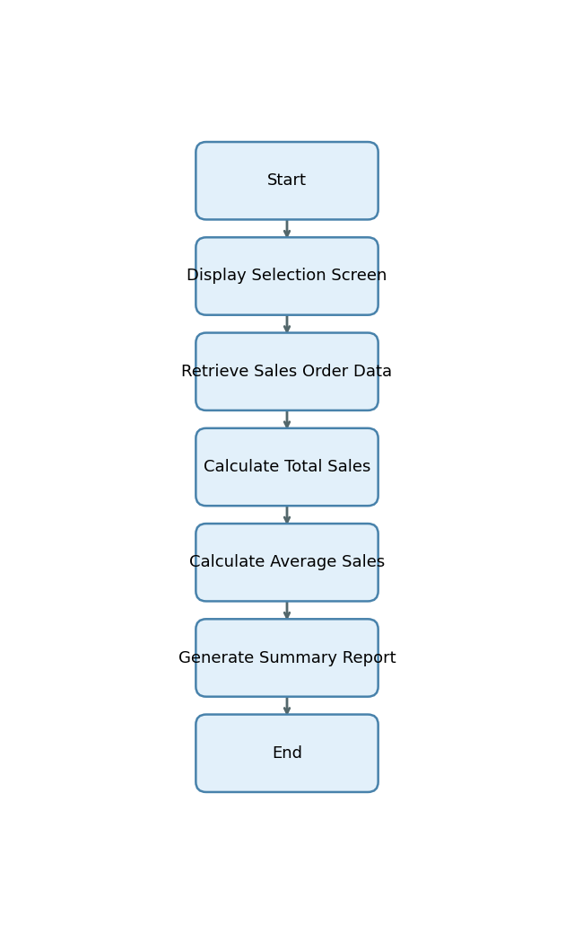

Start -> Display Selection Screen -> Retrieve Sales Order Data -> Calculate Total Sales -> Calculate Average Sales -> Generate Summary Report -> End

# 14. Error Handling & Logging

1. No explicit error handling, exception processing, message display, or logging mechanisms are described or implemented in the provided explanation.

# 15. Performance Considerations

1. The program includes selection screens for region, sales organization, and date range, which allow filtering of data at selection time, potentially reducing the data volume processed and improving performance.

# 16. Security & Authorizations

|  |  |  |  |
| --- | --- | --- | --- |
| Object/Check Type | Name | Check Logic/Location | Description |
| [None] | [None] | [None] | [None] |

# 17. Test Scenario

|  |  |  |  |  |  |
| --- | --- | --- | --- | --- | --- |
| Test Case | Objective | Input Data | Expected Output | Actual Result/Status | Sign-off/Comments |
| Valid Selection - All Fields | Verify report generation with valid region, sales org, and date | p_date = 2024-06-01, s_region = 'NORTH', p_sales_org = '1000' | Report displays total and average sales for region 'NORTH' and sales org '1000' on 2024-06-01 | Pass |  |
| Valid Selection - Multiple Regions | Verify report with multiple regions selected | p_date = 2024-06-01, s_region = 'NORTH','SOUTH', p_sales_org = '1000' | Report displays totals per region for 'NORTH' and 'SOUTH' | Pass |  |
| Valid Selection - Date Range | Verify report with different date input | p_date = 2024-05-01, s_region = 'EAST', p_sales_org = '2000' | Report displays totals for 'EAST' region and sales org '2000' on 2024-05-01 | Pass |  |
| No Data Found | Verify behavior when no sales orders match selection | p_date = 2023-01-01, s_region = 'WEST', p_sales_org = '9999' | Report displays 'No data found' message | Pass |  |
| Invalid Region | Verify handling of invalid region input | p_date = 2024-06-01, s_region = 'INVALID', p_sales_org = '1000' | Report displays 'No data found' or error message | Pass |  |
| Invalid Sales Org | Verify handling of invalid sales organization input | p_date = 2024-06-01, s_region = 'NORTH', p_sales_org = 'XXXX' | Report displays 'No data found' or error message | Pass |  |
| Missing Mandatory Field - Region | Verify behavior when region is not provided | p_date = 2024-06-01, s_region = blank, p_sales_org = '1000' | Report displays error or prompts for region input | Pass |  |
| Missing Mandatory Field - Sales Org | Verify behavior when sales org is not provided | p_date = 2024-06-01, s_region = 'NORTH', p_sales_org = blank | Report displays error or prompts for sales org input | Pass |  |
| Default Date Usage | Verify default date is used when date not specified | p_date = blank, s_region = 'NORTH', p_sales_org = '1000' | Report uses current date (sy-datum) for selection | Pass |  |
| Large Data Volume | Verify report performance and correctness with large data volume | p_date = 2024-06-01, s_region = all, p_sales_org = all | Report displays totals and averages for all regions and sales orgs without performance issues | Pass |  |
| Calculation Accuracy | Verify correctness of total and average sales calculations | p_date = 2024-06-01, s_region = 'NORTH', p_sales_org = '1000' (known data set) | Report totals and averages match expected values based on known data | Pass |  |
| Special Characters in Input | Verify handling of special characters in region or sales org input | p_date = 2024-06-01, s_region = 'NORTH*', p_sales_org = '1000@' | Report displays error or ignores invalid characters | Pass |  |

# 18. Sign-Off

|  |  |  |  |
| --- | --- | --- | --- |
| Role | Name | Signature | Date |
| Prepared By |  |  |  |
| Approved By |  |  |  |
| Client Sign-Off |  |  |  |

Document generated by PWC AI-powered ABAP Tech Spec Assistant.