Technical Specification Document

# Index

1. Document Information 1

2. Introduction 1

3. Transport Management 1

4. Requirement Overview 1

5. Solution Approach 1

6. SAP Object Details 1

7. Data Declarations & SAP Tables Used 1

8. Smartform Layout 1

9. Smartform Details 1

10. User Interface Details 1

11. Processing Logic & Control Flow 1

12. Detailed Logic Block Descriptions 1

13. Output Details 1

14. Enhancements & Modifications 1

15. Flow Diagram 1

16. Error Handling & Logging 1

17. Performance Considerations 1

18. Security & Authorizations 1

19. Test Scenario 1

20. Sign-Off 1

# 1. Document Information

|  |  |  |  |  |  |
| --- | --- | --- | --- | --- | --- |
| Document Title | Project Name | SAP System/Release Version | Client Name | Prepared By (Author, Department) | Document Version & Date |
|  |  |  |  | PWC AI Asset |  |

# 2. Introduction

This document provides the technical specification for the SAP SmartForm 'ZIT_RGPNRGP_SF'. The objective is to outline the design, structure, and logic implemented within the SmartForm, which is used for processing and displaying gate pass information, including graphical elements, vendor and plant data, and material details. The scope covers the SmartForm's page and window hierarchy, ABAP code integration, and data mapping to SAP tables. The intended audience includes SAP ABAP developers, technical consultants, and project stakeholders involved in the development, maintenance, or review of this SmartForm solution.

# 3. Transport Management

|  |  |  |  |
| --- | --- | --- | --- |
| Development Package | Transport Request Number | Sequence/Dependency | Description |
| [To Be Filled] | [To Be Filled] | [To Be Filled] | [To Be Filled] |

# 4. Requirement Overview

The business requirement is to automate and standardize the generation of gate pass documents within SAP, ensuring accurate and consistent presentation of material, vendor, plant, and personnel data. The solution aims to provide a visually enhanced, data-driven SmartForm that supports both returnable and non-returnable gate pass processes, integrates with relevant SAP master data tables, and facilitates clear, branded output for operational and audit purposes.

# 5. Solution Approach

1. The SmartForm is structured with a clear page and window hierarchy, including specialized windows for graphics, main processing, vendor/plant data, and additional information, ensuring modular and maintainable design.

2. ABAP code is integrated within the SmartForm windows to perform data retrieval, formatting, and conditional logic, such as determining gate pass types, fetching master data from SAP tables (e.g., LFA1, T001P, T001W, ADRC, ZIT_RGPNRGP), and handling serial number formatting and calculations.

3. The solution employs conditional logic and data mapping to dynamically display relevant information based on transaction type and input data, while graphical windows enhance the form's branding and usability, supporting both business and technical requirements.

# 6. SAP Object Details

|  |  |  |  |
| --- | --- | --- | --- |
| Object Type | Object Name | Description | Related Main Program/Module |
| SmartForm | ZIT_RGPNRGP_SF | Main SmartForm for gate pass processing and output |  |
| Page | %PAGE1 | Primary page of the SmartForm | ZIT_RGPNRGP_SF |
| Window | %GRAPHIC1 | Graphical window for images/logos | %PAGE1 |
| Window | %WINDOW2 | Window for gate pass information and processing | %PAGE1 |
| Window | %NEWWINDOW3 | Window for personnel and location data display | %PAGE1 |
| Window | %WINDOW1 | Window for vendor and organizational data | %PAGE1 |
| Window | MAIN | Main processing window for material data | %PAGE1 |
| Table | ZIT_RGPNRGP | Custom table for gate pass records | %WINDOW2 |
| Table | T001P | SAP table for plant/personnel area data | %WINDOW2, %NEWWINDOW3, %WINDOW1 |
| Table | T001W | SAP table for plant data | %NEWWINDOW3, %WINDOW1 |
| Table | LFA1 | SAP table for vendor master data | %WINDOW1 |
| Table | ADRC | SAP table for address data | %NEWWINDOW3 |
| ABAP Routine | (Embedded code) | Data retrieval, formatting, and conditional logic within SmartForm windows | ZIT_RGPNRGP_SF |

# 7. Data Declarations & SAP Tables Used

Declaration Name | Data Type/Object | Description | Usage Context

# 8. Smartform Layout

[Error: Section Smartform Layout not found in LLM output.]

# 9. Smartform Details

[Error: Section Smartform Details not found in LLM output.]

# 10. User Interface Details

|  |  |  |  |
| --- | --- | --- | --- |
| Field Name | Source (Table/Structure) | Default Value | Description |
|  |  |  |  |

# 11. Processing Logic & Control Flow

- The SmartForm execution begins on %PAGE1, which contains several windows: %GRAPHIC1, %WINDOW2, %NEWWINDOW3, %WINDOW1, and MAIN.

- In the %GRAPHIC1 window, there is no ABAP code or data processing; this window is used solely for displaying static graphical content such as images or logos.

- The %WINDOW2 window processes gate pass information:

- It manipulates the serial number by removing leading zeros and uses this value to select records from the ZIT_RGPNRGP table into the IT_DISPLAY internal table.

- It contains conditional logic to determine the type of gate pass: if WA_DISPLAY_2-TRAN_TYPE equals 'RGP', the type is set to 'RETURNABLE GATE PASS'; if 'NRGP', it is set to 'NON RETURNABLE GATE PASS'.

- There is commented-out code for potentially retrieving department descriptions from T001P based on personnel numbers.

- The %NEWWINDOW3 window handles personnel and location data:

- It includes similar conditional logic as %WINDOW2 to set the gate pass type based on WA_DISPLAY_2-TRAN_TYPE.

- It retrieves the plant address number (ADRNR) from T001W using the plant code (WA_DISPLAY_3-WERKS), then fetches address details (NAME1, CITY1, STREET, SORT1, SORT2) from ADRC using the address number.

- Commented-out code indicates possible debugging and retrieval of department descriptions from T001P.

- The %WINDOW1 window displays vendor and organizational data:

- It retrieves the plant name from T001W using the plant code (WA_DISPLAY-WERKS).

- The vendor number (WA_DISPLAY-LIFNR) is zero-padded to a length of 10 before being used to fetch vendor address details (NAME1, NAME2, ORT01) from LFA1.

- It retrieves the department description from T001P using the personnel area (WA_DISPLAY-BTRTL).

- Debugging points are present as commented-out BREAK-POINT statements.

- The MAIN window is responsible for material data processing and calculations:

- It checks the result of previous operations using SY-SUBRC; if successful, it clears the work area wa_display_1 and reads entries from IT_DISPLAY into wa_display_1 based on the serial number (SL_NO).

- It increments a counter S for each successful read.

- It calculates the total amount (V_TOTAL) from WA_DISPLAY-AMOUNT and accumulates it into V_SUBTOTAL.

- Debugging statements are present but commented out.

- Throughout the form, conditional logic (IF/ELSEIF/ENDIF) is used to control the flow based on transaction types and operation results, and data retrieval is performed using SELECT statements from relevant tables.

# 12. Detailed Logic Block Descriptions

# 13. Output Details

|  |  |  |  |  |  |
| --- | --- | --- | --- | --- | --- |
|  | Output Type | Format/Layout | Output Destination | Description |  |
|  | ------------- | -------------- | -------------------- | ------------- |  |

# 14. Enhancements & Modifications

Type | Name | Impacted Object | Location | Description

# 15. Flow Diagram

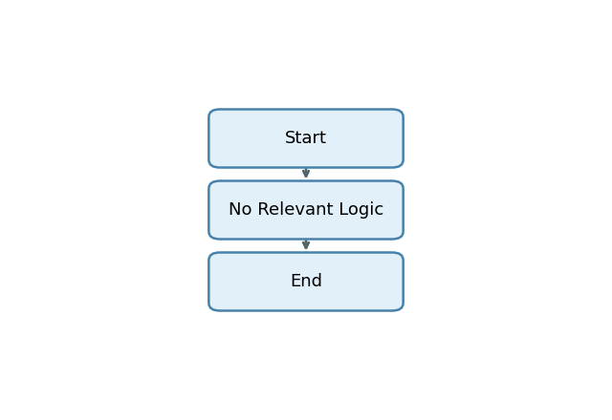

Start -> No Relevant Logic -> End

# 16. Error Handling & Logging

# 17. Performance Considerations

# 18. Security & Authorizations

Object/Check Type | Name | Check Logic/Location | Description

# 19. Test Scenario

[Error: Section Test Scenario not found in LLM output.]

# 20. Sign-Off

|  |  |  |  |
| --- | --- | --- | --- |
| Role | Name | Signature | Date |
| Prepared By |  |  |  |
| Approved By |  |  |  |
| Client Sign-Off |  |  |  |

Document generated by PWC AI-powered ABAP Tech Spec Assistant.