Technical Specification Document

# Index

1. Document Information 1

2. Introduction 1

3. Transport Management 1

4. Requirement Overview 1

5. Solution Approach 1

6. SAP Object Details 1

7. Data Declarations & SAP Tables Used 1

8. SmartForm Layout Details 1

9. Field Mapping Details 1

10. User Interface Details 1

11. Processing Logic & Control Flow 1

12. Detailed Logic Block Descriptions 1

13. Output Details 1

14. Enhancements & Modifications 1

15. Flow Diagram 1

16. Error Handling & Logging 1

17. Performance Considerations 1

18. Security & Authorizations 1

19. Test Scenario 1

20. Sign-Off 1

# 1. Document Information

|  |  |  |  |  |  |
| --- | --- | --- | --- | --- | --- |
| Document Title | Project Name | SAP System/Release Version | Client Name | Prepared By (Author, Department) | Document Version & Date |
|  |  |  |  | PWC AI Asset |  |

# 2. Introduction

This document provides the technical specification for the SAP SmartForm named Z_ORDER_TEST. It outlines the purpose, scope, and intended audience for the development and implementation of this SmartForm. The scope includes the design and structure of the SmartForm, focusing on its pages and windows. The intended audience for this document includes SAP ABAP developers, technical consultants, and project stakeholders involved in the development, review, or maintenance of the Z_ORDER_TEST SmartForm.

# 3. Transport Management

|  |  |  |  |
| --- | --- | --- | --- |
| Development Package | Transport Request Number | Sequence/Dependency | Description |
| [To Be Filled] | [To Be Filled] | [To Be Filled] | [To Be Filled] |

# 4. Requirement Overview

The business requirement is to design and implement a SmartForm in SAP, identified as Z_ORDER_TEST. The objective is to provide a structured and customizable output form that includes specific pages and windows, such as a main window and various display options, to support business processes that require formatted document generation.

# 5. Solution Approach

1. The solution utilizes the SAP SmartForm Z_ORDER_TEST, which is structured with a clear hierarchy including defined pages and a main window to organize the output layout.

2. The design incorporates elements such as captions for the main window, display options, and page identification to enhance readability and maintainability.

3. The SmartForm architecture allows for integration with ABAP logic and can be extended with conditions and additional elements as required for future business needs.

# 6. SAP Object Details

|  |  |  |  |
| --- | --- | --- | --- |
| Object Type | Object Name | Description | Related SmartForm/Page/Window |
| SmartForm | Z_ORDER_TEST | Main SmartForm for document output | Z_ORDER_TEST |
| Page | %PAGE1 | Page definition within the SmartForm | Z_ORDER_TEST |
| Window | MAIN | Main window for content display | %PAGE1 |
| Caption | Main Window | Caption for the main window | MAIN |
| Caption | New Display Option | Caption for a display option | Z_ORDER_TEST |
| Caption | New Page | Caption for a new page | Z_ORDER_TEST |

# 7. Data Declarations & SAP Tables Used

|  |  |  |  |
| --- | --- | --- | --- |
| Declaration Name | Data Type/Object | Description | Usage Context |
| [None] | [None] | [None] | [None] |

# 8. SmartForm Layout Details

|  |  |  |  |  |
| --- | --- | --- | --- | --- |
| Page | Window | Element | Type | Description |
| %PAGE1 | MAIN | CAPTION:Main Window | Caption | Main window caption |
| %PAGE1 | MAIN | CAPTION:New Display Option | Caption | New display option caption |
| %PAGE1 | MAIN | CAPTION:New Page | Caption | New page caption |
| %PAGE1 | MAIN | FORMNAME:Z_ORDER_TEST | FormName | SmartForm name |

# 9. Field Mapping Details

|  |  |  |  |
| --- | --- | --- | --- |
| SmartForm Field | Source Variable/Table | Mapping Logic | Usage |
| CAPTION:Main Window |  |  | Main window caption display |
| CAPTION:New Display Option |  |  | New display option caption |
| CAPTION:New Page |  |  | New page caption display |
| FORMNAME:Z_ORDER_TEST |  |  | SmartForm name display |

# 10. User Interface Details

|  |  |  |  |
| --- | --- | --- | --- |
| Field Name | Source (Table/Structure) | Default Value | Description |
|  |  |  |  |

# 11. Processing Logic & Control Flow

No explicit processing logic or control flow is described in the provided payload. There are no details regarding implemented steps, conditions, or loops.

# 12. Detailed Logic Block Descriptions

# 13. Output Details

|  |  |  |  |  |  |
| --- | --- | --- | --- | --- | --- |
|  | Output Type | Format/Layout | Output Destination | Description |  |
|  | ------------- | -------------- | -------------------- | ------------- |  |

# 14. Enhancements & Modifications

|  |  |  |  |  |
| --- | --- | --- | --- | --- |
| Type | Name | Impacted Object | Location | Description |
| [None] | [None] | [None] | [None] | [None] |

# 15. Flow Diagram

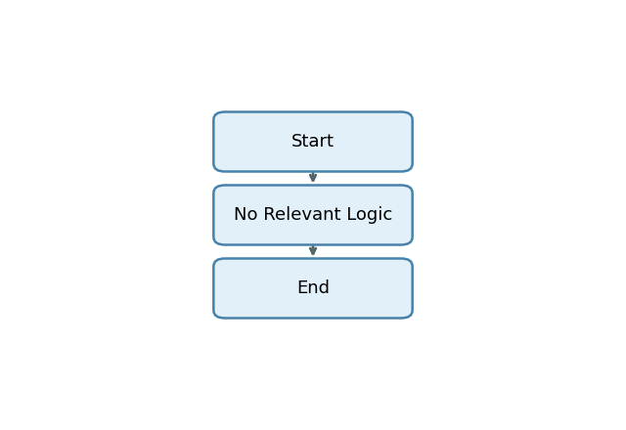

Start -> No Relevant Logic -> End

# 16. Error Handling & Logging

1. No error handling, exception processing, message display, logging, or user notification mechanisms are explicitly present in the provided payload explanation.

# 17. Performance Considerations

1. No performance-related techniques or data volume handling strategies are explicitly implemented or referenced in the provided payload explanation.

# 18. Security & Authorizations

|  |  |  |  |
| --- | --- | --- | --- |
| Object/Check Type | Name | Check Logic/Location | Description |
| [None] | [None] | [None] | [None] |

# 19. Test Scenario

|  |  |  |  |  |  |
| --- | --- | --- | --- | --- | --- |
| Test Case | Objective | Input Data | Expected Output | Actual Result/Status | Sign-off/Comments |
| TC01: Main Window Caption Display | Verify that the caption "Main Window" is displayed | None | "Main Window" caption appears in MAIN window | Pending | No selection screen data |
| TC02: New Display Option Caption Display | Verify "New Display Option" caption is shown | None | "New Display Option" caption appears | Pending | No selection screen data |
| TC03: New Page Caption Display | Verify "New Page" caption is shown | None | "New Page" caption appears on %PAGE1 | Pending | No selection screen data |
| TC04: Form Name Mapping | Ensure form name is correctly set as Z_ORDER_TEST | None | Form name "Z_ORDER_TEST" is used in output | Pending | No declarations present |
| TC05: Window Mapping | Ensure MAIN window is present and mapped | None | MAIN window is created in output | Pending | No window logic present |
| TC06: Page Mapping | Ensure %PAGE1 is present and mapped | None | %PAGE1 is created in output | Pending | No page logic present |
| TC07: Missing Declarations | Check behavior with no declarations | None | Output generated without variable fields | Pending | No declarations present |
| TC08: Missing Selection Screen | Check behavior with no selection screen parameters | None | Output generated without input-dependent fields | Pending | No selection screen data |
| TC09: Output Format Consistency | Verify output format is consistent with captions | None | Captions appear in correct locations | Pending | No formatting logic |

# 20. Sign-Off

|  |  |  |  |
| --- | --- | --- | --- |
| Role | Name | Signature | Date |
| Prepared By |  |  |  |
| Approved By |  |  |  |
| Client Sign-Off |  |  |  |

Document generated by PWC AI-powered ABAP Tech Spec Assistant.