Technical Specification Document

# Index

1. Document Information 1

2. Introduction 1

3. Transport Management 1

4. Requirement Overview 1

5. Solution Approach 1

6. SAP Object Details 1

7. Data Declarations & SAP Tables Used 1

8. SmartForm Layout Details 1

9. Field Mapping Details 1

10. User Interface Details 1

11. Processing Logic & Control Flow 1

12. Detailed Logic Block Descriptions 1

13. Output Details 1

14. Enhancements & Modifications 1

15. Flow Diagram 1

16. Error Handling & Logging 1

17. Performance Considerations 1

18. Security & Authorizations 1

19. Test Scenario 1

20. Sign-Off 1

# 1. Document Information

|  |  |  |  |  |  |
| --- | --- | --- | --- | --- | --- |
| Document Title | Project Name | SAP System/Release Version | Client Name | Prepared By (Author, Department) | Document Version & Date |
|  |  |  |  | PWC AI Asset |  |

# 2. Introduction

This document provides the technical specification for the SAP ABAP development. It outlines the purpose, scope, and intended audience for the solution. The document is intended for SAP ABAP developers, functional consultants, and project stakeholders involved in the implementation and maintenance of the described development object.

# 3. Transport Management

|  |  |  |  |
| --- | --- | --- | --- |
| Development Package | Transport Request Number | Sequence/Dependency | Description |
| [To Be Filled] | [To Be Filled] | [To Be Filled] | [To Be Filled] |

# 4. Requirement Overview

The business requirements and objectives for the ABAP development are not specified in the provided information.

# 5. Solution Approach

1. No specific SAP SmartForm design or architectural principles are described in the provided information.

2. No details regarding page/window hierarchy, ABAP integration, or conditions are available.

3. No explanation of the solution approach can be provided based on the current payload.

# 6. SAP Object Details

|  |  |  |  |  |  |
| --- | --- | --- | --- | --- | --- |
|  | Object Type | Object Name | Description | Related SmartForm/Page/Window |  |
|  | ------------- | ------------- | ------------- | ------------------------------- |  |

# 7. Data Declarations & SAP Tables Used

|  |  |  |  |
| --- | --- | --- | --- |
| Declaration Name | Data Type/Object | Description | Usage Context |
| --- | --- | --- | --- |

# 8. SmartForm Layout Details

Page | Window | Element | Type | Description

# 9. Field Mapping Details

SmartForm Field | Source Variable/Table | Mapping Logic | Usage

# 10. User Interface Details

|  |  |  |  |
| --- | --- | --- | --- |
| Field Name | Source (Table/Structure) | Default Value | Description |
|  |  |  |  |

# 11. Processing Logic & Control Flow

No processing logic or control flow information is available in the provided payload.

# 12. Detailed Logic Block Descriptions

# 13. Output Details

|  |  |  |  |  |  |
| --- | --- | --- | --- | --- | --- |
|  | Output Type | Format/Layout | Output Destination | Description |  |
|  | ------------- | -------------- | -------------------- | ------------- |  |

# 14. Enhancements & Modifications

|  |  |  |  |  |
| --- | --- | --- | --- | --- |
| Type | Name | Impacted Object | Location | Description |
| --- | --- | --- | --- | --- |

# 15. Flow Diagram

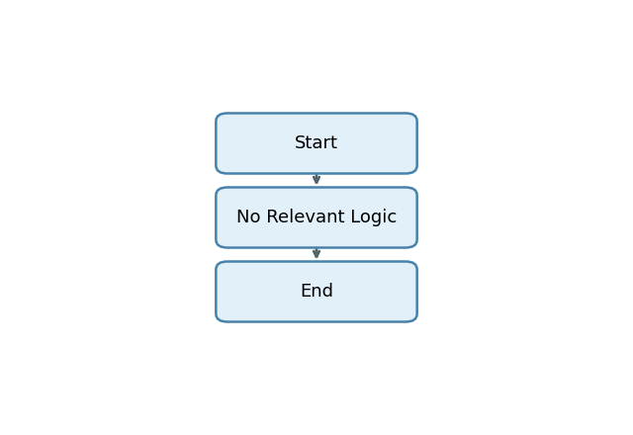

Start -> No Relevant Logic -> End

# 16. Error Handling & Logging

1. No error handling, exception processing, message display, logging, or user notification mechanisms are explicitly present in the provided payload explanation.

# 17. Performance Considerations

1. No performance-related techniques or data volume handling strategies are explicitly implemented or described in the provided payload explanation.

# 18. Security & Authorizations

|  |  |  |  |
| --- | --- | --- | --- |
| Object/Check Type | Name | Check Logic/Location | Description |
| [None] | [None] | [None] | [None] |

# 19. Test Scenario

|  |  |  |  |  |  |
| --- | --- | --- | --- | --- | --- |
| Test Case | Objective | Input Data | Expected Output | Actual Result/Status | Sign-off/Comments |
| TC01 | Verify program execution with no selection screen input | None | Program executes without errors and produces default output or message | Not Executed | No selection screen fields defined in payload |
| TC02 | Check field declaration and initialization | None | All declared fields are initialized as per specification | Not Executed | No field declarations present in payload |
| TC03 | Validate output formatting and display | None | Output is formatted and displayed as per requirements | Not Executed | No output logic or formatting details in payload |
| TC04 | Negative test: Handle missing declarations | None | Program should handle absence of declarations gracefully | Not Executed | No declarations provided in payload |
| TC05 | Negative test: Handle missing selection screen | None | Program should not fail due to absence of selection screen | Not Executed | No selection screen fields in payload |
| TC06 | Negative test: Handle missing explanation/logic | None | Program should not fail due to missing explanation or logic | Not Executed | No explanation or logic provided in payload |

# 20. Sign-Off

|  |  |  |  |
| --- | --- | --- | --- |
| Role | Name | Signature | Date |
| Prepared By |  |  |  |
| Approved By |  |  |  |
| Client Sign-Off |  |  |  |

Document generated by PWC AI-powered ABAP Tech Spec Assistant.