Trees Notes

1) Trees can have the Nodes and the edges

where edges = node -1

trees can have different shapes and sizes

- Complete binary tree vs Full tree

- Full tree - every node in the tree either have 0 or 2 children

- Complete tree - if you stack the tree in the array from L -> R then the array that been created shouldn’t have any spaces in between

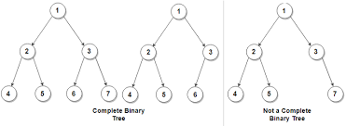

Tree Traversal:

Three methods are there to traverse the tree

1. Pre Order: Node -> Left child -> Right Child
2. In Order: Left child -> Node -> Right Child
3. Post order: Left -> Right -> Node
4. 