**RATNAMANI KONDETI** 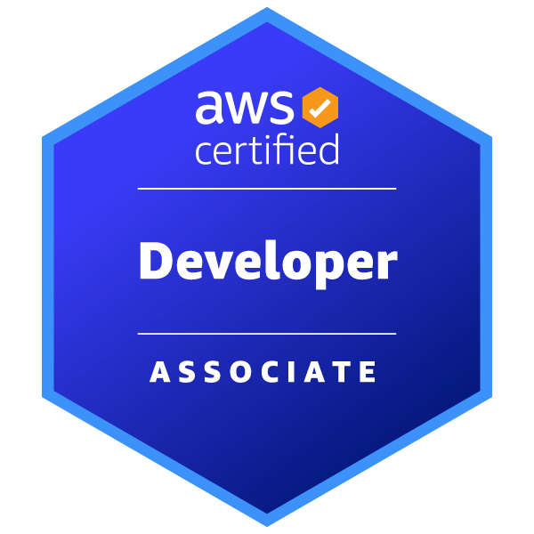

Charleston, IL, USA -61920 | +12177905527 | [ratnamani552@gmail.com](mailto:ratnamani552@gmail.com) | [LinkedIn](https://www.linkedin.com/in/ratnamani-kondeti/) | [GitHub](https://github.com/RatnamaniKondeti/FullStackWebsite) | [AWS Certification](https://www.credly.com/badges/bdf462f4-7e3c-4f62-9719-efbe76ed9142/public_url)

**SUMMARY**

Dynamic Software Engineer with 5+ years of progressive experience driving scalable, innovative solutions from 4G-to-5G telecom transformations to full-stack web development. Expert in Java, Spring Boot, microservices, and database optimization, AWS cloud services, with a proven track record in agile CI/CD automation and cloud integration (AWS). Currently an advanced technical acumen with a master’s in computer technology and AWS Certified Developer.

**SKILLS**

**Languages:** Java, J2EE, C/C++, Python, HTML5, CSS3, JavaScript, AJAX  
**Frameworks & Technologies:** Spring, Spring Boot, Spring MVC, Swagger, Hibernate, OOD, JSP, REST APIs, Microservices, IOC Containers, Spring Initializer, Exception Handling, JPA Query, Spring Security 6, Dependency Injection, JDBC, AWT token, Multi-threading  
**Database Systems:** MySQL, Oracle, SQL, Data Warehouse Management, Redis  
**Cloud Platforms**: AWS (Certified Developer – Associate), AWS Lambda, AWS API Gateway, AWS CloudFormation, AWS Code Commit, AWS Code Build, AWS Code Deploy, AWS Code Pipeline, Amazon S3, AWS DynamoDB, AWS RDS, AWS CloudWatch, AWS IAM, AWS SDK for Java, Kubernetes, Docker, Apache NiFi, Apache Kafka, CI/CD pipelines  
**Tools & Methodologies:** A/B Testing, Git, GitHub, JIRA, Agile, Scrum, Maven, JWT, Waterfall, Postman, CICD, Linux/Unix, Windows, iOS, MS Office, Eclipse, IntelliJ, Make/CMake, Meld tool, SQL Developer, Bash, PowerShell, GTest, AES encryption and decryption

**PROFESSIONAL EXPERIENCE**

**Technical Marketing Analyst, EIU - IL, USA *Jan 2024 – Present***

* **Google Analytics** and Adobe analyze social media campaign performance and user behavior, driving a 25% increase in engagement through data-driven optimizations.
* Collaborate with marketing, technical, and content teams to design and implement targeted digital strategies that enhance content delivery and expand audience reach.
* Monitor and manage social media channels (Facebook, Instagram), tracking key performance metrics and refining content strategies to boost follower growth and interaction.
* Develop and optimize technical content for university newsletters, ensuring **SEO** best practices and alignment with performance goals.

**Software Development Engineer 2, Rakuten Symphony *– India April 2022 – June 2023***  
***Next-Generation OSS Product Team – 5G Network Transformation (RCP – 5G-RAN)***

* **4G to 5G Transformation Leadership:** Spearheaded development for major telecom projects (Drillisch, Dish, AT&T, RAN, IoT) driving 4G to 5G migrations, achieving a 15% boost in operational efficiency.
* **Hardware Integration & Scalability:** Engineered critical hardware replacement features (RRH, RIU, PTP) that enhanced 5G deployment scalability and improved MM Wave data transmission speeds by 15%.
* **Advanced Database Design:** Architected and implemented robust MySQL database structures across Femto, 4G, 5G, and small cell networks, optimizing query efficiency by 20% and ensuring accurate network hierarchies.
* **5G Control Plane Development:** Designed and developed 5G Central Unit Control Plane (CUCP) and User Plane (CUUP) components to elevate scalability and reliability in next-generation network deployments.
* **Agile Leadership & Operational Excellence:** Led daily sprint meetings, delivered knowledge transfer sessions on code management and API documentation, and provided 24/7 production support to ensure uninterrupted network service delivery.

**Software Development Engineer, InnoEye Technologies *– India Dec 2020 – April 2022***

***OSS Product Team – Foresight (4G-vRAN Network Service)***

* Developed **RESTful microservices** in **Java/Spring Boot for Foresight**, enabling real-time data exchange across **4G-vRAN components.**
* Secured APIs by integrating Spring Security 6 with JWT and providing comprehensive Swagger documentation for seamless third-party connectivity and **Collaborated in Agile sprints**, resolving **cross-module integration challenges** to improve project delivery.
* Optimized **MySQL/Oracle** performance by refactoring **JPA queries** and employing **multi-threaded** processing, boosting query efficiency by 20%.
* Engineered an automated **CI/CD** pipeline using **Apache NiFi** and **Maven** to reduce manual deployments and accelerate feature rollouts.
* Collaborated in Agile sprints via **JIRA** and **Git/GitHub**, effectively resolving cross-module integration challenges to enhance overall project delivery.

**Associate Software Engineer**, **InnoEye Technologies-India** ***Sep 2018 – Dec 2020***

***OSS Product Team – Early-stage of virtualized RAN systems (Foresight – 4G-vRAN Network Service)***

* Designed and implemented RESTful APIs with **Java, Spring MVC, and JDBC** for **Foresight (4G-vRAN)**, enabling efficient communication between virtualized **RAN** components and **MySQL**.
* Developed automated test suites using **GTest** and **Postman** to validate API endpoints and embedded network functionalities.
* Employed **Maven** for build automation and deployed artifacts (**JAR, Pom.xml**) on **Linux/Unix** via **Bash** scripting.
* Collaborated with cross-functional teams using **Git/GitHub** and **JIRA** in an Agile/Scrum environment, participating in stand-ups, sprint planning, and code reviews with **Eclipse/IntelliJ**.
* Implemented **AES encryption/decryption** and basic authorization workflows to secure sensitive network data and **OSS communication channels.**

**Education**

**Master’s in computer technology | Eastern Illinois University, Charleston, IL *August 2023 – May 2025***

* **Relevant Coursework:** Advanced Database Systems, Cloud Computing, Software Engineering, Data Structures, and Algorithms, Java Application in Technology.
* **Projects:** Full-Stack Web Development, Network Security Enhancements, and AI-Driven Data Analysis.