SmartBook

As the bus was introduced a very long time back, she had to go all the way to the bus booking counter to book the tickets. After entering the counter, she will select the counter for her destination. Then she will have to ask the cashier if there is any seat available for the specific destination. If the seats are available then the cashier will ask the number of tickets for her. Then the cashier will ask her for her name and id numbers. After that the cashier will give the seat number along with the tickets and then she will pay for the tickets that she has booked. And if the tickets are not available then she has to go to another counter to look for the tickets. So, this process is quite inconvenient for her since she has to come a very long way to book the bus tickets and it's very time consuming.

So, in order to solve this problem, we came up with the idea of an online ticket booking system. In this system if the person is not registered then she has to register using her phone number and id card number. And after registering one otp will be sent in the registered mobile number and then the user will get registered to use the system. After that the interface will be displaced where the bus icon will be displaced. After clicking on the bus icon, the person will be asked to fill up where they want to go from and where they want to go. And also, they have to select the departure date (this departure date can be changed according to the user's need.). then the available bus will be displaced. After selecting the bus, available seats will be displaced, after that the person will have to choose the desired seat. If the seat is not available then the message will be displaced saying unavailable seats. After selecting the seats, the user has to make payment by clicking on the payment button. The person can play in various payment modes like BoB,MPay,eteru. After the payment is done, a confirmation message will be sent through the registered mobile number .

**2.System capabilities**

* Store the personal details of the travellers
* Shows the availability of the buses
* Allows to choose the bus and bus seats
* Accept only online payment
* Allows to change date according to their needs
* Sends confirmation message through registered mobile number

**3.Business benefit**

* Cost saving
* Time saving
* It is convenient for both

**User:**

1.customer

2. System administrative

3 .bus owner

4.bus driver

**System requirement**

1. the customer has to enter the destination place and date
2. the customer can change the date if they want to
3. the customer can choose for bus
4. The customer has to enter date and destination for ticket booking
5. if the bus is fully booked the the message will be displayed saying no seats available and the customer can choose for another bus
6. if the seat are booked it will be displayed in red colour, if the seats are not booked it will be displayed in green colour
7. the total amount will be displayed once the seats are booked
8. Before making the payment ,the customer has to sign up or login in order to pay.
9. The customer has to make payment through Mpay,mbob,pnb.
10. After that the confirmation message will be sent which includes the bus name ,date,reporting time,departure time,destination,seat no,bus no to the registered number or the customer will be asked to download the tickets or keep a screenshot of the ticket.
11. If the customer wishes to cancel the message will be displayed which includes the name and phone number of the customer.
12. The bus owner has to register in our system in order to make the bus available in the system
13. The amount collected through the online ticket booking system will be given to the bus owner on a monthly basis.

**Rules.**

1. The online booking system will be open 24 hours.

2. If the cancellation is made within 3 days the 50 percent of the money will be refunded.

3.if the cancellation is made at the very last movement then ,the money will not be refunded.

4.if the cancellation is made before one week, then the whole amount will be refunded.

**Users**

1. customer
2. Cashier
3. Bus owner

**Users story**

1. Traveller

* As a customer, I want to book the tickets quickly form wherever I am
* As a customer, I want to chose the bus and seat as I want
* As a customer, I should be able to give feedback about the online service

1. System administrator

* As a system administrator, I want to sell the tickets quickly by making my tickets online
* As a system administrator, I want to see the list of transactions that happened on a particular day.
* As a system administrator, I should be able to modify the booking such as date and seat whenever the customer wants to make changes.

3.bus owner

* As a bus owner , I want to be able to register my bus so that it is available in the online ticket booking system.
* As a bus owner, I should be able to cancel the bus registration if I want to.

4.bus driver

* As a bus driver i should be able to register my own bus in the system
* And i should be also be able to cancel the registration in the system and also check the bus shedule

**User acceptance for customer**

* availability of the bus and the bus seat must be displayed
* confirmation message should be received by the users
* user should be able to change the date
* user must be able to choose the desired seats
* Users should be able to cancel the booking if they want to cancel.

**User acceptance for system administrator**

* should be able to send the confirmation message to the customers
* should be able to make changes in the system like date and seat for the customers.
* Should be able to add bus, remove bus from the system
* Should be able to update the bus price
* Collect the information for payment
* Collect the bus owner information to make the bus available in the system.

**User acceptance for bus owner**

* Should be able to register the bus in order to make the bus available
* Should be able to cancel the bus registration.

**User acceptance for bus driver**

* Should be able to register the bus in order to make the bus available in the system
* Should be able to cancel the bus registration.

**Use cases**

|  |  |
| --- | --- |
| User | User goal resulting to use cases |
| customer | * Select the date and destination for the ticket booking * update the date and the seat * choose the bus they want to travel * choose the desired seat * View the total amount * Make payment online * receives the confirmation message |
| System administrator | * if the bus is fully booked the message will be displayed saying no seats available and the customer can choose for another bus * if the seat is booked it will be displayed in red colour, if the seats are not booked it will be displayed in green colour * the total amount will be displayed once the seats are booked * Collect payment * make the confirmation message. * Should be able to add and remove the bus from the system |
| Bus owner | * Will have to register in the system,in order to make the bus available in the system * should be able to cancel the bus registration if they don’t want to cancel |

**Activity diagram**

1. **customer booking a ticket**

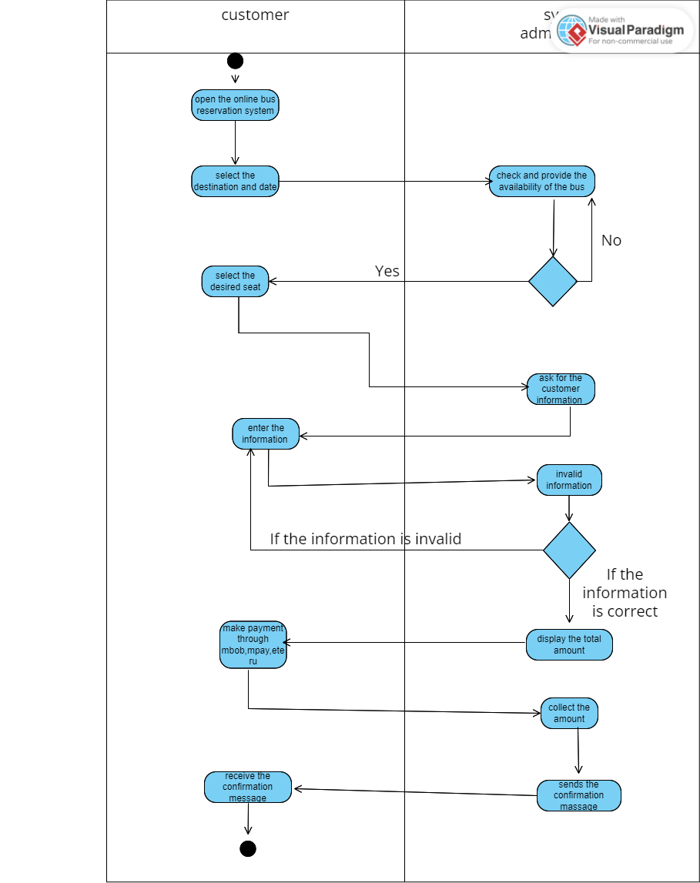

**2.Bus owner registration**

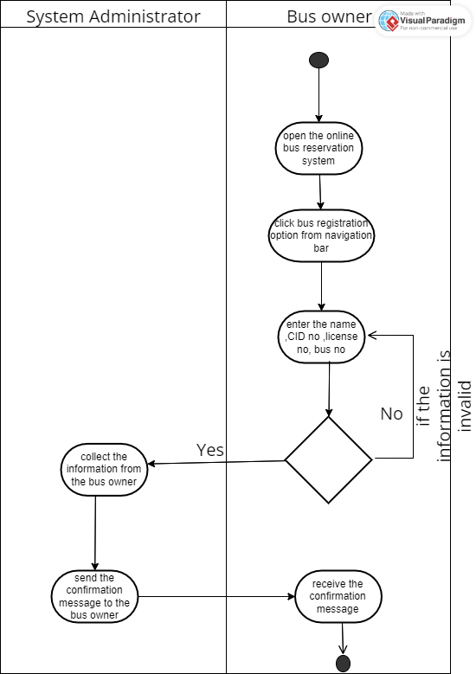

**3. Cancellation**

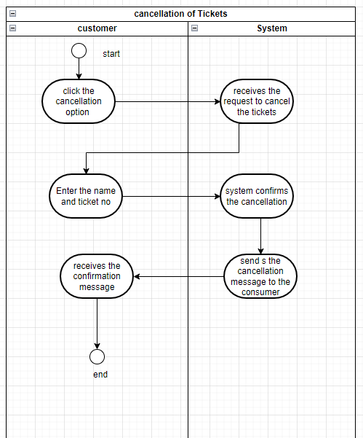

**4.payment**

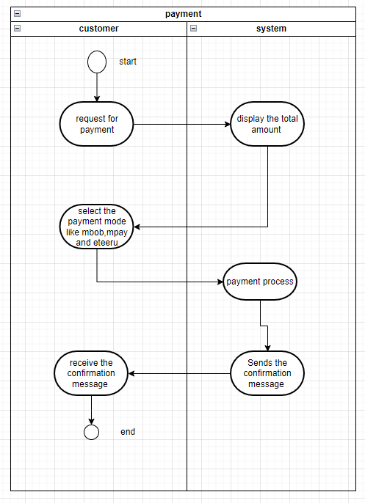

**Use case diagram**

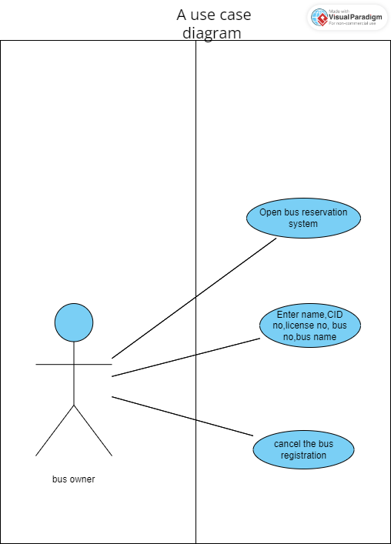

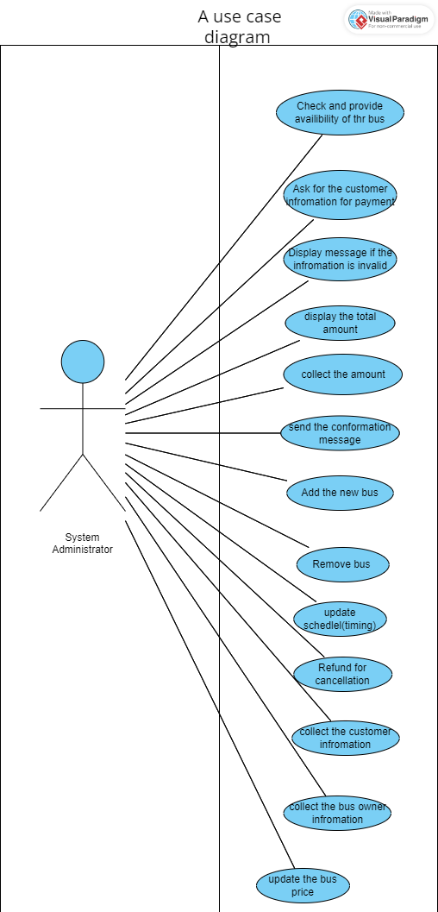

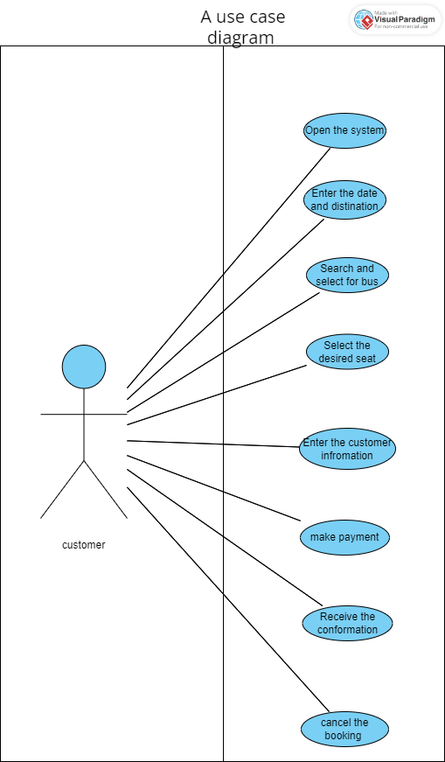

**Domain model class diagram**

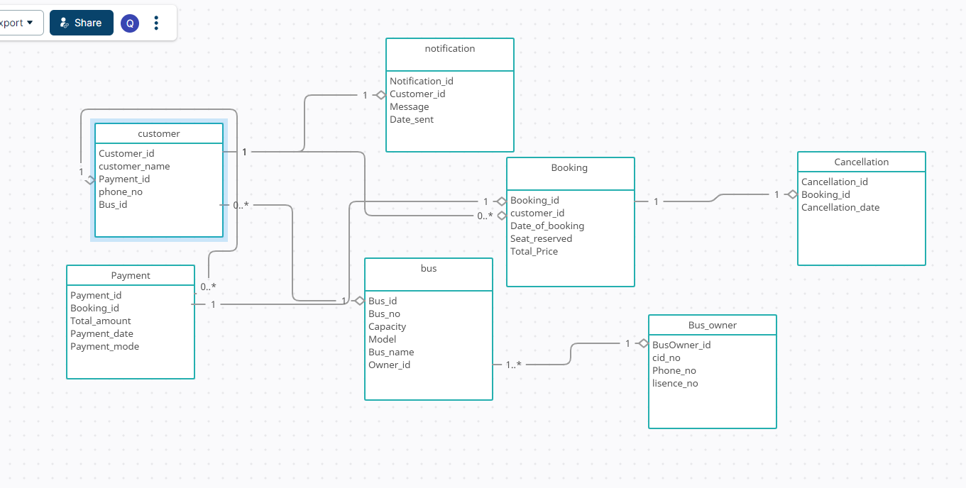

**Fully developed use case description**

**Bus ticket booking for customer**

|  |  |  |
| --- | --- | --- |
| **Use case name:** | bus ticket booking for customers | |
| **Scenario:** | The customer can reserve seats in the bus using the system | |
| **Triggering event:** | when the customer books the ticket | |
| **Brief description:** | The customer can book the tickets ,search for the bus ,select the seats and pay online. | |
| **Actors:** | Customers,system administrator | |
| **Related use cases:** | payment | |
| **Stakeholders:** | customer, system administrator, bus owner | |
| **Preconditions:** | * The user must enter date and destination and seat in order to book the tickets * The customer can cancel the tickets | |
| **Postconditions:** | * The customer receives the confirmation message after the ticket booking * The tickets will be cancelled and the amount will be refunded | |
| **Flow of activities** | **Actor** | **System** |
|  | **1.**The customer can search the bus.  1.1 the system provides the availability of the bus  2. The customer can select the desired seat.  2.1 the system display the availability of seat  3.The customer can pay online  3.1 The system will send the confirmation message  4.if the bus is unavailable or fully booked  4.1 The system will display message | |
| **Exception Conditions:** | 1.if the bus is already full, the customer can select another bus  2.if the seat is already booked, it will be displayed in red colour .  3.if the customer doesn't receive the confirmation message, recheck the contact number | |

**Registration for bus owner**

|  |  |  |
| --- | --- | --- |
| **Use case name:** | Registration for bus owner | |
| **Scenario:** | The bus driver can register using this system. | |
| **Triggering event:** | The bus owner wants to make his bus available. | |
| **Brief description:** | Bus owners have to register their bus in order to make the bus available in the system. | |
| **Actors:** | Bus owner, system administrator | |
| **Related use cases:** | none | |
| **Stakeholders:** | Bus owners,system administrator | |
| **Preconditions:** | * Bus owner must enter the details in order to register * Bus owner can cancel the registration | |
| **Postconditions:** | * The bus will be available in the system for the customer to book * The bus availability will be cancelled. | |
| **Flow of activities** | **Actor** | **System** |
|  | 1.Bus owners can search the online ticket reservation system.  1.1 The system will display the online ticket reservation system.  2.Bus owners have to fill in the details .  2.1 The system will store the details of the bus owner. | |
| **Exception Conditions:** | 1.if the bus owner doesn't give the details correctly, it will display an error message and try again. | |

**Payment processing for ticket**

|  |  |  |
| --- | --- | --- |
| **Use case name:** | Payment processing for ticket | |
| **Scenario:** | The customer makes payment online | |
| **Triggering event:** | The user selects the bus, seat , destination,date and proceed to the payment | |
| **Brief description:** | After selecting everything the customer proceeds to payment for the seat that they have booked. | |
| **Actors:** | Customer,System administrator | |
| **Related use cases:** | none | |
| **Stakeholders:** | Customer,System administrator,bus owner | |
| **Preconditions:** | The user has successfully selected a bus seat, destination and date. | |
| **Postconditions:** | * The amount of the ticket will be made. * The user will be able to make payment. | |
| **Flow of activities** | **Actor** | **System** |
|  | 1.customer must use the mbob,mpay while making the payment.  1.1 The system will display the total amount for the ticket  2.Before making the payment the customer must select the bus, seat , destination and date.  2.1 the system will display bus availability seat, destination and date  3.the customer should put the exact amount of the ticket.  3.1 the system will record the transaction of payment made. | |
| **Exception Conditions:** | If the bob or mpay is not working you have to wait a lil bit | |

**Cancellation of booking**

|  |  |  |
| --- | --- | --- |
| **Use case name:** | Cancel the booking | |
| **scenario** | Customer decide to cancel the booking | |
| **Triggering event:** | When the customer doesn’t want the ticket | |
| **Brief description:** | This use case describes the process of cancelling the booking . | |
| **Actors:** | Customer, | |
| **Related use cases:** | none | |
| **Stakeholders:** | Customer,system administrator | |
| **Preconditions:** | The user has an existing booking . | |
| **Postconditions:** | 1.The cancellation was successful .  2.Confirmation message is sent to the customer.  3.The cancelled seat are now available for other customer to book  4.after cancelling a bus reservation, the customer should received refund for the cancellation of ticket | |
| **Flow of activities** | **Actor** | **System** |
|  | 1.The customer clicks the cancel reservation button.  1.1 system received cancelation request  1.2.system confirm the cancellation  message    1.customer receives the confirmation message | |
| **Exception Conditions:** | 1.if the customer tries to cancel a booking after the cancellation period has expired,display a message indicating that the cancellation period has expired. | |

**Refund for the cancellation ticket**

|  |  |  |
| --- | --- | --- |
| **Use case name:** | Refund for the cancellation ticket | |
| **Scenario:** | When the customer cancels the ticket,the amount will be refunded. | |
| **Triggering event:** | When customer cancel the ticket | |
| **Brief description:** | This use case describe the process of refunding the amount for cancelled ticket | |
| **Actors:** | Customer | |
| **Related use cases:** | Cancellation.,bus ticket booking | |
| **Stakeholders:** | Customer,system administrator | |
| **Preconditions:** | 1.the tickets should be already booked  2.the payments has to be already made | |
| **Postconditions** | 1.Refund successfull  2Customer receives the refund message. | |
| **Flow of activities** | **Actor** | **System** |
|  | 1.customer must use the mbob,mpay while making the payment.  1.1 The system will display the total amount for the ticket  2.Before making the payment the customer must select the bus, seat , destination and date.  2.1 the system will display bus availability seat, destination and date  3.the customer should put the exact amount of the ticket.  3.1 the system will record the transaction of payment made. | |
| **Exception Conditions:** | If the mbob or mpay is not working , the customer has to refund. | |

**System sequence diagram**

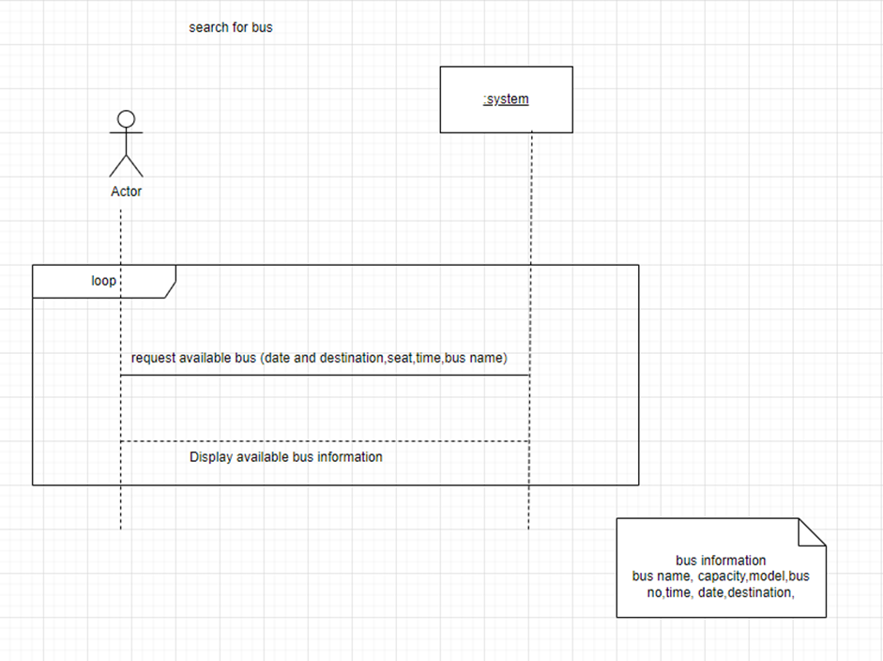

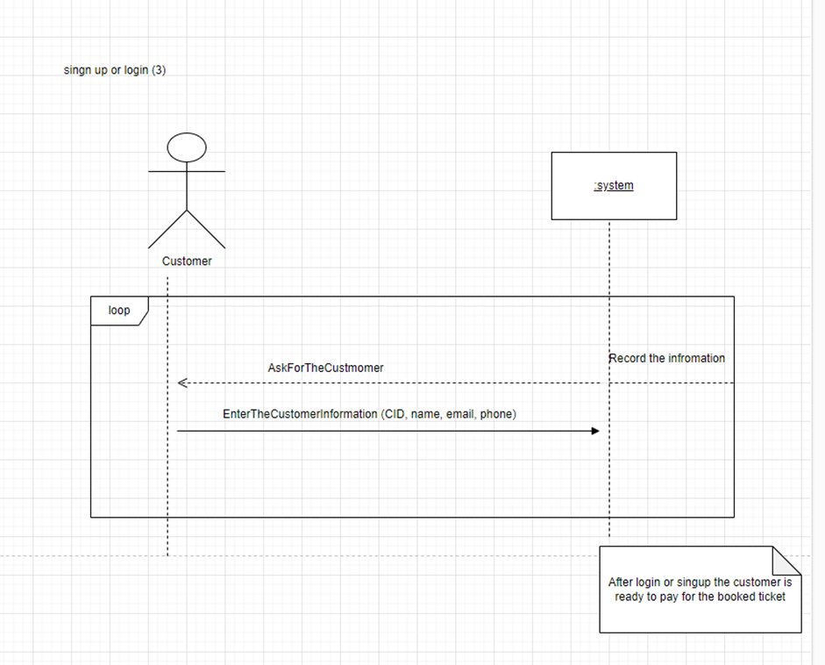

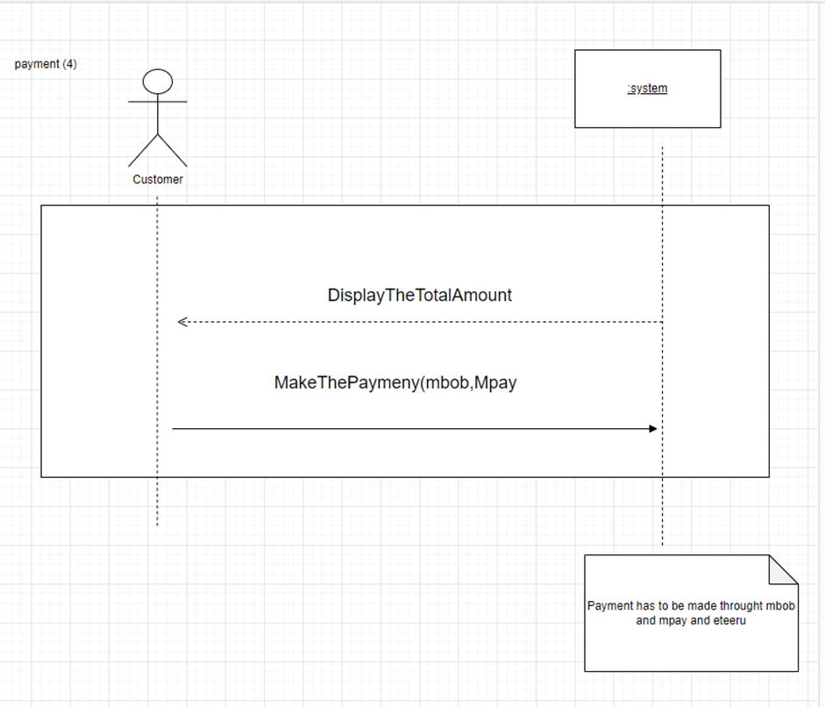

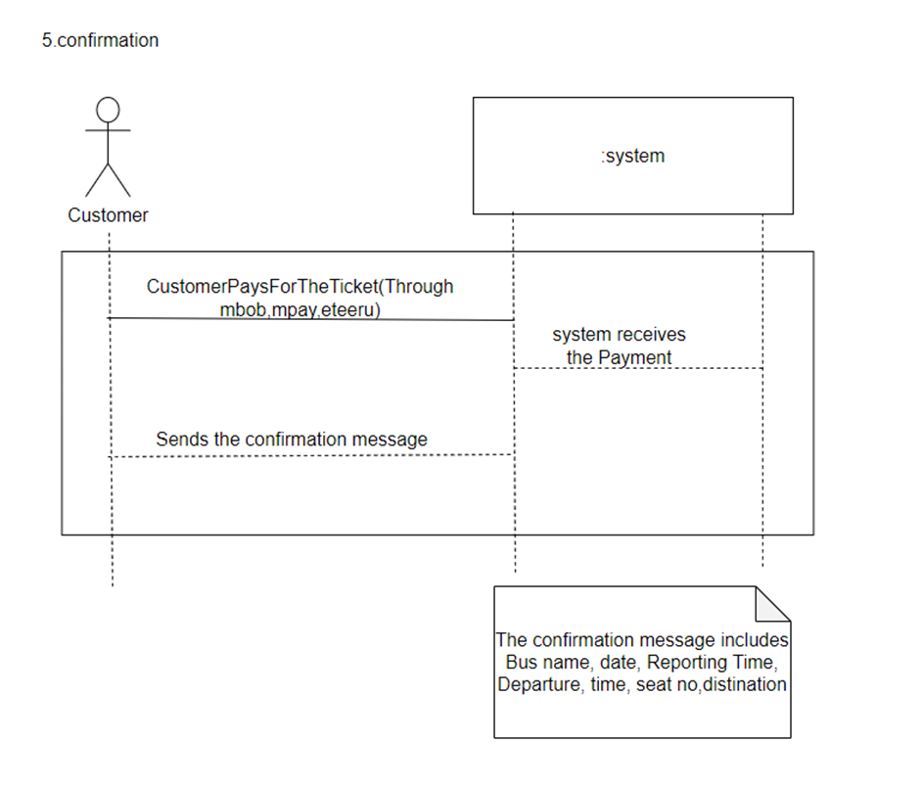

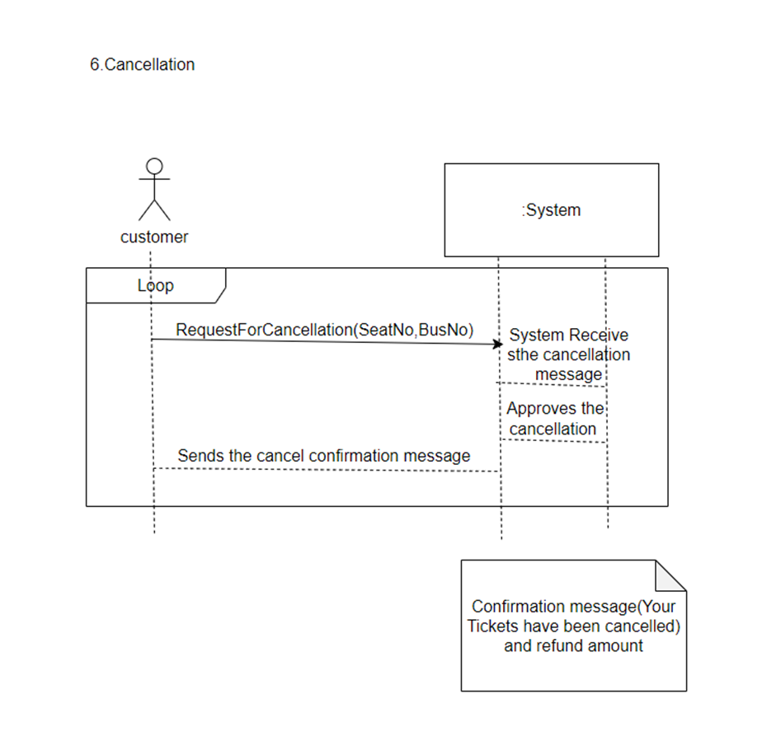

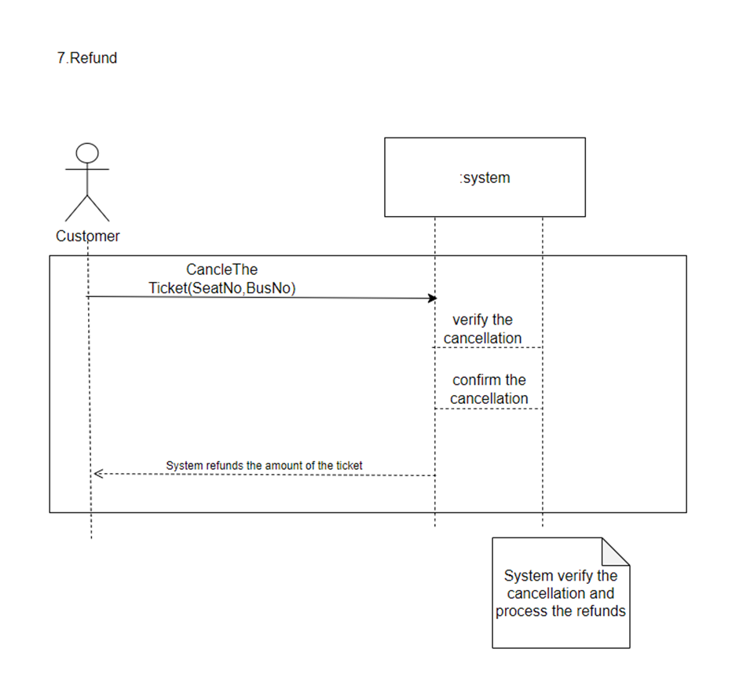

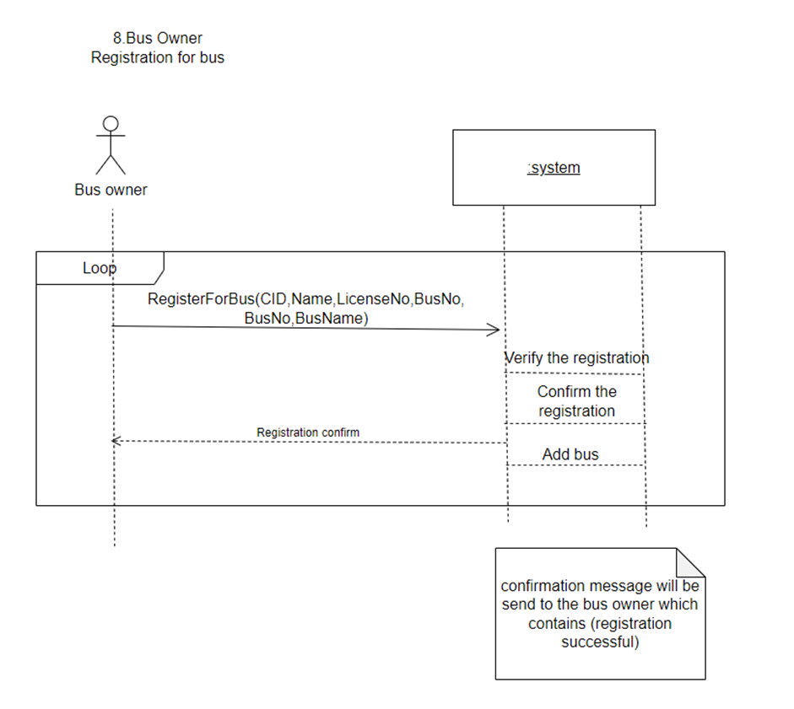

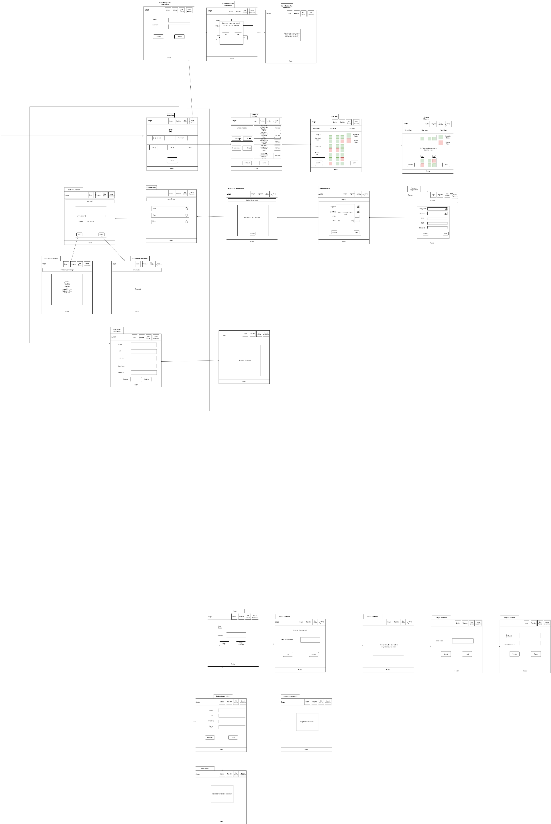

Link to draw.io

<https://app.diagrams.net/#G15Zd2SJKpOvcxhxccdynwoZt9Sdz9S-Wx>

**ERD diagram**