A Project Report On

Coffee & Bakery Shop

Submitted in partial fulfillment of the requirement for the award of the degree

Bachelor of Computer Application (BCA)

Academic Year 2025 – 26

raghav gondaliya ratnesh kotiya dhruv parekh
92300527048 92300527255 92300527043

Internal Guide
Prof. Dr. Jignesh hirapara



Rajkot-Morbi Road, At & PO : Gauridad, Rajkot 360 003. Gujarat. India.

Faculty of Computer Applications (FCA)



This is to certify that the project work entitled

Coffee & Bakery Store

submitted in partial fulfillment of the requirement for

the award of the degree of

Bachelor of Computer Application

of the

Marwadi University

is a result of the bonafide work carried out by

Raghav gondaliya (92300527048)

Ratnesh kotiya (92300527255)

Dhruv parekh(92300527043)

during the academic year 2025-26

Dr. Jignesh hirapara Dr. Sunil Bajeja Dr. Sridaran Rajagopal
Faculty Guide |  | HOD |  | Dean

DECLARATION

I/We hereby declare that this project work entitled Coffee & Bakery Store is a record done by me.

I also declare that the matter embodied in this project is genuine work done by me and has not been submitted whether to this University or to any other University / Institute for the fulfillment of the requirement of any course of study.

Place : Rajkot
Date :28/08/2025

Raghav gondaliya (92300527048) Signature : 
Ratnesh kotiya (92300527255) Signature : 
Dhruv parekh (92300527043) Signature : 

ACKNOWLEDGEMENT

It is indeed a great pleasure to express our thanks and gratitude to all those who helped us. No serious and lasting achievement or success one can ever achieve without the help of friendly guidance and co-operation of so many people involved in the work.

We are very thankful to our guide Dr.Jignesh Hirapara, the person who makes us to follow the right steps during our project work. We express our deep sense of gratitude to for his /her guidance, suggestions and expertise at every stage. A part from that his/her valuable and expertise suggestion during documentation of our report indeed help us a lot.

Thanks to our friend and colleague who have been a source of inspiration and motivation that helped to us during our project work.

We are heartily thankful to the Dean of our department Dr. R. Sridaran sir and HoD Dr. Sunil Bajeja sir for giving us an opportunity to work over this project and for their end-less and great support to all other people who directly or indirectly supported and help us to fulfil our task.

Raghav Gondaliya (92300527048) Signature:
Ratnehs Kotiya (92300527255) Signature:
Dhruv Parekh (92300527043) Signature:

CONTENTS

Chapters | Particulars | Page No.
1 | SYNOPSIS | 6
2  2.1  2.2 | PREAMBLE  General Introduction  Module description | 7
3 | REVIEW OF LITERATURE | 8
4  4.1  4.2 | TECHNICAL DESCRIPTION  Hardware Requirement  Software Requirement | 9
5  5.1  5.2  5.2.1  5.3  5.3.1  5.3.2  5.3.3  5.4  5.4.1  5.4.2 | SYSTEM DESIGN AND DEVELOPMENT  Architectural Design  - Class Diagram  Dynamic Modeling  - Use Case Diagram  - Sequence Diagram  - Activity Diagram  Database Design  Relationship Diagram (ER)  Menu Design  Screen Design | 10
6 | CONCLUSION | 17
7 | LEARNING DURING PROJECT WORK | 17
8  8.1  8.2 | BIBLIOGRAPHY  Online References  Offline References | 18

- SYNOPSIS:
The Coffee & Bakery Shop project is a web-based application developed in PHP with MySQL as the backend. It allows customers to browse products, add items to their cart, and place orders. An admin panel is provided for managing products, viewing orders, and maintaining inventory.
This system enhances the shopping experience by providing:
- A user-friendly interface for customers.
- A shopping cart feature for order management.
- Secure login/logout for both users and admin.
- A dynamic admin dashboard for product management.
The project aims to provide a simple but scalable e-commerce platform for a coffee and bakery store.

PREAMBLE:

2.1 General Introduction
E-commerce has transformed the way businesses operate. Cafes and bakeries also benefit from online platforms by making their products available to customers digitally.
The Coffee & Bakery Shop System provides an online platform where users can explore bakery and coffee products, add them to their cart, and place orders. Meanwhile, the admin can add, update, and manage products efficiently.

2.2 Module Description
- User Module
  - Register/Login, view products, add to cart, manage cart, place orders.
- Admin Module
  - Admin login, add new products, view existing products, and manage product list.
- Database Module
  - MySQL database (coffee_shop.sql) for storing users, products, and orders.
- Authentication Module
  - Secure login/logout system for users and admin.

REVIEW OF LITERATURE:
Many small businesses rely on manual processes for order management, which are inefficient. Existing e-commerce platforms like Amazon and Flipkart are too complex and costly for small shops.
This project aims to provide a lightweight, affordable, and user-friendly web application for local cafes and bakeries. It combines core features of online shopping systems but tailored for small-scale business needs.

TECHNICAL DESCRIPTION:

4.1 Hardware Requirement
- Processor: Intel i3 or higher
- RAM: 4 GB minimum
- Storage: 1 GB free space
- Operating System: Windows/Linux/Mac

4.2 Software Requirement
- Frontend: HTML, CSS, JavaScript
- Backend: PHP 7+
- Database: MySQL
- Server: XAMPP/WAMP/LAMP server
- Browser: Chrome/Firefox/Edge
- IDE/Editor: VS Code / Sublime Text

SYSTEM DESIGN AND DEVELOPMENT:

5.1 Architectural Design

Client (User/Admin) → Web Browser (HTML, CSS, JS) → PHP Scripts → MySQL Database

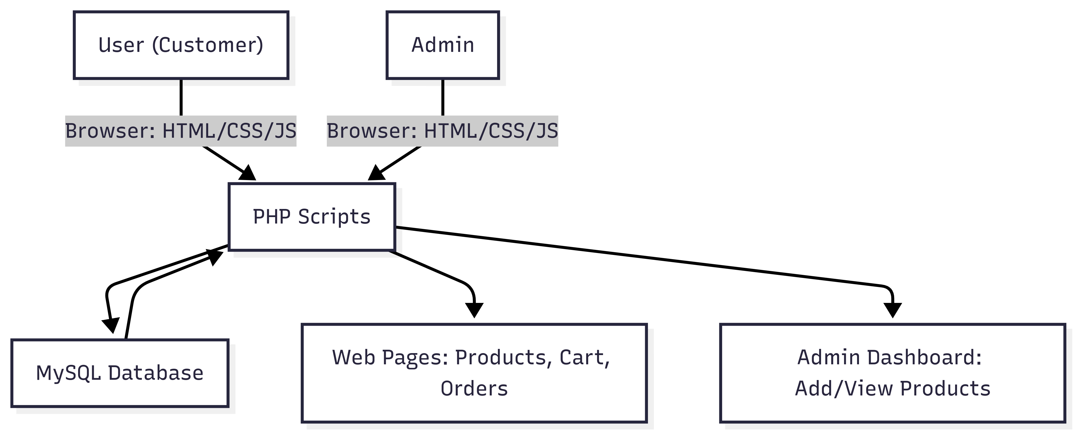

5.2 Class Diagram

- User (userID, name, email, password) → can browse products, manage cart.
- Admin (adminID, username, password) → can manage products.
- Product (productID, name, price, image) → stored in database.
- Cart (cartID, productID, userID, quantity) → temporary storage for user orders.
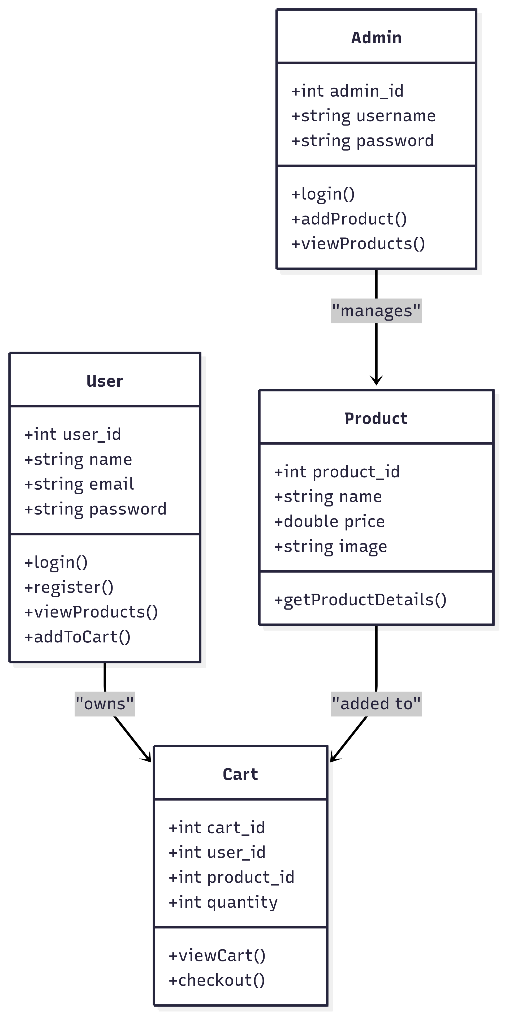

5.3 Dynamic Modeling
- 5.3.1 Use Case Diagram
  - Users: login, browse products, add to cart, view cart.
  - Admin: login, add/view products.
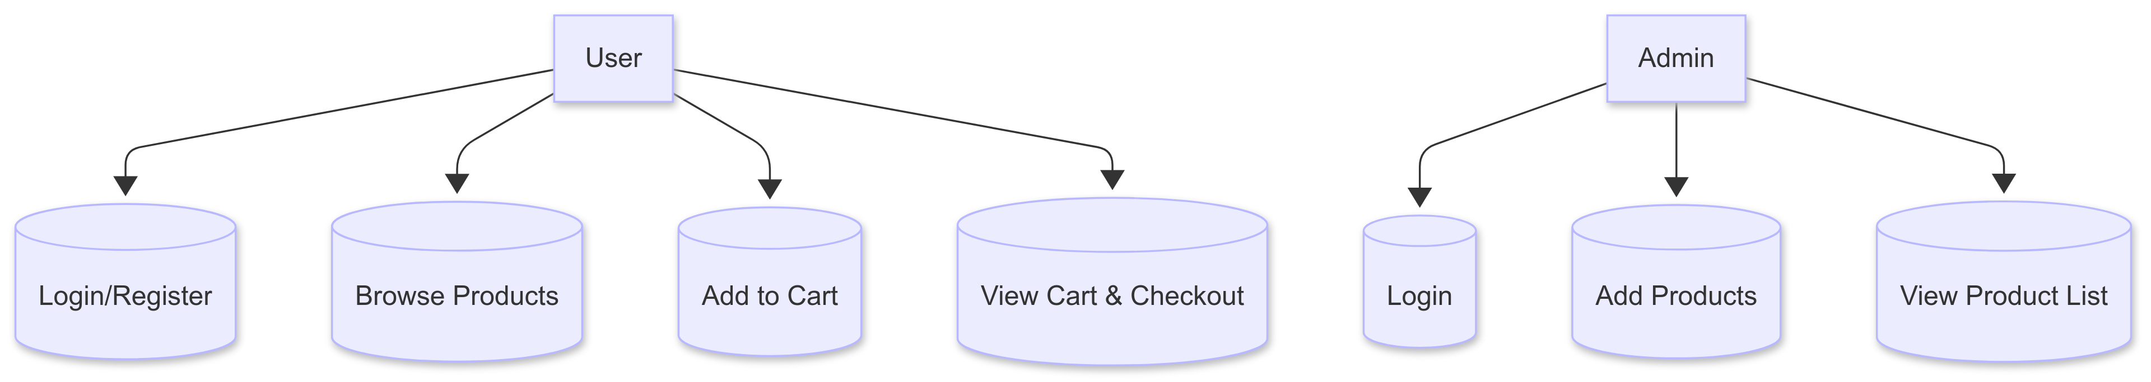

- 5.3.2 Sequence Diagram
  - User → Login → View Products → Add to Cart → Checkout.
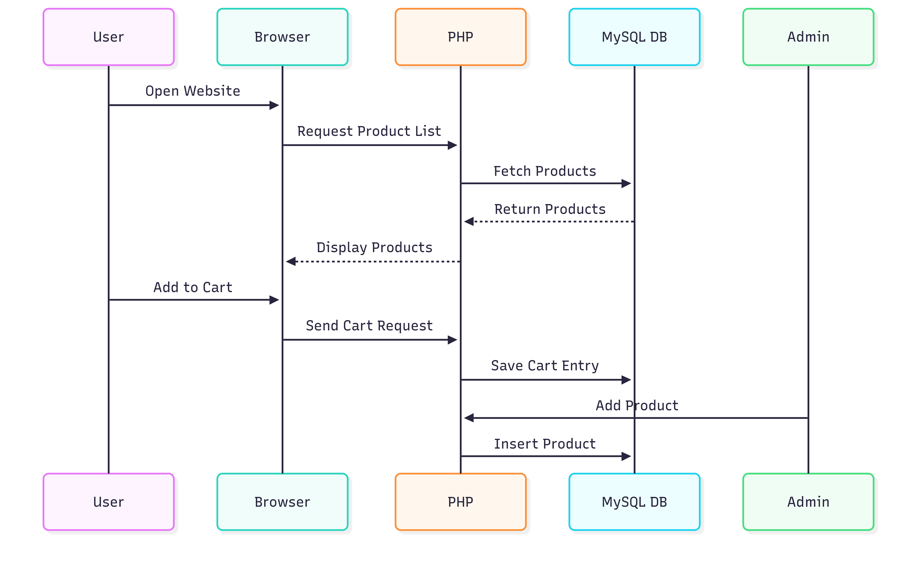

- 5.3.3 Activity Diagram
  - User browses → Adds items → Places order → Admin manages products.
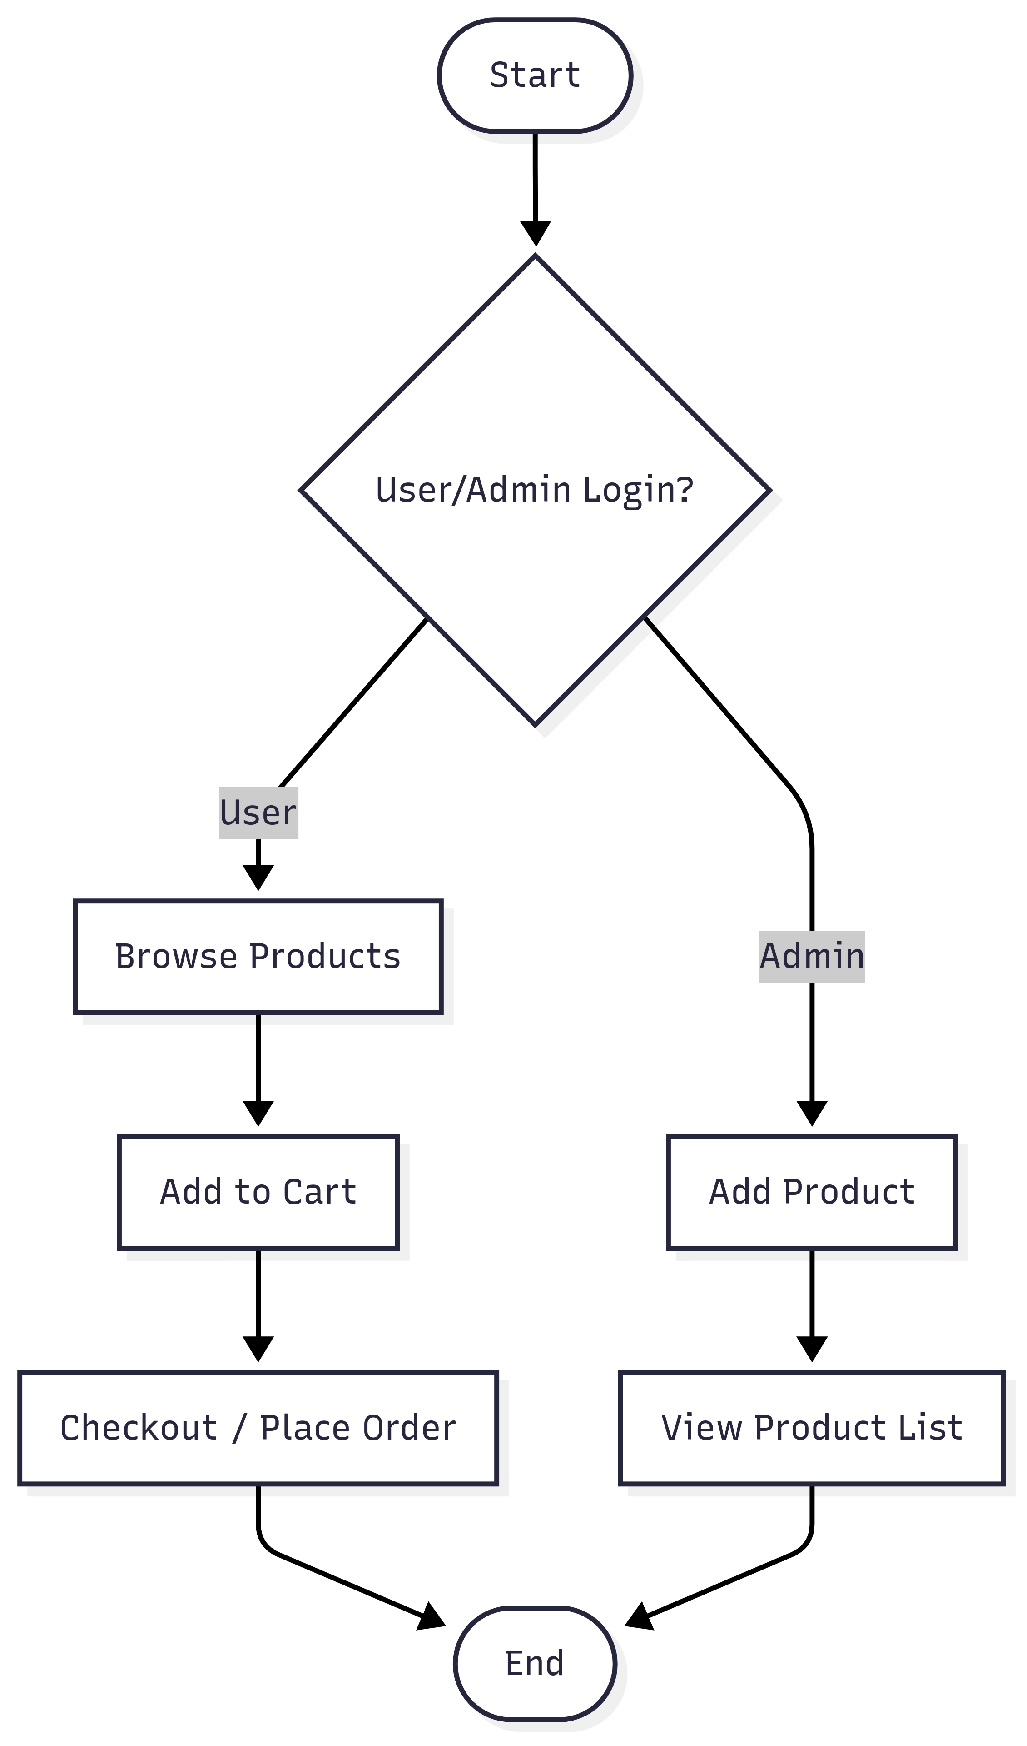

5.4 Database Design
- Tables:
  - users(user_id, name, email, password)
  - admin(admin_id, username, password)
  - products(product_id, name, price, image)
  - cart(cart_id, product_id, user_id, quantity)
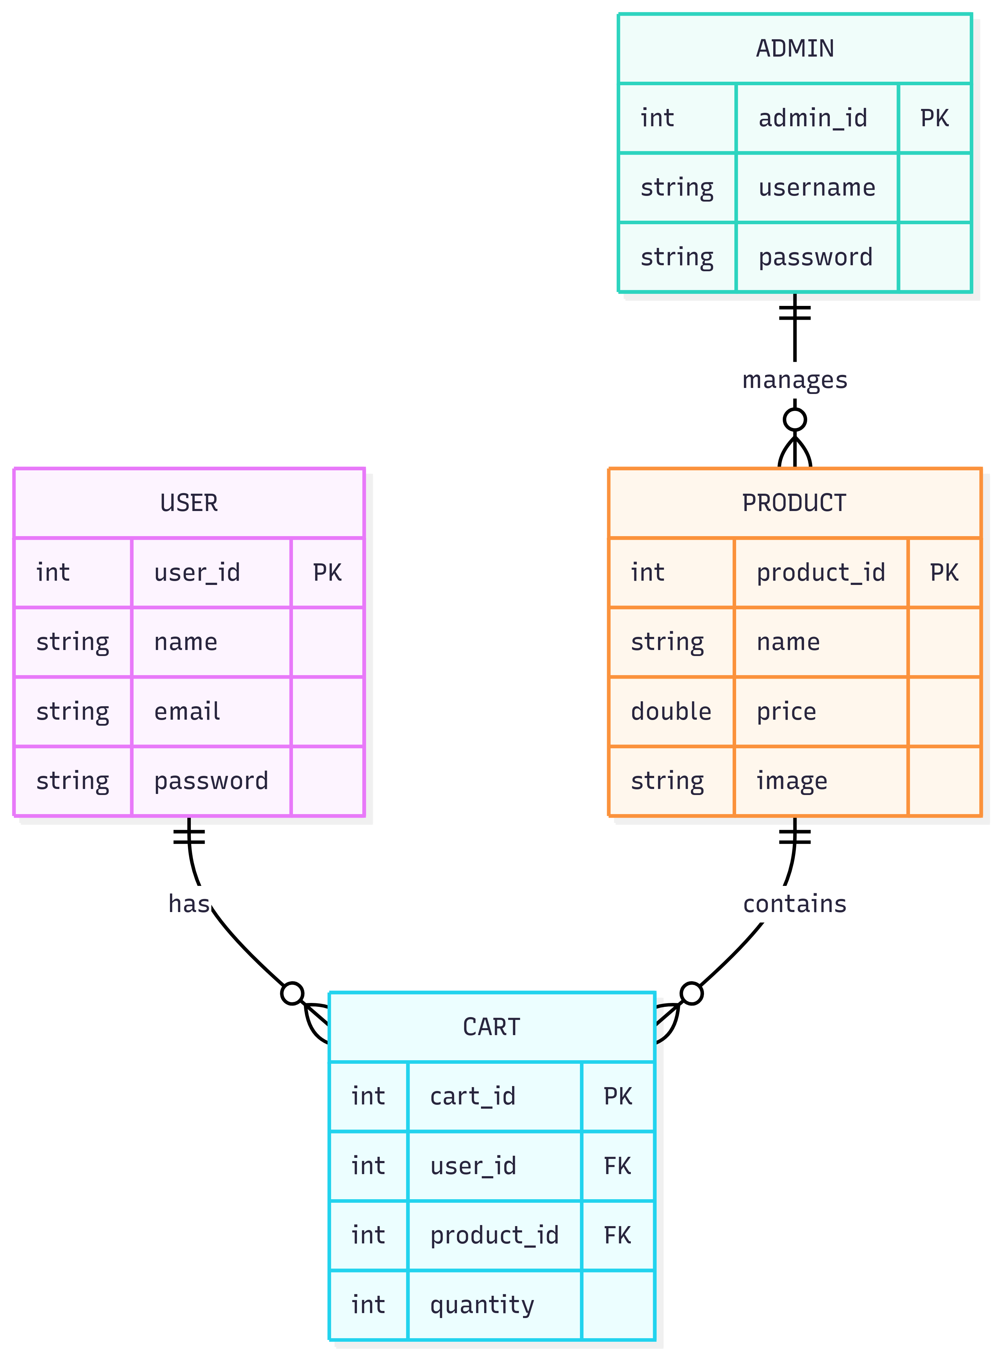

5.5 Menu Design
- User Panel: Home, View Products, Cart, Checkout, Logout.
- Admin Panel: Add Product, View Products, Logout.
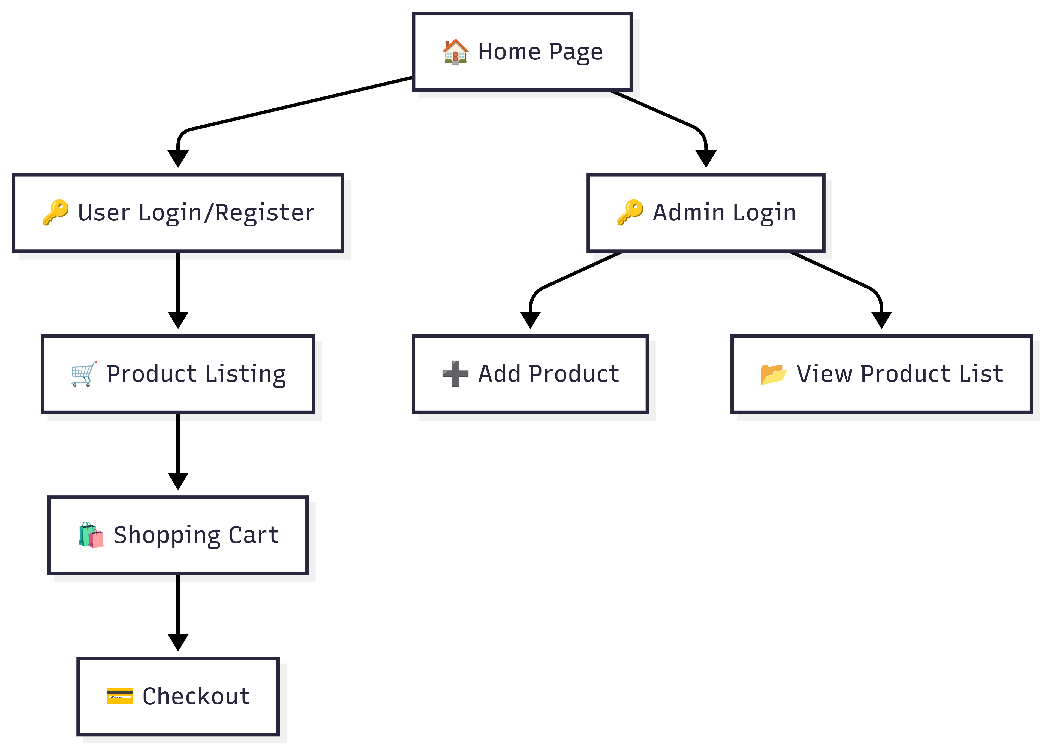

5.6 Screen Design
- Login Page – Separate login for user and admin.
- User Pages – Product listing, shopping cart, checkout page.
- Admin Pages – Add new product, view product list.
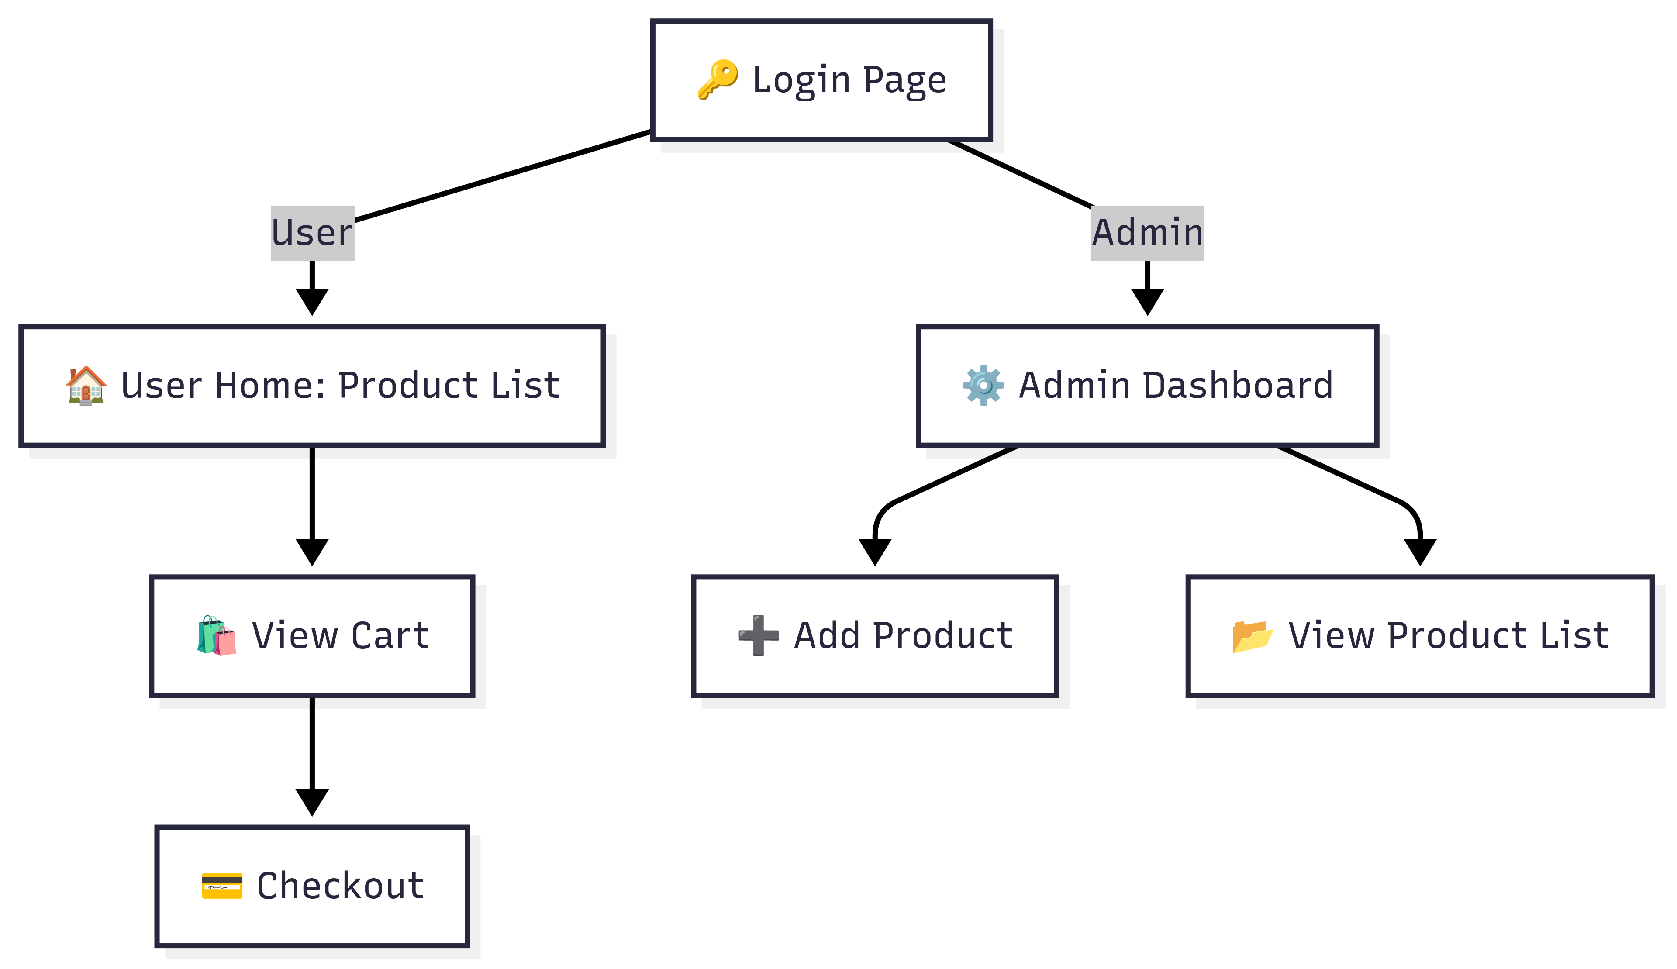

CONCLUSION:
The Coffee & Bakery Shop System provides a simple, efficient, and user-friendly solution for small shops to move online. With core features like cart management and product administration, it demonstrates how even small businesses can adopt digital platforms.

LEARNING DURING PROJECT WORK:
- Practical implementation of PHP & MySQL.
- Designing an e-commerce database schema.
- Handling sessions for login/logout.
- Implementing a shopping cart system.
- Frontend design with HTML/CSS.
- Realizing the importance of combining backend logic with UI/UX.

BIBLIOGRAPHY:

8.1 Online References
- PHP Documentation – https://www.php.net/
- MySQL Documentation – https://dev.mysql.com/doc/
- W3Schools (PHP, MySQL, HTML, CSS) – https://www.w3schools.com/

8.2 Offline References
- Classroom Notes
- Reference Books on PHP, MySQL & Web Development

