Algorithmic Analysis
  - Verified analysis pipeline, correctness boundaries and complexity

Project | PQMigrate - Post-Quantum Cryptography Migration Analysis Tool
Document | Algorithmic Analysis
Version | 1.0
Baseline | main at commit 74b7ba4
Prepared | 27 September 2026

Review position. This document describes the verified D0-D11 prototype. It separates implemented evidence from planned work and preserves UNKNOWN/ABSTAIN when the available evidence is insufficient.

Executive summary
PQMigrate is a conservative source-analysis prototype for post-quantum migration planning. It first discovers cryptographic evidence, then attempts a bounded semantic classification, and finally produces role-aware advice or an explicit abstention. It does not execute the scanned source and it does not authorize automatic code mutation.
Question | Verified answer
What does it analyze? | Supported Python and Go source files in an approved tree.
How does it reason? | Python AST plus bounded identity/data-flow links; Go regex detection remains partial.
What does it output? | Schema 2.2 JSON, decision traces, multi-axis priority, SARIF 2.1.0 and CycloneDX 1.7 CBOM.
What happens under uncertainty? | The role becomes UNKNOWN and the planner abstains.
Does it patch code? | No. D11 enforces a fail-closed gate; current reports cannot authorize mutation.

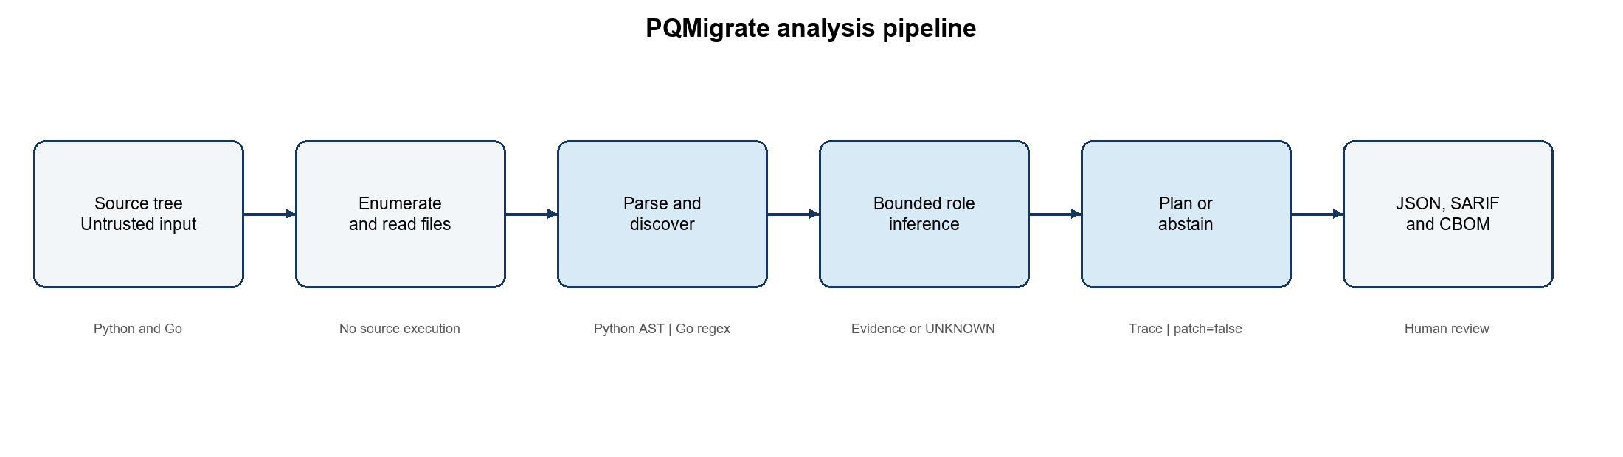
Figure 1. Verified PQMigrate analysis pipeline

1. Problem definition
A cryptographic primitive name is not enough to choose a post-quantum replacement. RSA may sign a JWT, encrypt application data, or transport a session secret. These uses have different migration families and compatibility requirements. PQMigrate therefore treats a finding as an evidence-backed observation rather than a direct replacement instruction.
The central design invariant is: discover the operation before planning migration. A bare import or key-generation call is retained as an inventory lead, but it does not prove signature, key establishment, or key transport.

1.1 Inputs and outputs
Category | Contents
Inputs | Approved source directory; supported file extensions; scanner options; versioned YAML rule registry.
Intermediate evidence | AST spans, resolved imports, same-scope assignments, linked call sites, parse failures and skipped files.
Outputs | CryptoIR findings, MigrationPlan or abstention, DecisionTrace, priority vector, coverage/error ledger and standards exports.
Safety boundary | No target-source execution during scanning; no general automatic patch; untrusted report fields cannot grant mutation authority.

2. End-to-end algorithm
SCAN(source_tree, rule_registry):
report <- new versioned report
for each accepted file in deterministic order:
read source without executing it
if Python: parse AST; emit supported candidates and inventory leads
if Go: apply documented regex detectors; preserve limitations
for each RSA lead:
collect same-scope key and secret assignments
link the exact key and argument to supported consumers
infer SIGNATURE, KEY_TRANSPORT, or UNKNOWN
match role-aware advisory rule; otherwise ABSTAIN
attach evidence, blockers, decision trace, and priority axes
validate and export JSON; optionally convert to SARIF and CBOM
leave patch_available=false
return report

2.1 Deterministic file processing
Files are enumerated in a repeatable order. Unsupported, ignored, unreadable or invalid files are represented by exclusions or errors rather than silently disappearing. A fatal worker failure, timeout, missing output or invalid JSON results in FAILED; it is never converted into a successful empty report.

2.2 Python discovery
Python source is parsed into an abstract syntax tree. The scanner records imports, supported calls, source locations, assignments and selected consumer relationships. AST analysis avoids executing the target project and provides structural locations that are more precise than plain text matching.

2.3 Go discovery
The current Go path uses bounded regular-expression detectors. It can find basic standard-library crypto patterns, but it does not provide alias-sensitive symbol resolution or the semantic guarantees of the Python resolver. D4 is therefore reported as partial.

2.4 Bounded RSA role inference
Evidence pattern | Result | Reason
Tracked generated RSA key reaches jwt.encode with an RS* algorithm | SIGNATURE + JWT | The exact key identity and supported signing sink are linked.
RSA encrypt consumes a tracked locally generated session secret | KEY_TRANSPORT | Both secret generation and encryption evidence are linked.
RSA import or unused generation only | UNKNOWN | Primitive presence does not establish an operation.
jwt.encode uses an unrelated key | UNKNOWN | Proximity is insufficient; object identity is not established.
One tracked key has conflicting supported roles | UNKNOWN | The resolver abstains when it cannot separate provenance safely.

3. Planning and decision trace
The versioned D7 registry contains nine validated advisory rules. Rules are matched by typed role and context rather than by primitive name alone. Duplicate identifiers, unsupported roles and rules that attempt to enable automatic patching are rejected during registry loading.
- Detection records the observed source location and recognized API.
- Role inference records the resolved role or UNKNOWN and its evidence.
- Rule matching records the selected rule ID and rule version.
- Blocker assessment records protocol, provider, interoperability and test prerequisites.
- Decision records recommend or abstain; it never authorizes mutation in the current release.
Trace identifiers exclude run IDs and timestamps, so equivalent semantic input and rule versions produce the same trace identity. This supports comparison across repeated scans while retaining a separate run-level scan ID.

4. Complexity analysis
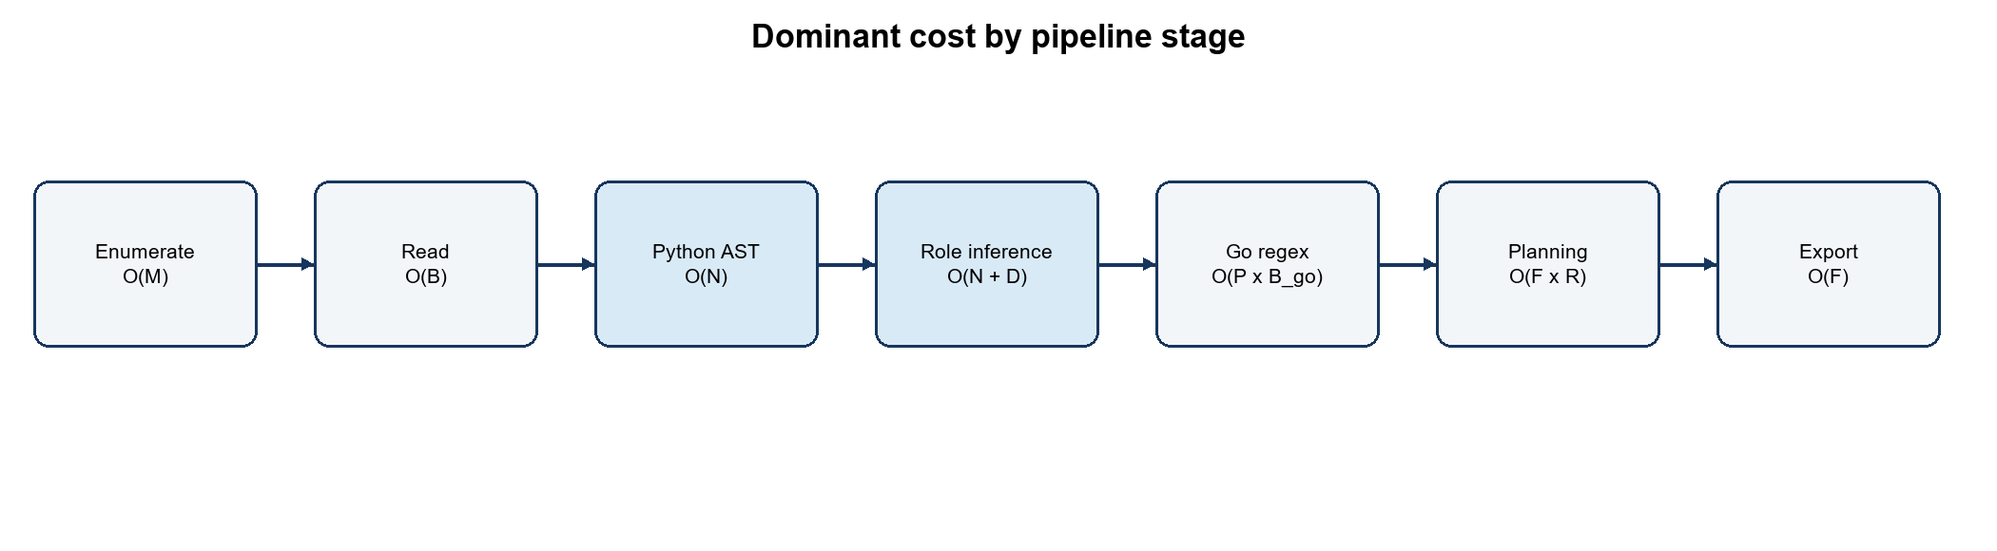
Figure 2. Cost model by stage
Stage | Variables | Time | Space | Qualification
File enumeration | M files | O(M) | O(M) or streaming | Depends on directory traversal and exclusion bookkeeping.
Source reading | B bytes | O(B) | O(B_file) | Total bytes read; implementation processes files separately.
Python parse/traverse | N AST nodes | O(N) | O(N) | Ordinary parser behavior; malformed files are recorded.
Bounded inference | N nodes, D links | O(N + D) | O(N + D) | Indexed tracked variables and bounded same-scope links.
Go regex | P patterns, B_go bytes | About O(P x B_go) | Pattern dependent | No universal linear-time claim is made.
Planning | F findings, R rules | O(F x R) | O(F) | R is nine in the current registry; effectively bounded.
Report/export | F records | O(F) | O(F) | Before external schema-validation overhead.
D11 audit | 5 tri-state gates | O(3^5)=243 | O(1) | Exhaustive fixed policy-space test, not a source-scan cost.

Asymptotic bounds describe growth, not measured performance. Wall time, file count, source bytes, parser failures and peak memory must be recorded for pinned workloads before making scale claims.

5. Correctness and failure behavior

5.1 Soundness strategy
- Require object-identity links for the two supported RSA inference cases.
- Separate findings from plans so an observation cannot silently become a migration action.
- Treat unknown or conflicting evidence as an abstention, not as a low-confidence automatic choice.
- Preserve rule version, source location, blockers and unresolved fields in each decision trace.
- Validate standards exports against pinned official schemas before writing final artifacts.

5.2 Known limitations
Limitation | Impact | Required next evidence
Go regex analysis | Aliases and semantic call targets may be missed or misclassified. | Go parser/type resolution plus positive and negative fixtures.
Bounded Python flows | Parameter, return-value, container and cross-module flows can be missed. | Explicit interprocedural design and independently labelled evaluation.
Synthetic D9 dataset | Metrics do not establish repository-level or product-wide accuracy. | Real-project corpus, two labelers, blinded predictions and adjudication.
No interoperability execution | Advice cannot prove endpoint or stored-artifact compatibility. | Pinned providers, peer inventory and observed negotiation/tests.
No approved transformation | A recommendation cannot be presented as a safe patch. | Construction-specific policy, isolated preview, tests, authorization and rollback.

6. Verification evidence
Evidence | Verified result | Claim boundary
Python pytest | 47 tests pass | Covers implemented unit/integration fixtures, not arbitrary repositories.
Legacy scanner checks | 23 of 23 pass | Preserves earlier Day-5 behavior.
Maven tests | 5 tests pass | Backend unit/build evidence; browser flow remains unverified.
Frontend build | Production build passes | Bundle-size warning remains; no browser E2E claim.
D9 pilot | 72 cases; 68 evaluated; 4 parse failures | Precision 1.000000, recall 0.769231, F1 0.869565 on the narrow synthetic pilot.
D10 exports | SARIF 2.1.0 and CycloneDX 1.7 validate | Third-party platform ingestion remains integration work.
D11 policy | 243 assignments; only all-true theoretically eligible | Current reports leave four gates unknown; mutation remains disabled.

7. Reproduction checklist
cd /home/ratneshp0411/pqc_migration_tool
scripts/validate_d0_d11.sh
# D4 is intentionally PARTIAL; use --strict to return exit code 2.
scripts/review_smoke.sh
The review artifact directory records raw outputs and the D0-D11 matrix. A reviewer should compare the source commit, scanner version, rules version, schema version, command exit statuses and fixture outputs before accepting a claim.

References
[1] National Institute of Standards and Technology, FIPS 203, Module-Lattice-Based Key-Encapsulation Mechanism Standard, 2024.
[2] National Institute of Standards and Technology, FIPS 204, Module-Lattice-Based Digital Signature Standard, 2024.
[3] National Institute of Standards and Technology, FIPS 205, Stateless Hash-Based Digital Signature Standard, 2024.
[4] OASIS, Static Analysis Results Interchange Format Version 2.1.0.
[5] OWASP, Software Component Verification Standard and secure source-analysis guidance.
[6] PQMigrate repository documentation: review evidence, schema specification, D7-D11 milestone records, commit 74b7ba4.

