UML and Data Flow Design
  - Architecture, interactions, state and trust boundaries

Project | PQMigrate - Post-Quantum Cryptography Migration Analysis Tool
Document | UML and Data Flow Design
Version | 1.0
Baseline | main at commit 74b7ba4
Prepared | 27 September 2026

Review position. This document describes the verified D0-D11 prototype. It separates implemented evidence from planned work and preserves UNKNOWN/ABSTAIN when the available evidence is insufficient.

Design overview
The diagrams describe the verified analysis architecture and explicitly separate observations, advisory plans and mutation eligibility. The Python scanner is the semantic source of truth; the Spring service orchestrates jobs, ownership and storage; the React interface presents evidence when used. Current review evidence is CLI-primary.
Notation | Meaning
Solid process/entity boxes | Implemented or represented in the current design.
UNKNOWN / ABSTAIN | A deliberate analysis result, not an error or a low-confidence patch.
Report store or JSON file | Local artifact in CLI mode; persisted record when backend mode is used.
PatchGate | Independent future-mutation boundary; current reports cannot make it pass.

1. System context
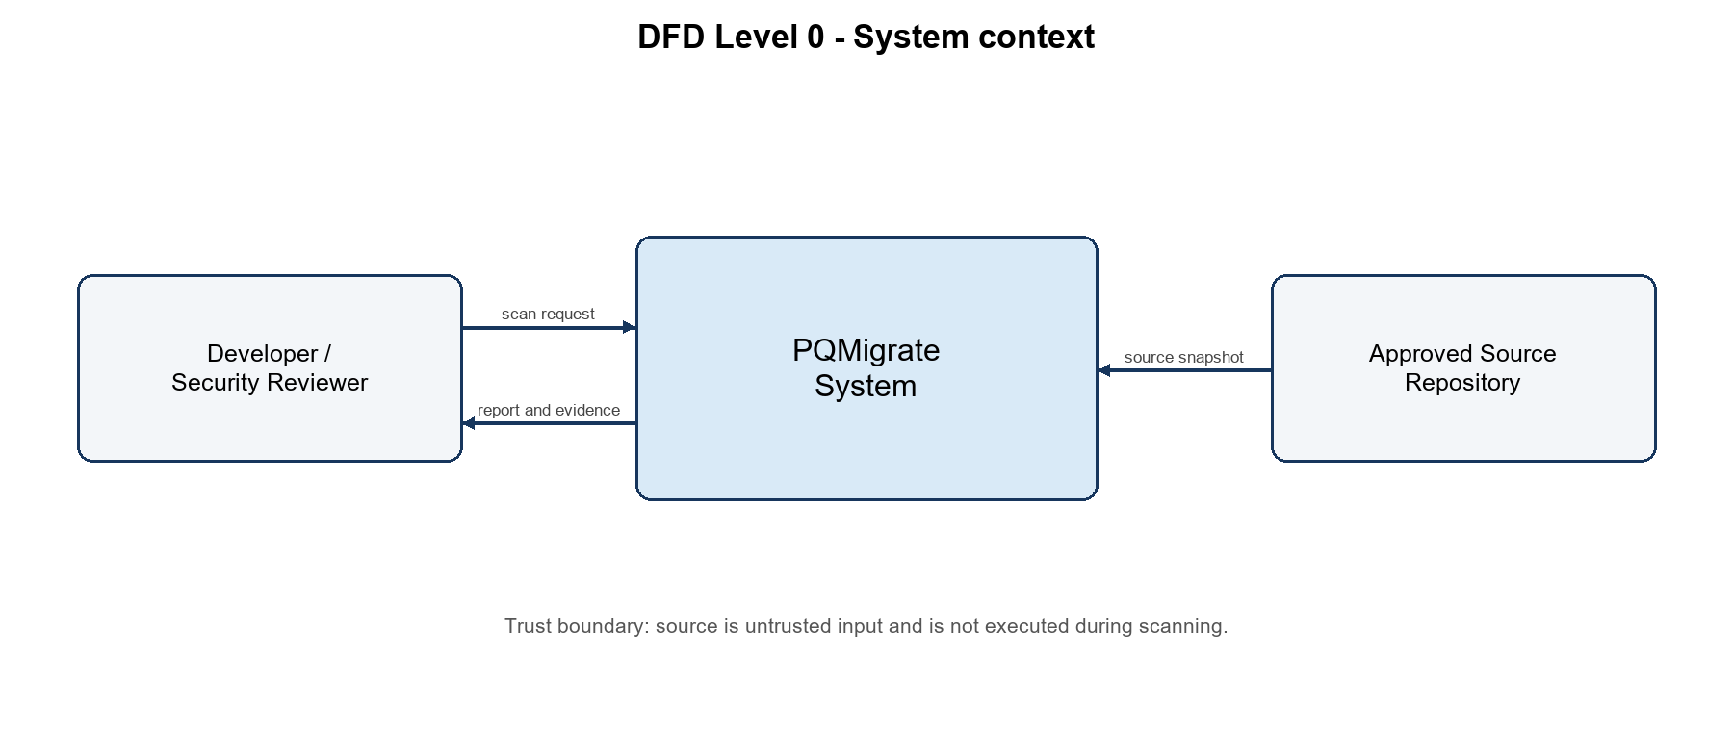
Figure 1. DFD Level 0 - PQMigrate context and trust boundary
The developer supplies a scan request and receives findings, evidence, coverage and advisory plans. The source repository is a separate external entity because it is untrusted input. The scanner reads accepted source files without executing the target project. A future verification runner belongs behind a separate controlled boundary.
Level-0 flow | Data
Developer to PQMigrate | Approved path/reference, options and identity when remote mode is used.
Repository to PQMigrate | Source snapshot and metadata.
PQMigrate to Developer | Versioned findings, errors/skips, evidence, decisions and standards exports.

2. Level-1 data flow
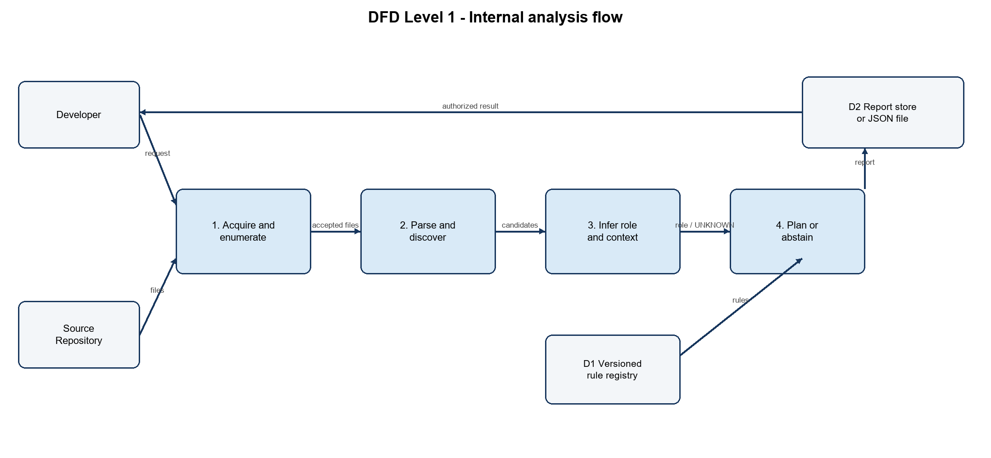
Figure 2. DFD Level 1 - analysis decomposition
Process | Input | Output | Status
P1 Acquire and enumerate | Request and source snapshot | Accepted files, exclusions and read errors | Implemented
P2 Parse and discover | Accepted files | Candidates, inventory leads and source spans | Python implemented; Go partial
P3 Infer role/context | Candidates and bounded identity links | Role plus evidence or UNKNOWN | Implemented for declared Python RSA cases
P4 Plan or abstain | Role, context and D1 rules | Advisory plan/ABSTAIN, trace and priority | Implemented; patch disabled
D1 Rule registry | Versioned YAML | Typed advisory rules and validation status | Nine rules
D2 Report store / JSON | Versioned report | Authorized output and exports | CLI verified; backend unit-level

Balancing check: the level-0 request and source inputs reappear in P1; the findings/report output reappears as the authorized D2-to-developer flow. D1 and D2 are internal stores, not external actors.

3. UML class model
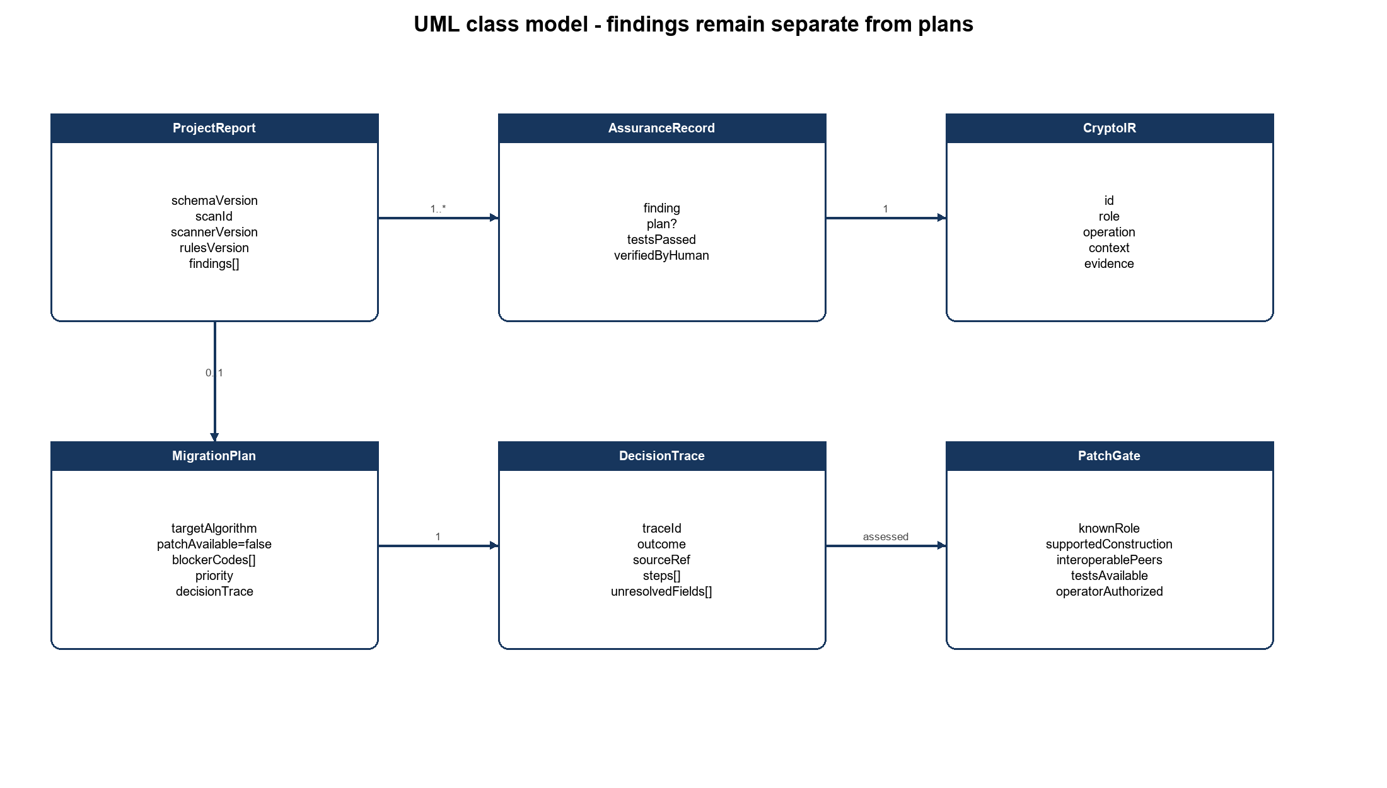
Figure 3. Core domain classes and associations

3.1 Class responsibilities
Class | Responsibility | Important invariant
ProjectReport | Run-level schema, versions, counts, errors and records. | A fatal scan failure cannot be represented as a clean completed report.
AssuranceRecord | Wraps one finding and optional plan plus verification flags. | Verification flags do not grant mutation authority.
CryptoIR | Typed source observation with location, role, operation, context and confidence. | Ambiguous evidence remains UNKNOWN.
MigrationPlan | Conditional family, blockers, priority and decision trace. | patchAvailable is false in current output.
DecisionTrace | Deterministic explanation from detection through decision. | Five ordered stages and unresolved fields are preserved.
PatchGate | Independent tri-state eligibility assessment. | Only K=S=I=T=O=true is eligible; current reports fail closed.

The most important separation is between CryptoIR and MigrationPlan: a finding records what was observed; a plan records conditional advice. PatchGate remains separate from both, so a report cannot approve its own mutation.

4. UML sequence
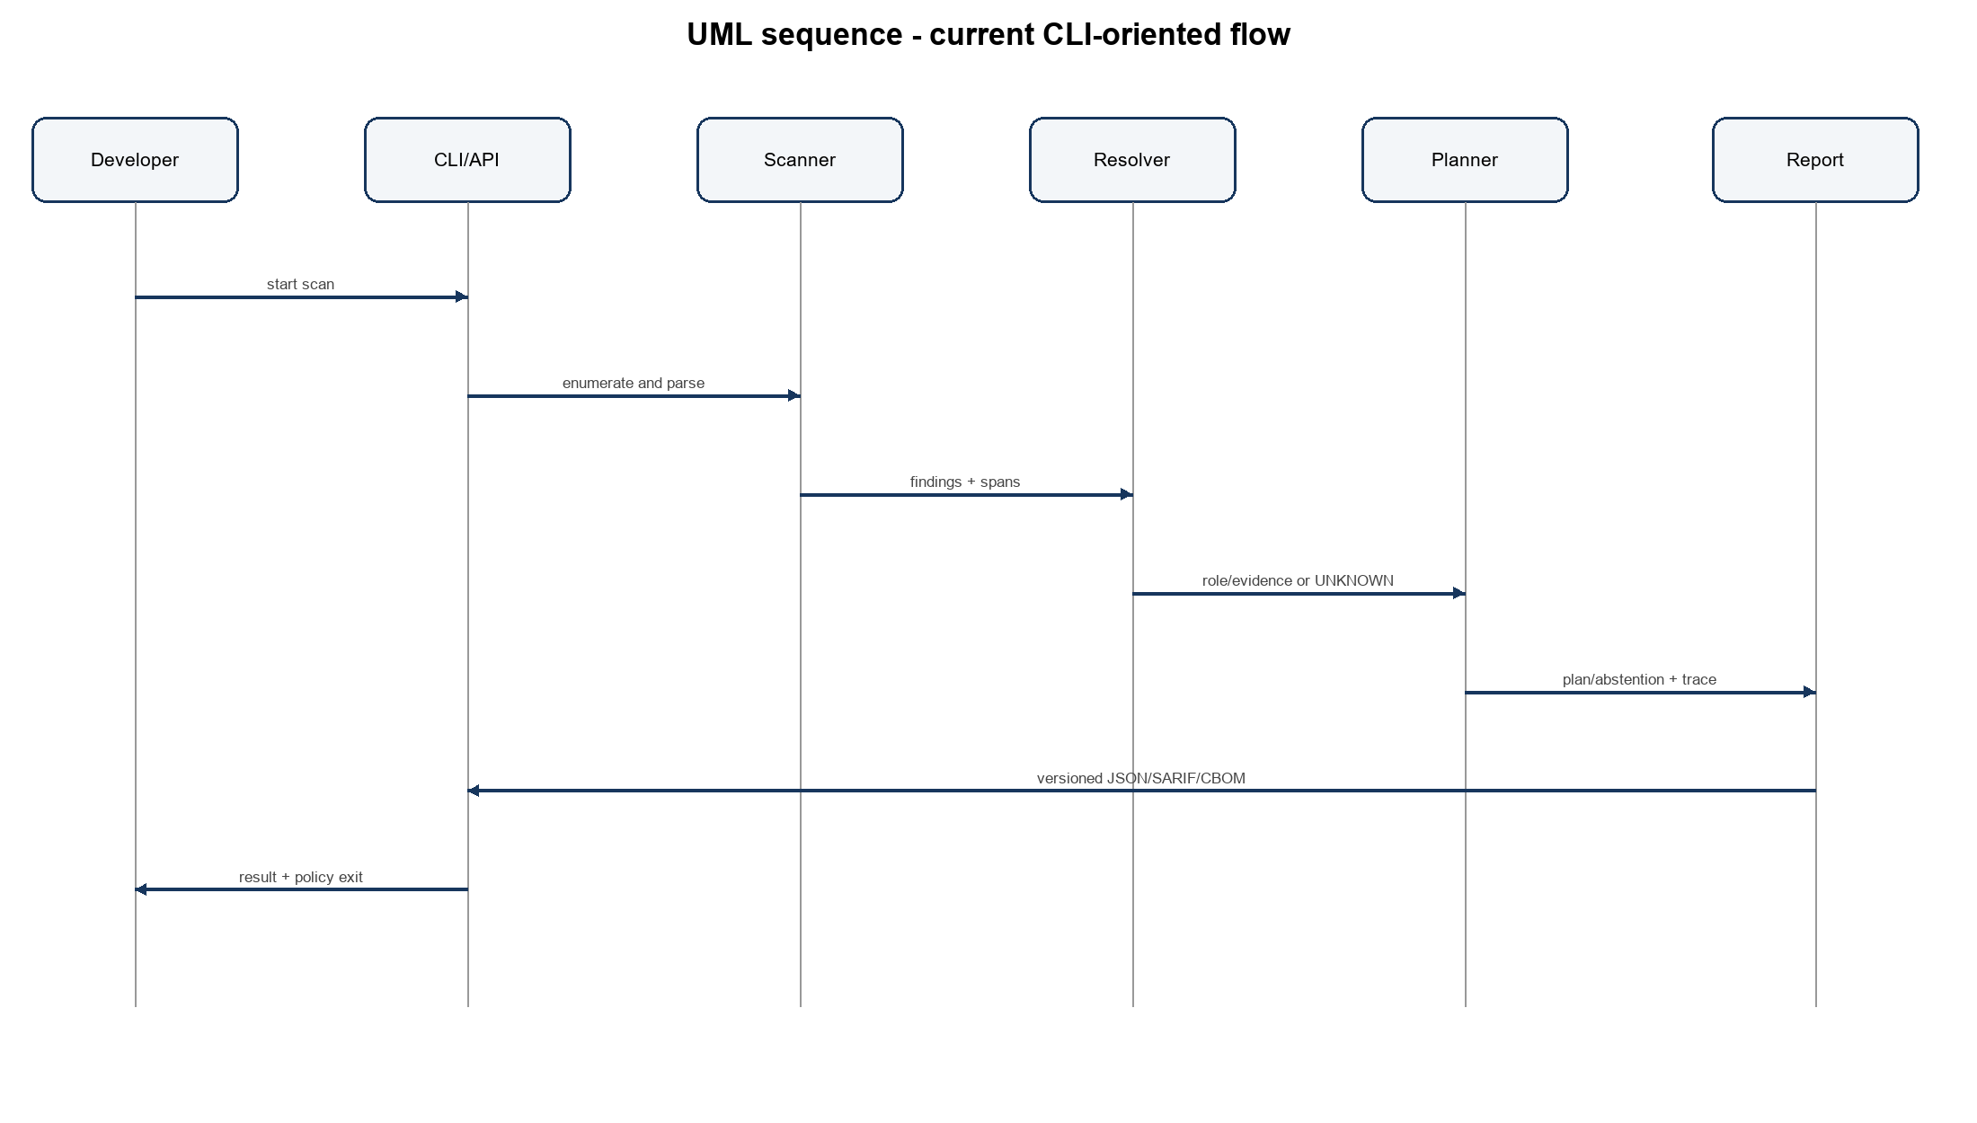
Figure 4. Current CLI-oriented scan sequence
- The developer starts a scan of an approved source tree.
- The CLI or API invokes the scanner, which enumerates and parses without executing target source.
- The scanner supplies findings and source spans to the bounded resolver.
- The resolver returns role/context evidence or UNKNOWN.
- The planner matches a versioned advisory rule or abstains and attaches a decision trace.
- The report layer emits schema 2.2 JSON and optional SARIF/CBOM artifacts.
- The developer receives the result and a policy-relevant exit status.
In backend mode, the API stores the report under the owning user and returns a scan identifier. The authenticated browser flow has not been verified end to end, so it is not the primary review sequence.

5. UML state model
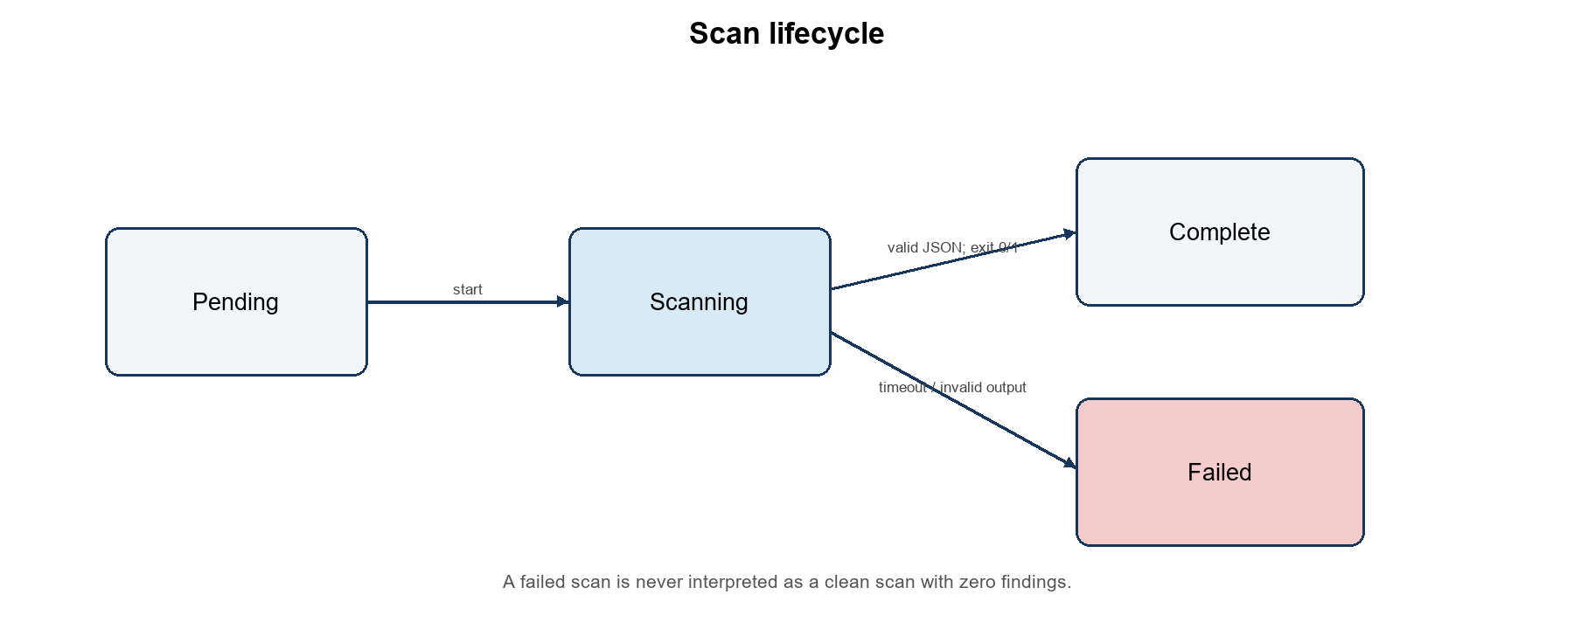
Figure 5. Scan lifecycle and fail-closed transition

State | Entry condition | Exit condition
Pending | Request accepted but worker not yet producing results. | Worker starts, request is cancelled, or orchestration fails.
Scanning | Worker is processing the source snapshot. | Valid JSON with accepted exit semantics, or timeout/exception/invalid output.
Complete | Worker exits 0 or 1 and a valid report exists. | Terminal for the current scan record.
Failed | Timeout, exception, missing output or invalid JSON. | Terminal; never interpreted as zero findings.

6. Deployment view
Component | Technology / role | Boundary
Scanner and planner | Python modules, AST resolver, YAML rules, schema/export logic | Semantic source of truth; local CLI path is verified.
Orchestrator | Spring service | Job lifecycle, owner-scoped records and worker-output validation.
Presentation | React dashboard | Displays evidence and plans; production build passes, browser E2E pending.
Artifact interfaces | JSON schema 2.2, SARIF 2.1.0, CycloneDX 1.7 | Versioned interchange; local schema validation verified.
Future verification sandbox | Disposable worktree/container | Not an approved mutation path in D11.

Duplicating cryptographic decision rules in Java and Python would risk conflicting outputs. The design keeps crypto semantics and rule evaluation in Python; Java orchestrates and stores, while React presents the versioned result.

7. Trust boundaries and controls
Boundary | Threat | Control
Repository to scanner | Malicious or malformed source. | Read-only analysis, no target import/execution, parse-error ledger and bounded processing.
Worker to backend | Missing, truncated or crafted output. | Valid JSON required; timeout/exception/invalid output produces FAILED.
Report to patch policy | Self-asserted patch eligibility. | Independent D11 gate ignores report claims as authority.
User to stored scans | Cross-user identifier guessing. | Owner-scoped list/detail/delete service operations; aggregate isolation remains pending.
Export to third party | Schema mismatch or unintended source disclosure. | Pinned schema validation and minimal evidence fields; platform import separately tested.
Future patch sandbox | Untrusted tests or incompatible change. | Disposable copy, isolation, timeouts, authorization, rescan and rollback; not yet approved.

8. Requirements-to-diagram traceability
Requirement | Diagram element | Review evidence
FR-01 to FR-04 | DFD P1/P2; Scan lifecycle | File/parse/error ledger and worker failure tests.
FR-05 to FR-06 | DFD P3; CryptoIR | Signature, key-transport and unknown fixtures.
FR-07 to FR-10 | DFD P4/D2; MigrationPlan; DecisionTrace | Schema 2.2, nine-rule registry, five-stage traces and patch=false.
FR-11 | Report sequence endpoint | Validated SARIF and CBOM artifacts.
FR-13 / FR-16 | PatchGate and trust boundary | 243 assignments, 242 refusals; no transformation approved.
FR-14 / FR-15 | Backend/presentation deployment components | Owner-scoped service tests; browser E2E pending.

9. Diagram review checklist
- Trace a source request through P1-P4 to D2 and back to the developer.
- Confirm level-0 and level-1 inputs/outputs are balanced.
- Confirm a finding is not modelled as a migration plan or patch authorization.
- Confirm UNKNOWN and FAILED are explicit states with conservative behavior.
- Confirm Go semantic resolution, browser E2E and patch execution are not shown as fully verified.
- Confirm every current output is advisory and tied to versions and source evidence.

References
[1] National Institute of Standards and Technology, FIPS 203, Module-Lattice-Based Key-Encapsulation Mechanism Standard, 2024.
[2] National Institute of Standards and Technology, FIPS 204, Module-Lattice-Based Digital Signature Standard, 2024.
[3] National Institute of Standards and Technology, FIPS 205, Stateless Hash-Based Digital Signature Standard, 2024.
[4] OASIS, Static Analysis Results Interchange Format Version 2.1.0.
[5] OWASP, Software Component Verification Standard and secure source-analysis guidance.
[6] PQMigrate repository documentation: review evidence, schema specification, D7-D11 milestone records, commit 74b7ba4.

