HTML — Step-by-step Notes (Complete)

1. Setup & Starter Template
What: How to create and open an HTML file.
Example:
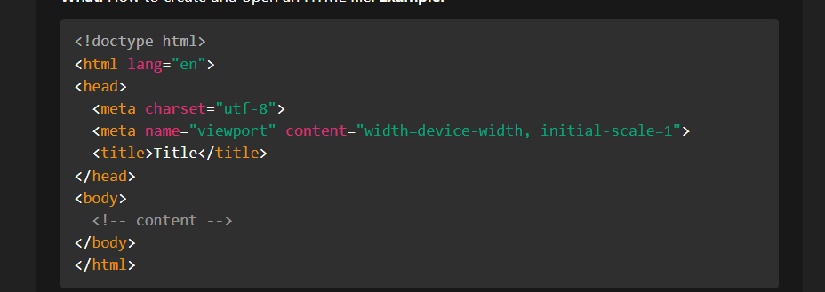
Practice: Create index.html, paste the template, open in browser.

2. Document Structure & Core Tags
<!doctype html> — declares HTML5
<html> — root element
<head> — metadata, title, links
<body> — visible content
Practice: Label each part of the starter template on paper.

3. Headings, Paragraphs & Text Formatting
Headings: <h1> to <h6> (importance order)

Paragraph: <p>
Inline formatting: <strong> (bold), <em> (italic), <small>, <mark>, <code>
Comments: <!-- comment -->
Practice: Write a short paragraph using at least two inline tags.

4. Links (<a>) and Anchors

Basic: <a href="https://example.com">Link</a>Open in new tab: target="_blank" rel="noopener"Internal anchors: <a href="#section1">Go</a> and <h2 id="section1">Section</h2>
Practice: Add an external and internal link to your page.

5. Images (<img>)
Syntax: <img src="path" alt="description" width="300">
Always include alt for accessibility
srcset and sizes for responsive images (advanced)
Practice: Insert an image and write a good alt text.

6. Lists
Unordered: <ul><li>...</li></ul>

Ordered: <ol>
Description list: <dl><dt>Term</dt><dd>Definition</dd></dl>
Practice: Create a ul of 5 skills and an ol of 3 steps.

7. Tables
Use for tabular data only: <table>, <thead>, <tbody>, <tr>, <th>, <td>
Avoid for layout
Practice: Make a 3x3 table with headings.

8. Forms & Inputs
Basic controls: <input>, <textarea>, <select>, <button>
Common input type values: text, email, password, checkbox, radio, submit.
Use <label for="id"> to associate labels.
name attribute is required to submit data.
Practice: Build a small contact form with name, email, message, and a submit button.

9. Semantic HTML
Semantic tags: <header>, <nav>, <main>, <section>, <article>, <aside>, <footer>
Use semantics for clarity, SEO, and accessibility
Practice: Structure your profile page using these tags.

10. Accessibility Basics
alt text for images

label elements for form inputs
Use proper heading order (h1 then h2 etc.)
Keyboard-friendly navigation
ARIA attributes (role, aria-label, aria-hidden) when necessary
Practice: Run a browser accessibility checker (or read Lighthouse suggestions) and fix one issue.

11. Multimedia (Audio & Video)
<audio controls src="audio.mp3"> and <video controls src="video.mp4">
Provide captions/transcripts when possible
Practice: Embed a short example media file or an external stream.

12. Linking CSS and JavaScript
CSS: <link rel="stylesheet" href="styles.css"> in <head>
JS: <script src="script.js" defer></script> before </body> or in head with defer
Practice: Create styles.css and script.js, change a style and console.log a message.

13. Meta Tags & Document Metadata
<meta charset="utf-8">
<meta name="viewport" content="width=device-width, initial-scale=1">
<meta name="description" content="short summary"> — useful for search engines
Practice: Add a meta description and check the page source.

14. Responsive Design Basics
Viewport meta (already in template)
Use relative units (%, em, rem) and media queries in CSS
Make images max-width: 100%
Practice: Create a container that changes layout when window width is < 600px.

15. HTML Forms: Validation & Attributes
Built-in validation: required, minlength, maxlength, pattern, type="email"
placeholder, autocomplete, disabled, readonly
Practice: Add required and type="email" to the contact form.

16. Best Practices & Tips
Keep HTML semantic and minimal — styles in CSS, behavior in JS
Use descriptive file names and folder structure (css/, js/, images/)
Test in multiple browsers and devices
Use rel="noopener noreferrer" for external links

17. Quick Tag Cheat Sheet (useful for notes)
Document: <!doctype html>, <html>, <head>, <body>
Text: <h1>–<h6>, <p>, <span>, <strong>, <em>
Media: <img>, <audio>, <video>
Links: <a href>

Lists: <ul>, <ol>, <li>
Table: <table>, <tr>, <td>, <th>
Form: <form>, <input>, <label>, <textarea>, <select>
Semantic: <header>, <nav>, <main>, <section>, <article>, <aside>, <footer>

