⚛️ 1️⃣ What is React?
React is a JavaScript library (not a full framework) used for building user interfaces (UI) — especially single-page applications (SPAs).
It was developed by Facebook (Meta) and is now one of the most popular front-end tools worldwide.
In simple terms:
🧠 React helps you build dynamic, fast, and reusable web pages using small building blocks called components.

🎨 2️⃣ Why Do We Use React?
Let’s understand why developers prefer React over plain JavaScript.
Need | Problem with Plain JavaScript | How React Helps
🧱 UI Reusability | You manually create and manage HTML & JS for every page. | React lets you create components (reusable UI blocks) like <Header />, <Footer />, etc.
⚡ Dynamic Updates | If data changes, you have to manually update the DOM. | React automatically updates only what changed using its Virtual DOM.
🔁 Code Maintenance | Hard to manage big apps with many JS files. | React divides UI into independent components, easier to debug & maintain.
🚀 Performance | Frequent DOM updates are slow. | React’s Virtual DOM makes updates fast.
🔍 Single Page Apps | You reload the page every time you navigate. | React uses React Router, so pages change without reloading (SPA).
So, React is all about:
👉 Reusability
👉 Performance
👉 Simplicity

🧩

3️⃣ How React Works (In Simple Terms)
React uses:
Components: Small UI blocks (like functions returning JSX)
JSX: A special syntax that lets you write HTML inside JavaScript
Virtual DOM: A virtual copy of the real DOM that React uses to update only necessary parts
Hooks: Like useState, useEffect — for handling state and lifecycle events

📘 Example:
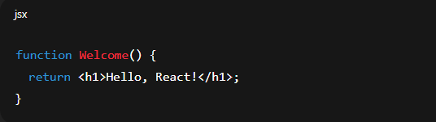This function is a React Component. It returns JSX, which looks like HTML but runs inside JavaScript.

💡 4️⃣ Difference Between React and JavaScript
Feature | JavaScript | React
Type | Programming language | JavaScript library
Purpose | Used for all kinds of web logic (frontend, backend, etc.) | Used only for building UI (frontend)
DOM Handling | You directly manipulate the DOM using document.getElementById etc. | React automatically updates the DOM with Virtual DOM
Reusability | No built-in component structure | Uses components for reusability
Data Handling | You manage state manually | Uses state & props to manage data
Syntax | Pure JS syntax | Uses JSX (HTML + JS mixed syntax)
Performance | Slower on large apps | Faster due to Virtual DOM

🧠 Simple Example
In Plain JavaScript:
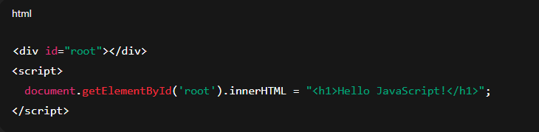
In React:
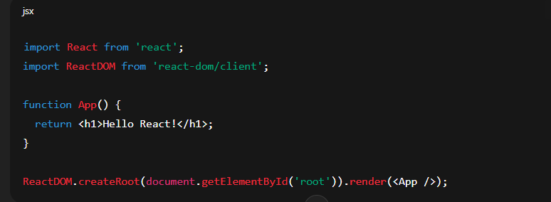
👉 React version looks cleaner, reusable, and automatically handles rendering efficiently.

🧩 5️⃣ In Summary
Key Point | Meaning
🧱 React is | A JavaScript library for building UI
🧠 Created by | Facebook (Meta)
⚡ Helps you | Build fast, reusable, and dynamic web apps
💬 Uses | Components, JSX, Virtual DOM, Hooks
🔍 Difference | React is built on top of JavaScript — it uses JavaScript, not replaces it

