Day 1-(Java basics,Keywords,Variables,Data types)

syntax of Java

Key Points in Java Syntax
- Case Sensitive → Hello and hello are different.
- Class Name Rule → Should start with a capital letter (MyClass).
- Method Name Rule → Should start with lowercase (myMethod()).
- File Name Rule → File name must be same as public class name (ClassName.java).
- Main Method → Entry point of any Java program:
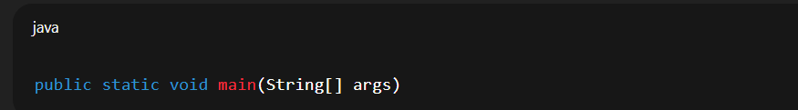
Statements End with Semicolon (;).
Blocks use {} braces.
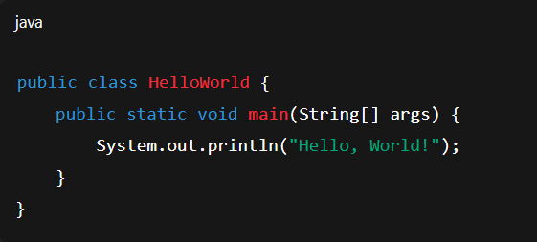

Keywords in Java

In Java, keywords are reserved words that have predefined meanings in the language and cannot be used as identifiers (like variable names, class names, or method names).

List of Java Keywords (as per JDK 21)
- There are 67 keywords in Java:
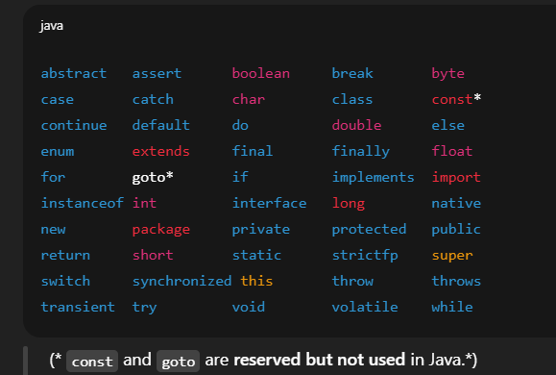

Literals treated as special values (not keywords but reserved):

true
- false
- null

Categories of Java Keywords:
- Data types → int, float, double, char, boolean, byte, long, short
- Control flow → if, else, switch, case, default, for, while, do, break, continue, return
- Access modifiers → public, private, protected
- Class-related → class, interface, extends, implements, package, import
- Exception handling → try, catch, finally, throw, throws
- Object-related → new, this, super, instanceof
- Memory management & others → static, final, abstract, volatile, synchronized, transient, native, strictfp

Variables in Java
A variable is a name given to a memory location that stores a value.
It’s like a container for data.
Syntax of Java Variable
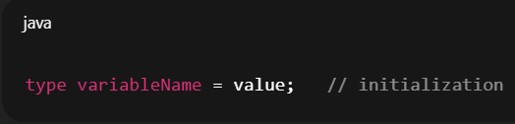
Example
Int roll_no=01;
String name=”Ratnmala”;

2.1 Types of Variables in Java

(A) Local Variables

Declared inside a method, constructor, or block.
- Created when method is called, destroyed when method ends.
- Must be initialized before use.
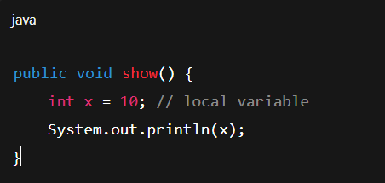

(B) Instance Variables ( Non-static variables)
- Declared inside a class but outside methods.
- Each object has its own copy.
- Stored in heap memory.
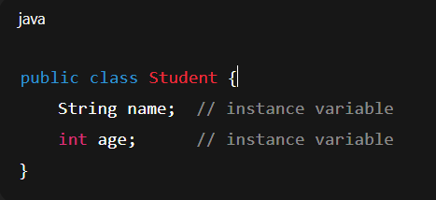

(C) Static Variables (Class variables)
- Declared with static keyword.
- Shared by all objects of the class.
- Stored in method area (class area).
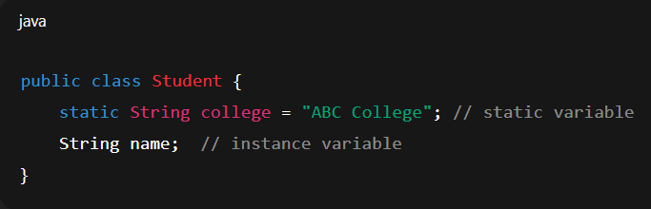

2.3 Variable Declaration Rules
- Must start with a letter, $, or _ (not digit).
- Cannot use Java keywords (int int = 5; ❌).
- Use camelCase convention: studentName, totalMarks.

2.4 Default Values
Local variables → no default value (must initialize).
Instance variables →
- int → 0
- float → 0.0
- boolean → false
- object reference → null
Example
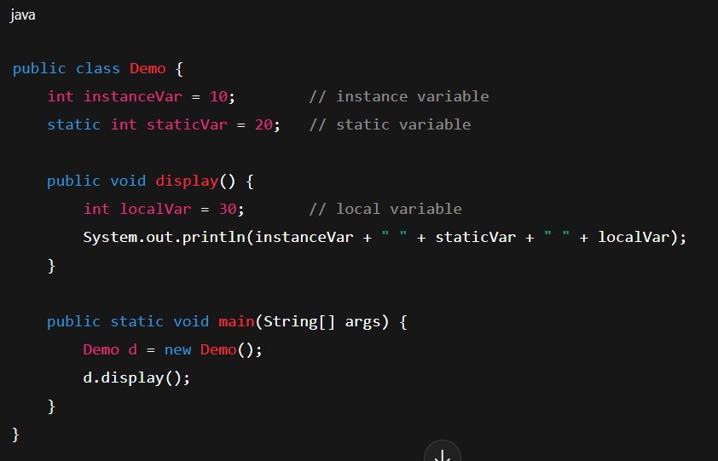
- Data Types In Java:
In Java, data types specify what kind of value a variable can hold.Java data types are divided into two main categories:
1.Primitive Data Types
2.Non-Primitive (Reference) Data Types

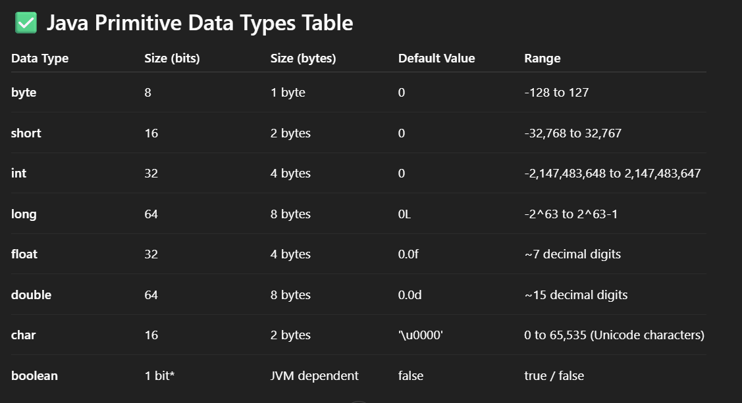
Example:
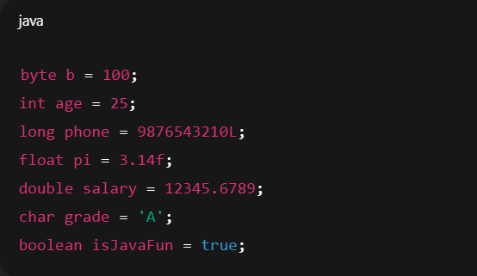

2.Non-Primitive (Reference) Data Types
These are created by the programmer and are not predefined like primitives.
Examples:
- String
- Arrays
- Classes
- Interfaces
- Objects
Example:
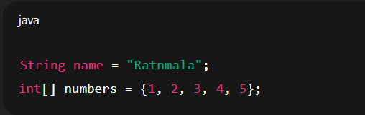

Memory Location :
Primitive types → stored directly in stack.
Reference types → reference stored in stack, actual object in heap.

Type Casting
Converting one data type into another.

Widening (Implicit casting) → smaller → bigger
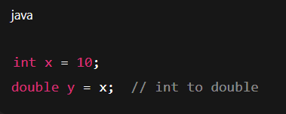

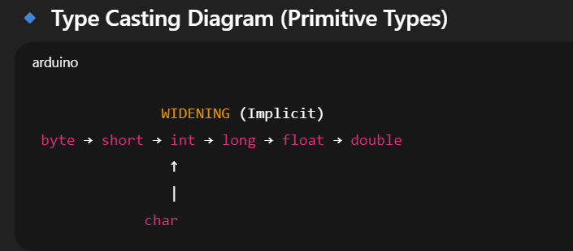

2.Narrowing (Explicit casting) → bigger → smaller
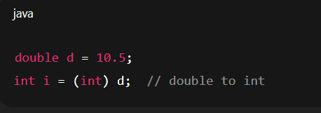

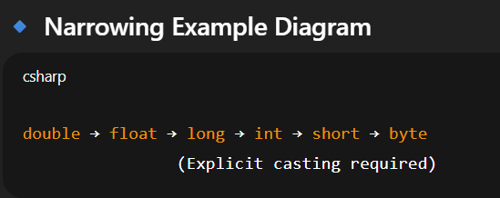

Day 2-(Operators,Control statement)

What are Operators?
- Operators are special symbols in Java used to perform operations on variables and values.

- Types of Operators in Java

1. Arithmetic Operators
- Used for mathematical calculations.
+ (Addition)
- (Subtraction)
* (Multiplication)
/ (Division → gives quotient)
% (Modulus → gives remainder)
- Example:

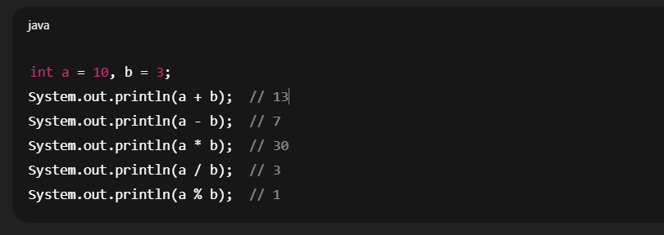

2. Relational (Comparison) Operators
- Used to compare values → returns true or false.
== (equal to)
!= (not equal to)
> (greater than)
< (less than)
>= (greater than or equal to)
<= (less than or equal to)
- Example:
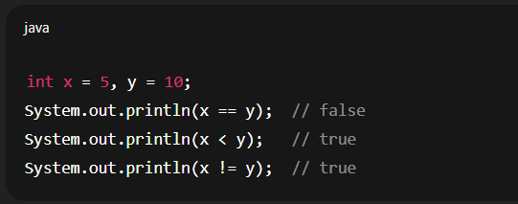

3. Logical Operators
- Used to combine conditions.
&& (Logical AND) → true if both true
|| (Logical OR) → true if at least one true
! (Logical NOT) → reverses condition
- Example:
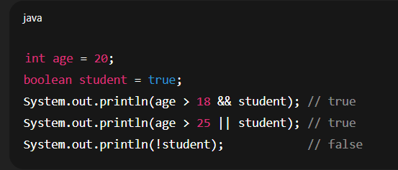

4. Assignment Operators
- Used to assign values.
= (assign)
+= (add & assign)
-= (subtract & assign)
*= (multiply & assign)
/= (divide & assign)
%= (modulus & assign)
- Example:
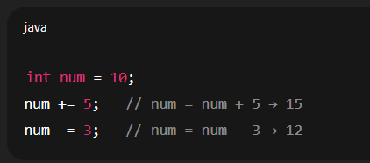

5. Unary Operators
- Work on a single operand.
++ (increment by 1)
-- (decrement by 1)
+ (unary plus, positive number)
- (unary minus, negative number)
- Example:
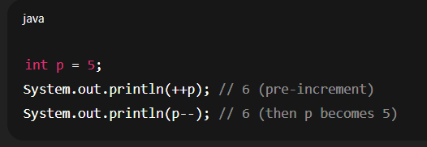

6. Ternary Operator
- Shortcut for if-else.
Syntax:
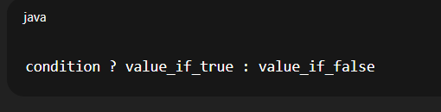
- Example
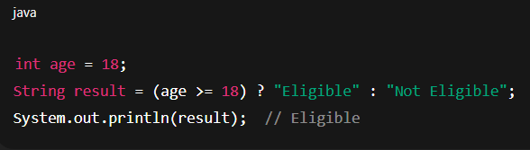

7.Bitwise Operators (work on bits)
& (Bitwise AND)
| (Bitwise OR)
^ (Bitwise XOR)
~ (Bitwise NOT)
<< (Left shift)
>> (Right shift)
- Example:
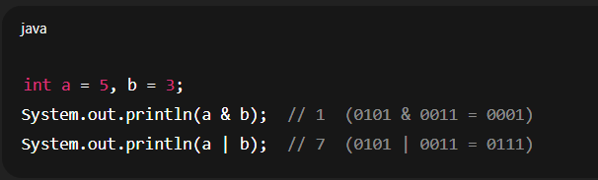
- Example of << (Left shift) and >>( Right shift)
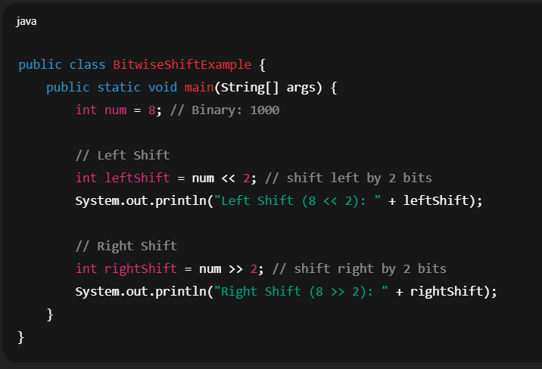

- Output
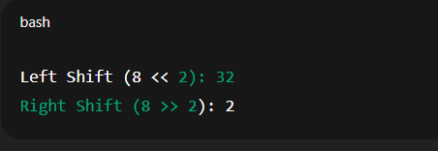

Explanation:
Left Shift (<<)
Moves all bits to the left.
Each shift multiplies the number by 2.
8 (1000) << 2 → 100000 → 32
Right Shift (>>)
Moves all bits to the right.
Each shift divides the number by 2.
8 (1000) >> 2 → 10 → 2

Java Control Statements
- Control statements in Java decide flow of execution of a program.
They allow conditional execution, looping, and jumping in code.

- flowchart for Control Statements in Java:

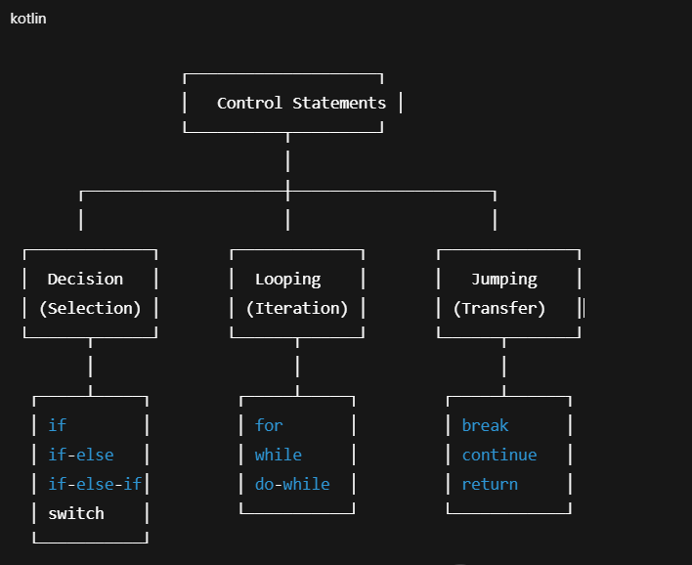

1. Conditional (Decision-making) Statements
- Used to make decisions based on conditions.
- if statement → Executes block if condition is true.
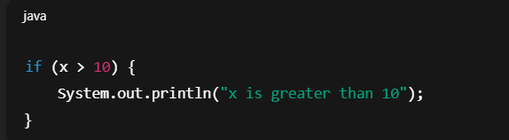

- if-else statement → Executes one block if condition true, another if false.
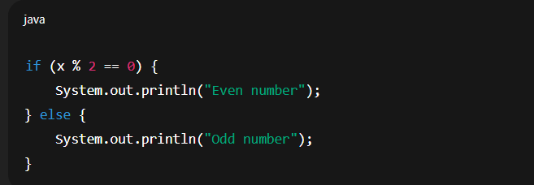

- if-else-if ladder → Multiple conditions.
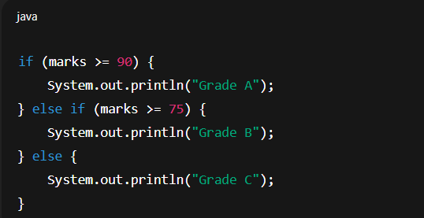

- switch statement → Select one option from multiple choices.
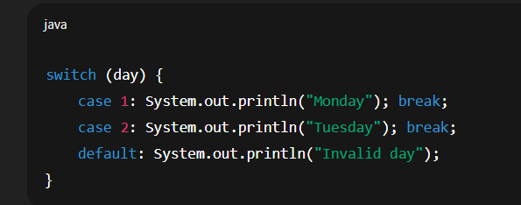

2. Looping Statements
- Used to execute block repeatedly.
- for loop → Executes block with known number of iterations.
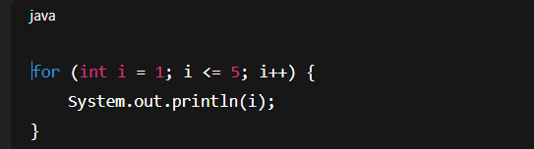
- while loop → Executes block until condition is false.
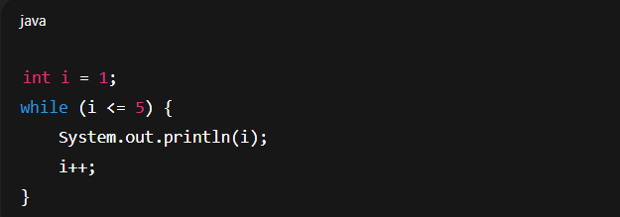

- do-while loop → Executes block at least once, then checks condition.
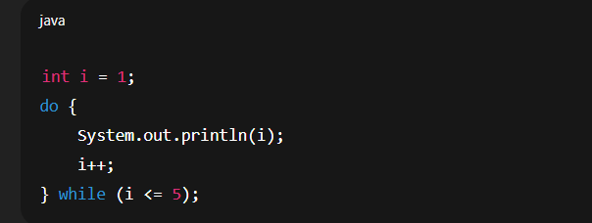

- for-each loop (Enhanced for) → Used for arrays/collections.
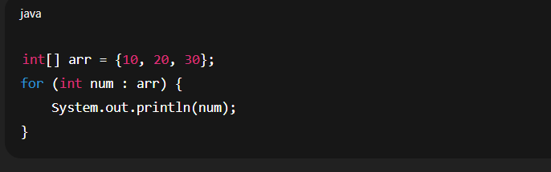

3. Jump Statements
- Used to change normal flow.
- break → Exit loop or switch.
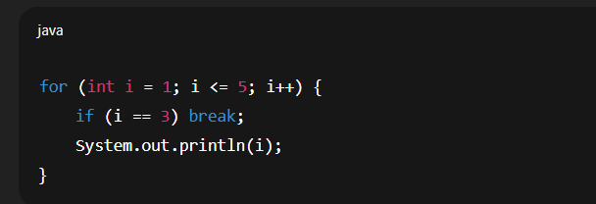
- continue → Skip current iteration, move to next.
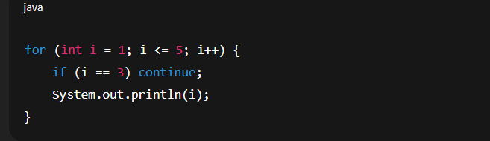

- return → Exit from method and return value.
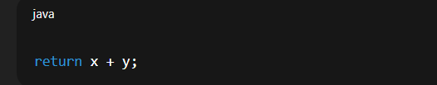

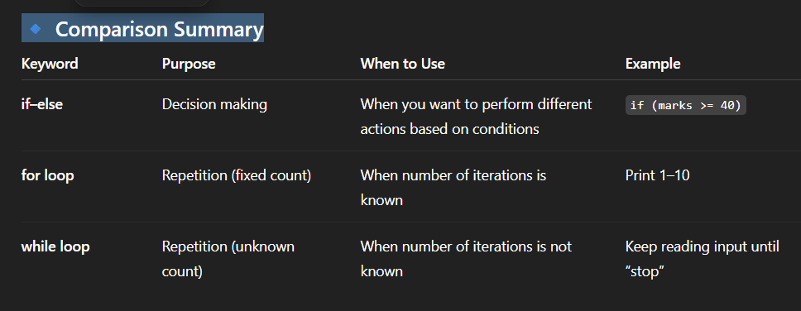

Day 3-(Methods ,Array)

What is a Method in Java?
- A method is a block of code that performs a specific task.
- It helps in code reusability, readability, and modularity.
- You can call a method whenever you need it, instead of writing the same code again and again.

Syntax of a Method:
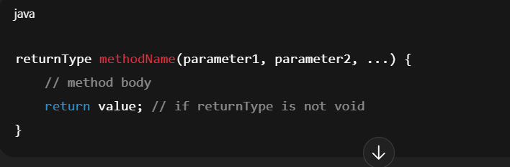

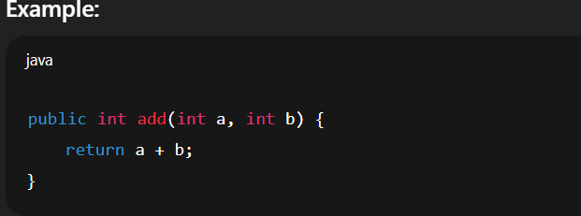

- public → access modifier
- int → return type
- add → method name
- (int a, int b) → parameters
- return a + b; → return statement

Types of Methods in Java
- Predefined (Library) Methods
Already defined in Java libraries.
Example:
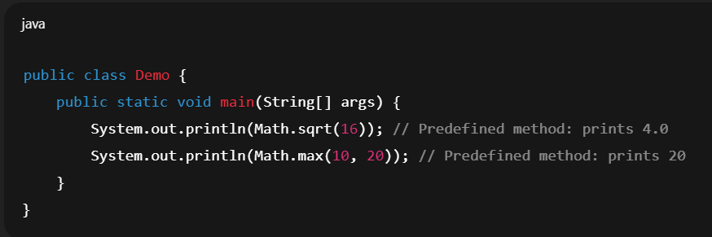
- User-defined Methods
Written by the programmer to perform specific tasks.
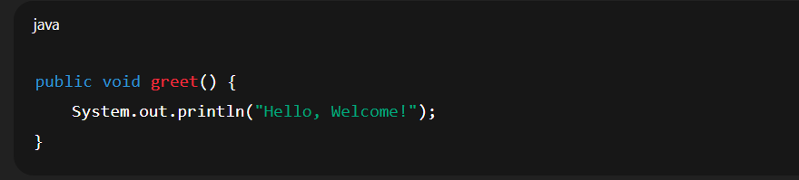

Different Categories
- Static Method
A static method belongs to the class, not to any specific object.
That means you can call it without creating an object of the class.
- Syntax
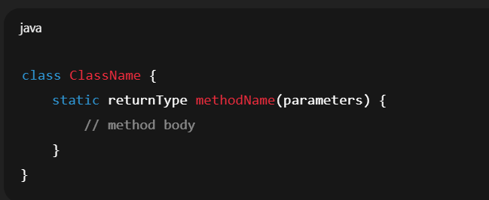

Key Points:
- Declared using the static keyword.
- Can be called directly using the class name (ClassName.methodName()).
- Cannot directly access instance variables or instance methods (because they belong to objects).
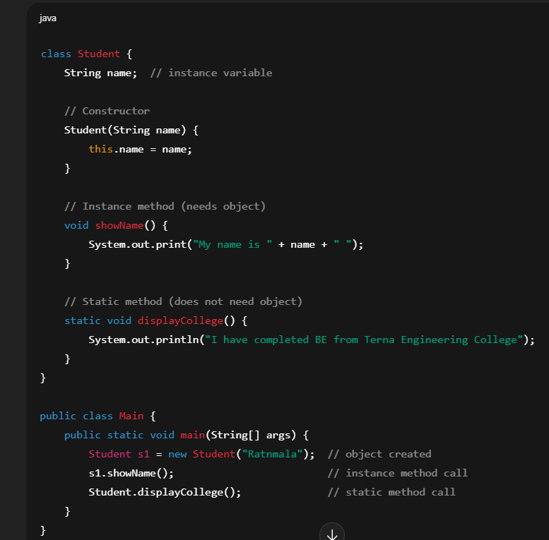

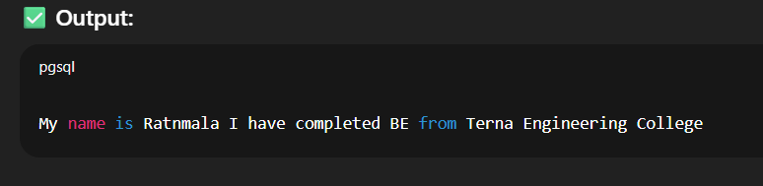

Instance Method

An instance method is a non-static method that belongs to an object (instance) of a class.

To call it, you need to create an object of that class.
- Instance methods can access:
- Instance variables (non-static fields)
- Static variables (class-level fields)
- Syntax
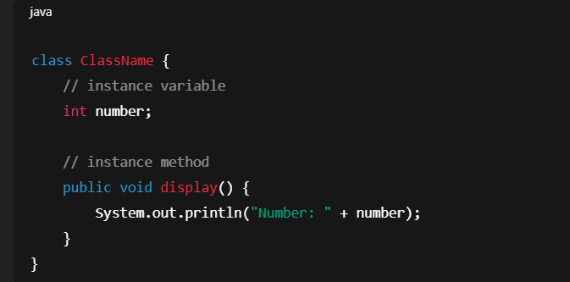
- Example
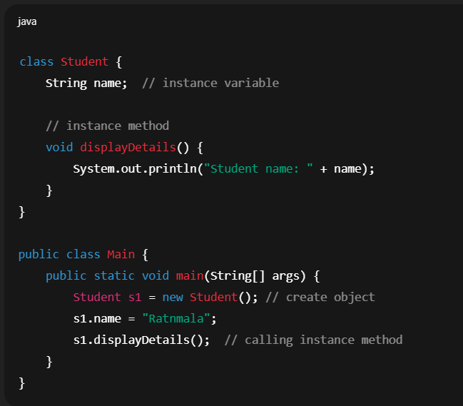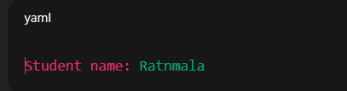

Key Points
- Declared without the static keyword.
- Must be called using object reference.
- Example: objectName.methodName().
- Can access both instance variables and static variables.
- Used when the behavior of a method depends on the individual object’s state.

When to Use Instance Methods?
When each object of a class should have its own behavior.
- Example:
- A Car object → startEngine() depends on that specific car’s state.
- A BankAccount object → withdraw(amount) depends on that account’s balance.
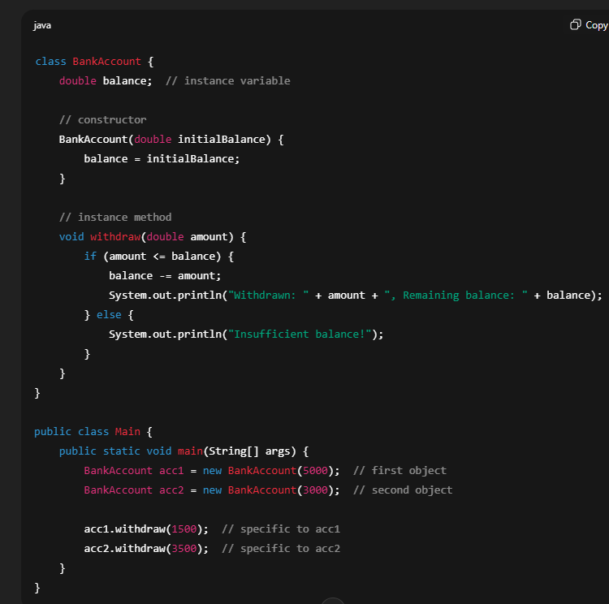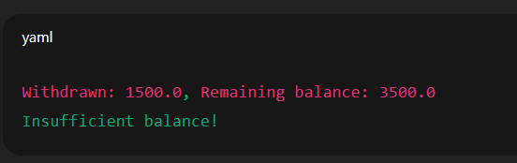

Abstract Method
- An abstract method is a method that is declared without implementation (no body).
- It is meant to be overridden in subclasses.
- Declared using the abstract keyword.
- Can only exist inside an abstract class or interface.

- Syntax

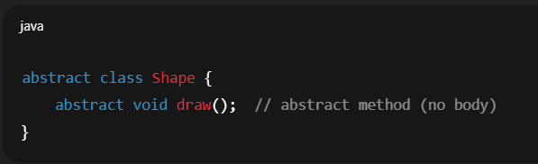
- Example
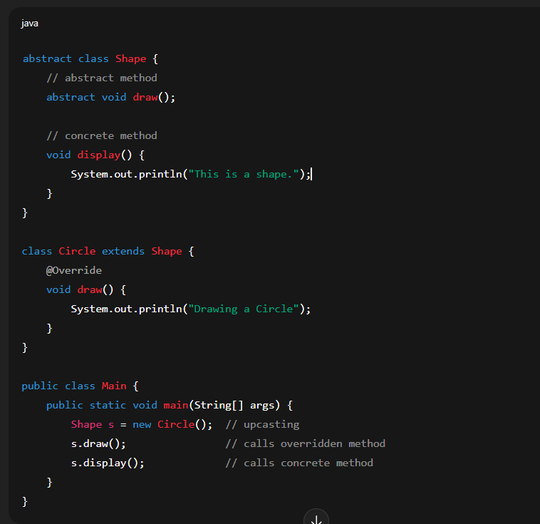
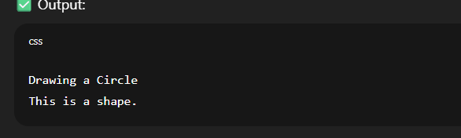

Rules for Abstract Methods
- Declared using the abstract keyword.
- No body → only method signature.
- Must be inside an abstract class or interface.
- Subclass must override the abstract method, unless the subclass is also abstract.
- Cannot be private, final, or static (because they need overriding).

- Why Use Abstract Methods?
- To enforce a common contract that subclasses must follow.
- To support polymorphism (different implementations of the same method).
- Example:
- Shape → draw() method (Circle draws a circle, Rectangle draws a rectangle).
- Payment → pay() method (CreditCard, UPI, PayPal each implement differently).

- Final Method
- A final method in Java is a method that cannot be overridden by subclasses.
- It is declared using the keyword final.
- You can still inherit it, but you cannot change its implementation in child classes.
- Syantax
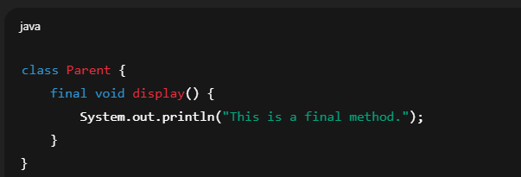

Why use a final method?
- To prevent overriding when you want to keep the same logic for all subclasses.
(e.g., security-related methods, business rules, etc.)
- For consistency – ensures no child class changes its behavior.
- Performance – JVM can optimize final methods because it knows they won’t change.

- Example
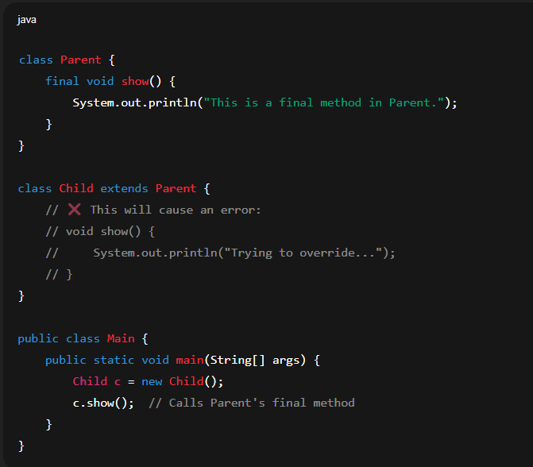
- Output
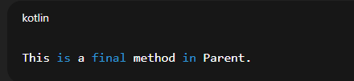

- If you try to override show() in Child, the compiler will give an error:
Cannot override the final method from Parent.

synchronized Method
- A synchronized method in Java ensures that only one thread at a time can access that method of an object.
This is used in multithreading to prevent data inconsistency when multiple threads try to modify shared resources.
- Why use synchronized?
- If multiple threads access the same object at the same time, data can become corrupted.
- Using synchronized locks the method, so only one thread enters, others must wait.
- Syntax
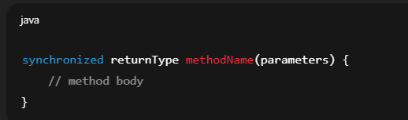

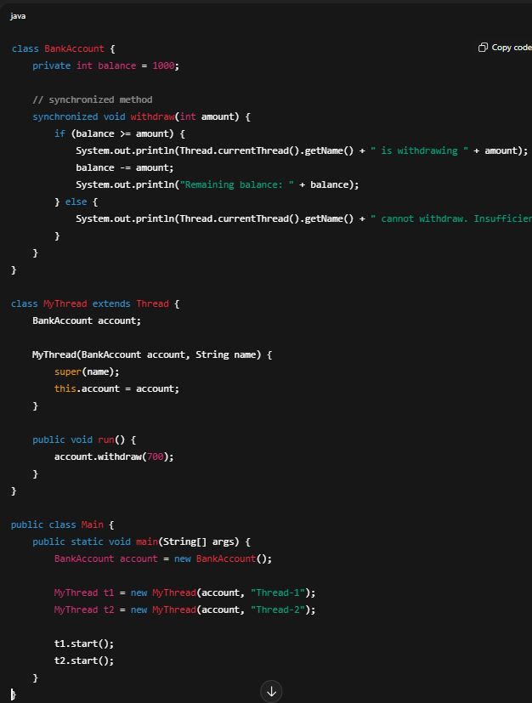
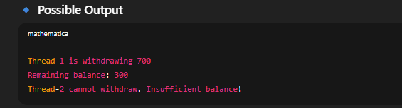
- Here, because the method is synchronized, only one thread at a time can withdraw money.
- Without synchronized, both threads may withdraw at the same time, leading to negative balance (data corruption).

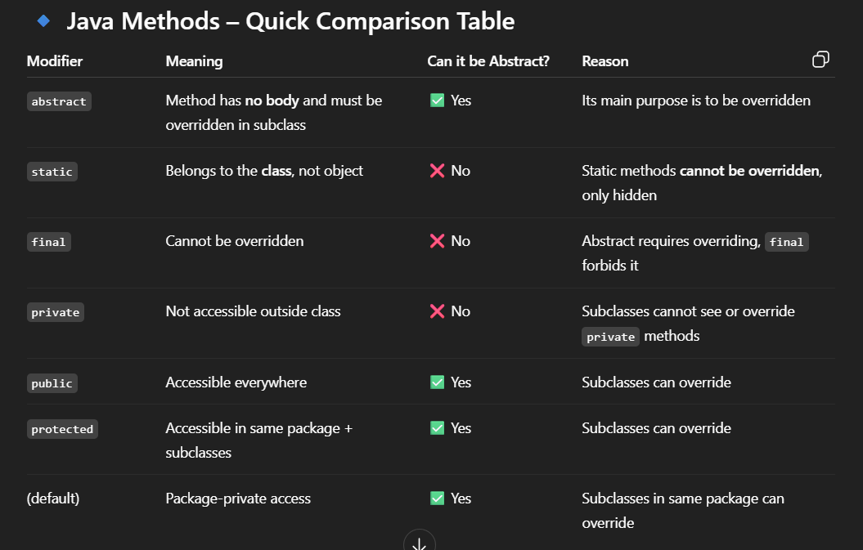

Array

What is an Array in Java?
- An array in Java is a collection of elements of the same type stored in a contiguous memory location.
- It is a fixed-size data structure → once created, its size cannot be changed.
- Each element is accessed using an index (starts from 0).
- Why use Arrays?
- To store multiple values in a single variable instead of declaring separate variables.
- Provides fast access using indexing.
- Useful for loops and bulk operations.
- Syntax of Array
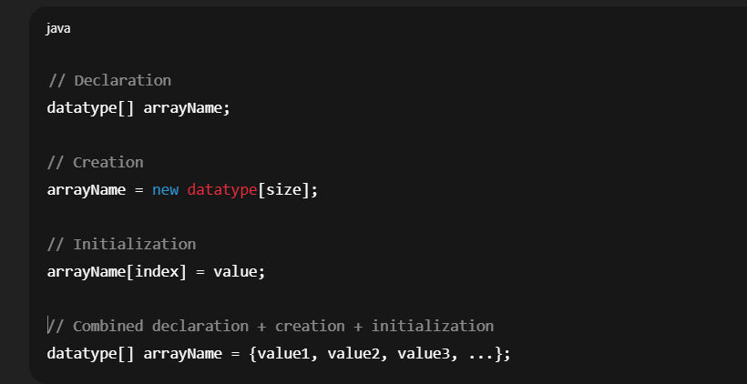

- Example

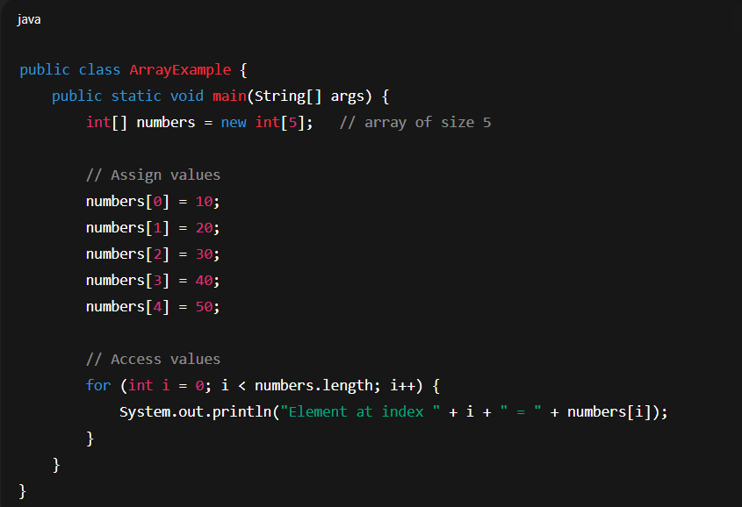
- Output
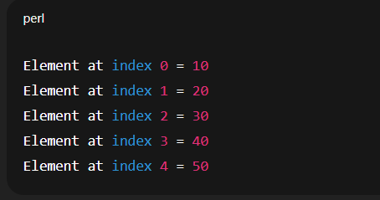

Types of Arrays in Java
- Single-Dimensional Array (1D Array)
- Linear collection of elements.

1D Array Declarations
- There are 3 valid ways to declare a one-dimensional array:
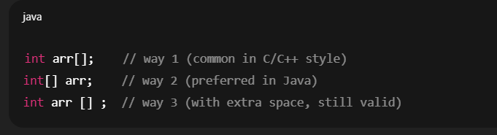
- Example
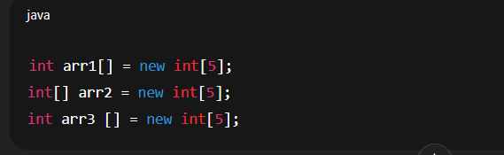
2.Multi-Dimensional Array
- An array of arrays. Most commonly 2D array.

2D Array Declarations
- Similarly, a two-dimensional array also has 3 valid ways:
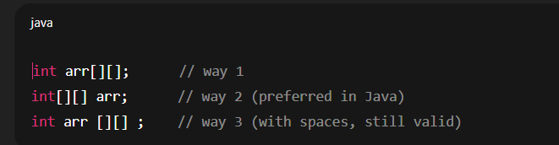
- Example
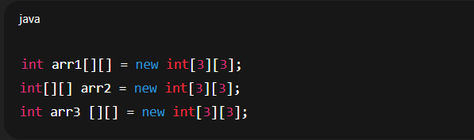

Special Case: Mixed Style (also valid)
- Java also allows placing brackets after the variable name:
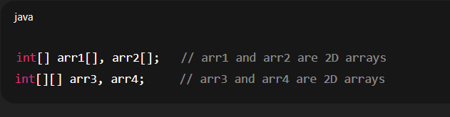

3.Jagged Array
- A 2D array where rows have different lengths.
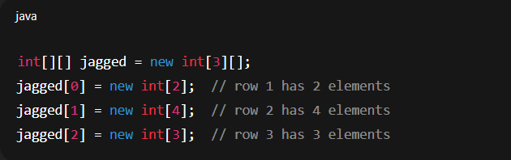

Important Properties
- Array size is fixed once created.
- arr.length gives the size (number of elements).
- Default values:
- Numeric → 0
- Boolean → false
- Objects → null

Valid and Invalid Array Declarations:
- int [][] arr; ✅ → Valid
2D array of integers.
- int arr[][]; ✅ → Valid
2D array of integers.
- int []arr[]; ✅ → Valid
2D array (1D array of 1D arrays).
- int [] arr []; ✅ → Valid
- int []a, b; ✅ valid
a → 1D array
b → just an int, NOT an array.
- int []a[], b; ✅ valid
a → 2D array
b → just an int.
- int [][] a, b; ✅ valid
Both a and b are 2D arrays.
- int [][]a[], b;✅ valid

