1. What is JavaScript?
JavaScript (JS) is a lightweight, interpreted, high-level programming language used mainly to make web pages interactive, dynamic, and responsive.
It runs in all browsers and is one of the core technologies of the web along with HTML and CSS.

2. History of JavaScript
- Developed by Brendan Eich in 1995 at Netscape.
- It was originally named Mocha, then LiveScript, and finally JavaScript.
- It was created in just 10 days.
- Standardized by ECMA International under the name ECMAScript (ES).
- Modern JS versions: ES5 (2009) and ES6 (2015) introduced major improvements.

3. Why JavaScript Was Developed
- JavaScript was created to:
- Add interactivity to web pages (like buttons, forms, animations).
- Allow browsers to run small programs without reloading the page.
- Make the web dynamic and user-friendly.
Before JS, web pages were static (only text + images).

4. Where JavaScript Is Used
JavaScript is used everywhere:

✅ Frontend development
Makes UI dynamic
Handles events
Updates DOM
Frameworks: React, Angular, Vue

✅ Backend development
Using Node.js (server-side JS)

✅ Mobile apps
React Native, Ionic

✅ Desktop apps
Electron (ex: VS Code)

✅ Game development

✅ Cloud & APIs

✅ Automation scripts
In short: One language → many platforms.

5. Key Features of JavaScript
- Interpreted language → runs directly in browser
- Dynamic typing
- Object-oriented (prototype-based)
- Event-driven
- Single-threaded but non-blocking (async)
- Supports functional programming
- Strong ecosystem → npm, frameworks, libraries
- Runs both client-side and server-side

6. Advantages of JavaScript
- Fast and runs in all browsers
- Easy to learn
- Huge community + rich libraries
- Can build full-stack apps with one language
- Supports asynchronous programming
- Great for UI/UX development

7. Limitations of JavaScript
- Single-threaded (but async solves many issues)
- Browser differences (less now)
- Security risks if used poorly

⭐ 1. JavaScript Keywords (short)
Keywords are reserved words in JS which have a special meaning.
You cannot use them as variable names.
Examples:
let, const, var, if, else, for, while, return, break, switch, case, try, catch, class, new, this, function
👉 Used to control logic, create variables, functions, loops, classes, etc.

⭐ 2. Variables (short)
Variables store data values.

Three ways to declare:
var → old, function-scoped, avoid
let → modern, block-scoped
const → cannot be reassigned (best for constants & functions)
Example:
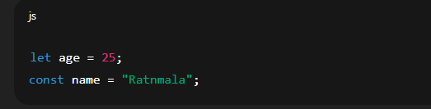

⭐ 3. Data Types in JavaScript (short)

A. Primitive (7 types)
String – "hello"
Number – 10, 10.5
Boolean – true, false
Undefined – declared but no value
Null – intentional empty value
BigInt – large numbers
Symbol – unique values

B. Non-Primitive
Object – { name: "Riya", age: 22 }
Array – [1, 2, 3]
Function – function() { }

⭐ 4. Operators in JavaScript (short)

A. Arithmetic Operators +, -, *, /, %, **
Example:
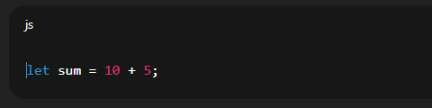

B. Assignment Operators
=, +=, -=, *=, /=
Example:
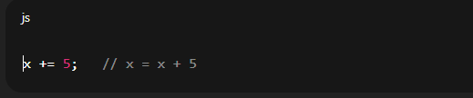

C. Comparison Operators
Used to compare values (returns true/false):
==, !=, ===, !==, >, <, >=, <=
👉 === is strict comparison (checks value + type)

D. Logical Operators
&& (AND)
|| (OR)
! (NOT)

E. String Operator
+ joins strings:
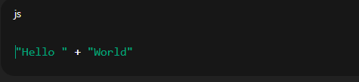

F. Ternary Operator
Short if-else:
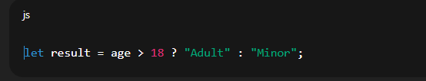

⭐ 5. Extra Important Concepts

• typeof operator
Used to check data type:

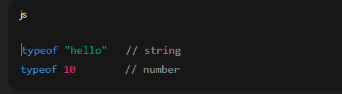 Comments
