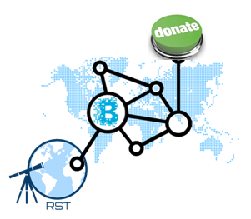

Block-chain Relief Fund Network

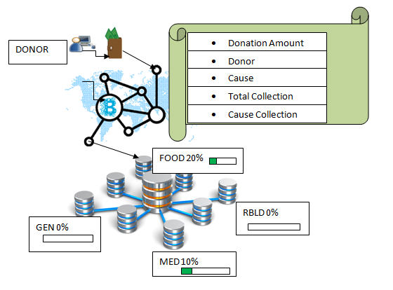

|  |  |  |  |  |  |  |  |  |  |  |  |  |  |  |  |  |  |  |  |  |  |  |  |  |  |  |  |  |  |  |  |  |  |  |  |  |
| --- | --- | --- | --- | --- | --- | --- | --- | --- | --- | --- | --- | --- | --- | --- | --- | --- | --- | --- | --- | --- | --- | --- | --- | --- | --- | --- | --- | --- | --- | --- | --- | --- | --- | --- | --- | --- |
| System Overview:  |  |  | | --- | --- | |  | Phase 1: | |  | 1. NGOs will list the sub-funds dedicated to specific cause. | |  | 1. Each sub-fund will list the estimated fund required. | |  | 1. Donor will donate to for particular cause using block chain wallet. | |  | 1. Transaction records will be generated. 2. Record should show: | |  |  | |  | * Amount of money transferred, | |  | * Name of donor and organization | |  | * Donor's balance after transaction | |  | * Total collection of the organization after transaction. | |  | * Total collection for the particular cause | |  | 6. Funds, Sub-Funds, Wallets are updated accordingly. | |  |  | |  |  | |  | Phase: 2 | |  |  | |  | * 1. Donor can also track the fund disbursement | |  | * 1. Disbursement will also record the details of local partners where fund got disbursed | |