
AMERICAN INTERNATIONAL UNIVERSITY-BANGLADESH
Faculty of Science and Technology
Department of Computer Science
CSC 3215: Web Technologies

Semester: Summer 2025-26 | Group No: 5 |  | Section:AA

Group Members:
SL. | Student ID | Name | Role | Signature
1 | 22-48617-3 | Ashanul Bari Chowdhury | Group Leader | Ashanul
2 | 22-4627-1 | Tarifush Shajid | Member | Tarifush
3 | 25-61087-1 | Md.Hasnat | Member | Hasnat
4 | 24-58528-2 | Md.Akib Hossain | Member | Akib
Project Title
Hotel Management System
Short Description
The Grand Hotel Management System is a comprehensive digital solution designed to streamline hotel operations and enhance guest experiences. This system provides an organized platform for managing room bookings, guest information, customer reviews, maintenance requests, and internal communications. By automating key processes and centralizing data management, the system helps hotel staff deliver better service while reducing manual work and errors.

Introduction
In today's fast-paced hospitality industry, efficient management is essential for success. The Grand Hotel Management System addresses the growing need for organized, accessible, and reliable hotel operations. This system brings together all critical aspects of hotel management into one unified platform, making it easier for staff to handle daily tasks and for guests to enjoy seamless service. The system allows users to browse and book rooms online, submit service requests, report damages, and leave reviews about their stay. Hotel staff can manage room availability, track bookings, respond to guest needs, and maintain clear communication through an integrated messaging system. By keeping all information in one secure database, the system eliminates the confusion of scattered records and reduces the risk of errors. This project aims to modernize traditional hotel operations by replacing manual processes with an efficient digital solution. The result is improved guest satisfaction, better staff productivity, and smoother overall management. Whether for small boutique hotels or larger establishments, this system provides the tools needed to compete in today's digital-first hospitality market.

ER Diagram

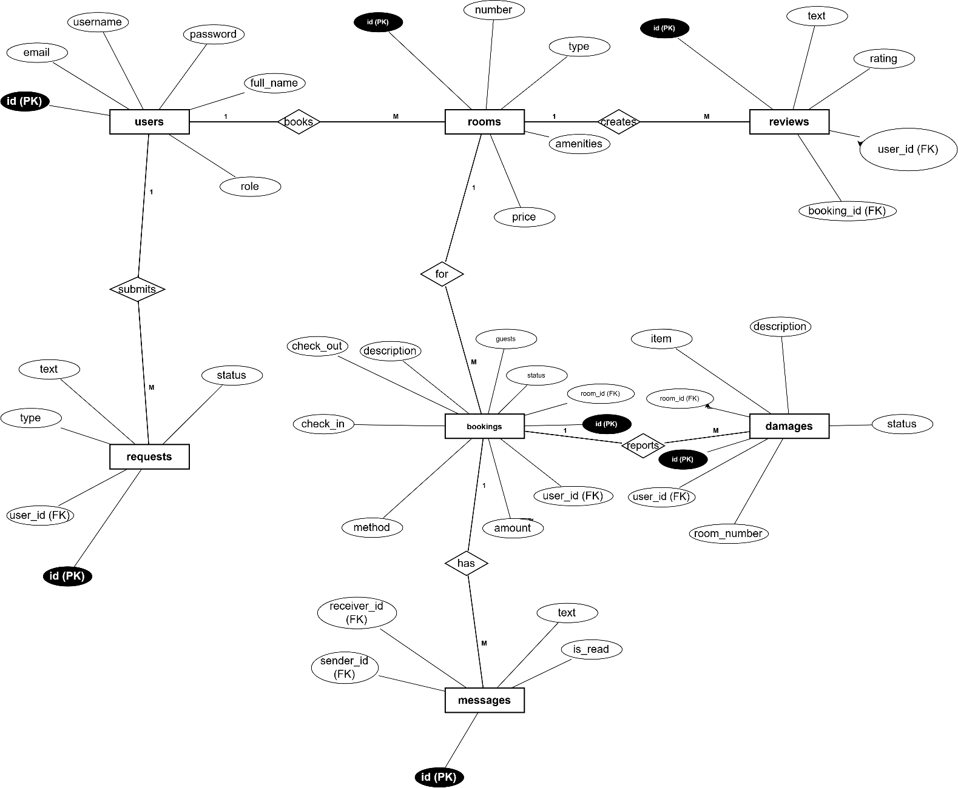

Use Case Diagram

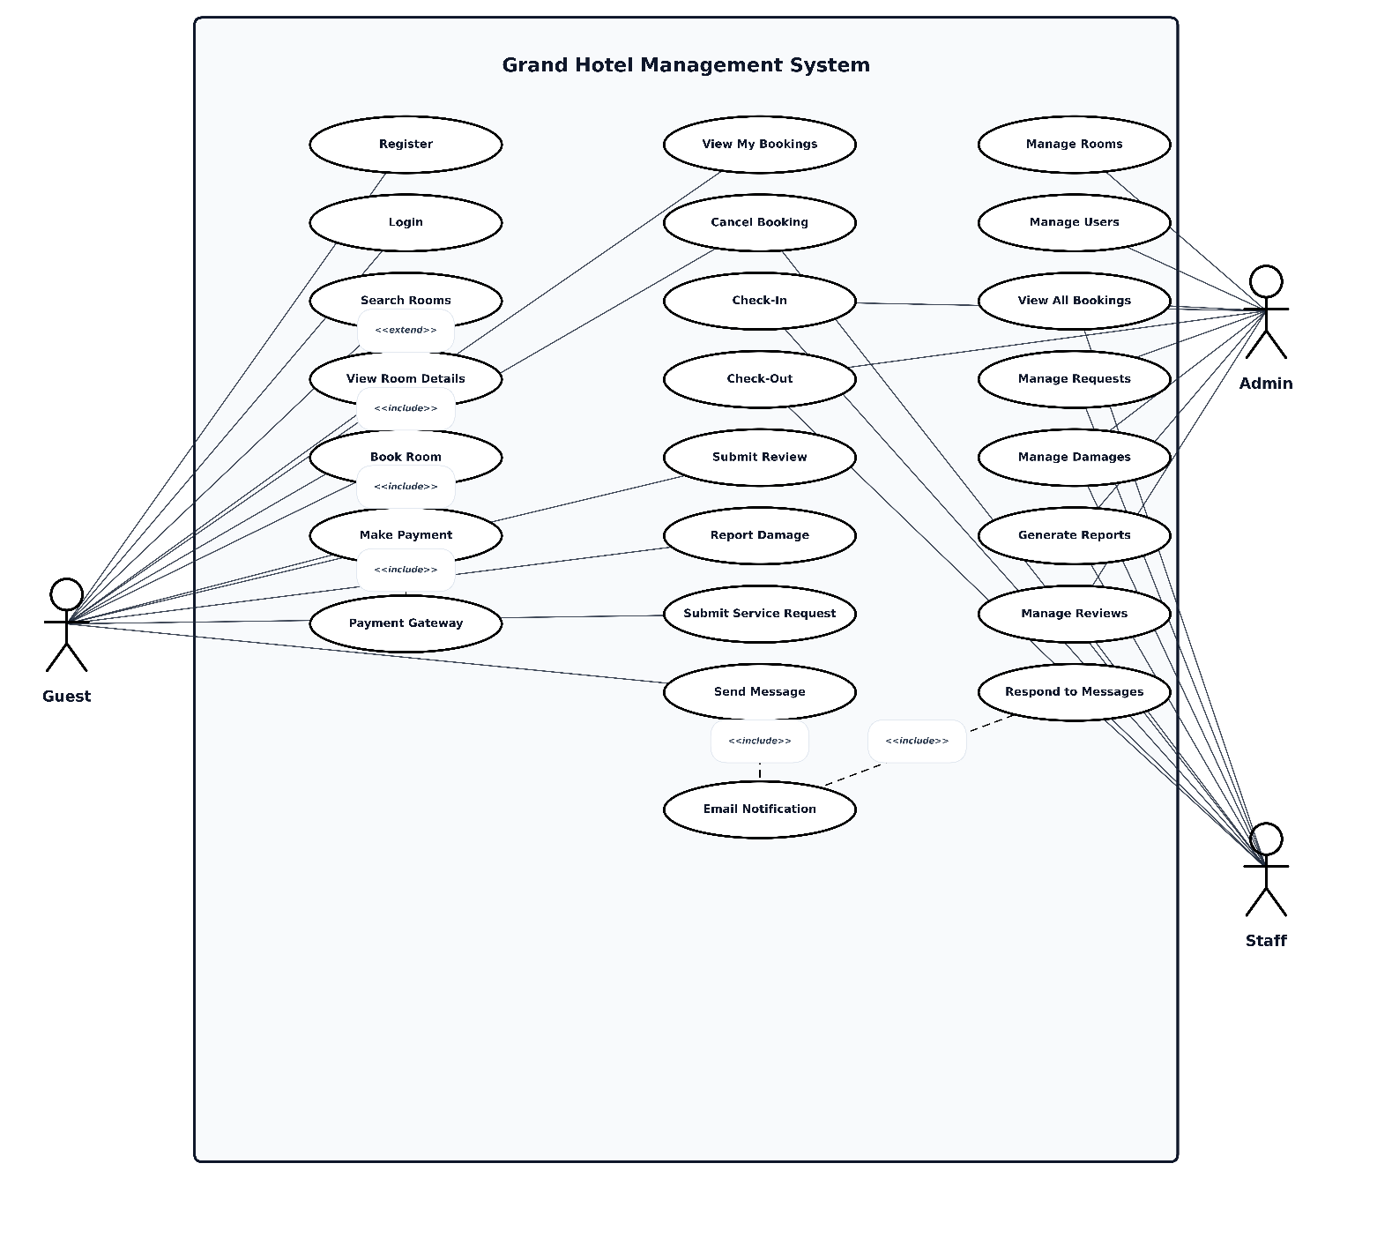
UI (Figma/Sketch)
Provide the tentative design of your system.

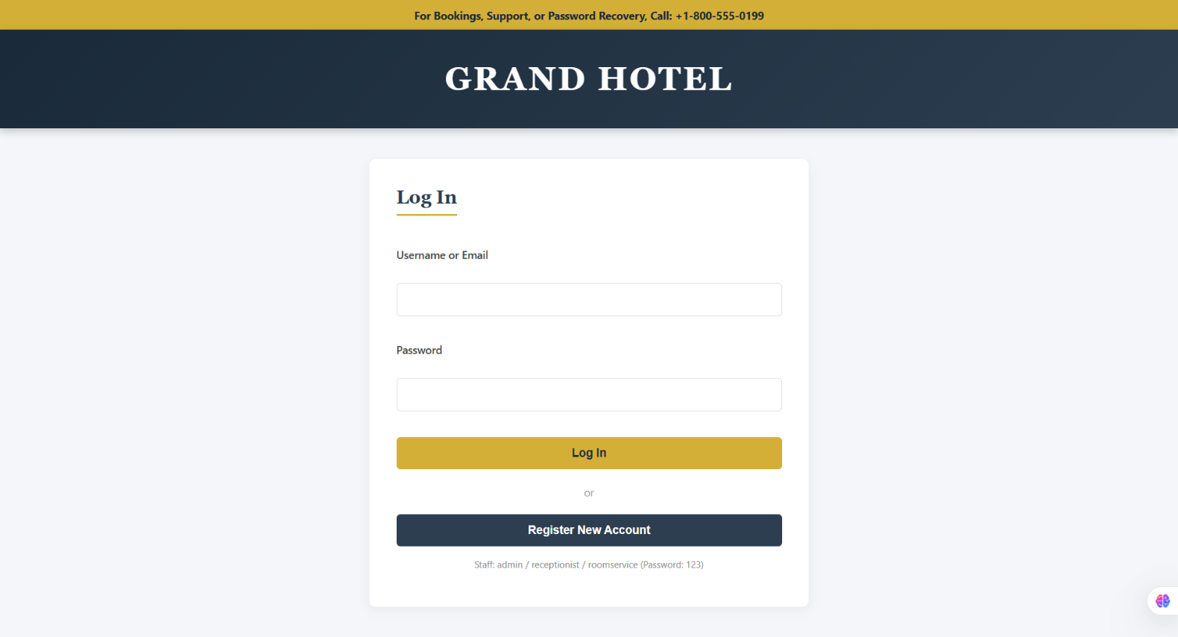

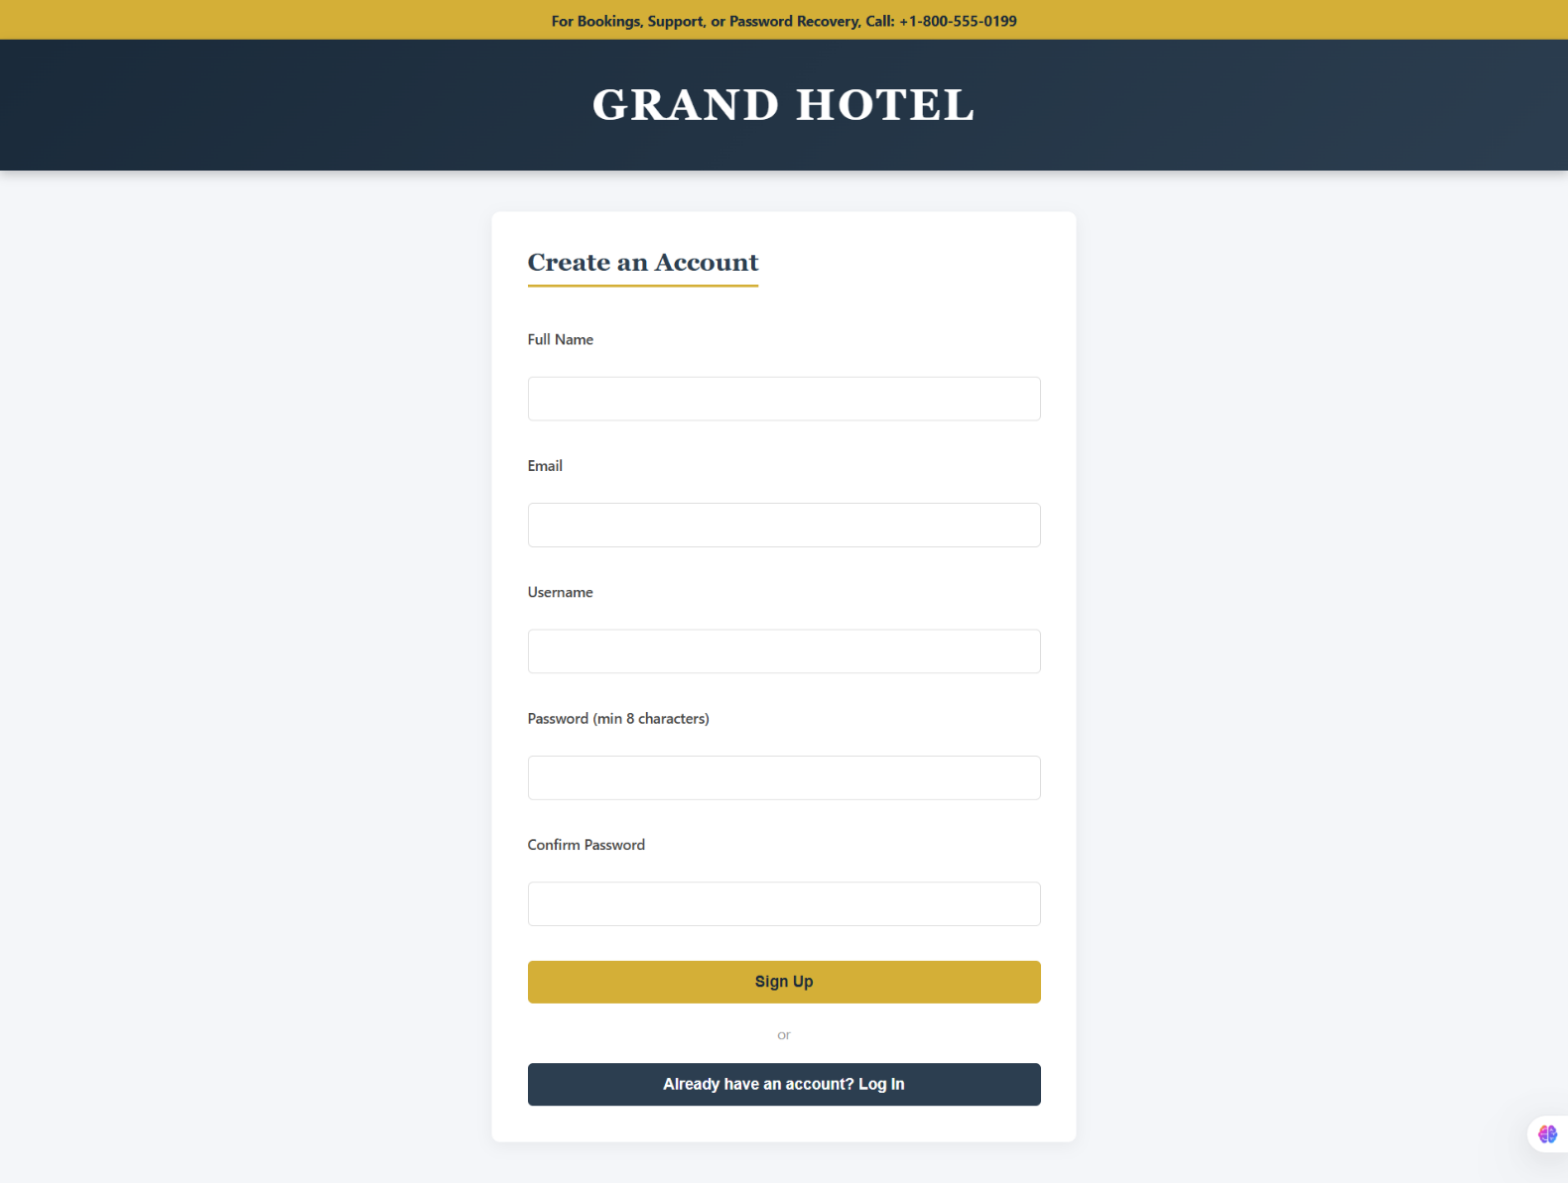
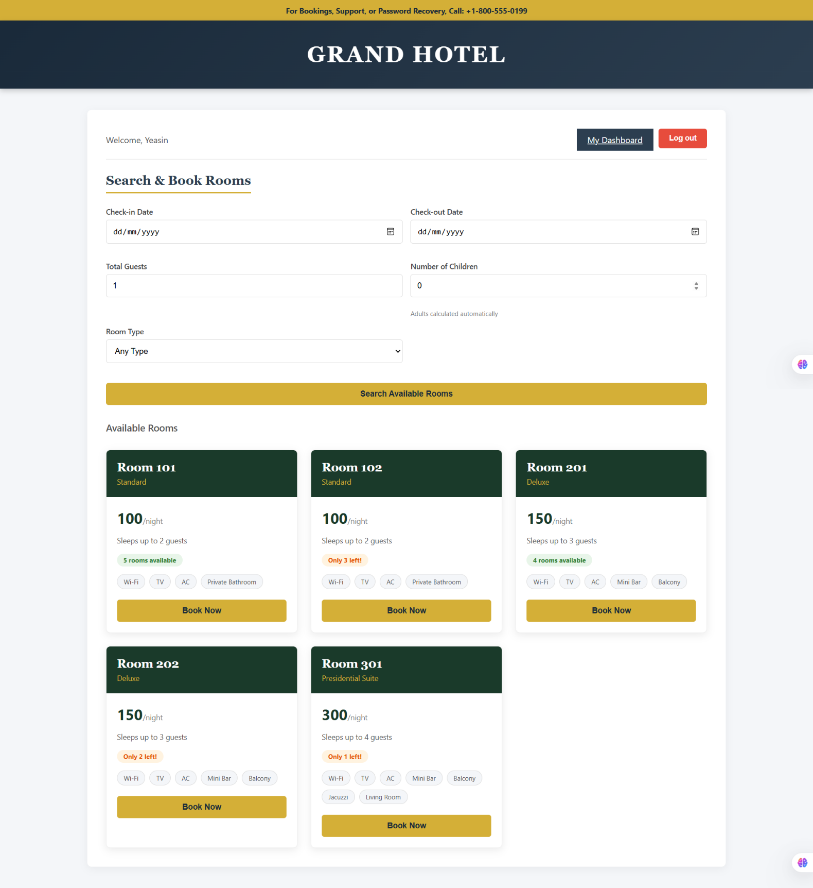
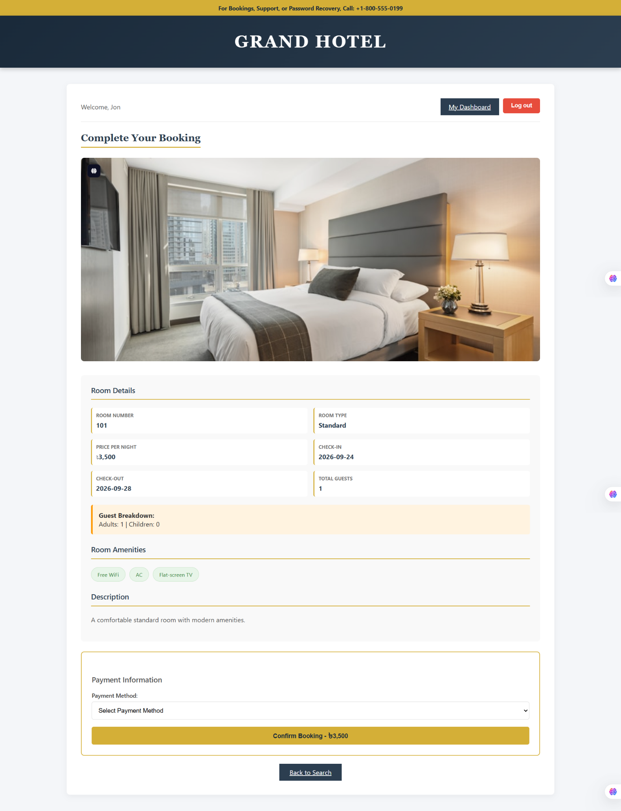

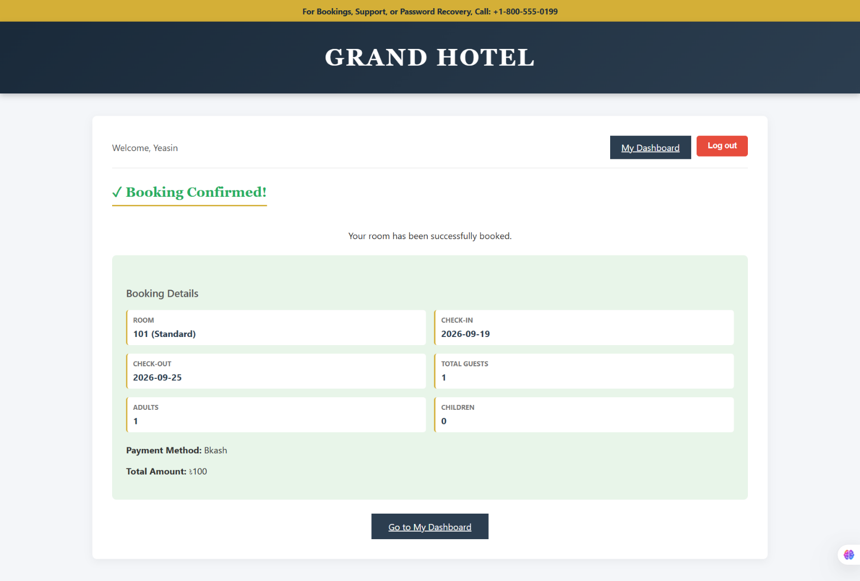

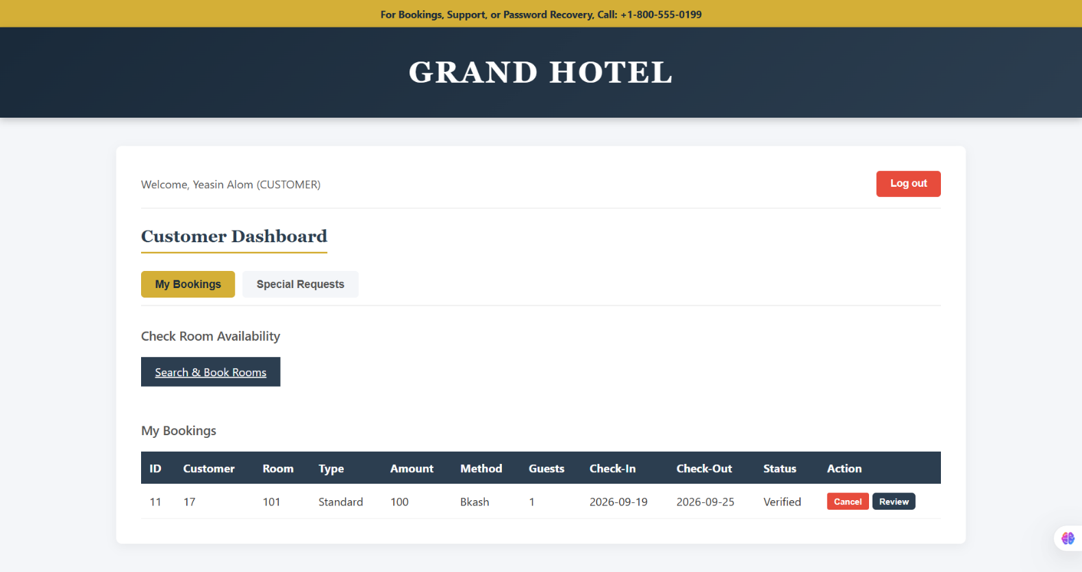

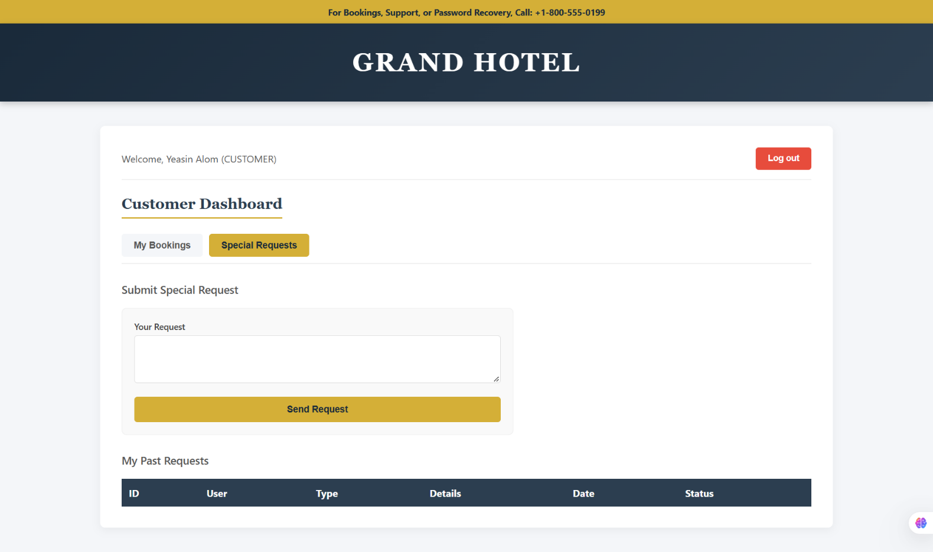

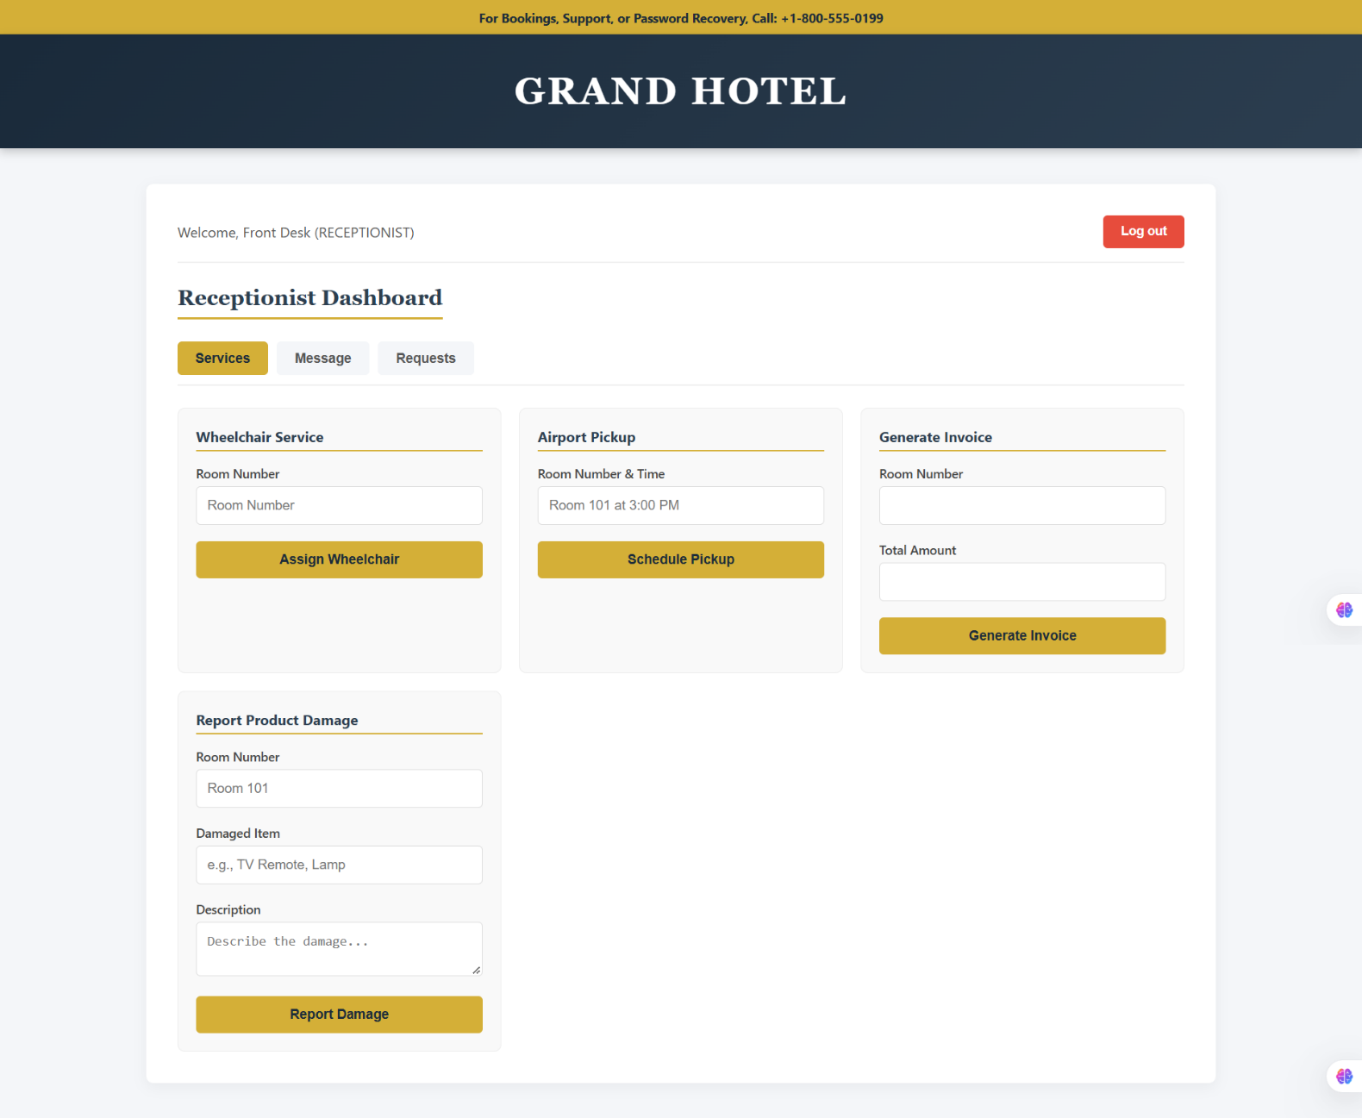

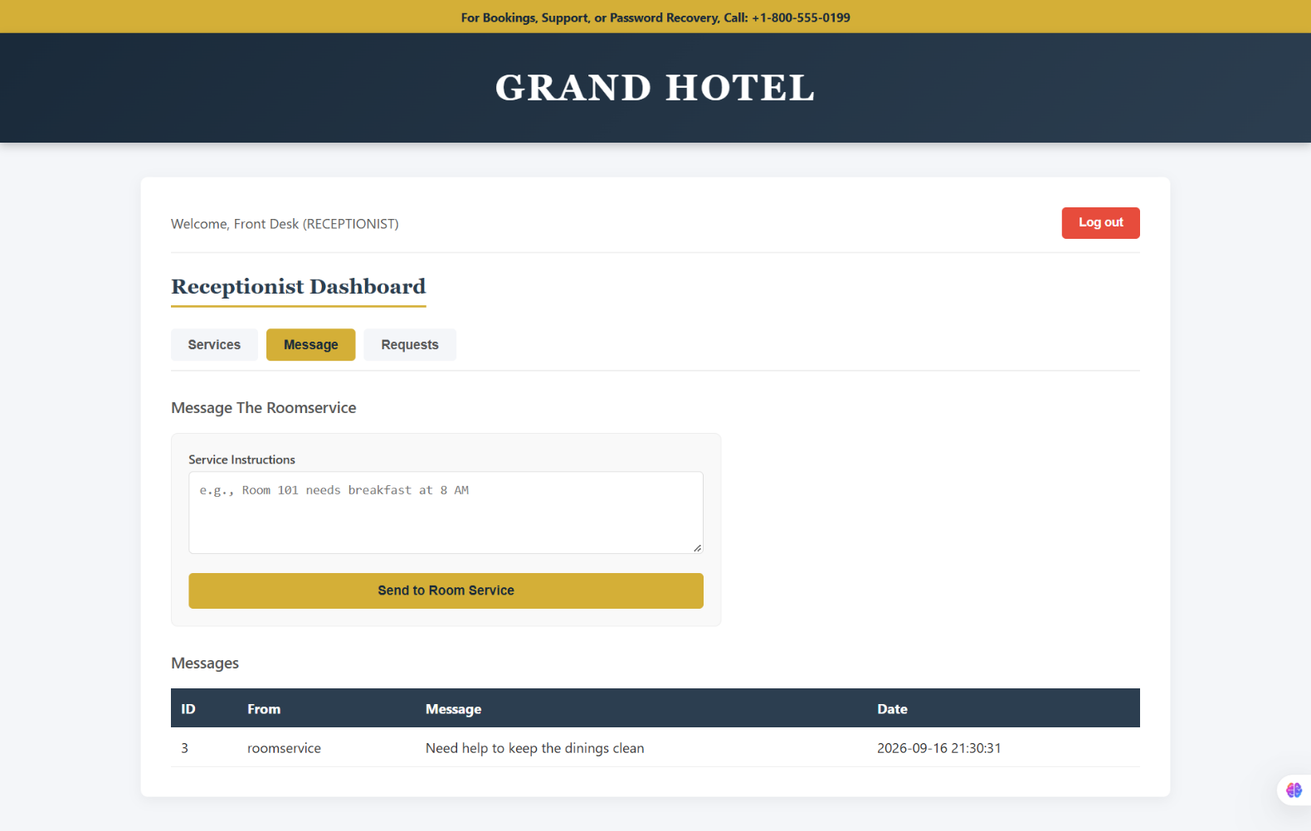

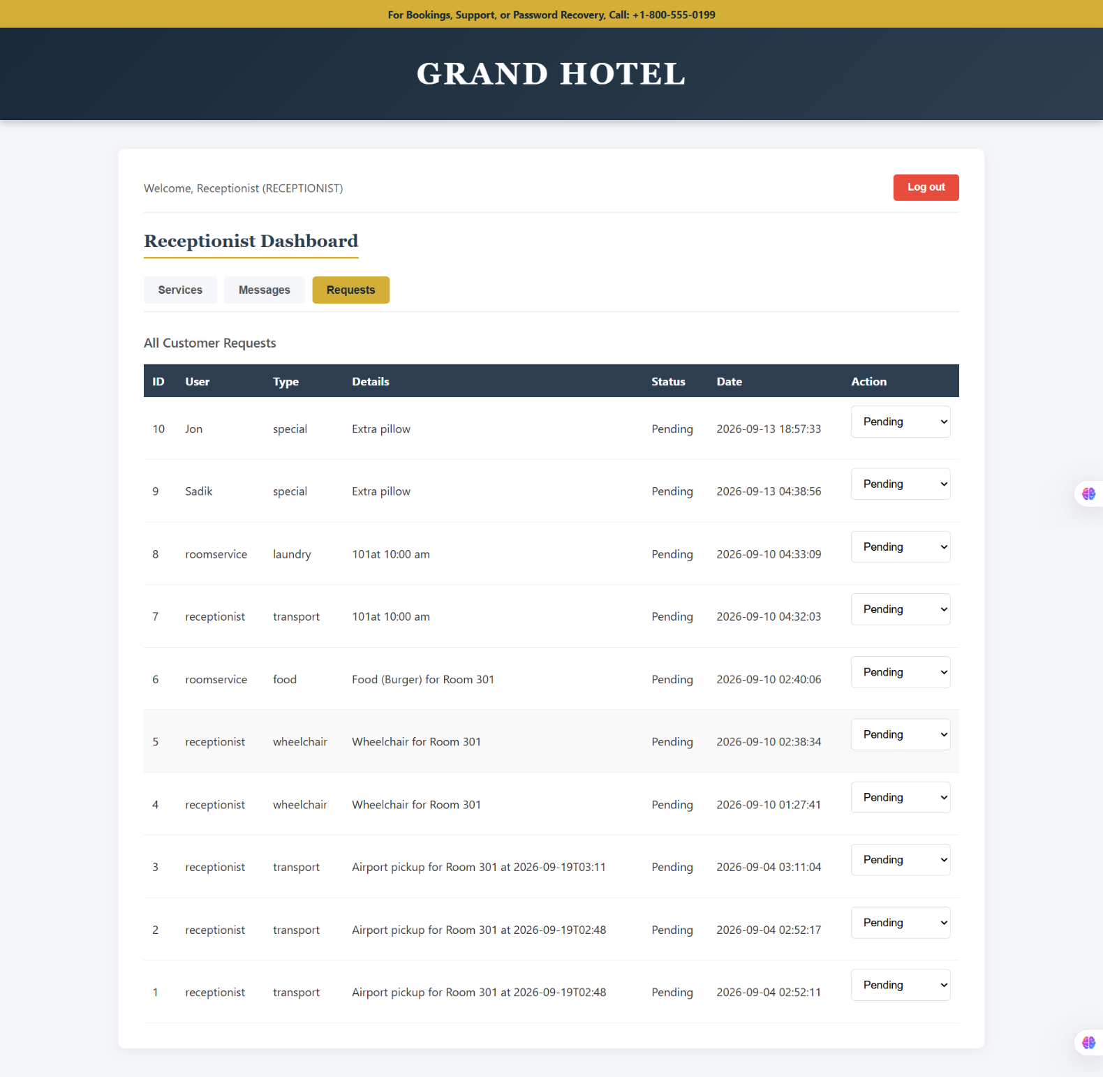

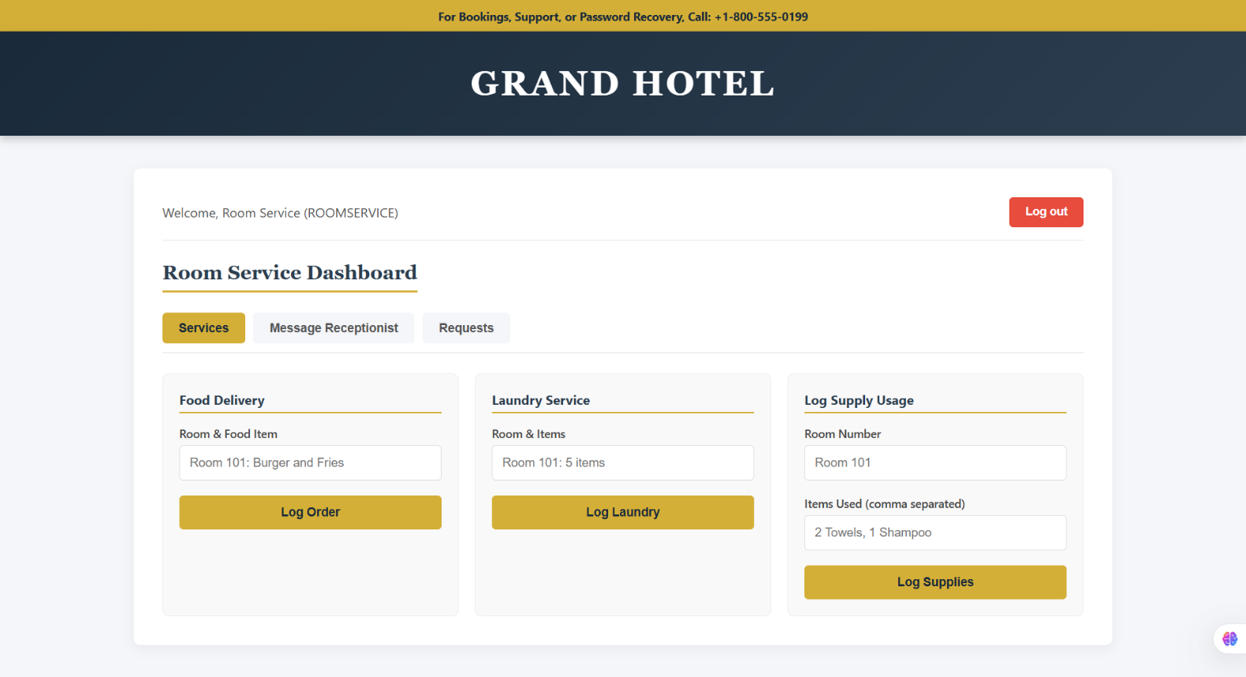

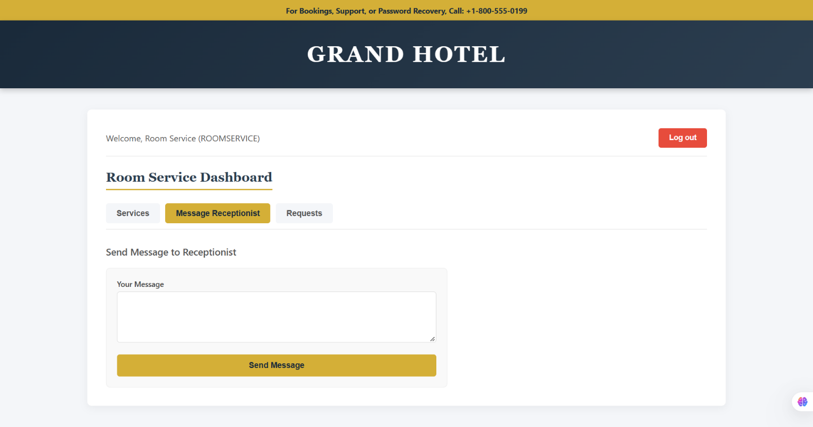

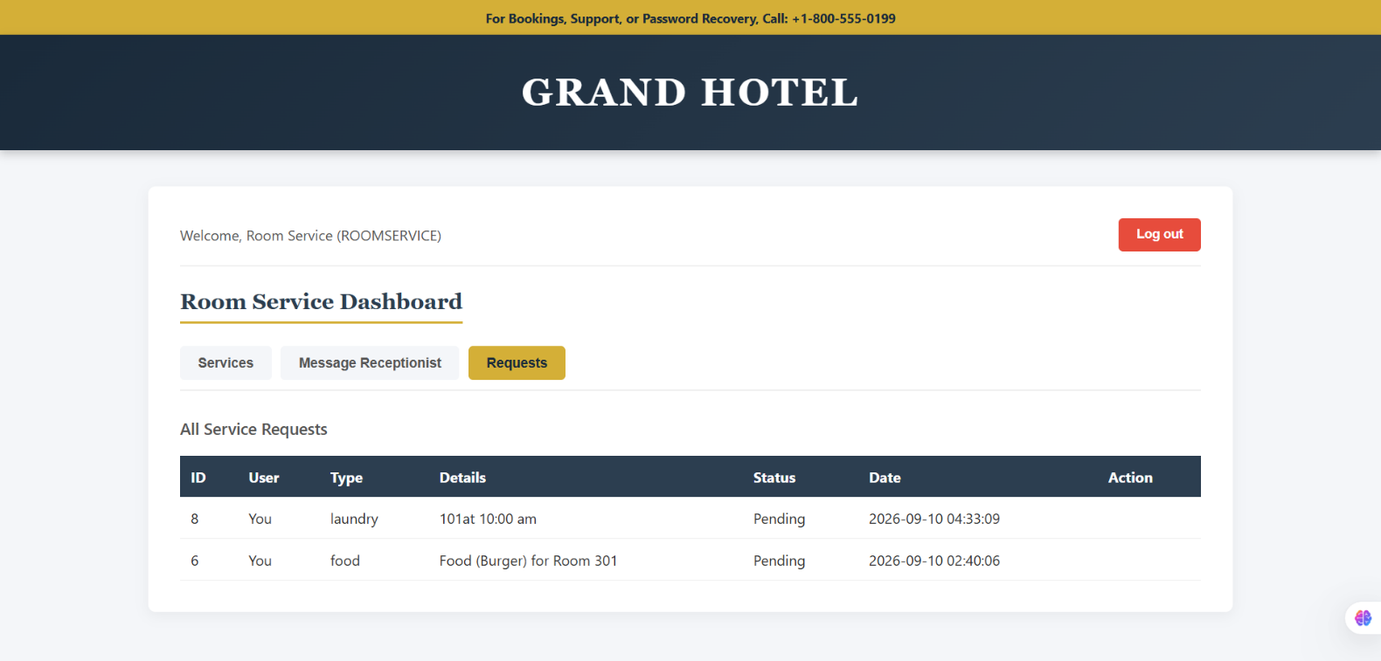

N.B: Each user type must have at least 3 distinct features different from the others. Additional features may be added if desired. Proposals with generic, incomplete, or duplicated features across user types will receive reduced marks under the criteria below.

Proposed System Features & Role-Based Access Control
The following section enforces strict role isolation. Each feature is exclusive to its role and protected by session role validation.

Common Features (Available to All Users)
Regardless of their role, all users have access to the following foundational system features:

Authentication
• Secure Login: All users can securely login with encrypted credentials.
• Secure Logout: All users can securely logout with automatic session termination.
• User Registration: New users can create Customer accounts via email verification.

Account Management
• Profile Management: All users can view, edit, and delete their own account data.

Dashboard
• Role-Specific Dashboard: All users get a personalized dashboard immediately upon successful login.

Specific Features by User Type
Each user type has at least 3 distinct features that are exclusive and not duplicated in other roles.

1. Manager (3 Distinct Features)
• Financial Analytics: Only the Manager can see revenue/money, total clients, and business performance metrics. (Receptionist, Beautician, and Customer cannot).
• Staff Deletion: Only the Manager can delete user or staff accounts. (No one else can).
• Global Resource Control: Only the Manager can shut down rooms/suites for maintenance and control global availability. (No one else can).

2. Receptionist (3 Distinct Features)
• Unified Global View: Can see all client details and bookings across hotel and spa. (Customers only see their own; Beauticians only see their schedule).
• Check-in/Check-out Workflow: Only the Receptionist can officially change a guest's status to "Checked-In" or "Checked-Out".
• Operational Coordination: Manages the front-desk flow without having access to the Manager's financial data. (Manager only can see revenue).

3. Beautician (3 Distinct Features)
• Daily Treatment Schedule Management: Only the Beautician can view and manage their own daily spa appointment queue and client treatment requests. (Receptionist sees all, but does not execute treatments; Manager does not).
• Service Completion Logging: Only the Beautician can mark a spa appointment as "Completed" after treatment. (Receptionist only handles hotel check-in/out; Customer cannot).
• Product and Inventory Usage Tracking: Only the Beautician can log specific beauty products and consumables used during a treatment for inventory depletion tracking. (No other role can).

4. Customer (3 Distinct Features)
• Integrated Search and Booking Engine: Only the Customer has access to the public search interface to find available rooms/spa services and complete secure checkout. (Staff roles do not book for themselves).
• Personal Reservation Management (Self-Modification): Can view, update, or cancel only their own bookings. System isolates data by unique user ID. (Receptionist sees all; Manager sees all; Beautician sees only assigned).
• Post-Service Feedback System: Only the Customer can rate and submit detailed feedback after a stay or treatment. (Manager, Receptionist, and Beautician cannot submit reviews; they only view).

Summary of Role Isolation
The system enforces these distinct features using the user's session role as a traffic controller. Financial statistics are protected by strict role-checking algorithms that terminate unauthorized access attempts. Customer data is isolated by their unique user ID, ensuring that no user can access features, data, or administrative tools outside their designated role. This guarantees that each user type has at least 3 distinct, non-duplicated features as required.

Types of Users:
1. Manager
2. Receptionist
3. Beautician
4. Customer

Common Features (Available to All Users)
• Authentication
1. Login to the system
2. Logout from the system
3. User registration
• Account Management
1. Change or reset password
2. Manage profile information (view, edit, delete)
• Dashboard
1. Access a personalized dashboard after login

Specific Features by User Type
• Features of Manager (22-48617-3)
1. Financial and System Analytics (Exclusive)
2. Comprehensive User and Staff Management (Exclusive)
3. Global Resource and Status Control
• Features of Receptionist (22-4627-1)
1. Unified Booking and Appointment Overview
2. Check-in and Check-out Workflow Management
3. Operational Coordination (Financial Restriction)
• Features of Beautician (25-61087-1)
1. Daily Treatment Schedule Management
2. Service Completion Logging
3. Product and Inventory Usage Tracking
• Features of Customer (24-58528-2)
1. Integrated Search and Booking Engine
2. Personal Reservation Management (Self-Modification)
3. Post-Service Feedback System

Group Members and File Contributions:
1. Ashanul Bari Chowdhury (22-48617-3) - dashboard.php, models.php, crud.php, index.php
2. Tarifush Shajid (22-4627-1) - login.php, booking.php, script.js
3. Md.Hasnat (25-61087-1) - config.php, signup.php, logout.php
4. MD. Akib Hossain (24-58528-2) - rooms.php, style.css, review.php

