CAPSTONE PROJECT

THE BATTLE OF THE NEIGHBORHOODS:

SHIFTING

Introduction-

This project is aimed at people who want to change their localities.

People need to shift from one area for various reasons. Job transfers and education are two important factors why people may want to change their locations.

But at the same time, changing localities means sacrificing the conveniences which you enjoy in your current location.

And everyone has their preferences when it comes to the ideal location. You may not care about having a fast food stall nearby, but you do care about having a pharmacy nearby.

Rather than searching for homes all over the city, it will be helpful to know which localities to target.

Through this project, I tried to do that.

It will give you an idea of which locality is most similar to your current or ideal location.

Data sources-

To keep the understanding of the project simple, I have only used data related to New York, assuming that a person wants to shift from one community board to another within New York. Later in the report, this assumption has been lifted.

The data used in the report is from the table in
https://en.wikipedia.org/wiki/Neighborhoods_in_New_York_City

The latitudes and longitudes were searched from google and typed into the source code.

Foursquare API is used to collect information about each community boards.

Jupyter notebook has been used to write the source code.

Methodology-

First, the table was copied from the Wikipedia webpage using the pandas library.
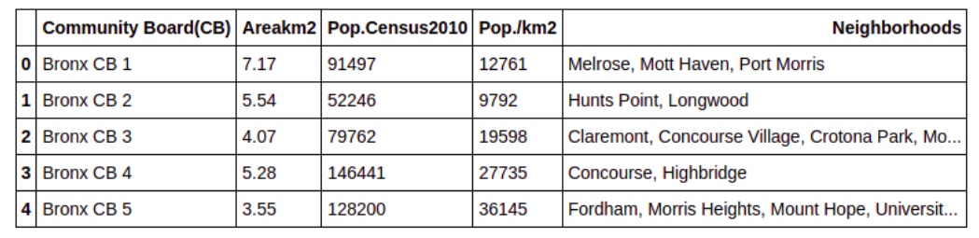

Then, the coordinates of each community board was searched in Google and made into two lists, latitudes and longitudes. These lists were appended to the data frame which was created above.

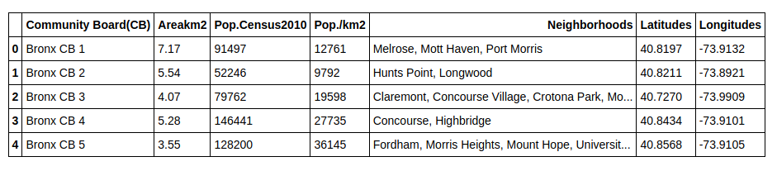

With the help of the coordinates and the Foursquare API, the list of venues of each locality was obtained.

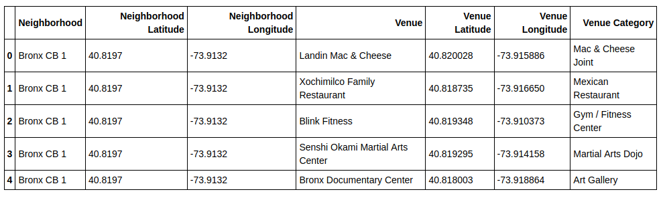

The count of each kind of venue per locality was taken.
From that, a data frame was created, using the 10 most popular venues for each locality (community board in this case).
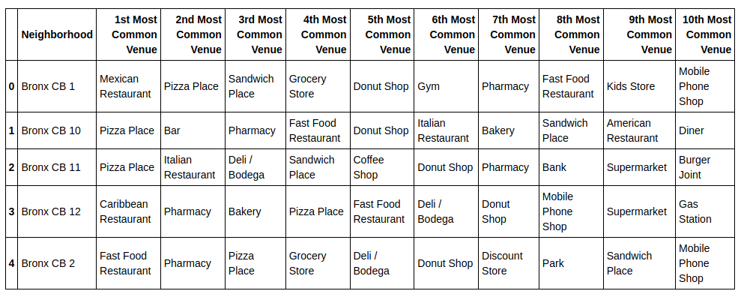

Now, to understand the similarity, a scoring system is introduced.

The top 10 venues of the known locality are given values from 10 -> 1, ie, the most common venue will get a value 10, and the 10th most common venue will get a value 1.

The same thing will be done to the locality to which we are comparing the known locality.

If one of the ten venues of the known locality matches with a certain venue of the other locality, the values assigned to them are multiplied together.

All those multiplied results are added together, which gives us the total score.

For example,
Let's compare Bronx CB 1 to Bronx CB 12, where Bronx CB 1 is the known locality and Bronx CB 12 is the unknown locality.

By the first statement-

Mexican Restaurant=10 , Pizza Place=9 , Sandwich Place=8 , Grocery Store=7, Donut Shop=6, Gym=5 , Pharmacy=4, Fast Food Restaurant=3, Kids Store=2, Mobile Phone Shop=1

By the second statement-

Caribbean Restaurant=10, Pharmacy=9, Bakery=8, Pizza Place=7, Fast Food Restaurant=6, Deli / Bodega=5, Donut Shop=4, Mobile Phone Shop=3, Supermarket=2, Gas Station=1

By statement three we get-

10x0 + 9x7 + 8x0 + 7x0 + 6x4 + 5x0 + 4x9 + 3x6 + 2x0 + 1x3 = 144

The highest score is 385.

Based on this, a table of similarity score is obtained.
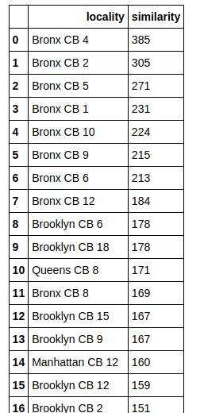

3 cases have been studied in the above procedure and their histogram and maps are drawn.

- The histogram is used to understand how to analyze the data in the table.
- The map helps us to understand the proximity of the points to the area of interest (office, schools or university, etc), helping us make better decisions.

Results -

Case 1- The known locality is in New York

Place considered as known – Bronx CB 4

Table obtaned after finding the similarities-

 | locality | similarity
0 | Bronx CB 4 | 385
1 | Bronx CB 2 | 305
2 | Bronx CB 5 | 271
3 | Bronx CB 1 | 231
4 | Bronx CB 10 | 224
5 | Bronx CB 9 | 215
6 | Bronx CB 6 | 213
7 | Bronx CB 12 | 184
8 | Brooklyn CB 6 | 178
9 | Brooklyn CB 18 | 178
10 | Queens CB 8 | 171
11 | Bronx CB 8 | 169
12 | Brooklyn CB 15 | 167
13 | Brooklyn CB 9 | 167
14 | Manhattan CB 12 | 160
15 | Brooklyn CB 12 | 159
16 | Brooklyn CB 2 | 151
17 | Queens CB 14 | 150
18 | Brooklyn CB 17 | 144
19 | Bronx CB 11 | 142
20 | Bronx CB 7 | 141
21 | Queens CB 2 | 140
22 | Queens CB 12 | 133
23 | Brooklyn CB 16 | 125
24 | Brooklyn CB 4 | 116
25 | Queens CB 9 | 114
26 | Queens CB 4 | 106
27 | Bronx CB 3 | 102
28 | Manhattan CB 3 | 102
29 | Queens CB 6 | 98
30 | Queens CB 5 | 96
31 | Brooklyn CB 14 | 96
32 | Brooklyn CB 3 | 94
33 | Brooklyn CB 7 | 82
34 | Queens CB 10 | 80
35 | Brooklyn CB 10 | 80
36 | Brooklyn CB 13 | 72
37 | Manhattan CB 2 | 71
38 | Manhattan CB 11 | 66
39 | Queens CB 11 | 66
40 | Manhattan CB 5 | 64
41 | Brooklyn CB 5 | 64
42 | Manhattan CB 6 | 58
43 | Brooklyn CB 8 | 48
44 | Queens CB 1 | 48
45 | Brooklyn CB 11 | 48
46 | Staten Island CB 3 | 47
47 | Staten Island CB 2 | 45
48 | Staten Island CB 1 | 38
49 | Manhattan CB 9 | 32
50 | Manhattan CB 10 | 30
51 | Queens CB 3 | 28
52 | Manhattan CB 7 | 9
53 | Manhattan CB 4 | 4
54 | Manhattan CB 1 | 2
55 | Queens CB 13 | 0
56 | Manhattan CB 8 | 0
57 | Queens CB 7 | 0
58 | Brooklyn CB 1 | 0

Histogram of the scores in the above table-
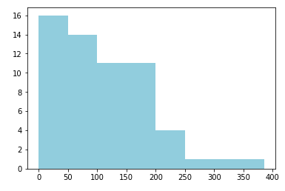

Though the majority of the scores are low, but there is a decent number of localities with 100+ or 150+ scores. So selecting an appropriate locality should be easy.
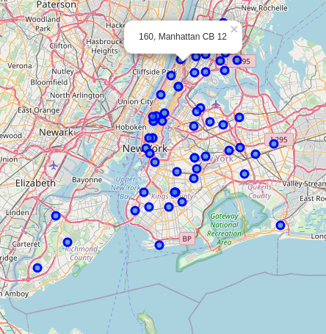

We can see that the pop-up is displaying the score and the name of the community board.

Case 2- Finding the ideal location

Place considered as known – Kolkata part 1

I have used the name Kolkata because I have used the coordinates of Kolkata for the above location, but that is not significant for this specific case.

I manually typed in 10 types of venues which someone may consider to be the properties of his/her ideal locality.

They are-
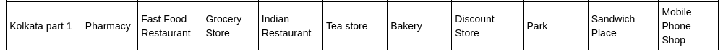
The table of similarity obtained in this case-

 | locality | similarity
0 | Kolkata part 1 | 385
1 | Bronx CB 2 | 266
2 | Bronx CB 4 | 223
3 | Bronx CB 12 | 187
4 | Bronx CB 10 | 169
5 | Bronx CB 1 | 140
6 | Brooklyn CB 12 | 132
7 | Brooklyn CB 18 | 123
8 | Brooklyn CB 6 | 123
9 | Brooklyn CB 9 | 116
10 | Brooklyn CB 15 | 116
11 | Queens CB 3 | 105
12 | Brooklyn CB 17 | 104
13 | Bronx CB 6 | 99
14 | Bronx CB 9 | 97
15 | Manhattan CB 12 | 96
16 | Bronx CB 7 | 96
17 | Queens CB 2 | 83
18 | Bronx CB 5 | 80
19 | Manhattan CB 11 | 76
20 | Queens CB 11 | 76
21 | Staten Island CB 1 | 75
22 | Staten Island CB 2 | 72
23 | Brooklyn CB 2 | 71
24 | Brooklyn CB 7 | 66
25 | Queens CB 12 | 61
26 | Manhattan CB 7 | 60
27 | Brooklyn CB 3 | 56
28 | Manhattan CB 6 | 56
29 | Bronx CB 11 | 54
30 | Queens CB 4 | 52
31 | Brooklyn CB 16 | 45
32 | Queens CB 8 | 44
33 | Manhattan CB 10 | 44
34 | Bronx CB 8 | 40
35 | Queens CB 1 | 40
36 | Brooklyn CB 13 | 40
37 | Brooklyn CB 8 | 35
38 | Brooklyn CB 11 | 35
39 | Queens CB 13 | 30
40 | Brooklyn CB 10 | 30
41 | Manhattan CB 9 | 30
42 | Brooklyn CB 1 | 27
43 | Bronx CB 3 | 24
44 | Manhattan CB 3 | 24
45 | Manhattan CB 1 | 24
46 | Queens CB 9 | 21
47 | Queens CB 7 | 20
48 | Queens CB 14 | 16
49 | Queens CB 6 | 15
50 | Brooklyn CB 4 | 15
51 | Brooklyn CB 14 | 15
52 | Manhattan CB 2 | 14
53 | Queens CB 5 | 11
54 | Staten Island CB 3 | 9
55 | Manhattan CB 4 | 8
56 | Queens CB 10 | 0
57 | Manhattan CB 8 | 0
58 | Manhattan CB 5 | 0
59 | Brooklyn CB 5 | 0

Histogram of the above score table-
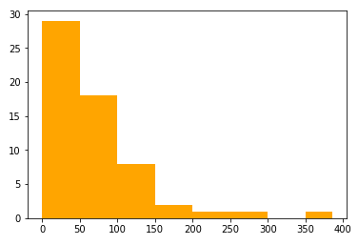

We can very easily conclude that this person should primarily focus on Bronx or Brooklyn, as these regions are more compatible with his choice of venues.

But what if he wants to shift to Manhattan(none of the community boards have a 100+ score)?

The chart is still very effective as we see that there are only 4 community boards that don’t have a score less than 50; namely 6,7,11 and 12. So it still holds as a very effective filter.
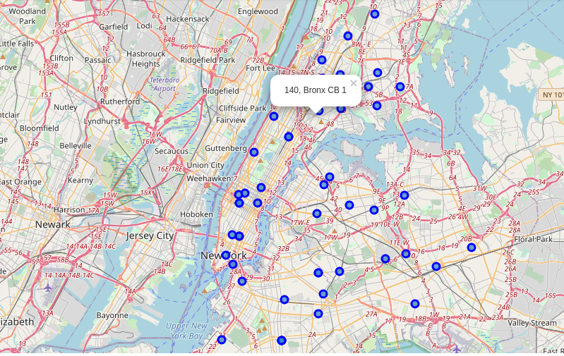

We can now see a second answer to the above question. Bronx CB 1 has a decent score of 140 and is located very near to the Manhattan borough. So it seems to be a very good choice.
Case 3-
Let’s assume that Kolkata part 1 is a real place in Kolkata.

Place considered as known – Manhattan CB 10

Table-
 | locality | similarity
0 | Manhattan CB 10 | 385
1 | Manhattan CB 5 | 237
2 | Brooklyn CB 5 | 237
3 | Manhattan CB 4 | 211
4 | Manhattan CB 8 | 179
5 | Manhattan CB 1 | 177
6 | Manhattan CB 6 | 156
7 | Manhattan CB 2 | 138
8 | Manhattan CB 3 | 123
9 | Bronx CB 3 | 123
10 | Manhattan CB 7 | 123
11 | Brooklyn CB 3 | 121
12 | Brooklyn CB 11 | 120
13 | Brooklyn CB 8 | 120
14 | Queens CB 11 | 107
15 | Manhattan CB 11 | 107
16 | Brooklyn CB 2 | 106
17 | Staten Island CB 2 | 96
18 | Brooklyn CB 7 | 86
19 | Brooklyn CB 1 | 80
20 | Manhattan CB 9 | 74
21 | Queens CB 2 | 62
22 | Queens CB 3 | 58
23 | Bronx CB 11 | 48
24 | Bronx CB 1 | 46
25 | Kolkata part 1 | 44
26 | Queens CB 1 | 42
27 | Manhattan CB 12 | 41
28 | Brooklyn CB 12 | 36
29 | Brooklyn CB 4 | 32
30 | Bronx CB 12 | 32
31 | Bronx CB 4 | 30
32 | Bronx CB 5 | 30
33 | Queens CB 13 | 24
34 | Brooklyn CB 10 | 24
35 | Bronx CB 2 | 21
36 | Bronx CB 9 | 18
37 | Bronx CB 10 | 16
38 | Queens CB 7 | 16
39 | Brooklyn CB 6 | 15
40 | Brooklyn CB 18 | 15
41 | Queens CB 14 | 13
42 | Brooklyn CB 9 | 12
43 | Brooklyn CB 14 | 12
44 | Brooklyn CB 15 | 12
45 | Queens CB 6 | 12
46 | Queens CB 12 | 8
47 | Queens CB 5 | 8
48 | Brooklyn CB 16 | 4
49 | Bronx CB 6 | 0
50 | Queens CB 8 | 0
51 | Staten Island CB 3 | 0
52 | Staten Island CB 1 | 0
53 | Queens CB 9 | 0
54 | Queens CB 4 | 0
55 | Bronx CB 7 | 0
56 | Brooklyn CB 13 | 0
57 | Bronx CB 8 | 0
58 | Brooklyn CB 17 | 0
59 | Queens CB 10 | 0

Histogram-
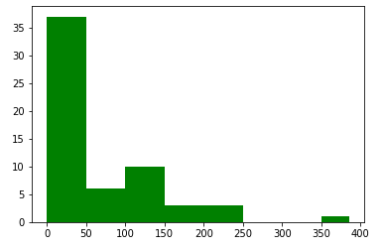

We can see that 35+ (37 exactly) places have a very low score, so it makes the filtering of data easy.
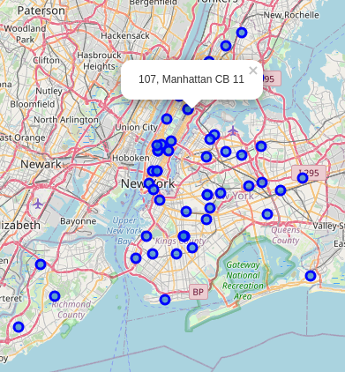
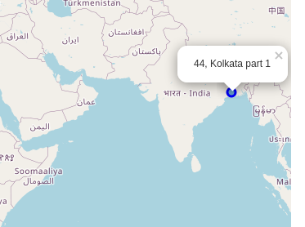

This case shows us how, with even a little information about a location, we can easily understand whether two localities are compatible, even if they are geographically miles apart.

Discussion-

Through the three cases, we can see why the model is so useful.

The first case was standard, in which the model worked as predicted.
The second case shows us that the map can give us vital information regarding a place, making our decision simpler.
The third case shows that even with a little information about a place, we can easily compare it with other places all around the world.

And the merits of the model doesn't end there.

Say you want to open a Chinese restaurant and want to make it a very important factor, ie, find a region where Chinese food is very popular. All you need to do is put 'Chinese restaurant' multiple times in your preference, making it a very important factor.

Suppose you have a list of 'must not' venues rather than most preferred.
You can still use the same process, just this time eliminate the places with a high score.

There are two scopes of improvement:
- The cost of living has not been considered as it is tricky to assign a weight to it. The concept of affordability is subjective, so it requires a much more complex model to consider that.
- The size of the community boards varies, but we consider the same are area (6.28 sq.km) every time, which may result in outliers. Though it gives a very good estimate of most community boards, it may not work on the larger ones.

Conclusion-

First of all, to avoid confusion, the scores obtained through this program are not indicative of how good or bad a locality is. It just shows how similar they are.

And the rank has no real significance. A locality with a score of 220 can be considered equal to a 280 scorer. Similarly, 0 and 30 are equally bad.

What it acts as is a very basic, yet effective filter.

And I think it will be helpful to a lot of people who have a very significant decision to take.

