**10/31/2019**

Proposal for   
**Senior Design**

Project name:Accedent Tracking and Alert System

Submitted by:

Md Adnan Shariar(1521948042)

Shoba Banik (1521172642)

Khandakar Ratul Ali(1610691042)

Date: 31 October, 2019

# Table of Contents

Table of Contents 2

Introduction 3

Objective 3

Platform………………………………………………………………………………………………………………………………..4

Approach…………………………………………………………………………………………………………………………....5

Competitive Advantages……………………………………………………………………………………………………..5

Problem Statement 6

Gantt Chart 7

System Flow Chart 8

# Introduction

Now a day, the alarming rise of road accidents has become one of the major concerns in Bangladesh. Unawareness and disrespect towards traffic rules, reckless driving, rapid growth of vehicles etc can be identified as factors leading to this issue. The distress of the accident victims can be reduced if the detection of accidents can be done in no time. Often emergency supports cannot be provided immediately due to unawareness of the accident to the concerned persons. In this project, an automated system has been proposed to deal with these affairs. Our proposed system will help the wretched victims by notifying the nearest necessary emergency supports. Therefore, our cost effective proposed system will be efficacious for a developing country like Bangladesh to diminish the distress of the people.

## Objective

Now a day, it became very difficult to know that an accident has occurred and to difficult, to locate the position where it happened. There is no system of identification and intimating of medical support regarding accident in previous. GPS and GSM make the usage for intimating and identification of palace. When ac accident occurs the information only sent through GSM. This project presents a GPS and GSM based accident identification and information system using GPS and GSM-SMS services.

So the main intention of the project is to find the accident spot at any place and intimating it to ambulance through GPS and GSM networks. The GPS based vehicle identification module contains vibration sensor, GPS and GSM module connected to the microcontroller.

An automatic alarm device for traffic accidents is introduced in this paper. It can automatically find a traffic accident, search for the spot and then send this basic information

To first aid centre within small time seconds covering geographical coordinates, the time and circumstances in which traffic accident takes place. The GPS networks will get the latitude and longitude values and then it will search the nearest hospital and send the accident information to the hospital. The hospital will then be sending the ambulance to the accident zone.

The following objectives are needed as a guide to achieve the goal of our project. They are:

* To Design a GPS and GSM based accident identification and information system using microcontroller.
* To trigger the car alarm when accidents are detected.
* To interface microcontroller to GPS and GSM module.
* To write a program for the microcontroller to detect the sensors signals and trigger the alarm.
* To provide security for the vehicle user and also detects the accident if occurred and informs respective authority (like ambulance, police, relative etc.) through wireless technologies.

**Platform**

 Here in this project, we are going to build an Arduino based vehicle accident alert system using GPS, GSM and accelerometer. A vibration sensor will be used to detect vehicle accident.

* Arduino Uno
* GSM Module (SIM900A)
* GPS Module (SIM28ML)
* Accelerometer (ADXL335)
* 16x2 LCD
* Power Supply
* Connecting Wires
* 10 K-POT
* Breadboard or PCB
* Power supply 12v 1amp

GPS Module

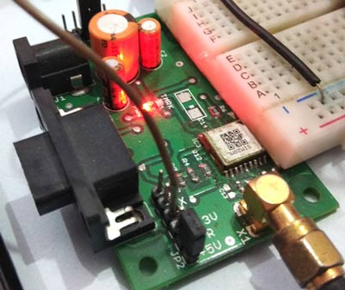

GSM Module

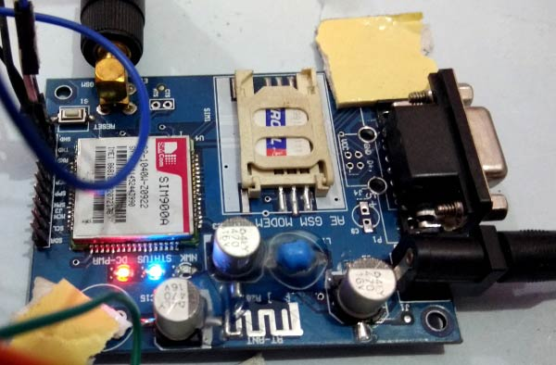

**Approach**

1. **Purpose-** This project used as a tracking system and reduced death rate any type of vehicle accident**.**
2. **Activities -** this project, Arduino is used for controlling whole the process with a **GPS Receiver and GSM module**. GPS Receiver is used for detecting coordinates of the vehicle, GSM module is used for sending the alert SMS with the coordinates and the link to Google Map.

**Competitive-advantage**

**-** This Vehicle Accident alert project can also be used as a Tracking System and much more, by just making few changes in hardware and software. This project can be an aid in constructing smart transport systems in Bangladesh in near future. Random vehicle theft can also be reduced through this system. The main goal of this project is to reduce the accidents by car or any type of vehicle and to reduce death rate by taking the injured persons to hospital through proper actions shortest possible time. This smart system will make vehicle more secure, trustworthy and effective to owner and will contribute to save peoples life

# 

# Problem Statement

As the world population is growing, a large number of vehicles is the demand of time. With the increase rate of transportation, every year road accidents claim exceedingly high number of lives. According to a report of the WHO (World Health Organization), approximately 3000 people die in road accidents every year, while millions are injured or disabled each year. The high demand of automobiles has also increased the traffic hazards and the road accidents. Road accident of Bangladesh also depicts the same scenario. Daily star said that, over the past few years there has been an alarming rise in road accidents, signiﬁcantly highway accidents in Bangladesh. A study has been conducted by the Accident Research Centre (ARC) of BUET on this issue and it has found that road accidents claim on average 12,000 lives annually and lead to about 35,000 injuries.

World Bank statistics says that annual fatality rate from road accidents is found to be 85.6 fatalities per 10,000 vehicles. According to BRTA statistics, 2009 to 2016 (up to July) 19,450 accidents occurred in Bangladesh by which 18,510 died and 14,442 injured. Traffic hazards and road accidents have increased the sufferings of people. One of the main reasons is the lack of emergency facilities available in our country. In most of the cases, when an accident occurs, relatives of that injured person get the news of his/her accident not in time and the emergency rescue teams reach late on the accident spot and the traffic

**Team Dynamic**

|  |  |
| --- | --- |
| Shoba Banik | Arduino, API, Set up |
| Khandakar Ratul Ali (1610691042) | API, Google Map, Set up |
| Md Adnan Sahriar (15219480482) | Android Studio, Set up |

# Gantt Chart

# Capture1.PNG

# System Flow Chart

Yes

Connect phone?

No

No

Pressure/ Gas Sensor High?

Yes

Reply?

Get Notification

Find 3 numbers?

No Yes

No

Yes Yes

Send location

Search nearest Hospital

No

Find?

Yes

Yes

Send Notifiation with location

Figure: System Flow Chart