02 — High-Level Architecture (HLA)
Enterprise logical architecture • Technology-neutral reference design

1. Architecture Intent
The HLA defines the major logical domains and controlled flow without prematurely selecting products. The design principle is separation of environments, sequential promotion, centralized intelligence, human control and observable operations.

2. Logical Architecture
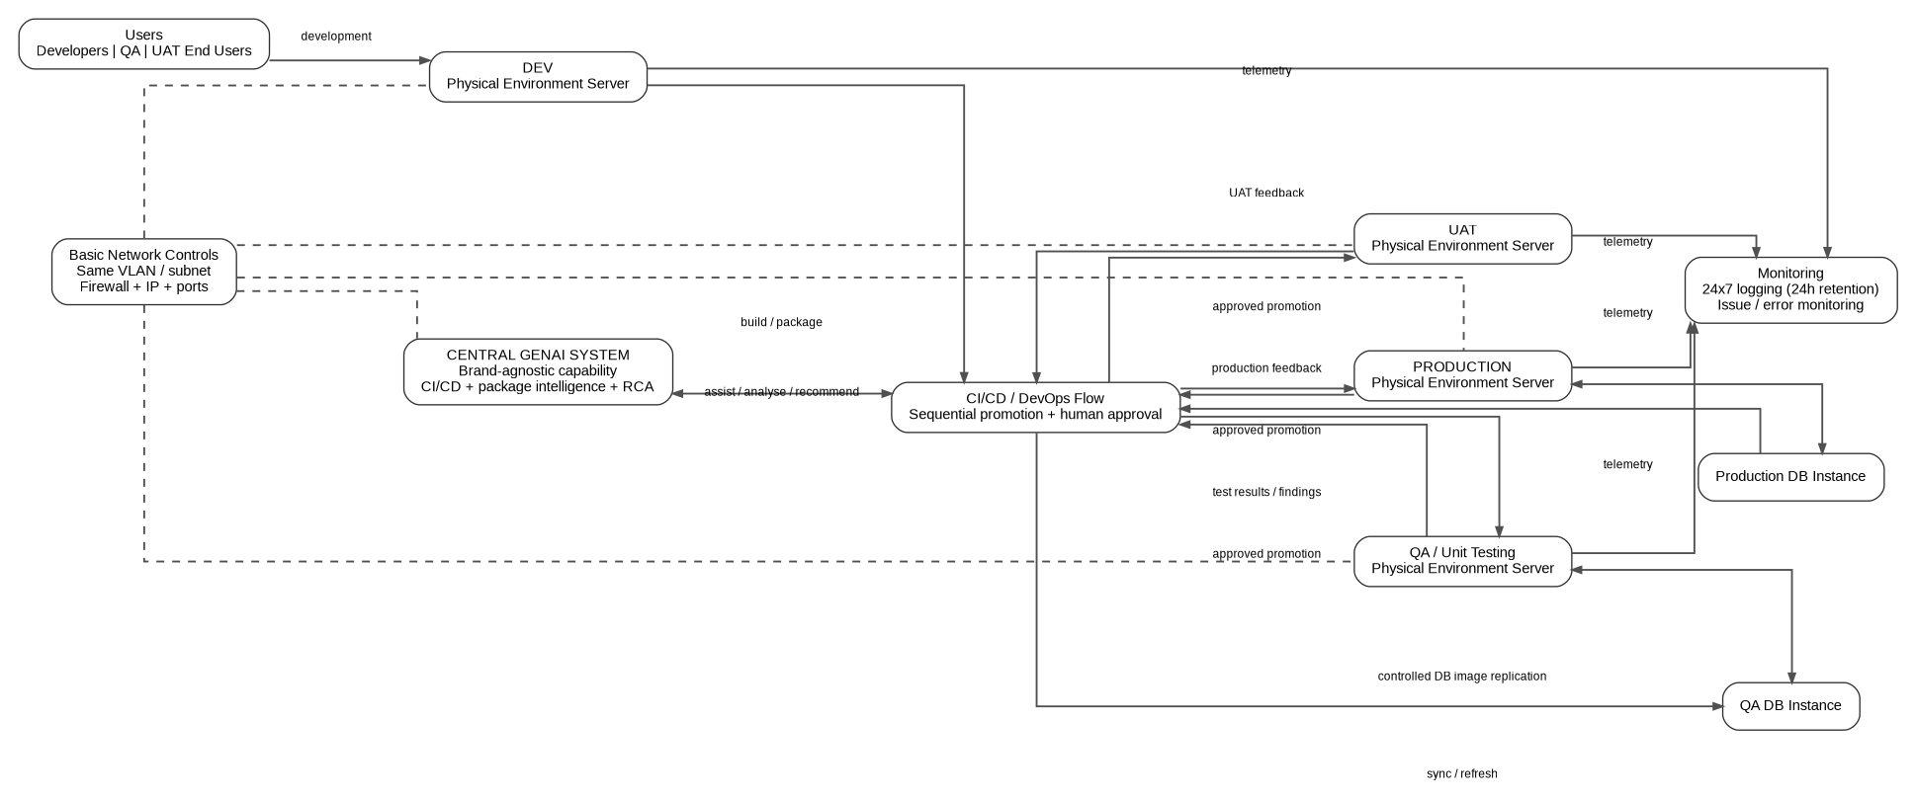
High-level architecture view.

3. Major Logical Domains
Domain | Role | Boundary
Development | Application development, package design/build preparation and developer feedback. | Development environment
QA/Test | Automated and manual verification; QA database instance. | QA environment
UAT | Business/end-user validation before production. | UAT environment
Production | Live application execution and production database instance. | Production environment
Central GenAI | Cross-environment reasoning, package analysis, test-failure analysis, RCA and controlled DevOps assistance. | Central service
CI/CD / DevOps control flow | Sequential promotion and release orchestration with human approval. | Cross-environment control plane
Observability | Continuous logging plus separate issue/service monitoring. | Cross-environment monitoring

4. Primary Flow
- Develop in Dev.
- Build/package and subject the candidate to automated validation.
- Promote sequentially to QA only through the DevOps pipeline and required approval gate.
- Execute QA automated/manual testing and use GenAI for test findings and RCA support.
- Promote to UAT after successful QA and human approval.
- UAT users execute business validation.
- Promote to Production only after successful UAT and human approval.
- Monitor production continuously; maintain 24-hour log-file retention/reset and issue monitoring.

5. Architectural Principles
- Vendor neutrality: capability requirements precede product selection.
- Human-in-the-loop: GenAI assists; humans authorize promotion.
- Sequential promotion: no bypass path is part of the baseline.
- Least invention: unresolved details remain explicit decisions.
- Observability by design: logs and issue monitoring are first-class concerns.
- Environment integrity: promotion should move controlled artifacts rather than ad hoc manual copies.

