03 — Detailed Infrastructure & Network Architecture (DINA)
Physical topology baseline • Detailed infrastructure-level design

1. Physical Baseline
Component | Baseline | Confirmed?
Dev server | 1 physical server in basic model | Yes
QA server | 1 physical server in basic model | Yes
UAT server | 1 physical server in basic model | Yes
Production server | 1 physical server in basic model | Yes
QA DB | Central QA database instance | Yes
Production DB | Central Production database instance | Yes
Virtualization | None | Yes
Cloud | None | Yes
Network | Same VLAN/subnet with logical separation | Yes

2. Detailed Infrastructure Diagram
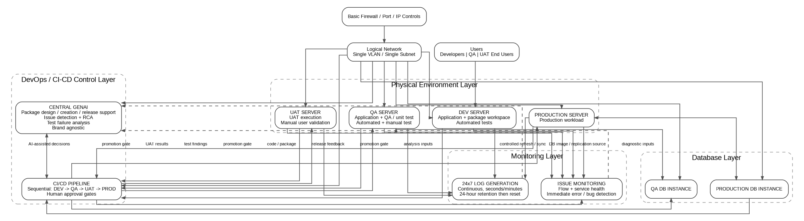
Detailed infrastructure/network topology.

3. Network Requirements
- Keep Dev, QA, UAT and Production logically separated while remaining on the same VLAN/subnet, as explicitly requested.
- Apply basic firewall controls using defined IP and port rules.
- Document allowed flows explicitly before implementation.
- Do not introduce additional network zones or appliances as confirmed requirements unless later approved.

4. Required Flow Matrix — To Be Finalized
Source | Destination | Purpose | IP/Port | Decision
Dev | QA | Controlled package promotion | TBD | Required
QA | UAT | Controlled package promotion | TBD | Required
UAT | Prod | Controlled release promotion | TBD | Required
Central GenAI | Dev/QA/UAT/Prod | Approved data/telemetry/control interactions | TBD | Architecture decision required
QA DB | Production DB | Synchronization/replication direction | TBD | Clarify exact mechanism
Production DB | QA DB | Production image replication to QA image | TBD | Confirmed requirement; mechanism TBD

5. Important Architecture Control
The same VLAN/subnet requirement creates weaker network isolation than separate VLANs/subnets. The blueprint therefore treats logical separation, firewall rules, host controls and strict promotion policy as compensating controls. This is an architectural observation, not a change to the stakeholder requirement.

