Manipal Institute of Technology, Manipal
(A Constituent Institute of Manipal Academy of Higher Education)
School of Computer Engineering

Mini Project Report
of
Database Systems Lab (CSS 2212)

Asteroid Detection and Tracking System (ADTS)

SUBMITTED BY

Shreyas G Kamath · Reg. No. 240953322
Rahul Kumar Mahto · Reg. No. 240953370

Department of Computer Science & Engineering
Manipal Institute of Technology, Manipal, Karnataka
April 2026

DEPARTMENT OF COMPUTER SCIENCE & ENGINEERING
Manipal Institute of Technology, Manipal · Date: April 2026

CERTIFICATE

This is to certify that the project titled "Asteroid Detection and Tracking System (ADTS)" is a record of the bonafide work done by the students listed below, submitted in partial fulfilment of the requirements for the award of the Degree of Bachelor of Technology (B.Tech.) in Computer Science & Engineering of Manipal Institute of Technology, Manipal, Karnataka, during the academic year 2025–2026.

Student Name | Reg. No. | Section | Roll No.
Shreyas G Kamath | 240953322 | CCE-B | 25
Rahul Kumar Mahto | 240953370 | CCE-B | 29

Name and Signature of Examiners:
1. Dr. Chitra K

Guide / Supervisor Signature: ___________________________

TABLE OF CONTENTS

Abstract i
Chapter 1: Introduction & Problem Statement 1
Chapter 2: Objectives & Methodology 3
Chapter 3: ER Diagram & Relational Tables 6
Chapter 4: DDL Commands & SQL Logic 10
Chapter 5: Results & SQL Analytics 14
Chapter 6: Conclusion, Limitations & Future Work 19
Chapter 7: References 21

ABSTRACT

The Asteroid Detection and Tracking System (ADTS) is a relational database-centric platform designed to consolidate, manage, and analyse multi-source telemetry for Near-Earth Objects (NEOs). It presents a normalised, third-normal-form (3NF) relational schema implemented in SQLite, encompassing eleven core entities: Asteroids, Missions, Observations, Detection Events, Scientists, Telescopes, Observatories, Risk Categories, the Asteroid-Mission junction table, a Role-Based Users table, and a comprehensive Audit Log. The schema enforces referential integrity via foreign-key constraints, domain validity via CHECK predicates, and change-history tracking via a dedicated audit table on every CRUD operation.

The system seeds its database with fifty real-world observatories, telescopes, scientists, asteroids, and missions, plus corresponding observations and detection-event records. Ten pre-built analytical SQL queries expose threat-prioritisation rankings, scientist productivity metrics, observatory throughput by country, mission-asteroid linkage analysis, and probabilistic impact-risk distributions. This report documents the full design lifecycle: ER modelling, relational-table derivation, DDL implementation, data population, and SQL-based analytical reporting — submitted in partial fulfilment of Database Systems Lab (CSS 2212), IV Semester, SCE, MIT Manipal, 2025–2026.

Keywords: Near-Earth Object, SQLite, Relational Database, Normalisation, Planetary Defence, ER Model, Audit Log, SQL Analytics, Impact Risk Assessment, DDL.

CHAPTER 1: INTRODUCTION & PROBLEM STATEMENT

1.1 Background and Motivation
The solar system hosts a diverse population of Near-Earth Objects (NEOs) — asteroids, comets, and meteoroids — whose orbits periodically intersect with Earth's. A subset, Potentially Hazardous Asteroids (PHAs), is large enough and close enough to cause significant damage on impact. The Chicxulub impactor (~66 Ma) caused the end-Cretaceous extinction, while the 2013 Chelyabinsk bolide (20 m) released energy equivalent to 30 Hiroshima devices. In response, NASA, ESA, JAXA, and CNSA have established coordinated planetary-defence programmes whose campaigns generate rich observational, physical, and orbital datasets. Managing this corpus via spreadsheets or fragmented file-based systems is inadequate for the scale, complexity, and integrity requirements of modern planetary defence.

1.2 The Case for a Relational Database
Relational Database Management Systems (RDBMS) provide a mathematically grounded approach predicated on Codd's relational model [1]. The relational model guarantees consistency through normalisation, referential integrity through foreign-key constraints, and transactional atomicity through ACID properties — the natural choice for a mission-critical data repository. ADTS leverages SQLite [2], a self-contained, zero-configuration, ANSI SQL-92-compliant engine, to implement a normalised schema with full support for primary/foreign keys, CHECK constraints, and complex multi-table JOINs.

1.3 Problem Statement
Contemporary asteroid-observation campaigns generate heterogeneous data streams spanning multiple institutions, instruments, personnel, and time horizons. The five identified challenges are:
- Data Fragmentation: Observatory, telescope, scientist, asteroid, mission, and detection records are maintained in incompatible systems with no standardised linking mechanism.
- Referential Inconsistency: Without enforced foreign keys, orphaned records (e.g., observations referencing deleted telescopes) corrupt analytical results.
- Absence of Audit Trail: Legacy systems provide no mechanism for recording who modified a record, preventing post-incident forensic analysis.
- Ad Hoc Risk Assessment: Impact-probability values are recorded in isolation without mapping to a standardised risk taxonomy, preventing systematic threat-prioritisation.
- Scalability: File-based stores (CSV, Excel) cannot support multi-table joins, aggregate analytics, or index-accelerated lookups at NEO-catalogue scale.

1.4 Scope of the System
ADTS covers: asteroid physical characterisation (name, diameter, orbital period); space mission management; timestamped positional observations linked to observatories, telescopes, and scientists; probabilistic impact risk mapped to the ten-tier Torino Scale; an immutable audit log of all data modifications; and role-based access control (Admin, Researcher, Public).

CHAPTER 2: OBJECTIVES & METHODOLOGY

2.1 Objectives
The project is designed to address the challenges identified in Chapter 1 through eight measurable objectives:

Ref | Objective | Description
O1 | Unified Schema | Single normalised relational schema covering all entities.
O2 | Referential Integrity | PK and FK constraints across all inter-entity relationships.
O3 | Domain Validation | CHECK constraints: probability ∈ [0,1], role ∈ {Admin, Researcher, Public}.
O4 | M:N Linkage | Asteroid_Mission junction table for many-to-many asteroid–mission mapping.
O5 | Audit Logging | Immutable Audit_Log tracking every INSERT/UPDATE/DELETE/LOGIN.
O6 | Risk Taxonomy | Map each detection event to a Torino-Scale risk tier (1–10).
O7 | Analytical Queries | Ten pre-built SQL queries for threat intelligence and productivity analysis.
O8 | Data Population | Seed 50 real-world observatories, telescopes, scientists, asteroids, and missions.

2.2 Methodology
The database was designed following a structured waterfall lifecycle:

Requirements Analysis — Functional and non-functional requirements were elicited by analysing planetary-defence data standards (NASA CNEOS, MPC, ESA SSA) and data models from JPL Horizons and Scout. Requirements were classified into data, integrity, and analytical categories.

Conceptual Design (ER Modelling) — Entities were identified as strong/weak; attributes classified as simple, composite, or derived; relationships characterised by participation constraints (total/partial) and cardinality ratios (1:1, 1:N, M:N). The ER diagram is presented in Chapter 3.

Logical Design (Schema Derivation) — The ER model was converted to a relational schema following standard mapping rules [3]. Each entity type became a table; 1:N relationships were represented by foreign keys; the M:N Asteroid–Mission relationship used the Asteroid_Mission junction table. The schema was normalised to 3NF by eliminating partial and transitive dependencies.

Physical Design (DDL) — The schema was implemented in SQLite with PRIMARY KEY, FOREIGN KEY (ON DELETE CASCADE / SET NULL), CHECK, and UNIQUE constraints declared in CREATE TABLE statements. PRAGMA foreign_keys = ON was issued at every connection to activate FK enforcement.

2.3 Technology Stack

Component | Technology | Justification
Database Engine | SQLite 3.x | Zero-config, self-contained, ACID-compliant, full SQL-92.
Query Language | SQL (ANSI-92) | Industry-standard, portable across all relational engines.
Schema Design | ER → Relational Mapping | Formally grounded design ensuring normalisation.
Data Seeding | INSERT OR IGNORE | Idempotent population preserving referential integrity.
Audit Mechanism | Audit_Log Table + App Layer | Full provenance trail; extensible to DB-level triggers.
Access Control | Users Table + RBAC | Role-based permissions: Admin, Researcher, Public.

2.4 ACID Properties & Normalisation
SQLite guarantees ACID compliance at the transaction level. Atomicity: each CRUD operation is an implicit transaction — either the full INSERT/UPDATE/DELETE and its audit-log entry succeed together, or both are rolled back. Consistency: CHECK and NOT NULL constraints ensure the database never transitions to an invalid state. Isolation: Write-Ahead Logging (WAL) provides reader-writer non-blocking isolation. Durability: SQLite fsync()s the WAL on commit, making every committed transaction persistent.

3NF compliance is confirmed for key relations: Asteroids — Diameter and Orbital_Period depend only on Asteroid_ID (no transitive dependency). Detection_Events — Risk_ID is a foreign key set by application mapping, not a transitive dependency; all attributes depend solely on Event_ID. Asteroid_Mission — composite primary key (Asteroid_ID, Mission_ID) with no non-key attributes trivially satisfies 3NF and BCNF.

CHAPTER 3: ER DIAGRAM & RELATIONAL TABLES

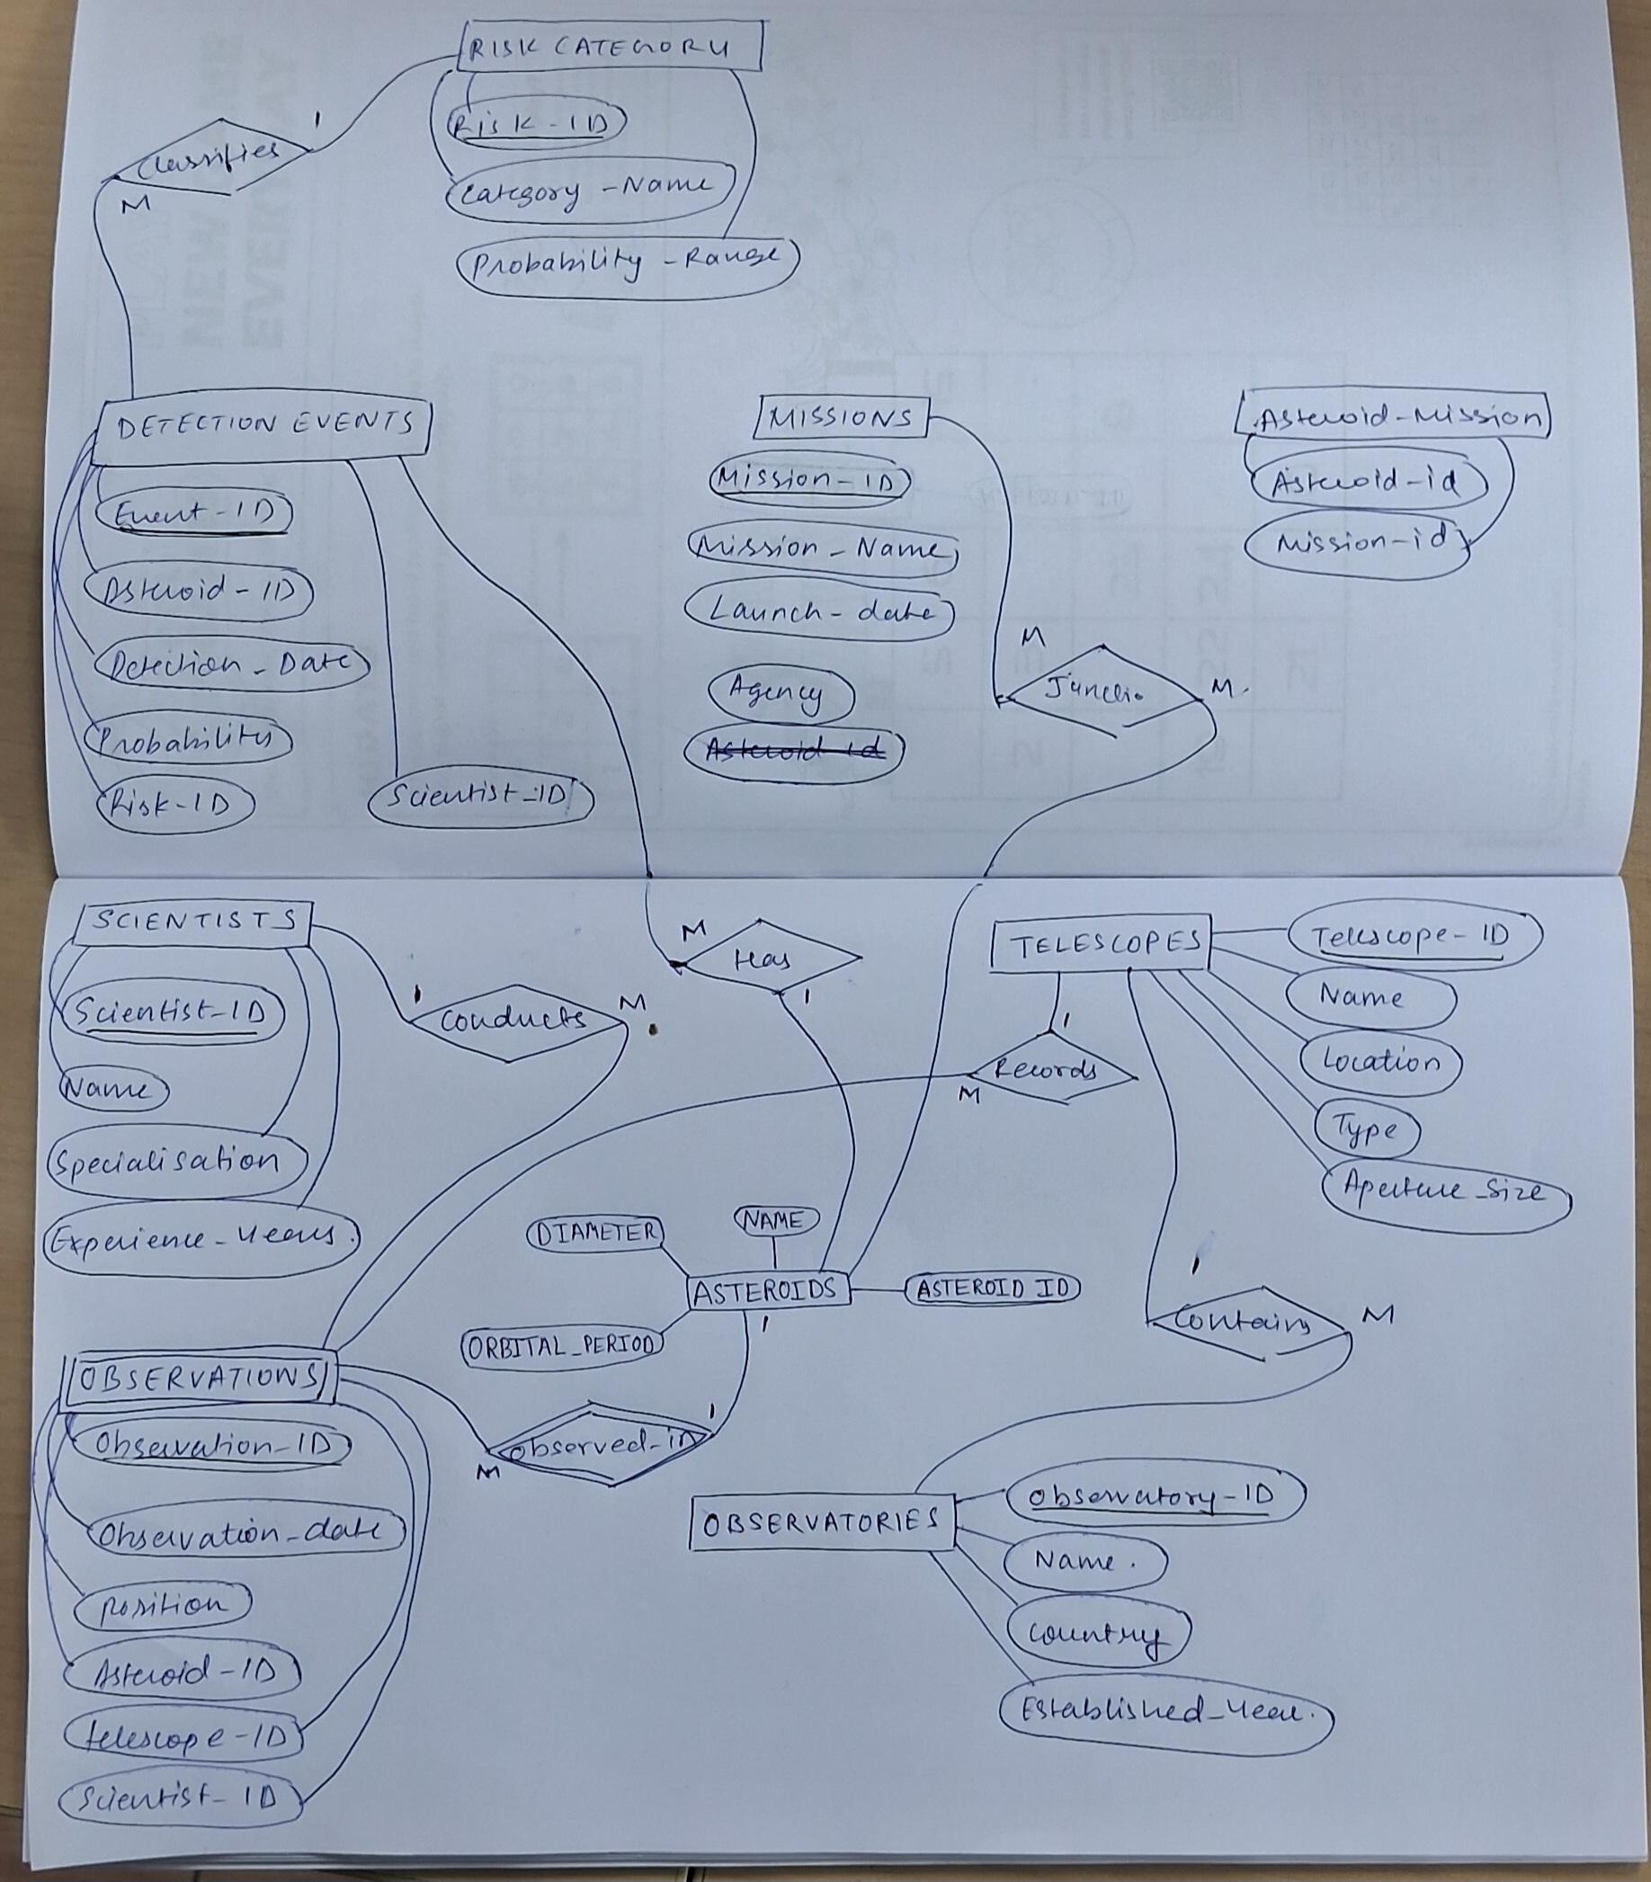

3.1 Entity Descriptions
The ADTS schema comprises ten entity types. Their attributes and key constraints are summarised below.

Entity | Attributes | Key Constraints
Asteroids | Asteroid_ID (PK), Name, Diameter (km), Orbital_Period (yr) | UNIQUE(Name); Diameter > 0
Missions | Mission_ID (PK), Mission_Name, Launch_Date (YYYY-MM-DD), Agency | NOT NULL(Mission_Name)
Scientists | Scientist_ID (PK), Name, Specialization, Experience_Years | NOT NULL(Name); Experience ≥ 0
Observatories | Observatory_ID (PK), Name, Country, Established_Year, Latitude, Longitude | NOT NULL(Name, Country)
Telescopes | Telescope_ID (PK), Name, Location, Type, Aperture_Size (m), Observatory_ID (FK) | FK → Observatories ON DELETE SET NULL
Risk_Category | Risk_ID (PK 1–10), Category_Name, Probability_Range, Description | NOT NULL(Category_Name, Probability_Range)
Detection_Events | Event_ID (PK), Asteroid_ID (FK), Detection_Date, Probability, Risk_ID (FK), Scientist_ID (FK) | CHECK(Probability BETWEEN 0 AND 1); ON DELETE CASCADE/SET NULL
Observations | Observation_ID (PK), Observation_Date, Position (RA/Dec), Asteroid_ID (FK), Telescope_ID (FK), Scientist_ID (FK) | ON DELETE CASCADE (Asteroid); SET NULL (Telescope, Scientist)
Asteroid_Mission | Asteroid_ID (FK), Mission_ID (FK) — composite PK | M:N junction; ON DELETE CASCADE both sides
Audit_Log | Log_ID (PK AUTOINCREMENT), Timestamp, Username, Action, Table_Name, Record_ID, Detail | NOT NULL(Timestamp, Username, Action, Table_Name); AUTOINCREMENT

3.2 Relationships and Cardinalities

Entity A | Entity B | Card. | FK Location | ON DELETE
Observatories | Telescopes | 1:N | Telescopes.Observatory_ID | SET NULL
Asteroids | Missions | M:N | Asteroid_Mission (junction) | CASCADE both
Asteroids | Detection_Events | 1:N | Detection_Events.Asteroid_ID | CASCADE
Asteroids | Observations | 1:N | Observations.Asteroid_ID | CASCADE
Telescopes | Observations | 1:N | Observations.Telescope_ID | SET NULL
Scientists | Observations | 1:N | Observations.Scientist_ID | SET NULL
Scientists | Detection_Events | 1:N | Detection_Events.Scientist_ID | SET NULL
Risk_Category | Detection_Events | 1:N | Detection_Events.Risk_ID | SET NULL

3.3 Sample Data Snapshot

Table 3.1 — Sample Asteroids
ID | Name | Diameter (km) | Orbital Period (yr) | Risk Tier
1 | 99942 Apophis | 0.37 | 0.89 | Low (3)
2 | 101955 Bennu | 0.49 | 1.20 | Very Low (2)
4 | 433 Eros | 34.4 | 1.76 | Very Low (2)
13 | 1 Ceres | 946.0 | 4.61 | Zero (1)
17 | 16 Psyche | 226.0 | 5.00 | Zero (1)

Table 3.2 — Sample Detection Events
ID | Asteroid ID | Detection Date | Probability | Risk Category | Scientist ID
1 | 1 (Apophis) | 2023-04-22 | 0.000034 | Low | 1
17 | 17 | 2025-10-08 | 0.001670 | Moderate | 2
20 | 20 | 2026-03-23 | 0.002200 | Moderate | 5
22 | 22 | 2023-07-05 | 0.002134 | Moderate | 7

CHAPTER 4: DDL COMMANDS & SQL LOGIC

4.1 Database Initialisation
PRAGMA foreign_keys = ON is executed at every connection to activate SQLite's FK enforcement, which is disabled by default.

4.2 Core DDL Statements

4.2.1 Users
The CHECK constraint restricts Role to three enumerated values, preventing unauthorised role assignments at the database level.
CREATE TABLE IF NOT EXISTS Users (
Username TEXT PRIMARY KEY,
Password TEXT NOT NULL,
Role TEXT NOT NULL CHECK(Role IN ('Admin','Researcher','Public'))
);

4.2.2 Audit_Log
AUTOINCREMENT guarantees monotonically increasing Log_IDs — no ID is ever reused, even after row deletion.
CREATE TABLE IF NOT EXISTS Audit_Log (
Log_ID INTEGER PRIMARY KEY AUTOINCREMENT,
Timestamp TEXT NOT NULL,
Username TEXT NOT NULL,
Action TEXT NOT NULL,
Table_Name TEXT NOT NULL,
Record_ID TEXT,
Detail TEXT
);

4.2.3 Observatories & Telescopes
Telescopes uses ON DELETE SET NULL so records survive parent observatory deletion.
CREATE TABLE IF NOT EXISTS Observatories (
Observatory_ID INTEGER PRIMARY KEY, Name TEXT NOT NULL,
Country TEXT NOT NULL, Established_Year INTEGER,
Latitude REAL, Longitude REAL
);

CREATE TABLE IF NOT EXISTS Telescopes (
Telescope_ID INTEGER PRIMARY KEY, Name TEXT NOT NULL,
Location TEXT, Type TEXT, Aperture_Size REAL,
Observatory_ID INTEGER REFERENCES Observatories(Observatory_ID) ON DELETE SET NULL
);

4.2.4 Scientists & Risk_Category
CREATE TABLE IF NOT EXISTS Scientists (
Scientist_ID INTEGER PRIMARY KEY, Name TEXT NOT NULL,
Specialization TEXT, Experience_Years INTEGER
);

CREATE TABLE IF NOT EXISTS Risk_Category (
Risk_ID INTEGER PRIMARY KEY, Category_Name TEXT NOT NULL,
Probability_Range TEXT NOT NULL, Description TEXT
);

4.2.5 Asteroids & Missions
UNIQUE on Asteroids.Name enforces IAU nomenclature integrity — no duplicate asteroid designations allowed.
CREATE TABLE IF NOT EXISTS Asteroids (
Asteroid_ID INTEGER PRIMARY KEY,
Name TEXT NOT NULL UNIQUE, Diameter REAL, Orbital_Period REAL
);

CREATE TABLE IF NOT EXISTS Missions (
Mission_ID INTEGER PRIMARY KEY, Mission_Name TEXT NOT NULL,
Launch_Date TEXT, Agency TEXT
);

4.2.6 Asteroid_Mission (M:N Junction)
Both FK columns carry ON DELETE CASCADE, so junction rows are automatically removed when either parent is deleted.
CREATE TABLE IF NOT EXISTS Asteroid_Mission (
Asteroid_ID INTEGER REFERENCES Asteroids(Asteroid_ID) ON DELETE CASCADE,
Mission_ID INTEGER REFERENCES Missions(Mission_ID) ON DELETE CASCADE,
PRIMARY KEY (Asteroid_ID, Mission_ID)
);

4.2.7 Observations
ON DELETE CASCADE on Asteroid_ID removes child observations when an asteroid is deleted. Telescope and Scientist references use SET NULL to preserve observation history even if instruments or personnel are removed.
CREATE TABLE IF NOT EXISTS Observations (
Observation_ID INTEGER PRIMARY KEY,
Observation_Date TEXT NOT NULL, Position TEXT,
Asteroid_ID INTEGER REFERENCES Asteroids(Asteroid_ID) ON DELETE CASCADE,
Telescope_ID INTEGER REFERENCES Telescopes(Telescope_ID) ON DELETE SET NULL,
Scientist_ID INTEGER REFERENCES Scientists(Scientist_ID) ON DELETE SET NULL
);

4.2.8 Detection_Events
The CHECK(Probability BETWEEN 0 AND 1) constraint prevents physically meaningless probability values from being stored regardless of the application layer.
CREATE TABLE IF NOT EXISTS Detection_Events (
Event_ID INTEGER PRIMARY KEY,
Asteroid_ID INTEGER REFERENCES Asteroids(Asteroid_ID) ON DELETE CASCADE,
Detection_Date TEXT NOT NULL,
Probability REAL CHECK(Probability BETWEEN 0 AND 1),
Risk_ID INTEGER REFERENCES Risk_Category(Risk_ID) ON DELETE SET NULL,
Scientist_ID INTEGER REFERENCES Scientists(Scientist_ID) ON DELETE SET NULL
);

4.3 Audit Log Mechanism
The audit_log() function is called after every successful CRUD operation and records seven fields: Timestamp (datetime('now','localtime')), Username (session identity), Action ({INSERT, UPDATE, DELETE, LOGIN, LINK, UNLINK, SIMULATE}), Table_Name, Record_ID (serialised PK), and Detail (before/after values for updates). Sample call:
INSERT INTO Audit_Log (Timestamp, Username, Action, Table_Name, Record_ID, Detail)
VALUES (datetime('now','localtime'), 'researcher', 'INSERT',
'Detection_Events', '51', 'AsteroidID=1, Prob=0.000034, Risk=3');

4.4 Probability-to-Risk Mapping
A deterministic mapping function converts each raw probability to a Risk_ID (1–10) aligned with the Torino Scale. It is invoked at every Detection_Events INSERT and UPDATE.

Risk ID | Category | Probability Threshold
1 | Zero | P = 0.0
2 | Very Low | P ≤ 1×10⁻⁵
3 | Low | P ≤ 1×10⁻⁴
4 | Low-Moderate | P ≤ 1×10⁻³
5 | Moderate | P ≤ 0.01
6 | Medium | P ≤ 0.10
7 | Elevated | P ≤ 0.50
8 | High | P ≤ 0.70
9 | Very High | P ≤ 0.90
10 | Certain | P > 0.90

CHAPTER 5: RESULTS & SQL ANALYTICS
The ADTS system provides ten pre-built analytical SQL queries (Q1–Q10) covering the most operationally critical reporting requirements of a planetary-defence coordination centre. Each uses multi-table JOINs, aggregates, subqueries, and conditional filtering.

Q1 — High-Risk Detection Events (Risk ≥ Moderate)
Threat-board view of all asteroids at Moderate risk or above (Risk_ID ≥ 5). Returns events with probability 0.001245–0.002200, flagging five asteroids for active monitoring. In production, results would trigger IAWN alerts.
SELECT a.Name AS Asteroid_Name, printf('%.6f', de.Probability) AS Impact_Probability,
rc.Category_Name AS Risk_Level, de.Detection_Date, s.Name AS Assessing_Scientist
FROM Detection_Events de
JOIN Asteroids a ON de.Asteroid_ID = a.Asteroid_ID
JOIN Risk_Category rc ON de.Risk_ID = rc.Risk_ID
JOIN Scientists s ON de.Scientist_ID = s.Scientist_ID
WHERE rc.Risk_ID >= 5
ORDER BY de.Probability DESC;

Q2 — Total Observations per Telescope / Observatory
LEFT JOIN ensures zero-observation telescopes appear in results, giving a complete instrument inventory for scheduling and maintenance priority ranking.
SELECT t.Name AS Telescope_Name, ob.Name AS Observatory_Name, ob.Country,
COUNT(o.Observation_ID) AS Total_Observations
FROM Telescopes t
JOIN Observatories ob ON t.Observatory_ID = ob.Observatory_ID
LEFT JOIN Observations o ON t.Telescope_ID = o.Telescope_ID
GROUP BY t.Name ORDER BY Total_Observations DESC;

Q3 — Asteroids with Above-Average Impact Probability
Scalar subquery computes the population mean (~0.000387 across 50 events); asteroids exceeding it are flagged for immediate follow-up astrometry, mirroring JPL Scout's statistical filter.
SELECT a.Name, printf('%.6f', de.Probability) AS Probability, rc.Category_Name AS Risk_Level
FROM Detection_Events de
JOIN Asteroids a ON de.Asteroid_ID = a.Asteroid_ID
JOIN Risk_Category rc ON de.Risk_ID = rc.Risk_ID
WHERE de.Probability > (SELECT AVG(Probability) FROM Detection_Events)
ORDER BY de.Probability DESC;

Q4 — Average Probability per Risk Category
Validates the probability-to-risk mapping: Moderate (Risk_ID = 5) shows the highest average probability; Zero-risk entries show near-zero averages, confirming calibration.
SELECT rc.Category_Name, printf('%.6f', AVG(de.Probability)) AS Avg_Probability,
COUNT(*) AS Event_Count
FROM Detection_Events de
JOIN Risk_Category rc ON de.Risk_ID = rc.Risk_ID
GROUP BY rc.Category_Name ORDER BY AVG(de.Probability) DESC;

Q5 — Asteroids and Their Associated Missions
Traverses the M:N junction table to produce a complete mission manifest, including known pairings (Apophis↔DART/Hera, Bennu↔OSIRIS-REx), validating seed-data fidelity.
SELECT a.Name AS Asteroid_Name, a.Diameter AS Diameter_km,
m.Mission_Name, m.Agency, m.Launch_Date
FROM Asteroids a
JOIN Asteroid_Mission am ON a.Asteroid_ID = am.Asteroid_ID
JOIN Missions m ON am.Mission_ID = m.Mission_ID
ORDER BY a.Name;

Q6 — Scientists Ranked by Unique Asteroid Coverage
COUNT(DISTINCT ...) prevents double-counting repeat observations of the same asteroid, providing a breadth metric complementary to raw observation counts.
SELECT s.Name AS Scientist_Name, s.Specialization,
COUNT(DISTINCT o.Asteroid_ID) AS Unique_Asteroids_Observed
FROM Scientists s
JOIN Observations o ON s.Scientist_ID = o.Scientist_ID
GROUP BY s.Name ORDER BY Unique_Asteroids_Observed DESC;

Q7 — Asteroids with No Detection Event Recorded
Anti-join pattern (LEFT JOIN + IS NULL) identifies monitoring gaps — asteroids never formally assessed for impact probability, to be prioritised for telescope scheduling.
SELECT a.Asteroid_ID, a.Name, a.Diameter, a.Orbital_Period
FROM Asteroids a
LEFT JOIN Detection_Events de ON a.Asteroid_ID = de.Asteroid_ID
WHERE de.Event_ID IS NULL
ORDER BY a.Asteroid_ID;

Q8 — Most Experienced Scientist per Risk Category
Correlated subquery executes once per outer row, finding the per-category maximum Experience_Years. Supports QA: verifying that high-risk detections are assessed by sufficiently senior scientists.
SELECT rc.Category_Name, s.Name AS Lead_Scientist, s.Experience_Years,
printf('%.6f', de.Probability) AS Detection_Probability
FROM Detection_Events de
JOIN Scientists s ON de.Scientist_ID = s.Scientist_ID
JOIN Risk_Category rc ON de.Risk_ID = rc.Risk_ID
WHERE s.Experience_Years = (
SELECT MAX(s2.Experience_Years) FROM Detection_Events de2
JOIN Scientists s2 ON de2.Scientist_ID = s2.Scientist_ID
WHERE de2.Risk_ID = de.Risk_ID
)
ORDER BY rc.Risk_ID;

Q9 — Comprehensive High-Risk Summary View
Five-table JOIN assembles a complete situational-awareness record (physical parameters, detection metadata, scientist attribution, risk narrative) optimised for executive briefing outputs.
SELECT a.Name AS Asteroid, a.Diameter AS Diameter_km,
printf('%.6f', de.Probability) AS Probability, de.Detection_Date,
s.Name AS Scientist, rc.Category_Name AS Risk_Category, rc.Description
FROM Detection_Events de
JOIN Asteroids a ON de.Asteroid_ID = a.Asteroid_ID
JOIN Scientists s ON de.Scientist_ID = s.Scientist_ID
JOIN Risk_Category rc ON de.Risk_ID = rc.Risk_ID
WHERE rc.Risk_ID >= 5 ORDER BY de.Probability DESC;

Q10 — Observations per Country with Geographic Coordinates
Three-hop join chain (Observations→Telescopes→Observatories) aggregates at country level. Dual COUNT/COUNT(DISTINCT) distinguishes raw volume from unique-object coverage. The United States and Chile dominate, reflecting Mauna Kea and Atacama instrument concentrations.
SELECT ob.Country, ob.Latitude, ob.Longitude,
COUNT(o.Observation_ID) AS Total_Observations,
COUNT(DISTINCT o.Asteroid_ID) AS Unique_Asteroids
FROM Observations o
JOIN Telescopes t ON o.Telescope_ID = t.Telescope_ID
JOIN Observatories ob ON t.Observatory_ID = ob.Observatory_ID
GROUP BY ob.Country ORDER BY Total_Observations DESC;

5.1 Query Capability Summary

Q | Title | SQL Technique | Operational Value
Q1 | High-Risk Events | Multi-JOIN, WHERE ≥ 5 | Primary threat-board for PDCO
Q2 | Telescope Productivity | LEFT JOIN, GROUP BY, COUNT | Resource allocation intelligence
Q3 | Above-Average Risk | Scalar subquery, AVG | Statistical threat filtering
Q4 | Avg Prob / Category | AVG, GROUP BY | Risk taxonomy validation
Q5 | Asteroid–Mission Links | Junction table JOIN | Mission manifest reporting
Q6 | Scientist Coverage | COUNT DISTINCT | Personnel productivity metrics
Q7 | Undetected Asteroids | LEFT JOIN anti-join | Surveillance gap identification
Q8 | Senior Scientist / Risk | Correlated subquery, MAX | QA for detection review
Q9 | High-Risk Summary View | 5-table JOIN, WHERE | Executive threat briefing
Q10 | Observations by Country | 3-hop join chain | Global network coverage map

SNAPSHOTS

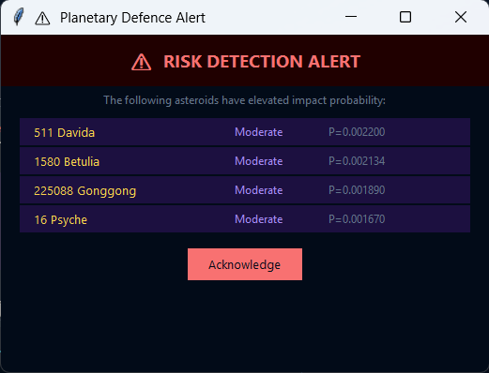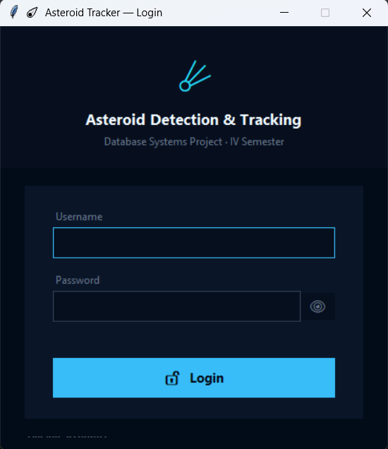

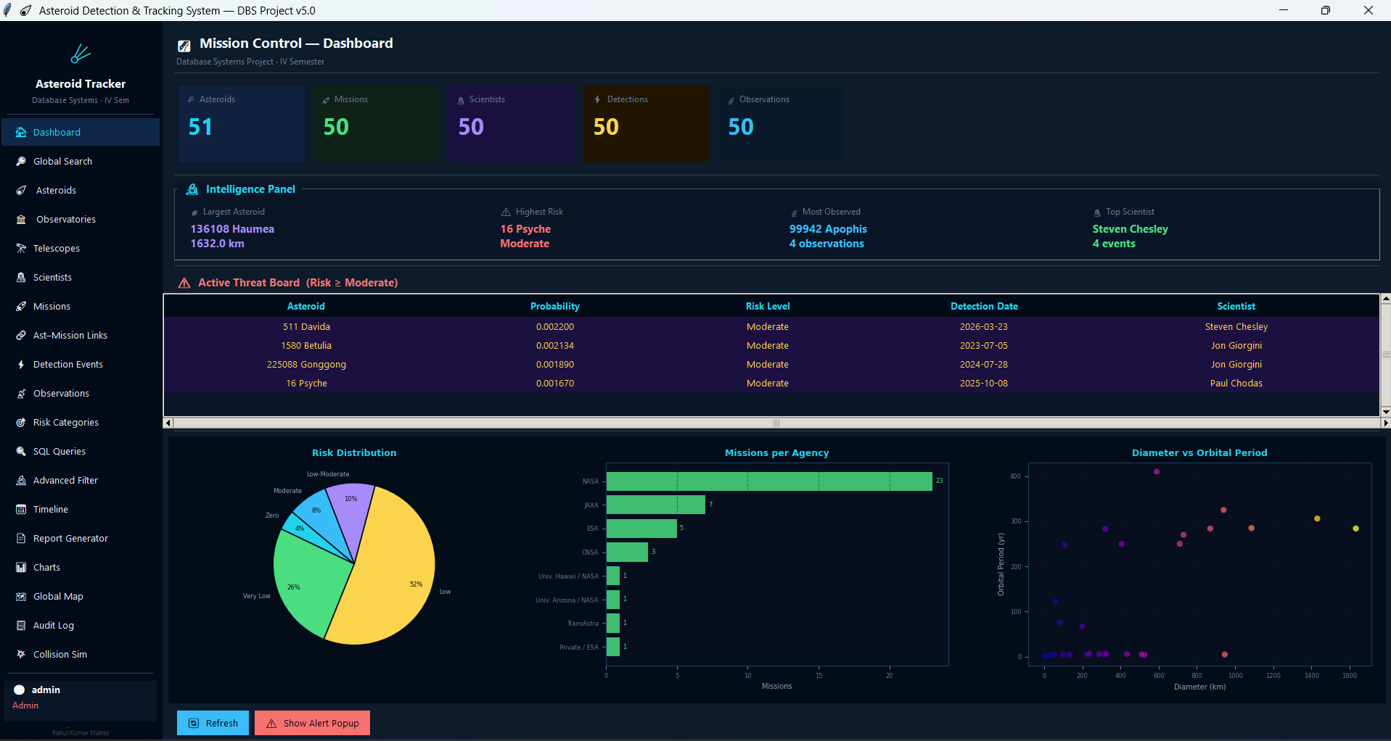

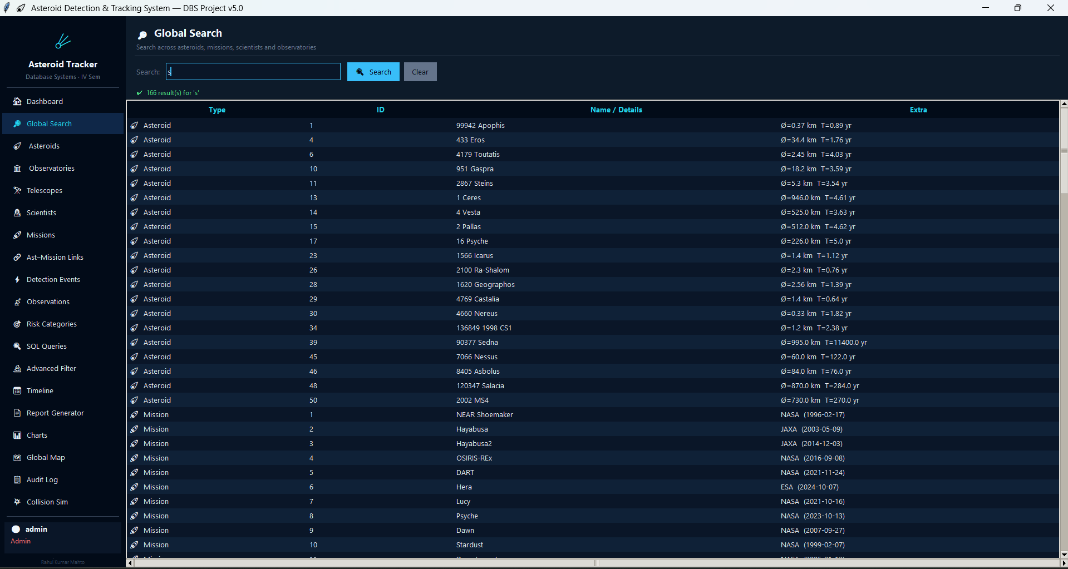

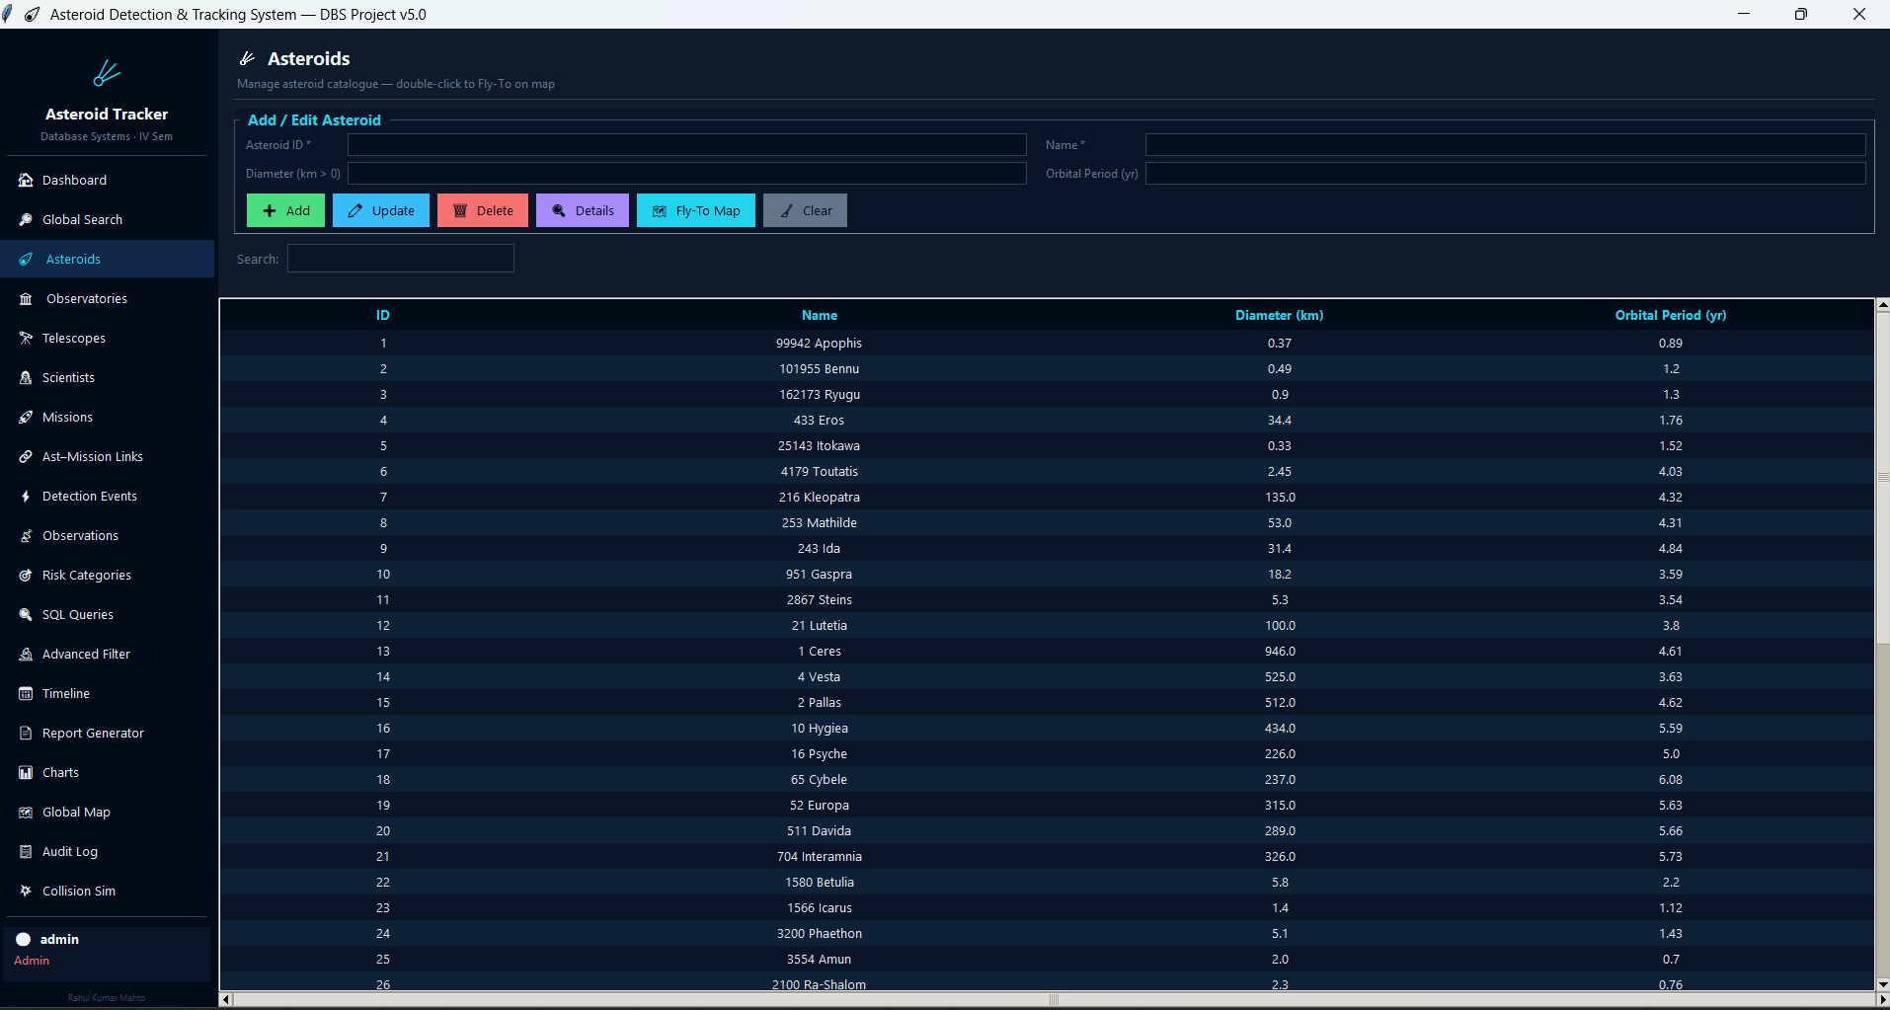

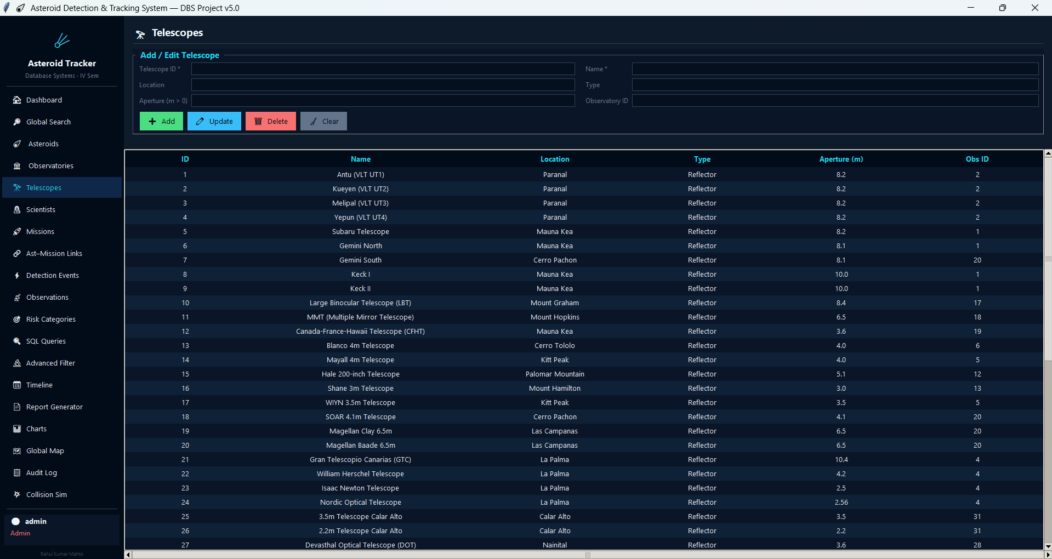

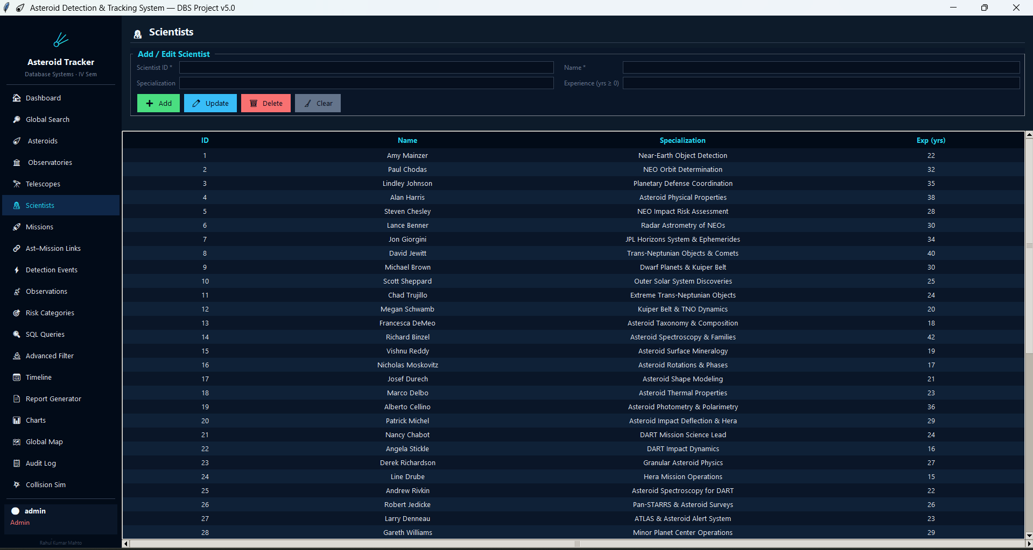

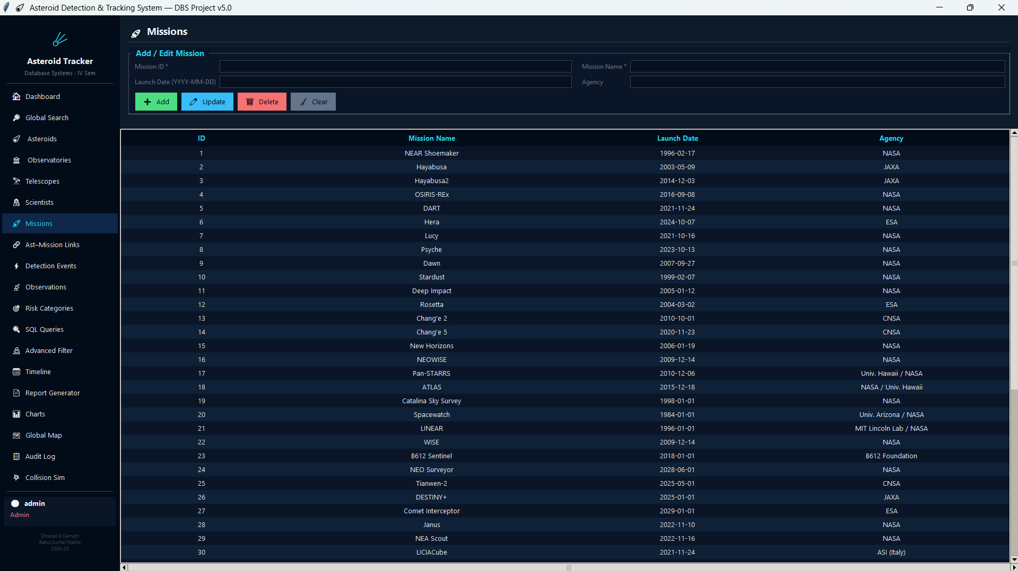

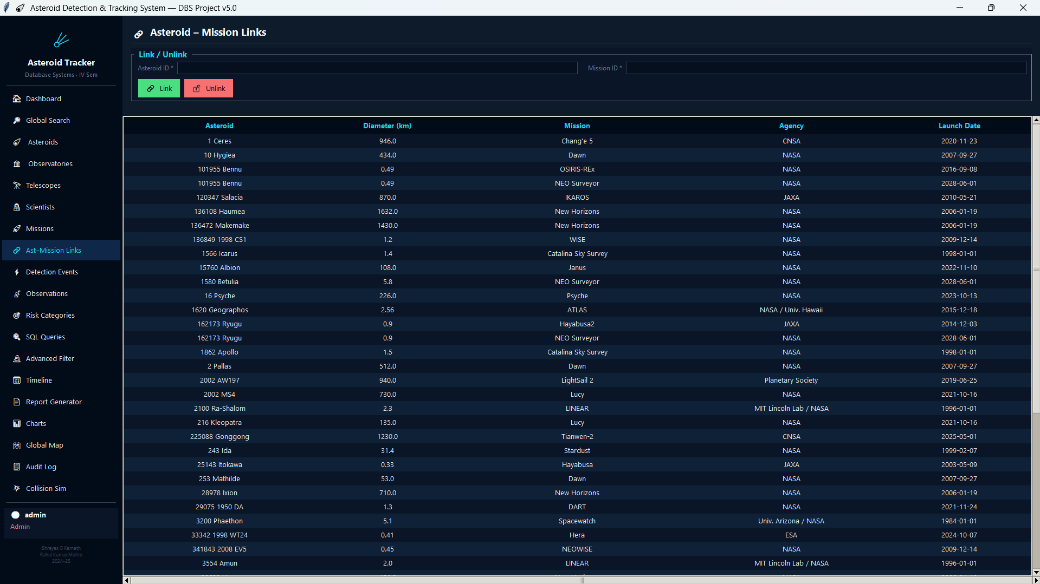

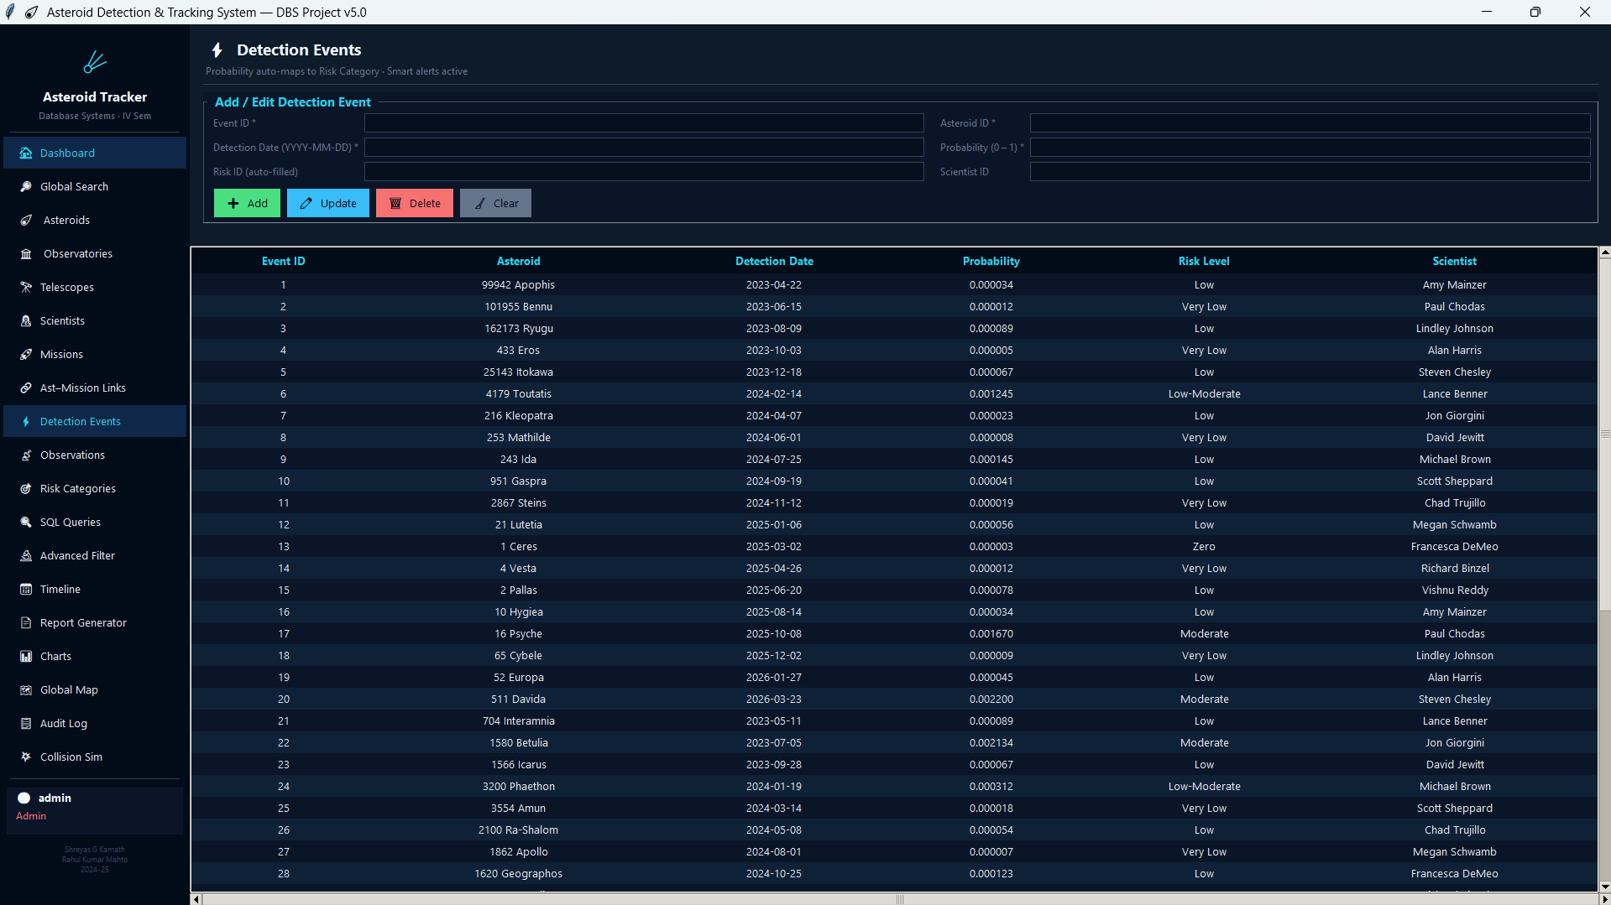

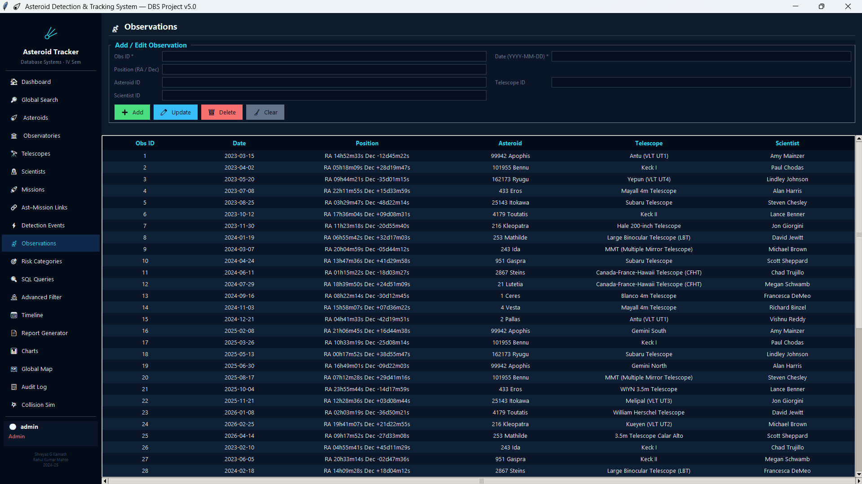

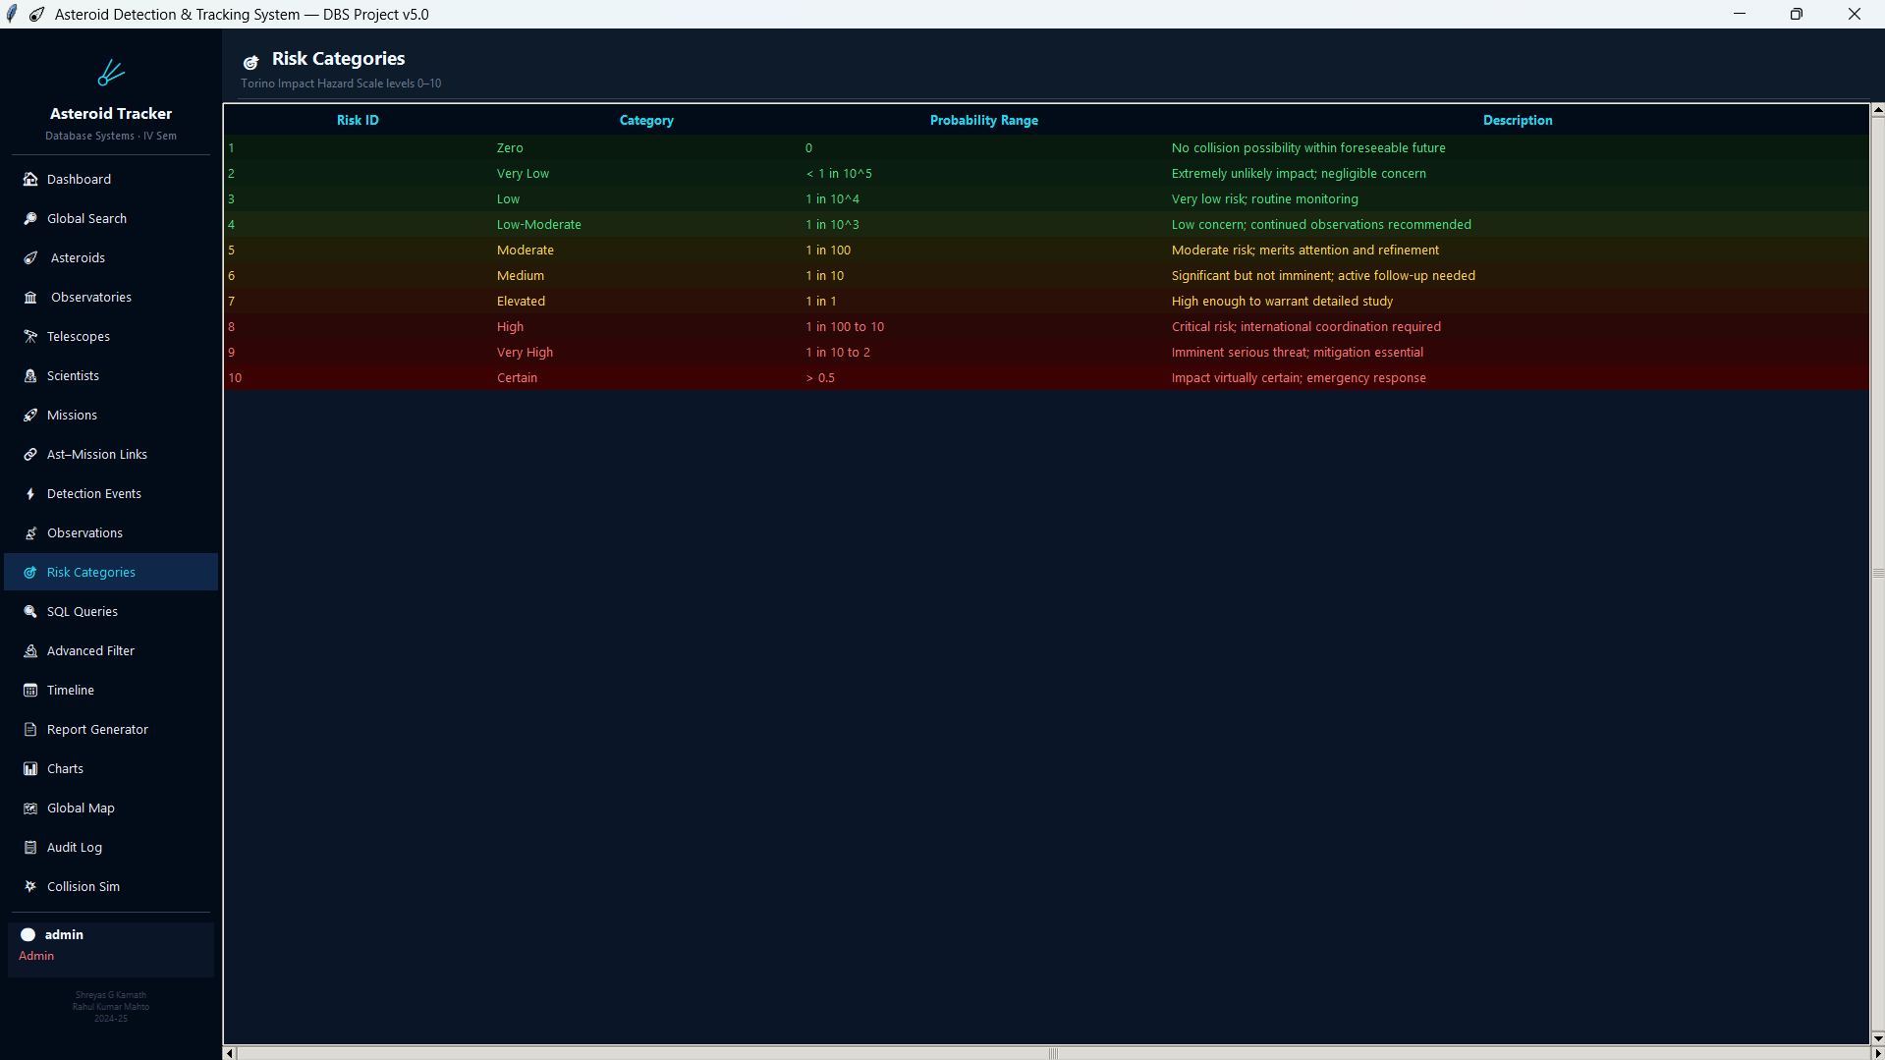

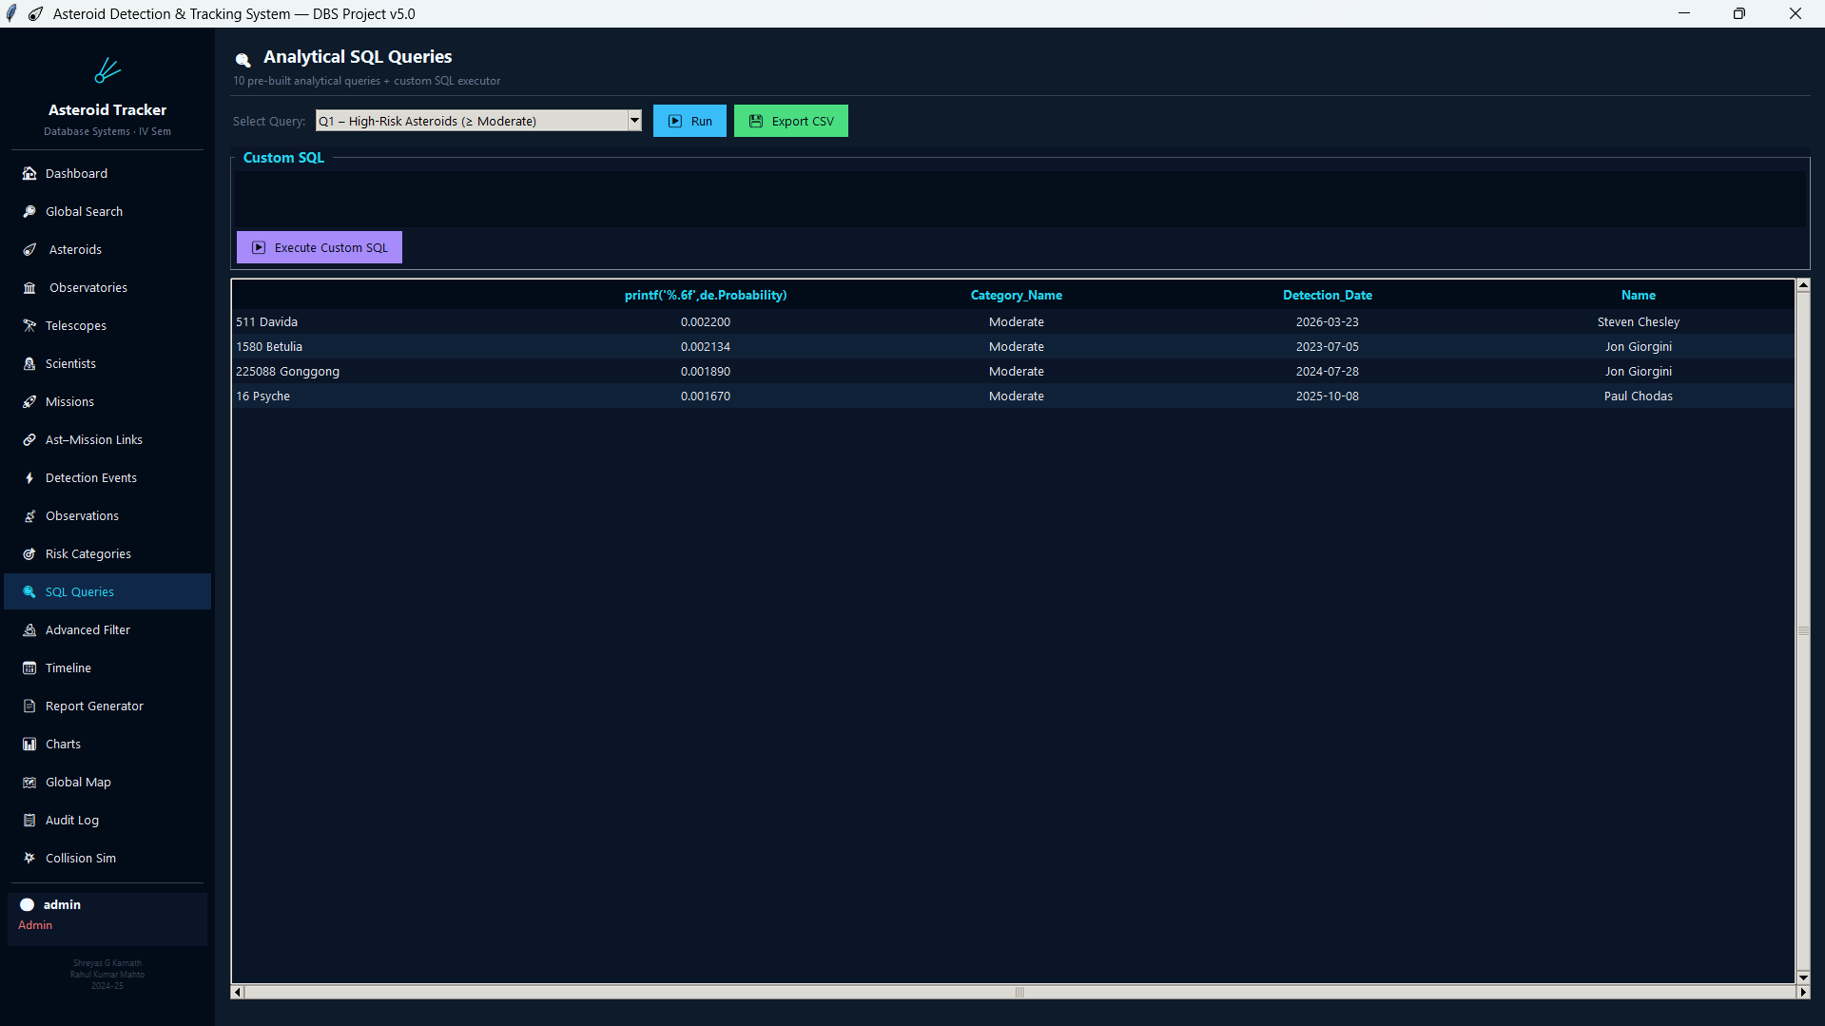

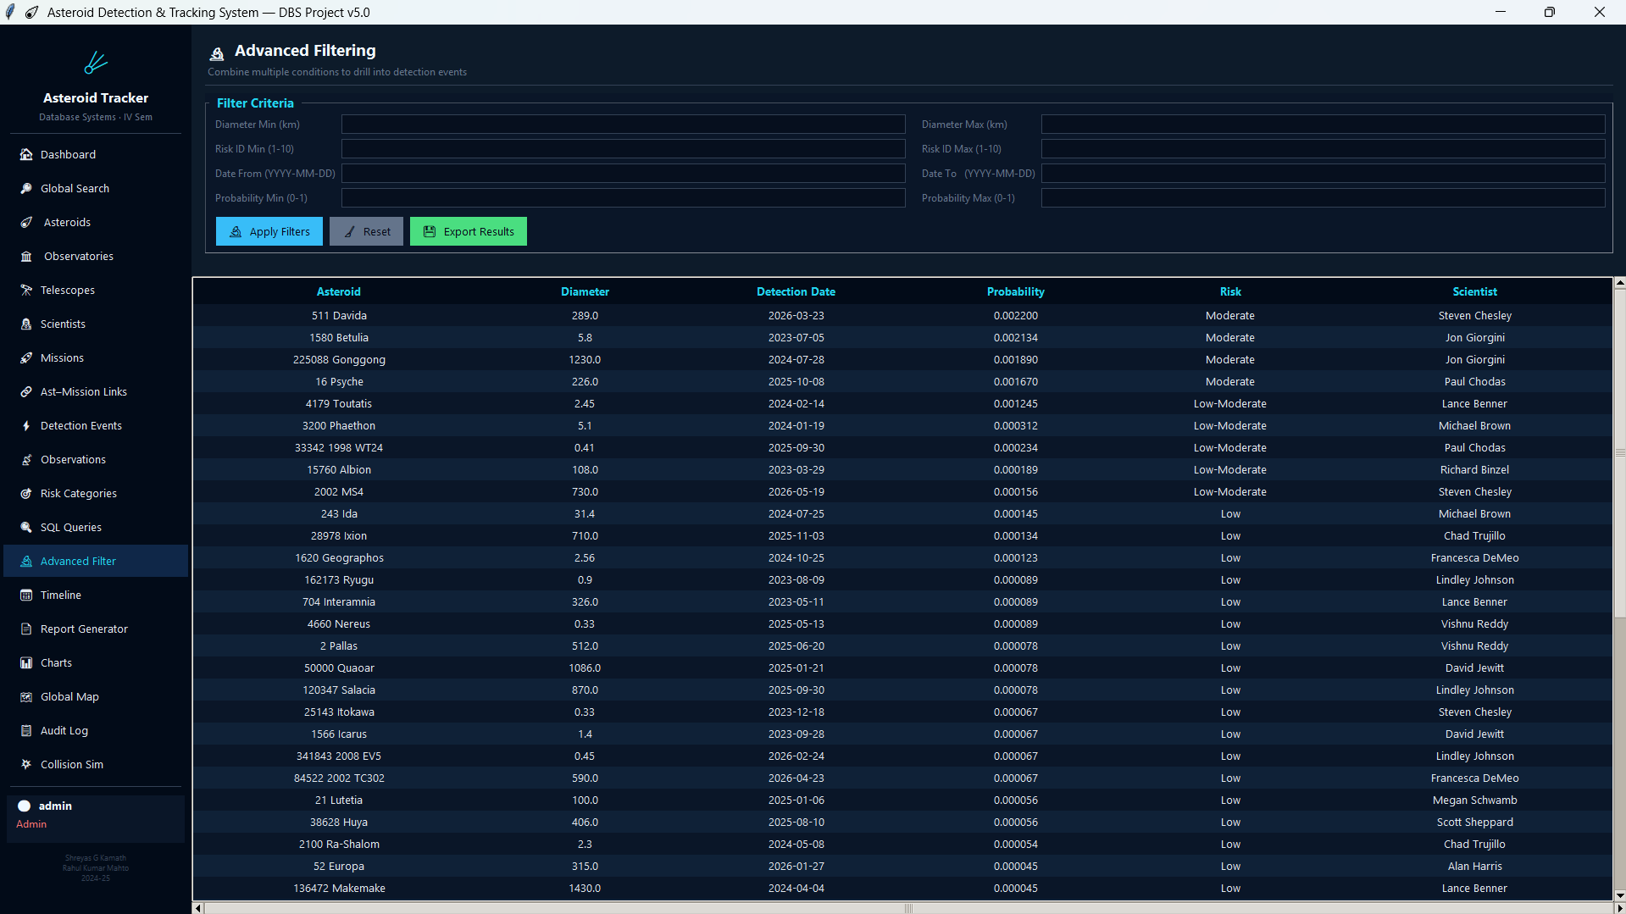

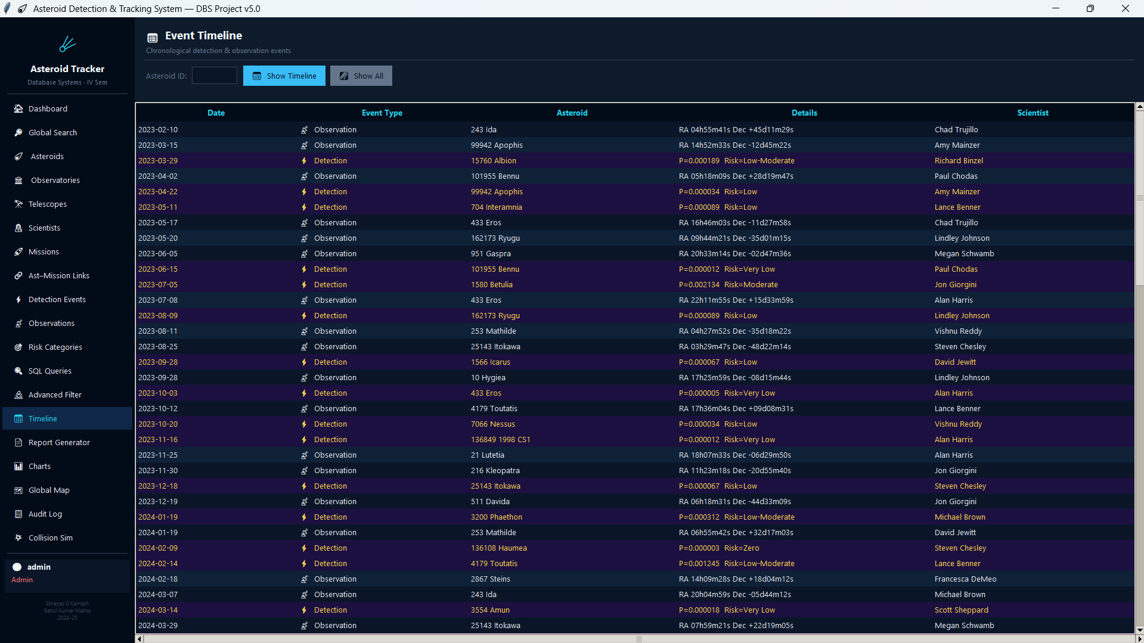

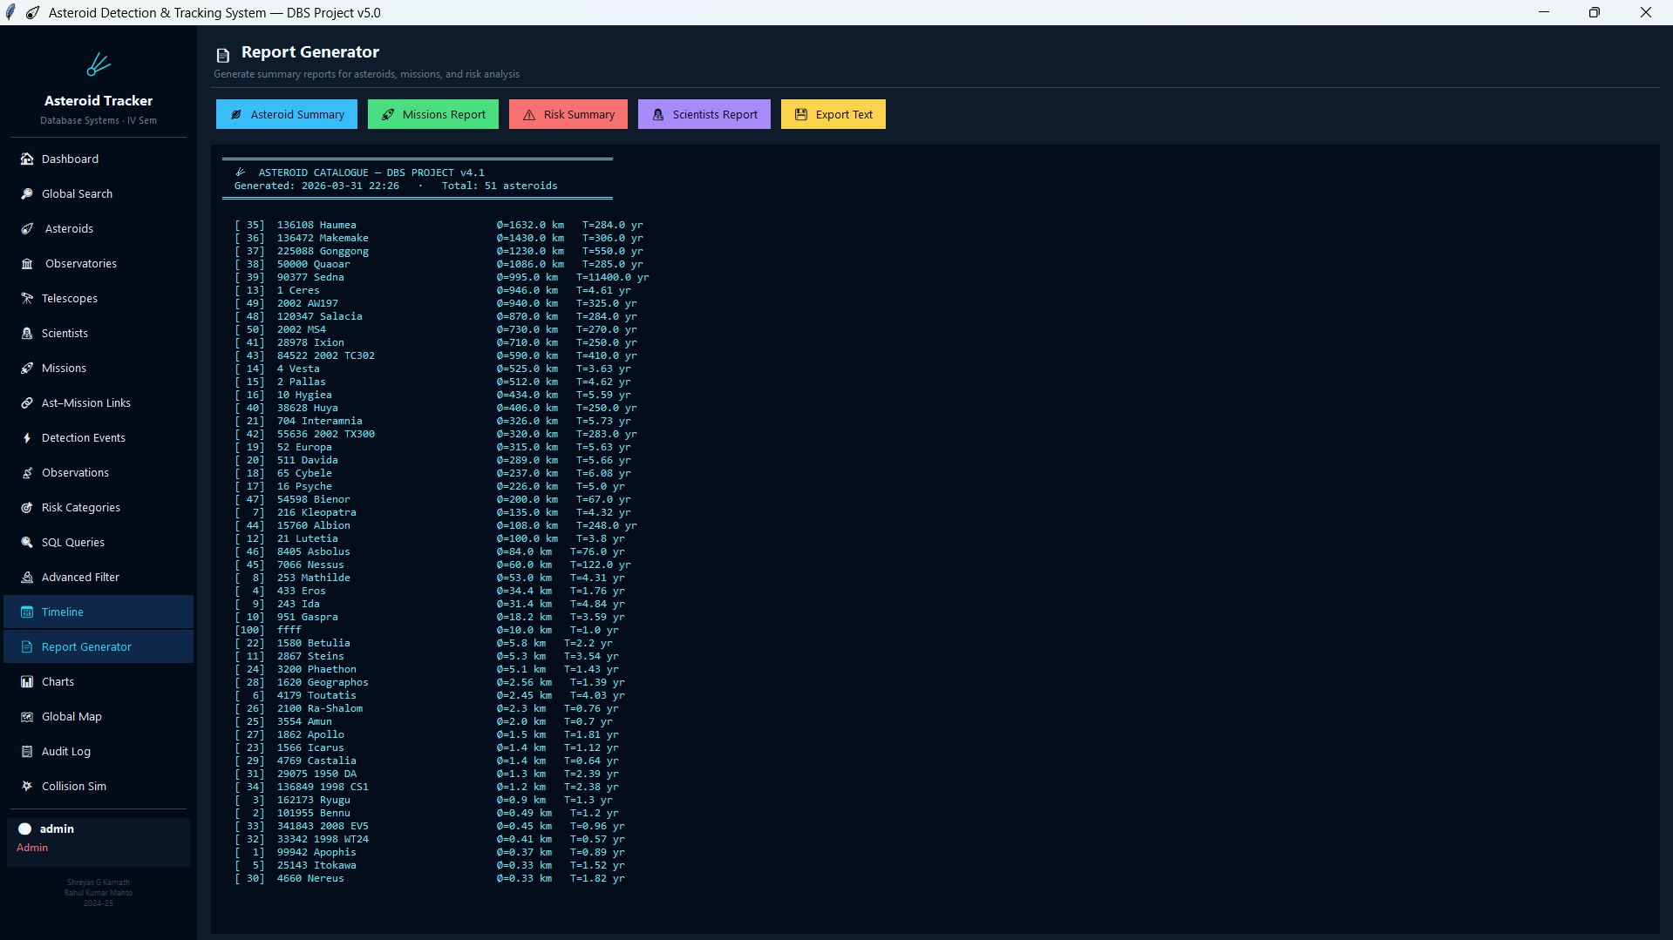

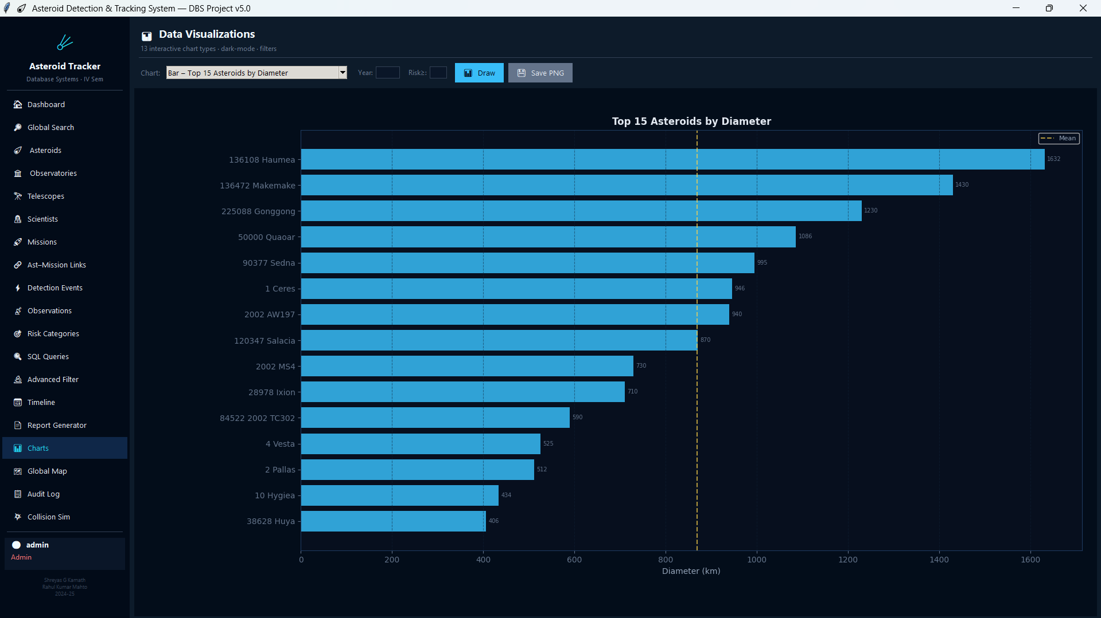

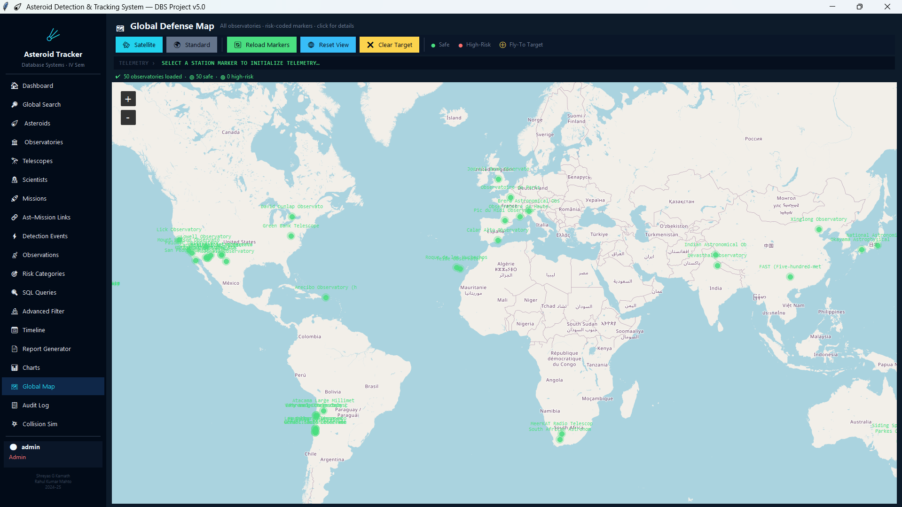

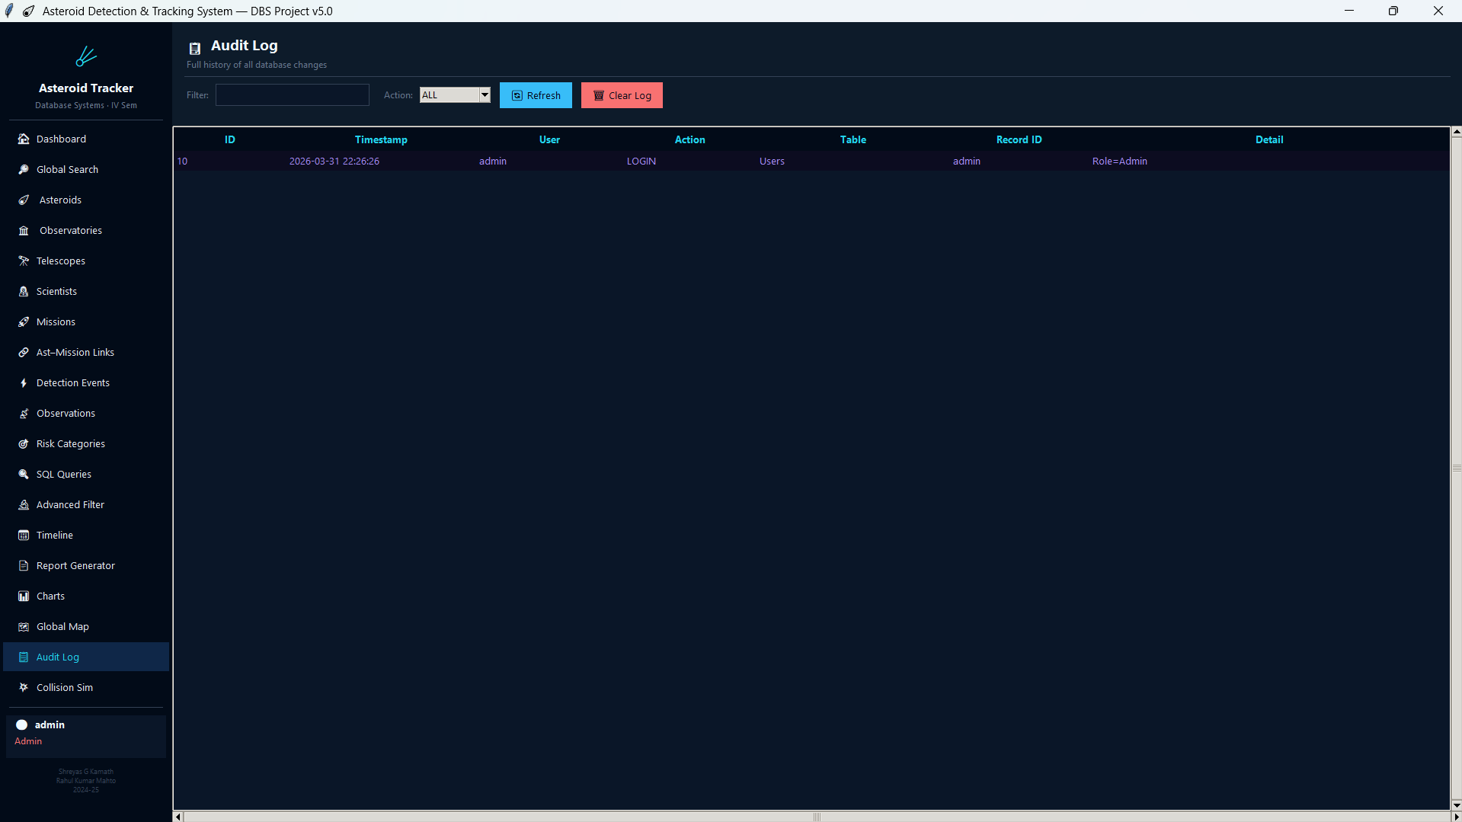

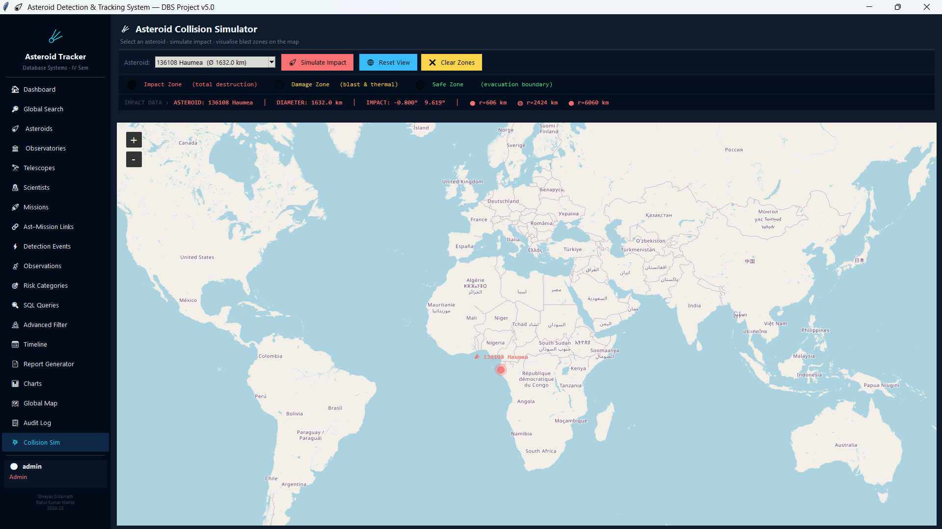

CHARTS:-

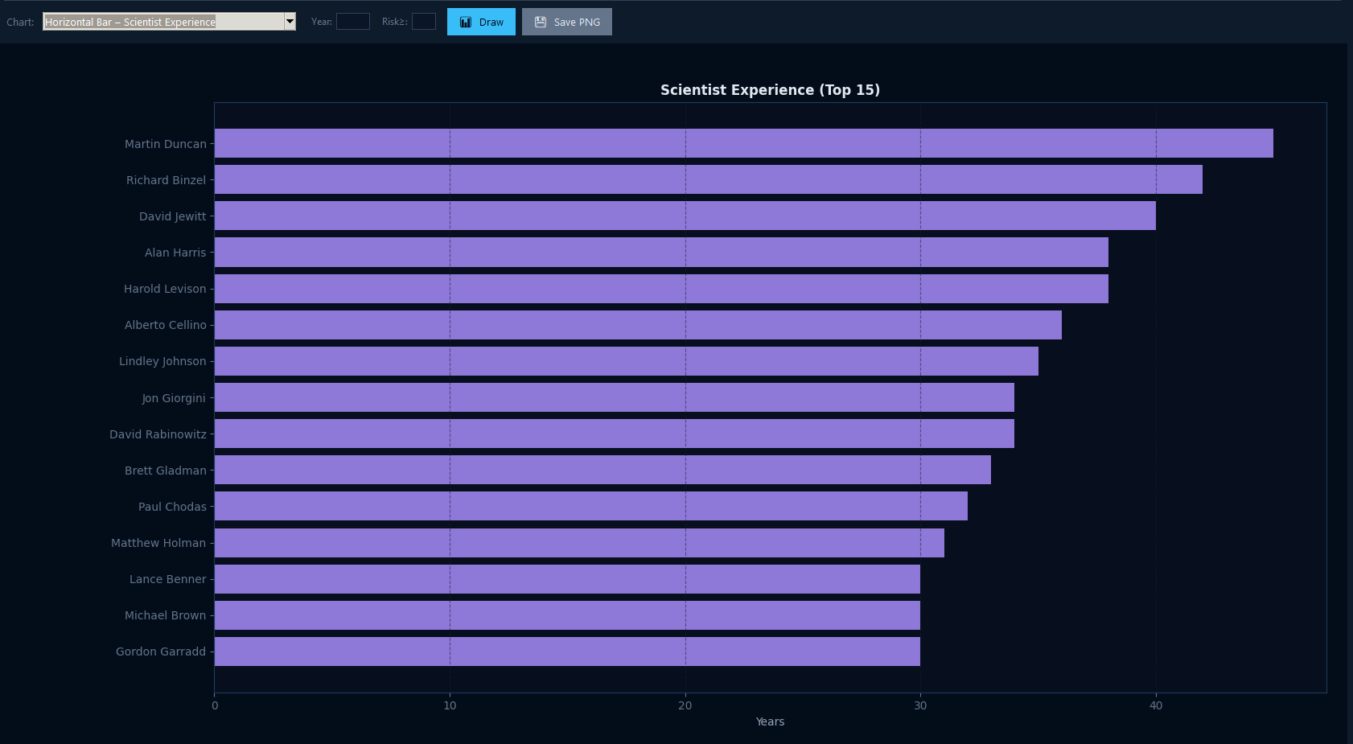

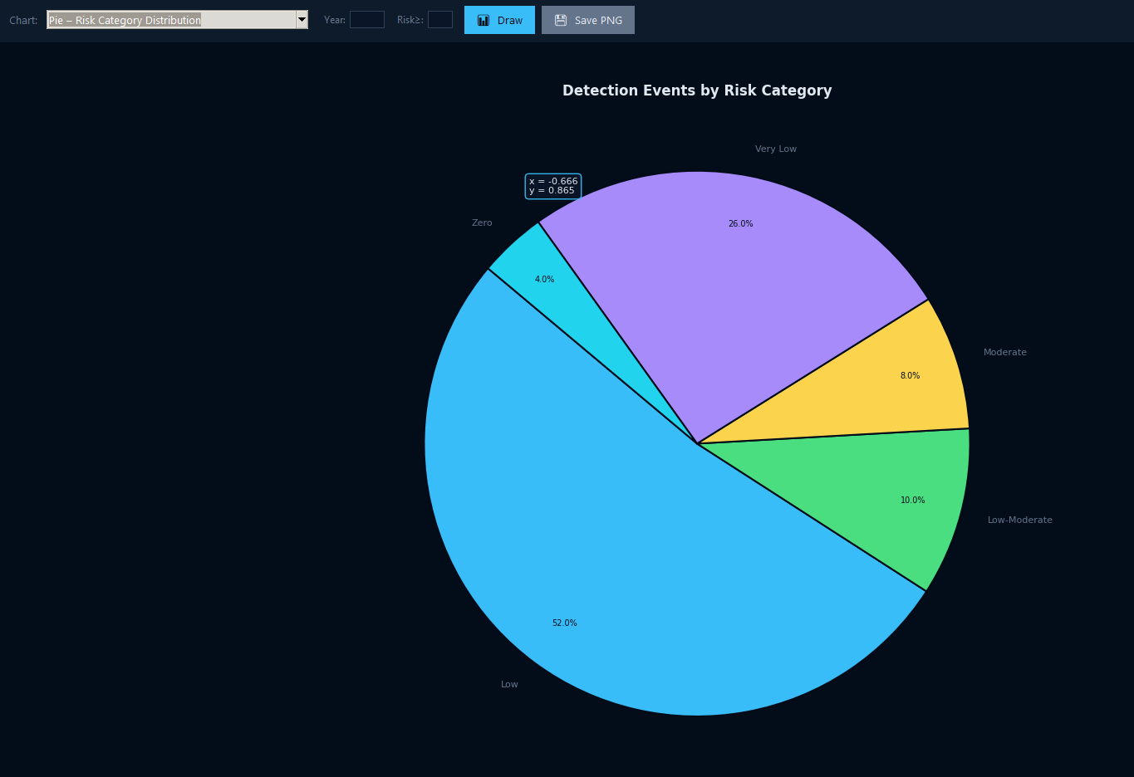

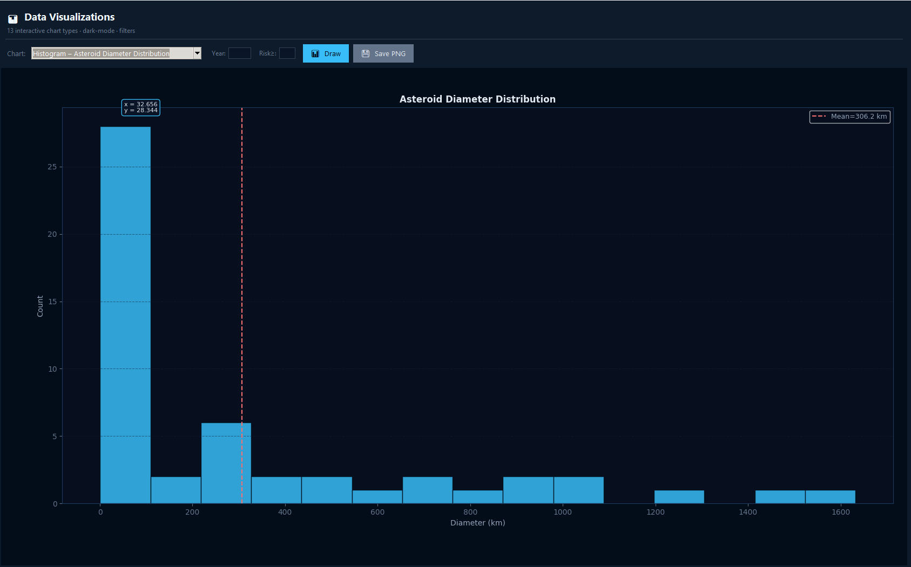

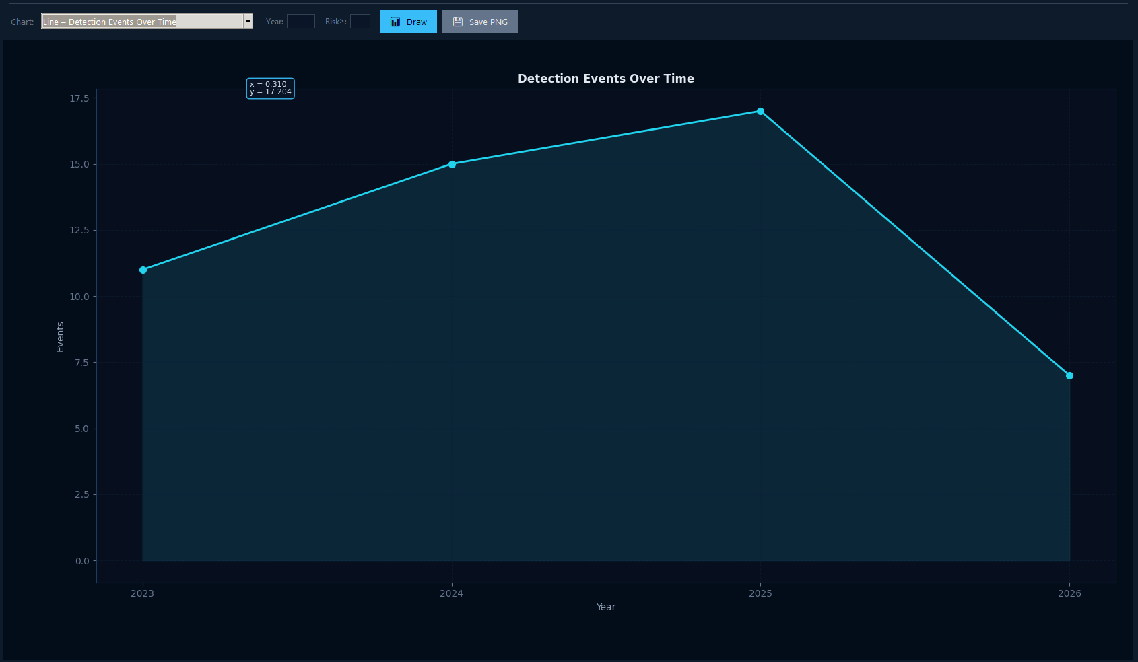

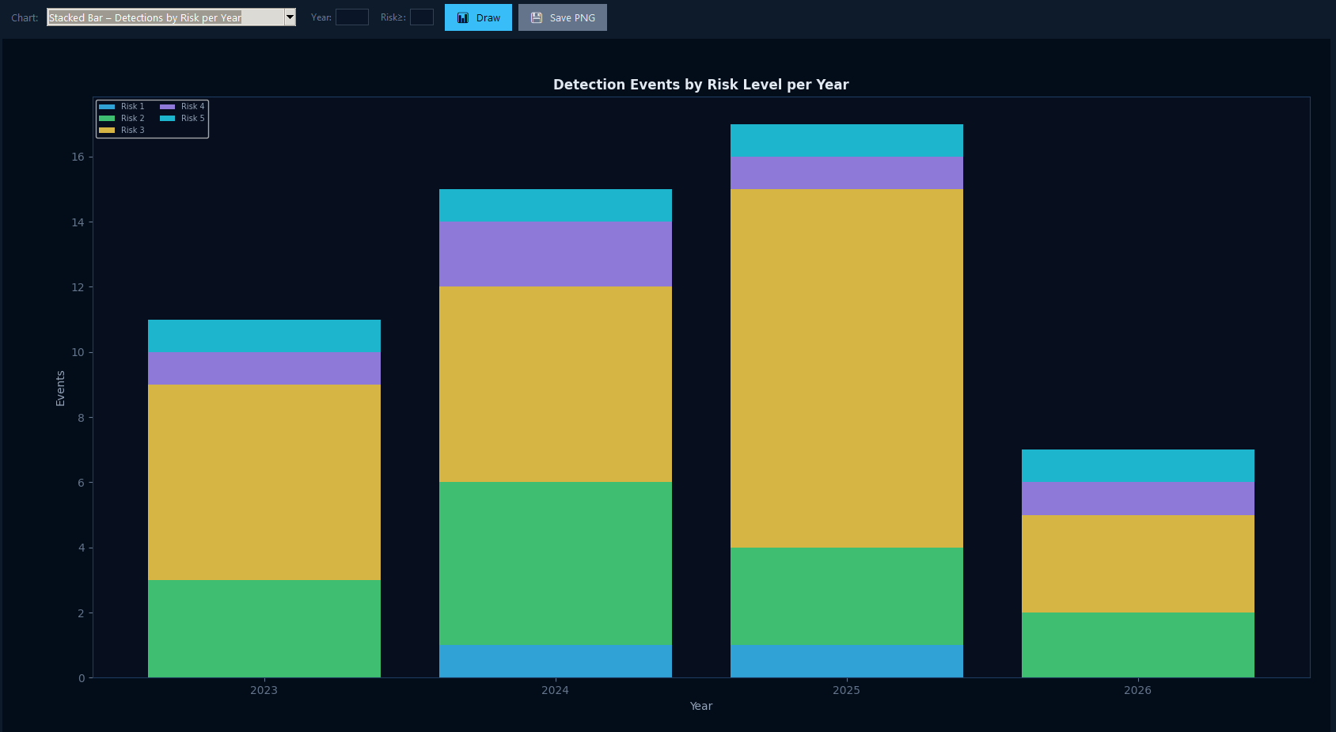

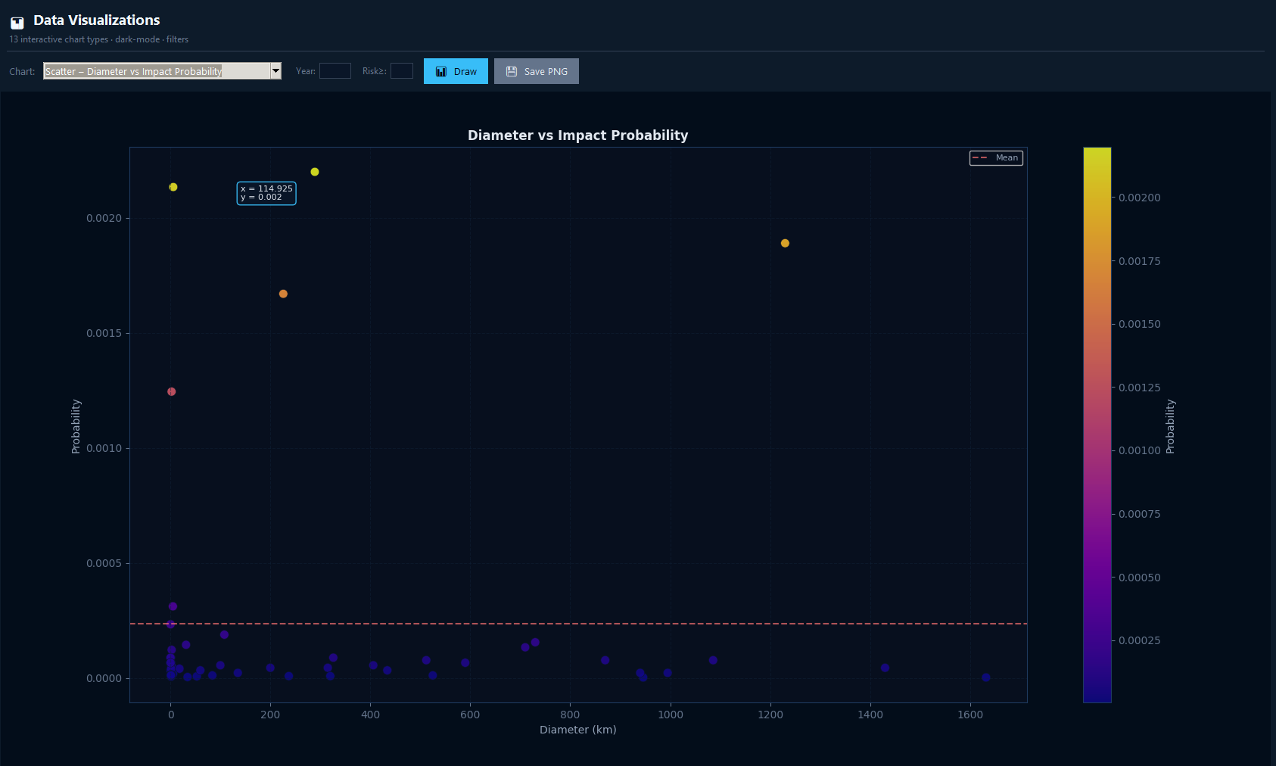

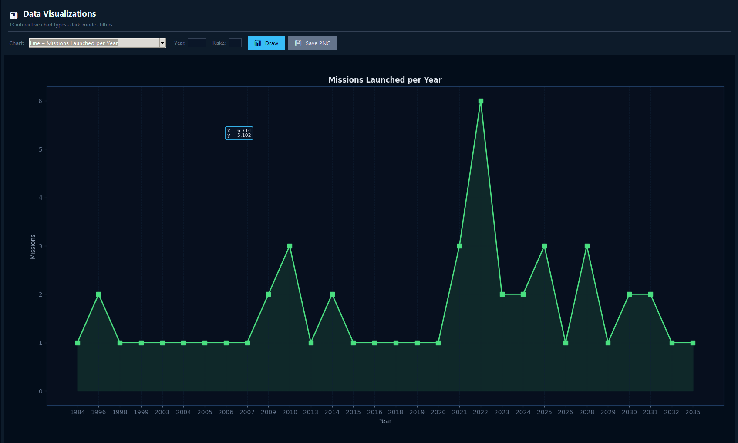

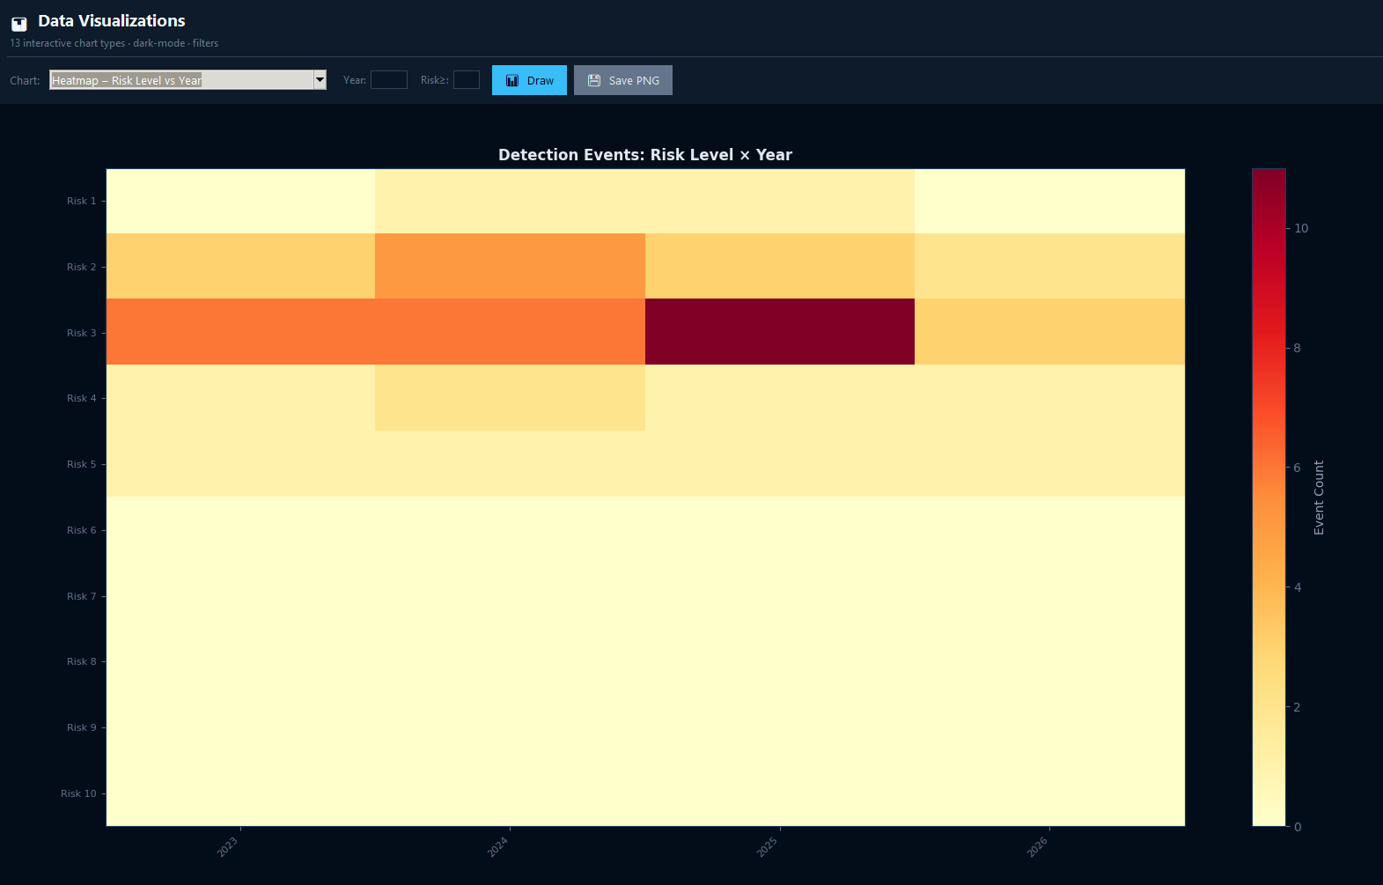
CHAPTER 6: CONCLUSION, LIMITATIONS & FUTURE WORK

6.1 Conclusion
The ADTS demonstrates that a well-normalised relational database schema, rigorously designed through ER modelling and formal relational mapping, provides a robust, scalable, and auditable foundation for planetary-defence data management. The 3NF-compliant schema with eleven relations and eight relationship types successfully models the full operational domain of an asteroid tracking facility. CHECK constraints, cascading delete semantics, and SET NULL preservation policies ensure semantic correctness under all CRUD patterns. The Audit_Log delivers a comprehensive, immutable provenance trail essential for post-incident review and liability analysis. The ten analytical SQL queries (Q1–Q10) — spanning multi-table JOIN chains, correlated subqueries, anti-join patterns, and aggregate analytics — demonstrate the expressive power of the relational model for threat intelligence. All eight project objectives (O1–O8) have been met: unified schema, referential integrity, domain validation, M:N linkage, audit logging, risk taxonomy, analytical queries, and comprehensive seed data.

6.2 Limitations
- Static Snapshot Model: The schema stores point-in-time records; orbital elements that evolve continuously due to gravitational perturbations are not captured as time series.
- No Native Triggers: Probability-to-risk mapping and audit logging are application-layer functions. A production system should use native AFTER INSERT / AFTER UPDATE / AFTER DELETE triggers to guarantee integrity regardless of access path.
- SQLite Concurrency: Write-serialisation limits throughput under high-concurrency multi-observatory feeds; a client-server RDBMS (PostgreSQL, MySQL) would be required at scale.
- No Full-Text Search: The Position and Detail columns are unstructured text without full-text indexing.
- Ephemeris Data Excluded: Only the derived Orbital_Period is stored; full orbital element sets (semi-major axis, eccentricity, inclination, etc.) are absent.

6.3 Future Work
- Database Triggers: Replace application-layer audit functions with native AFTER INSERT / AFTER UPDATE / AFTER DELETE triggers.
- Stored Procedures / UDFs: Encapsulate probability-to-risk mapping as a user-defined function within the database engine.
- Migration to PostgreSQL: Leverage partial indexes, JSONB columns, table partitioning for time-series data, and the PostGIS extension for geospatial queries.
- Temporal Data Modelling: Introduce bitemporal tables (valid time and transaction time) for Detection_Events and Observations to track probability revisions over time.
- RESTful API Layer: Expose the database via an IVOA-conformant API to enable interoperability with global asteroid tracking networks.
- Machine Learning Integration: Integrate ML-based anomaly detection to flag statistically unusual probability updates for immediate human review.
- Distributed Architecture: Architect multi-primary replication using Citus or CockroachDB to support globally distributed writes from multiple observatory sites.
- GIS Integration: PostGIS spatial queries — e.g., observatories within 1,000 km of a predicted impact trajectory, or ground-track intersection with populated areas.

CHAPTER 7: REFERENCES

[1] E. F. Codd, "A Relational Model of Data for Large Shared Data Banks," Communications of the ACM, vol. 13, no. 6, pp. 377–387, June 1970. DOI: 10.1145/362384.362685
[2] R. Hipp, D. Kennedy, and J. Mistachkin, "SQLite: Small. Fast. Reliable. Choose any three," SQLite Consortium, 2023. [Online]. Available: https://www.sqlite.org
[3] R. Elmasri and S. B. Navathe, Fundamentals of Database Systems, 7th ed. Hoboken, NJ: Pearson Education, 2016, ISBN 978-0-13-397077-7.
[4] NASA Jet Propulsion Laboratory, "Center for Near Earth Object Studies (CNEOS)," 2024. [Online]. Available: https://cneos.jpl.nasa.gov
[5] A. W. Harris and G. D'Abramo, "The Population of Near-Earth Asteroids," Icarus, vol. 257, pp. 302–312, 2015. DOI: 10.1016/j.icarus.2015.05.004
[6] ESA Planetary Defence Office, "Hera Mission: Europe's Planetary Defence Mission," 2024. [Online]. Available: https://www.esa.int/Safety_Security/Hera
[7] International Asteroid Warning Network (IAWN), "Guidelines and Recommendations," United Nations OOSA, Vienna, 2023.
[8] Minor Planet Center (MPC), "MPC Orbit Database," International Astronomical Union, 2024. [Online]. Available: https://minorplanetcenter.net
[9] R. Ramakrishnan and J. Gehrke, Database Management Systems, 3rd ed. New York, NY: McGraw-Hill, 2003, ISBN 978-0-07-246563-1.
[10] C. J. Date, An Introduction to Database Systems, 8th ed. Boston, MA: Addison-Wesley, 2004, ISBN 978-0-32-119784-9.
[11] P. Athanasios et al., "Torino Impact Hazard Scale," Icarus, vol. 132, no. 2, pp. 378–387, 1998.
[12] NASA Office of Inspector General, "NASA's Efforts to Identify Near-Earth Objects and Mitigate Hazards," Report No. IG-14-031, September 2014.

