WHISPERCIRCLE

WEB TECHNOLOGY PROJECT REPORT, V SEM. BTech
FLEXICORE-3131

SUBMITTED TO
SCHOOL OF COMPUTER ENGINEERING, M.I.T., MANIPAL


By
Rahul Kumar Mahto (Reg. No.: 240953370 | Roll No.: 56)
Akshith K (Reg. No.: 240953290 | Roll No.: 58)

Under the guidance of: Dr. Roshan David
November 2026


Team Details and Work Split

Sl. | Name | Reg. No. | Modules / Pages designed (2 per student) | Signature
1 | Rahul Kumar Mahto | 240953370  Roll No.: 56 | 1. Guest Entry  2. Room Directory / Group Chat | Digital-sign…
2 | Akshith K | 240953290  Roll No.: 58 | 1. Express API / Socket.IO  2. Reporting / Moderation

1. Project Overview
WhisperCircle is a full-stack web application that enables users to participate in topic-based group discussions and private one-to-one conversations through pseudonymous guest identities. Visitors can choose or generate a nickname, browse six discussion clubs, exchange real-time messages, and share anonymous confessions. The platform also provides online presence, reporting, blocking, and a basic moderation queue. The frontend is built with React and Vite, the backend uses Node.js and Express, Socket.IO handles real-time communication, and MongoDB with Mongoose provides persistent storage when configured.
1.1 Purpose of the Website
WhisperCircle addresses the difficulty some people face when joining conversations under their real identity. It offers a low-barrier discussion space where users can participate with a nickname instead of a public personal profile. Topic-based rooms make it easier to find relevant conversations, while private chat supports one-to-one communication. Reporting, blocking, and moderation features provide basic community-safety mechanisms.
1.2 Objectives
The main objectives and features are: pseudonymous guest entry; six topic-based rooms; real-time group messaging; online member presence; private one-to-one chat; anonymous confessions; message reporting; user blocking; a moderation queue; responsive desktop and mobile layouts; message history; and server-side validation and rate limiting.
1.3 Target Users
The intended users are students and general visitors who want to join topic-focused conversations without displaying a real name. The responsive layout supports desktop and mobile-only users. Clear labels, conventional controls, readable contrast, and keyboard-operable browser controls support usability. The project does not claim full WCAG conformance or dedicated screen-reader testing.
1.4 Site Map
The main navigation flow is: Guest Entry → Room Directory → (Group Chat / Online Member List) → Private Chat. The Room Directory also links to Anonymous Confessions. Messages can be reported from chat views; users can block a private-chat participant. The Moderation Queue is accessible as a demonstration moderation interface. Frontend screens and interactions were primarily implemented by Rahul Kumar Mahto; backend APIs, Socket.IO events, persistence and moderation logic were primarily implemented by Akshith K. Both members contributed to integration and testing.
• Home → About, Services, Gallery, Contact ...
• Mention which student built each page.
1.5 Tools and Technologies
Item | Details
HTML version | HTML5 (React-rendered application)
CSS framework and version | Plain CSS; responsive dark theme
JavaScript (if any) | JavaScript with React 18 and Node.js
Data source (static / JSON / API) | Express HTTP API and Socket.IO JSON event payloads; MongoDB/Mongoose when configured; in-memory fallback
IDE and Environment used | Visual Studio Code; Node.js and npm; Vite development server
Accessibility Guidelines for Users with Disabilities | Responsive layouts, readable contrast and labelled controls; formal WCAG conformance not claimed
Testing tools (Lighthouse, WAVE etc.) | Node.js built-in test runner and Playwright end-to-end tests

1.5 Common Design Followed by the Team
The application uses a consistent dark visual theme with purple accents, reusable navigation and room cards, clear chat panels, consistent button styles, and responsive layouts. React components structure the interface into guest entry, room directory, chat, confession, report and moderation views. CSS provides layout, spacing, typography, colours and mobile adaptations. The interface uses lucide-react icons.
2. Student 1: Rahul Kumar Mahto (Reg. No.: 240953370; Roll No.: 56)
Modules / Pages: Guest Entry and Room Directory; Group Chat and Confessions
2.1 Module Description
Guest Entry allows a visitor to choose a nickname or generate one randomly before entering the application. The nickname is validated for length and stored in sessionStorage for the browser tab. The Room Directory displays six topic clubs and supports searching by room name or description. Group Chat displays room messages, recent history, online participants and a message composer. Confessions provides a dedicated interface for anonymous posts. React components, forms, cards, navigation elements, lists, dialogs and responsive CSS are used across these modules.
Dynamic flow: the user supplies a nickname, search term or message. The client validates and normalises input, then communicates with the server using Socket.IO events or HTTP requests. The server validates the payload and applies rate limits before broadcasting or returning data. The React interface updates the visible room, member list or message feed from the response.
2.2 Design of the module
The React client obtains room information through the Express HTTP API and uses a persistent Socket.IO connection for real-time events. Room joining emits room:join; group messages use the group-message event flow; presence updates are received from the server and reflected in the member list. Confessions are delivered in real time. Data is exchanged as JSON event payloads. Client-side checks improve feedback, while server-side Zod validation, length limits, sanitisation and rate limiting enforce input rules. The server stores messages when MongoDB is configured; otherwise it uses in-memory storage.
2.3 Development of the module
Representative frontend logic: React state holds the current nickname, selected room, messages and online members. Event handlers validate the message text, emit the relevant Socket.IO event, and update the UI when the server broadcasts the accepted message. The source implementation is available in the client/ directory of the GitHub repository.

2.4 Results
The original project report includes screenshots of the guest entry screen and room directory on page 6, group chat sessions on page 7, private chat and report submission on page 8, moderation queue and anonymous confessions on page 9, and mobile layouts on page 10. These figures demonstrate the frontend modules and responsive behaviour.
3. Student 2: Akshith K (Reg. No.: 240953290; Roll No.: 58)
Modules / Pages: Express API and Socket.IO Messaging; Reporting, Blocking and Moderation
3.1 Module Description
The backend provides HTTP endpoints for health status, room information and moderation report actions. Socket.IO manages room joining and leaving, presence updates, group messages, private messages, private history, blocking and report submission. The storage layer supports message and report persistence through MongoDB and Mongoose, with an in-memory fallback for local development. The moderation interface lists reports and supports reviewed or dismissed statuses.
Dynamic flow: the backend receives JSON requests or Socket.IO event payloads, validates the data, checks room membership and rate limits, then processes the requested action. Group messages are delivered to room members; private messages are sent only to the sender and recipient. Reports are created using a server-side lookup of the original message so the reported content is not trusted solely from client input.
3.2 Design of the module
The frontend communicates with Express over HTTP for API routes and with Socket.IO over a persistent WebSocket connection for live messaging. The Express and Socket.IO services share a Node HTTP server. MongoDB is accessed through Mongoose when MONGODB_URI is configured. Server-side validation includes Zod schemas, message and report length limits, control-character stripping, rate limiting and moderation API protection. The health endpoint reports the active storage mode. In-memory storage is temporary and is cleared when the server restarts.
3.3 Development of the module
Representative backend logic: Socket.IO handlers validate a connected guest session, verify room and recipient details, apply rate limits, and then emit accepted messages to the appropriate room or recipient. Express moderation routes retrieve reports and update their status. The source implementation and backend tests are available in the server/ directory of the GitHub repository.

3.4 Results
The earlier project report documents 34 of 34 end-to-end checks and 12 of 12 backend tests passing in the tested in-memory storage configuration. Screenshots of group chat from two browser sessions appear on page 7; private chat and report submission on page 8; and the moderation queue on page 9. The report notes that persistence across a server restart should be separately verified with a configured MongoDB URI.

4. Conclusion and Future Scope
WhisperCircle combines a responsive React interface, Express APIs, Socket.IO real-time communication and MongoDB-compatible persistence in a single full-stack application. The team implemented guest identities, topic rooms, group and private chat, anonymous confessions, presence, reporting, blocking and a moderation queue. The project provided practical experience in frontend component design, backend APIs, WebSocket events, data modelling, validation, testing and Git-based collaboration. Future work can include authenticated moderator roles, persistent block lists, stronger abuse detection, message deletion, room creation, notification preferences, privacy controls and production deployment over HTTPS.

5. Reference
React: https://react.dev/ | Vite: https://vite.dev/ | Node.js: https://nodejs.org/ | Express: https://expressjs.com/ | Socket.IO: https://socket.io/docs/v4/ | MongoDB: https://www.mongodb.com/docs/ | Mongoose: https://mongoosejs.com/docs/ | Playwright: https://playwright.dev/docs/ | MDN Web Docs: https://developer.mozilla.org/
GitHub repository link 1
GitHub repository link 2

Technology and implementation details in this report are based on the WhisperCircle project source and the previously prepared project report. Framework documentation links are listed above.

Appendix A: Application Screenshots
The following screenshots are taken from the previously prepared WhisperCircle project report and show the implemented interface across desktop and mobile layouts.
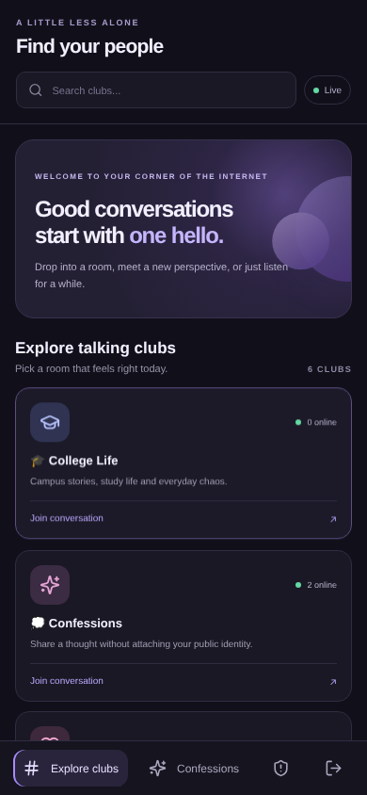
Figure A1: Guest entry screen
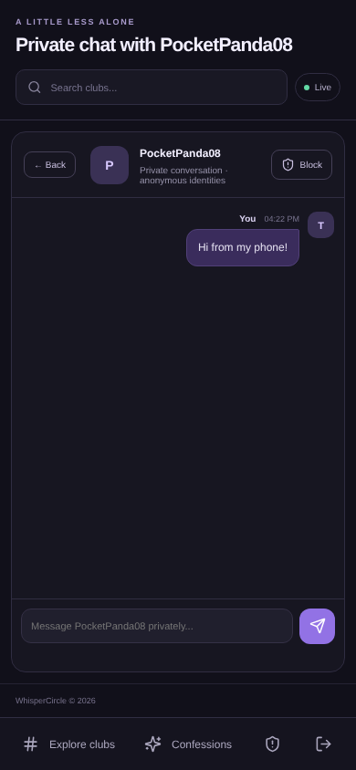
Figure A2: Room directory
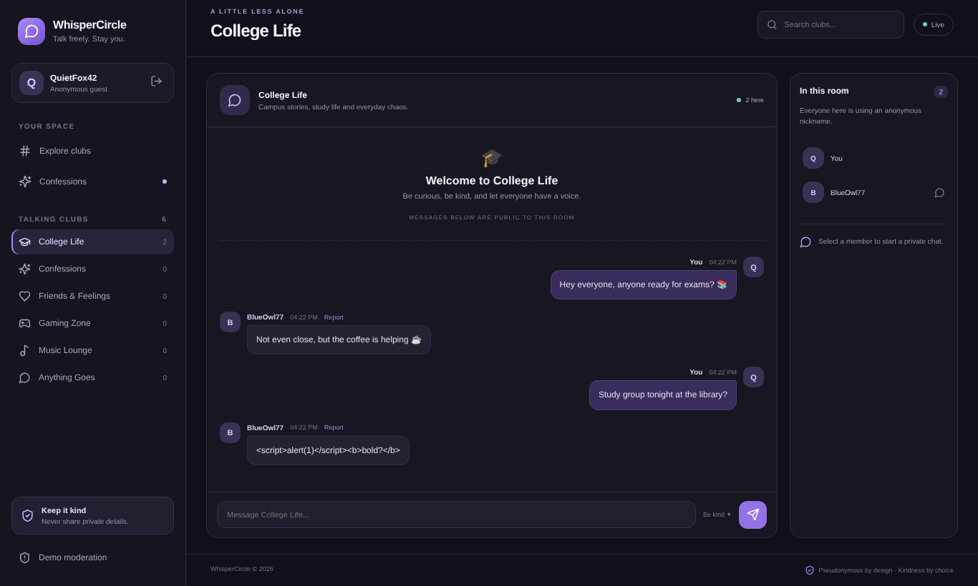
Figure A3: Group chat session
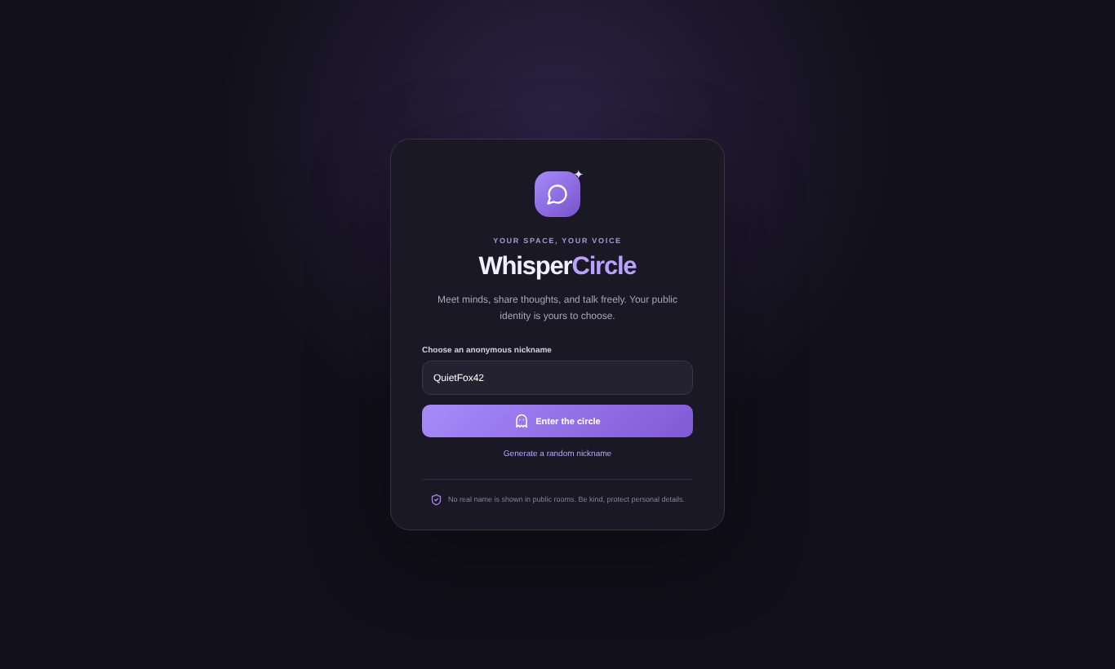
Figure A4: Group chat from a second browser session
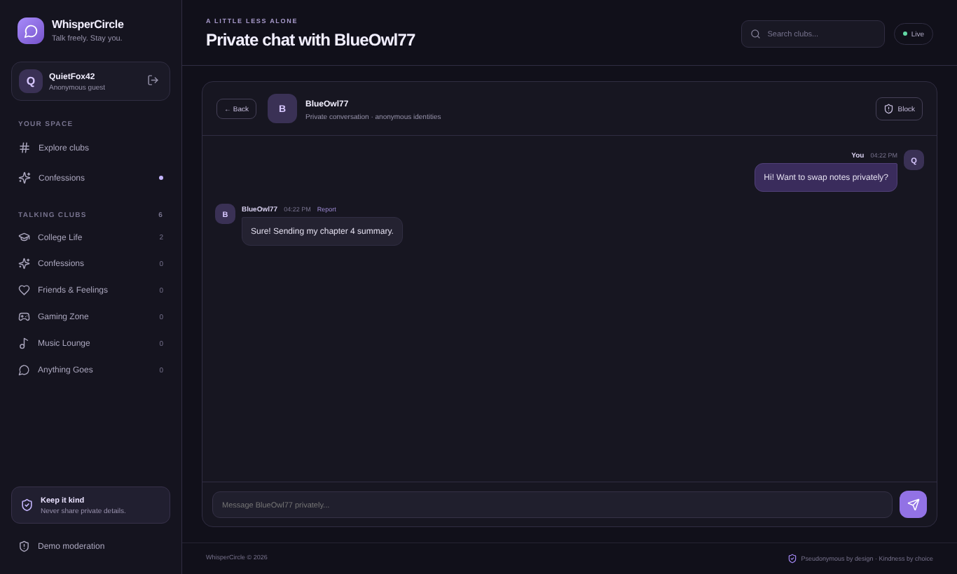
Figure A5: Private one-to-one chat
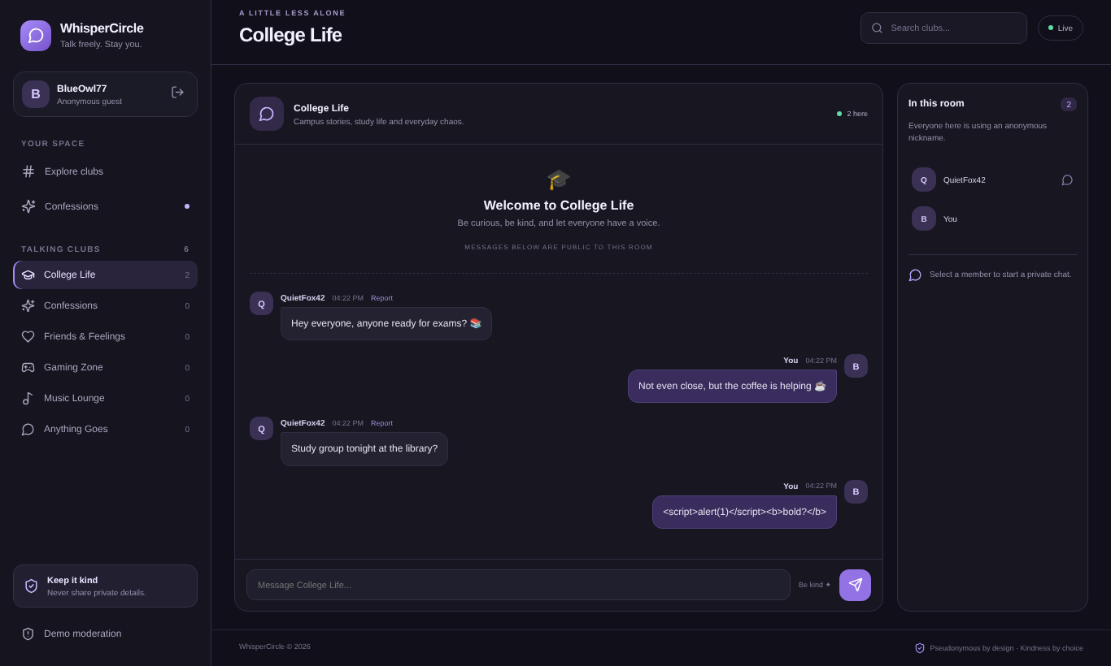
Figure A6: Message report dialog
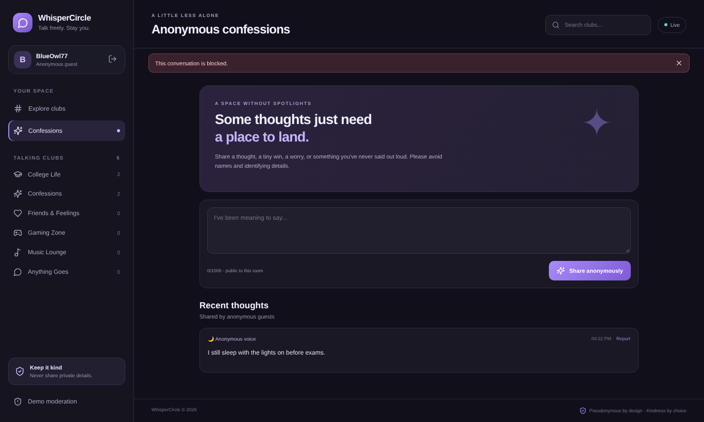
Figure A7: Moderation queue
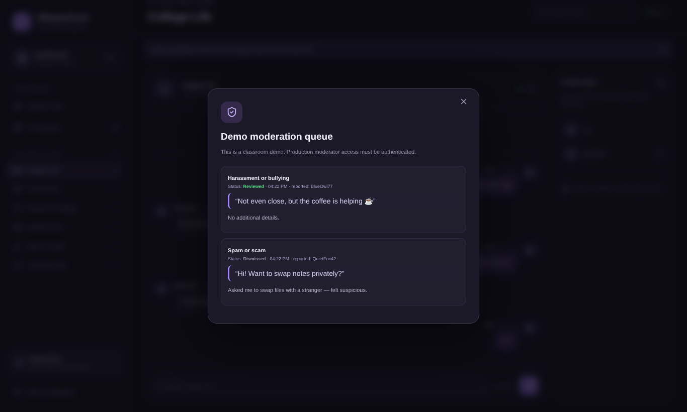
Figure A8: Anonymous confessions
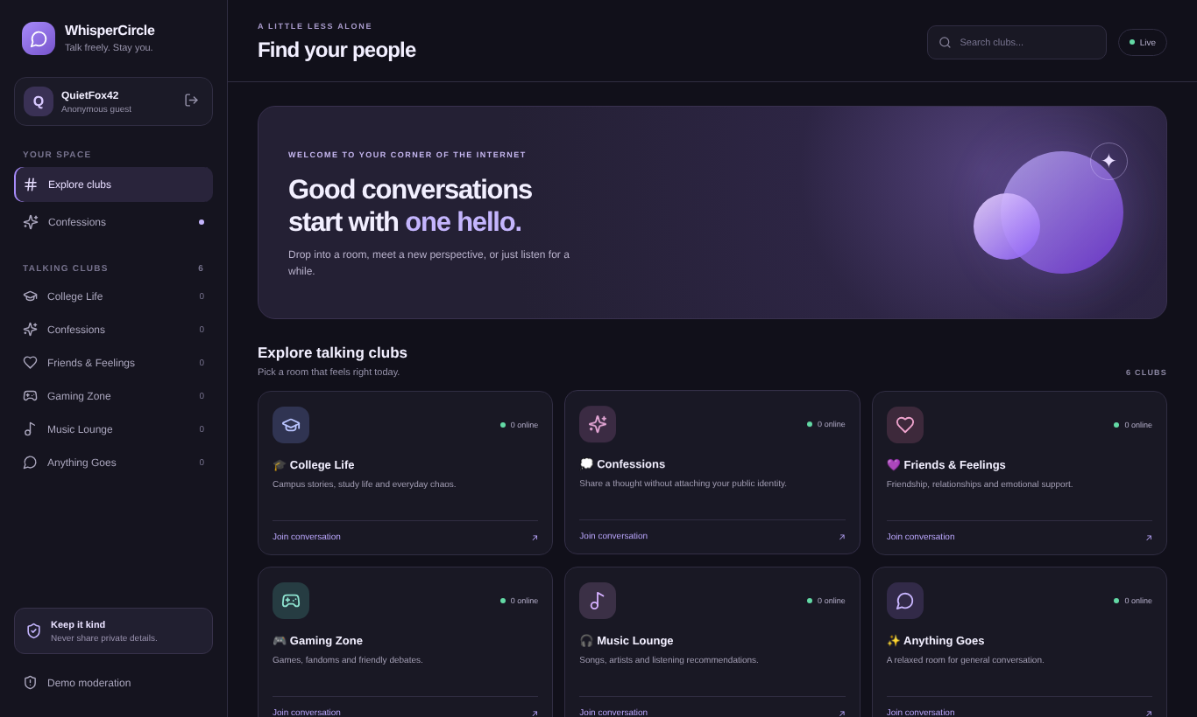
Figure A9: Responsive mobile room directory
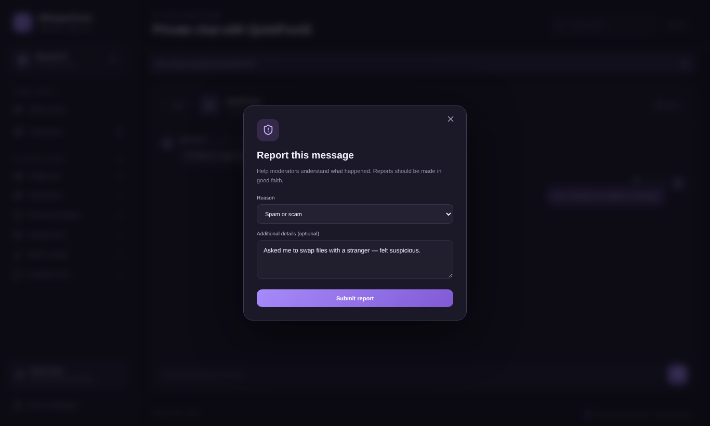
Figure A10: Responsive mobile private chat

