WhisperCircle
Anonymous Talking Club and Discussion Platform
A Full-Stack Web Application — Project Report
Submitted by
Rahul Kumar Mahto — Registration No.: 240953370 — Roll No.: 56
Akshith K — Registration No.: 240953290 — Roll No.: 58
[Department / Course]
[College / University name]
Guided by: [Guide / Faculty name]
November 2026

Abstract
WhisperCircle is a full-stack web application that lets people join topic-based group conversations and private one-to-one chats using pseudonymous guest identities. Users pick or generate a nickname, browse six discussion clubs, and talk in real time. The platform also includes an anonymous confessions space, an online member list, user blocking, message reporting, and a basic moderation queue where a moderator can review or dismiss reports.
The system is built with React and Vite on the frontend, Node.js and Express on the backend, Socket.IO for real-time messaging, and MongoDB with Mongoose for persistence (with an in-memory fallback for local development). It was verified with an automated backend test suite (12 tests) and an automated two-browser end-to-end suite (34 checks), all of which pass. The project is intended as an educational demonstration of frontend development, backend APIs, real-time communication, data persistence and safety-aware design.

1. Problem Statement
Many people find it hard to start or join conversations when their real identity is visible, whether because of shyness, fear of judgement, or the sensitivity of the topic. Existing mainstream social platforms tie every interaction to a profile, while fully anonymous forums often lack basic safety tools and become hostile. There is a need for a lightweight space where people can talk freely using a pseudonym, while still having reporting, blocking and moderation tools that support respectful use.

2. Objectives
- Build a responsive, dark-themed full-stack web application.
- Provide pseudonymous guest identities with no sign-up and no real name shown publicly.
- Support topic-based group chat and private one-to-one messaging in real time.
- Store chat history and reports in a database.
- Add safety features: reporting, blocking, rate limiting and input sanitisation.
- Provide a basic moderation queue for reviewing reports.
- Demonstrate teamwork, testing, GitHub collaboration and documentation.

3. Existing and Proposed System

3.1 Existing system
General-purpose messaging apps and social networks require accounts linked to a phone number, email or real name. Anonymous message boards, on the other hand, usually have no private messaging, no presence information, and weak or no reporting tools. Neither approach gives a low-barrier, real-time, topic-focused space with built-in safety controls.

3.2 Proposed system
WhisperCircle lets a visitor enter with a chosen or randomly generated nickname. They browse clubs such as College Life, Confessions, Friends & Feelings, Gaming Zone, Music Lounge and Anything Goes, join a room, and see who else is present. Messages are delivered instantly through Socket.IO. Selecting another online member opens a private conversation. Any received message can be reported with a reason, and any private conversation can be blocked. Reports are stored together with a server-side snapshot of the reported message and appear in a moderation queue.
Note on privacy: WhisperCircle provides pseudonymous public identities, not guaranteed anonymity. The server still handles technical connection information such as IP addresses, and the project makes no promise otherwise.

4. Technology Stack
Layer | Technology and purpose
Frontend | React 18 + Vite — component-based user interface and fast development build
Icons / styling | Plain CSS (responsive, dark theme) and lucide-react icons
Backend | Node.js + Express — HTTP API for room data and moderation actions
Real-time | Socket.IO — room presence, group messages, private messages, reports
Database | MongoDB + Mongoose — persistent messages and reports; in-memory fallback for development
Security | Helmet, CORS allow-list, express-rate-limit, Zod validation, input sanitisation
Testing | Node built-in test runner (backend), Playwright (end-to-end, two browser sessions)
Version control | Git + GitHub

5. System Architecture
The browser runs the React single-page application. It talks to the Express server over HTTP for the room list and moderation routes, and over a persistent Socket.IO WebSocket connection for everything real-time. Express and Socket.IO share a single Node HTTP server. Messages and reports are written to MongoDB through Mongoose when MONGODB_URI is configured; otherwise the server falls back to in-memory arrays, which lose data on restart and are meant only for local development.
Component | Responsibility
React client | Guest entry, room directory and search, group chat, private chat, confessions, report dialog, moderation modal
Express API | GET /api/health, GET /api/rooms, GET /api/mod/reports, PATCH /api/mod/reports/:id
Socket.IO events | room:join, room:leave, room:presence, message:group, message:new, message:private, private:history, user:block, message:report, report:received
Storage layer | saveMessage, saveReport, getRecent and findMessage — choose MongoDB or memory automatically
Safety layer | Rate limits (API, group, private, reports), length limits, control-character stripping, block list, server-side report lookup

6. Feature Descriptions
- Anonymous guest identity. Users type a nickname (2–24 characters) or press "Generate a random nickname", which builds names such as QuietFox42. Leaving the box empty also generates one. Identity is stored only in sessionStorage for the browser tab.
- Topic-based group rooms. Six clubs with online counts that update live. A search box filters clubs by name and description.
- Real-time group chat. Messages are broadcast to everyone in the room; the last 50 messages are loaded as history for new joiners. HTML typed into a message is displayed as text and never executed.
- Online member list. The right-hand panel (and a scrolling chip strip on phones) lists everyone currently in the room by nickname.
- Private one-to-one chat. Selecting a member opens a private conversation. Messages go only to the sender and the recipient; history is loaded on open, and the other user receives a notification if the chat is not open.
- Anonymous confessions. A dedicated space for sharing thoughts. Cards show "Anonymous voice" rather than the nickname, and arrive in real time.
- Report and block. Received messages (group, confession or private) can be reported with a reason and optional details. The server looks the message up itself, so the stored report reflects what was actually said and who actually said it. Blocking stops private messages in both directions for the active server session.
- Moderation queue. A demo dashboard lists reports with reason, time, reported nickname and the quoted message. The moderator can mark a report reviewed or dismiss it; the status is saved on the server.

7. Database Design
Two collections are used. Both carry an application-level unique string id (a UUID) in addition to the MongoDB _id.

7.1 Message
Field | Type | Description
id | String (unique) | UUID of the message
roomId | String | Room identifier for group messages
senderId / senderName | String | Pseudonymous session id and public nickname
recipientId | String | Recipient for private messages
text | String (≤1000) | Message body, trimmed and stripped of control characters
kind | Enum | group or private
createdAt | Date | Timestamp

7.2 Report
Field | Type | Description
id | String (unique) | UUID of the report
reporterId | String | Pseudonymous id of the reporter
reportedUserId / reportedName | String | Taken from the stored message, not from the client
messageId | String | Related message
messageText, roomId, kind | String | Snapshot of the reported message for the moderator
reason, details | String | Reason (≤100) and optional details (≤500)
status | String | open, reviewed or dismissed
createdAt | Date | Timestamp

8. Screenshots
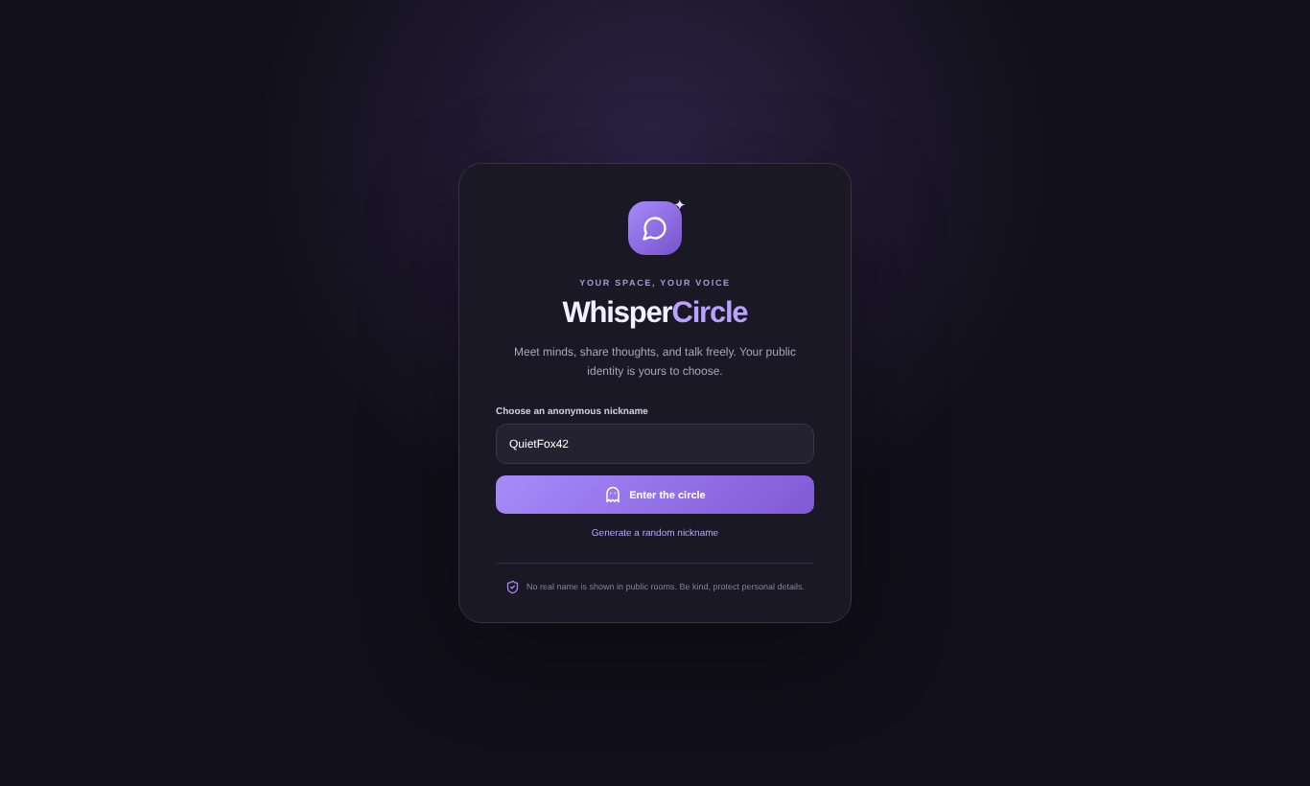
Figure 1: Guest entry screen
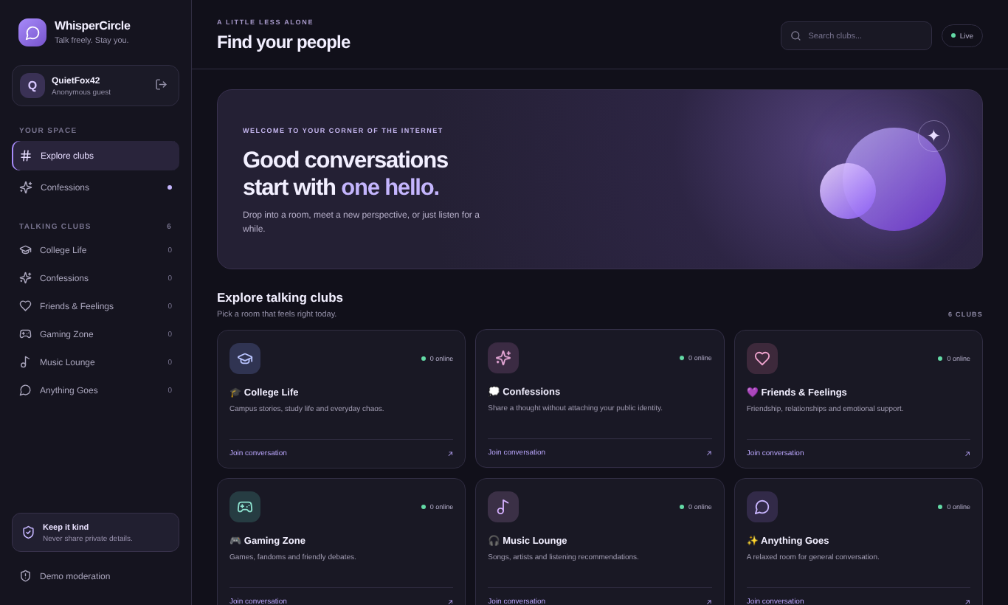
Figure 2: Room directory
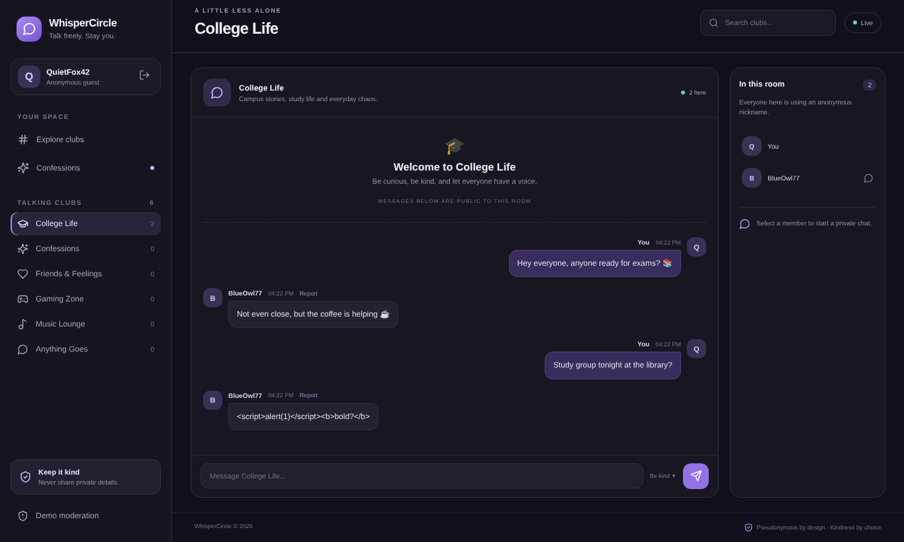
Figure 3: Group chat — session of QuietFox42 (BlueOwl77 joined from a second browser)
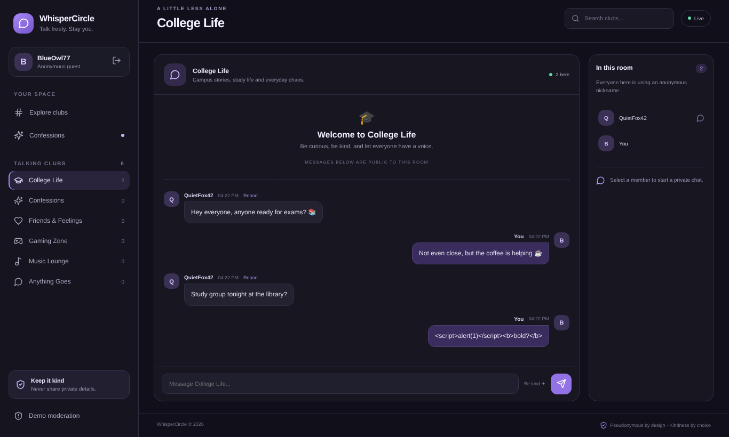
Figure 4: Group chat — the second browser session (BlueOwl77)
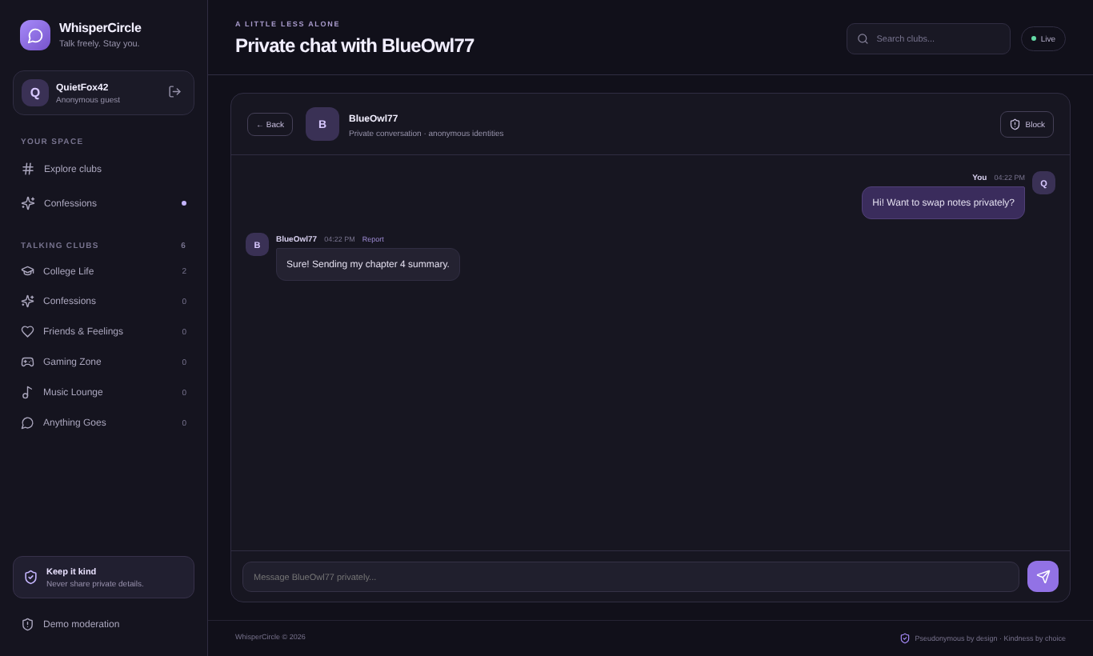
Figure 5: Private one-to-one chat
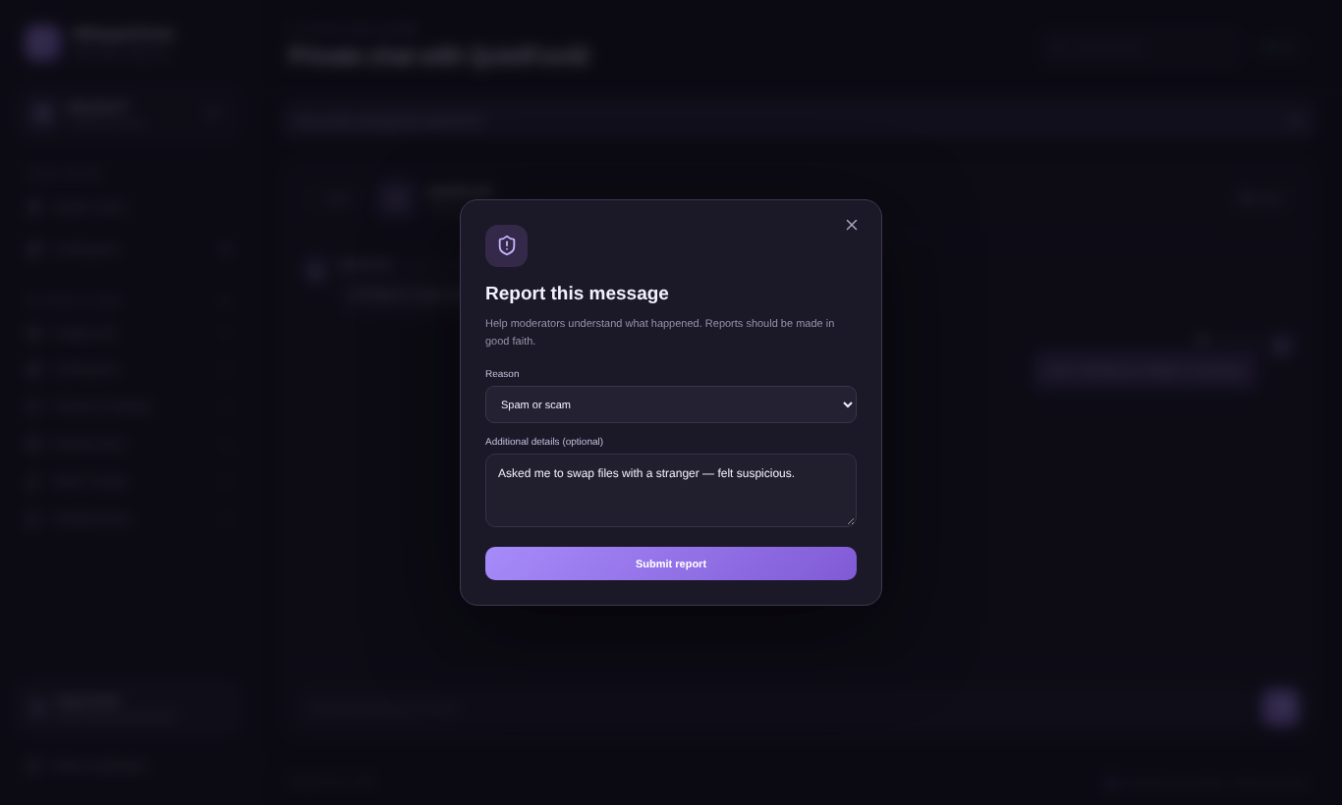
Figure 6: Report submission dialog
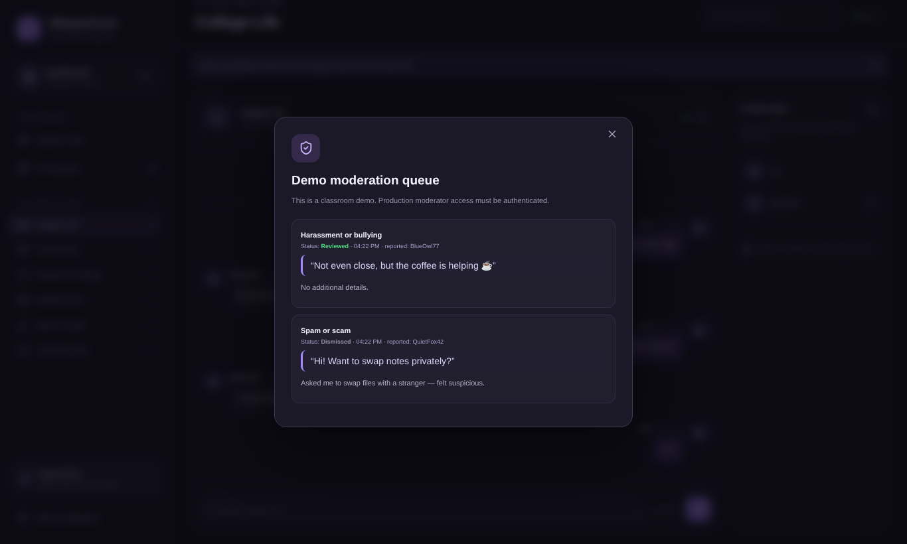
Figure 7: Moderation queue after one report was reviewed and one dismissed
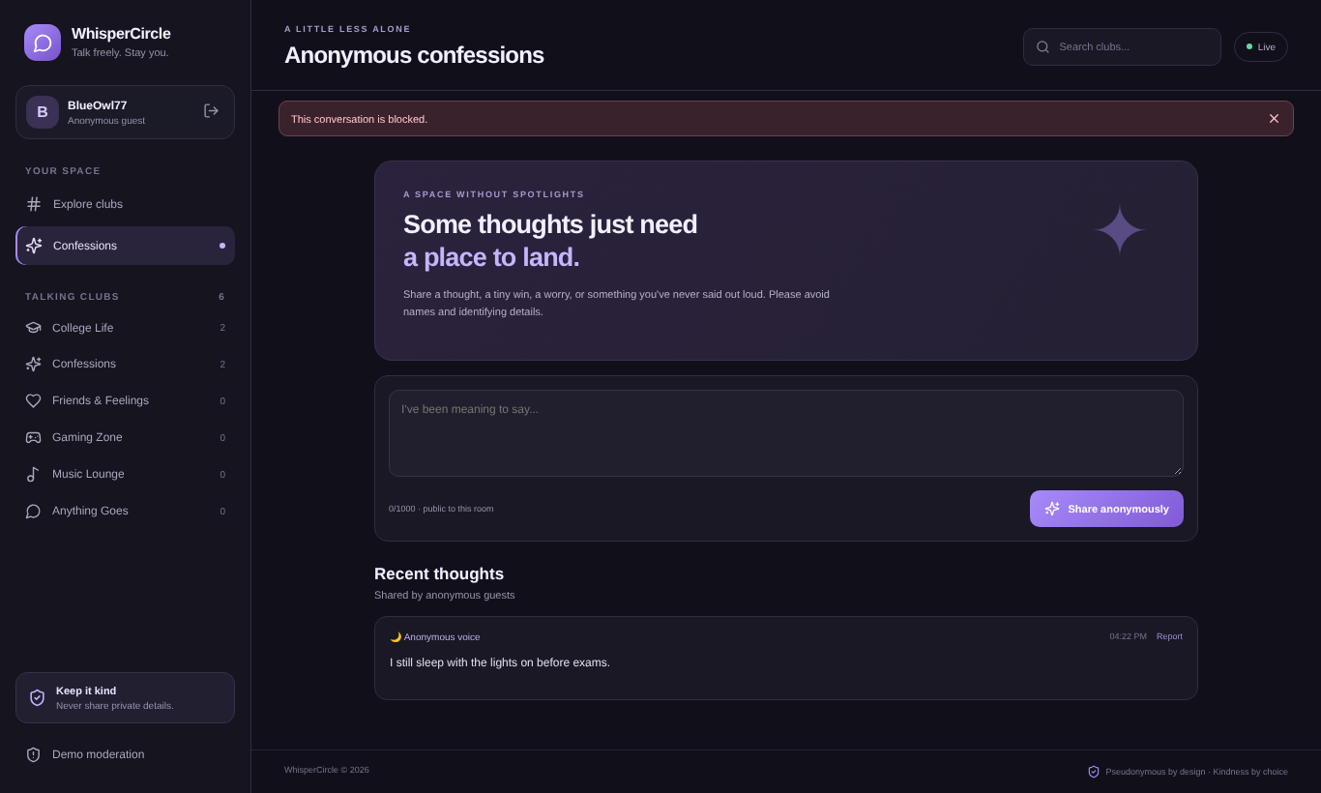
Figure 8: Anonymous confessions
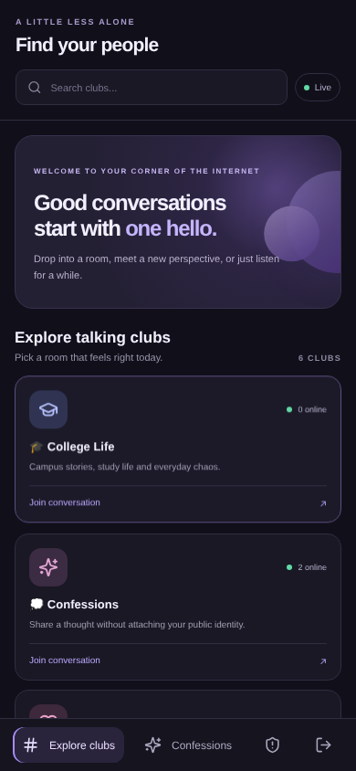  Figure 9: Responsive layout (390 px) — rooms | 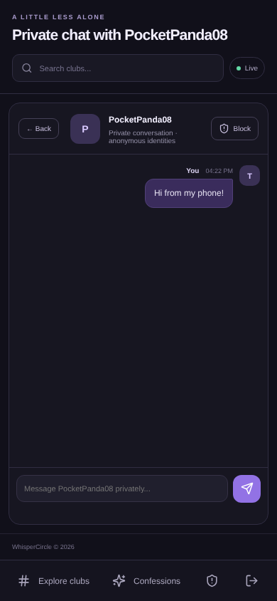  Figure 10: Responsive layout (390 px) — private chat

9. Testing
Testing was automated at two levels, and every check below was actually executed against the running application. The end-to-end suite drives two to four real browser sessions (Chromium via Playwright) with separate storage, so each behaves as a different person.

9.1 End-to-end checks (2 browser sessions and more)
# | Test case | Result
1 | Generate random nickname fills the field | Pass
2 | 1-character nickname is rejected | Pass
3 | Empty nickname gets an auto-generated one | Pass
4 | Guest enters; identity pill shows nickname | Pass
5 | Room directory shows 6 clubs | Pass
6 | Search "gaming" filters to 1 club | Pass
7 | Search with no match shows 0 clubs | Pass
8 | Member list shows both users in the room | Pass
9 | B receives A's group message in real time | Pass
10 | A receives B's reply in real time | Pass
11 | HTML in a message is shown as plain text (XSS-safe) | Pass
12 | Late joiner receives room history | Pass
13 | Presence shows 3 members after a third user joins | Pass
14 | Rapid sending triggers the slow-down warning | Pass
15 | B is notified of the incoming private message | Pass
16 | Private history loads for the recipient | Pass
17 | Private reply is delivered to A in real time | Pass
18 | Third user does not see private messages in the room | Pass
19 | Report from a private chat shows confirmation | Pass
20 | Report from a group message shows confirmation | Pass
21 | Moderation queue lists both reports | Pass
22 | Report stores the original message text | Pass
23 | Moderator can mark reviewed and dismiss | Pass
24 | Action buttons disappear after a decision | Pass
25 | Updated status persists on the server | Pass
26 | Blocking a user confirms and closes the chat | Pass
27 | Blocked user cannot send private messages | Pass
28 | Confession appears for another user in real time | Pass
29 | Confession card hides the author nickname | Pass
30 | Narrow screen (390px): no horizontal overflow on room list | Pass
31 | Narrow screen (390px): no horizontal overflow in chat | Pass
32 | Mobile: member strip lists other people in the room | Pass
33 | Mobile: private chat can be started and used | Pass
34 | Mobile: Leave session returns to guest entry | Pass

9.2 Backend tests (npm test in /server)
# | Test case | Result
1 | GET /api/health reports the storage mode | Pass
2 | GET /api/rooms returns the six clubs with online counts | Pass
3 | Socket connection without a nickname is rejected | Pass
4 | Group message reaches everyone in the room, and only that room | Pass
5 | Invalid room and empty message are ignored / rejected | Pass
6 | Rapid group messages are throttled | Pass
7 | Private message goes to sender and recipient only; history is stored | Pass
8 | Blocking stops private messages in both directions | Pass
9 | Reports store the real message text (server ignores a spoofed reported user) and appear in the queue | Pass
10 | Reporting without a reason is rejected | Pass
11 | Moderator can review and dismiss; invalid status (400) and unknown id (404) are rejected | Pass
12 | Production mode: moderation API is closed unless a key is configured and sent | Pass

Summary: 34 of 34 end-to-end checks and 12 of 12 backend tests passed, with storage in memory mode. [Add one row here after you run the app once with your own MongoDB URI: "Messages and reports survive a server restart" — Pass/Fail.]

10. Division of Work
Note: The frontend/backend allocation below follows the original Student 1 / Student 2 template order. Confirm that this matches the work actually completed by each team member.
Rahul Kumar Mahto  Registration No.: 240953370 | Roll No.: 56 — Frontend | Akshith K  Registration No.: 240953290 | Roll No.: 58 — Backend
- React UI and responsive styling  - Guest entry and nickname display  - Room directory, search and navigation  - Group and private chat screens  - Confessions interface  - Capturing UI screenshots | - Express server and API routes  - Socket.IO room and messaging events  - MongoDB models and persistence  - Reporting and blocking logic  - Moderation queue endpoints  - Backend testing and deployment setup

Both students took part in integration, end-to-end testing, report writing, GitHub updates and the final presentation.

11. Limitations and Future Enhancements

Current limitations
- Identity is pseudonymous, not anonymous: the server sees connection details, and identity is a client-held random id, so a determined user could impersonate an id they have learned.
- Blocking is kept in server memory and is reset when the server restarts.
- The moderation queue is a classroom demo with no moderator login. In production mode it is closed unless a demo key is configured.
- Rooms are fixed; there is no profanity or abuse detection and no message deletion.
- Private chat history is addressed by pseudonymous id, so it is lost to the user when they start a new session.

Future enhancements
- Authenticated moderator roles, permanent bans and moderator actions such as deleting messages.
- Server-issued, signed session tokens and persistent block lists.
- Retention controls and a privacy policy.
- Automated abuse detection with human review.
- Room creation, polls, reactions and notification preferences.
- Deployment over HTTPS with production-grade secrets.

12. Conclusion
WhisperCircle demonstrates how a full-stack application can combine a responsive interface, real-time communication, persistent data and basic community-safety features. The project covers the complete path from user interface to socket events to storage, and was validated with automated tests at both the API and browser level. It provides a foundation for a pseudonymous discussion platform while highlighting the importance of responsible moderation, privacy and abuse prevention.
GitHub Repository
https://github.com/RaulX098/WhisperCircle

