Caravan Bridge (Turkey)
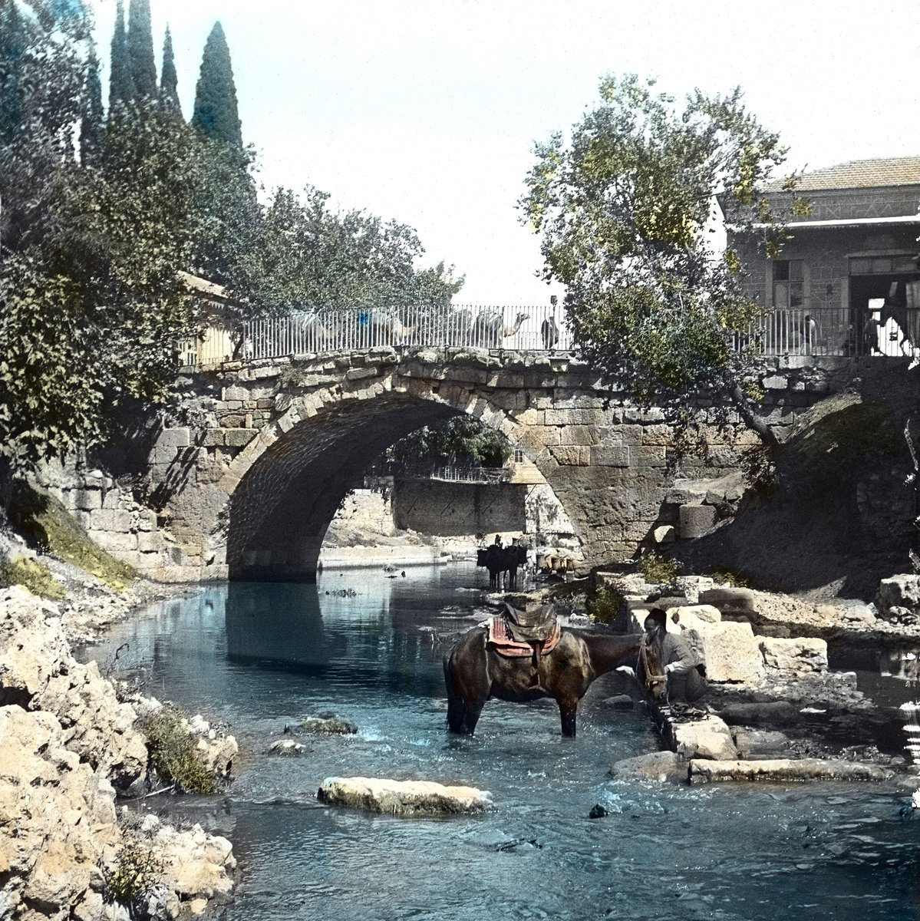
The Caravan Bridge, located in Izmir (ancient Smyrna), Turkey, is widely recognized as one of the oldest still-functioning
bridges in the world. Built around 850 BC during the reign of the ancient Lydian civilization, it has been continuously
used for nearly 3,000 years.
Constructed from sturdy stone blocks, the Caravan Bridge spans the Meles River—a site historically associated with the
ancient Greek poet Homer, who was said to have walked along its banks. The bridge served as a crucial crossing point for
caravans and traders traveling between Asia Minor and the Aegean coast, giving it its name.
Despite numerous floods, wars, and reconstructions in the surrounding area, the bridge itself has survived with its
original structure largely intact. It continues to carry light pedestrian traffic, symbolizing endurance and historical
continuity across civilizations.
The Caravan Bridge stands as a remarkable testament to ancient engineering and remains one of the most enduring
architectural landmarks of the ancient world.

History of Caravan Bridge
The history of the Caravan Bridge dates back to the early first millennium BC, during the Lydian and early Greek periods.
Its strategic location over the Meles River made it an essential part of regional trade routes. Ancient sources mention
the bridge as part of the old road connecting Smyrna (modern Izmir) to Sardis, the Lydian capital.
Throughout Roman, Byzantine, and Ottoman periods, the bridge continued to serve merchants and travelers. The structure has
been repaired and reinforced multiple times but always preserved in its original stone-arch design.
Local legends associate the bridge and river with the ancient poet Homer, suggesting that he composed verses along the
Meles River’s tranquil banks. Today, the Caravan Bridge represents a living link between ancient civilizations and modern
Turkey, symbolizing resilience, continuity, and the spirit of human craftsmanship.

