Great Belt Bridge (Denmark)
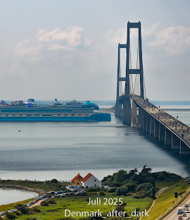

Overview
The Great Belt Bridge, also known as the Great Belt Fixed Link, is one of the most iconic suspension bridges in the world. Located in Denmark, it connects the eastern and western parts of the country, linking the islands of Zealand and Funen. This engineering marvel plays a vital role in Denmark’s infrastructure and economy by facilitating transportation and trade.

Location
The bridge spans the Great Belt strait between the Danish islands of Zealand and Funen. It forms part of the European route E20 and connects the capital city, Copenhagen, with other parts of Denmark and mainland Europe.

Design and Structure
The Great Belt Bridge consists of two main parts: the East Bridge and the West Bridge. The East Bridge is a suspension bridge with a main span of 1,624 meters (5,328 ft), making it one of the longest suspension bridges in the world. Its towers rise 254 meters (833 ft) above sea level. The West Bridge, on the other hand, is a box girder bridge for both rail and road traffic.

Construction and History
Construction of the Great Belt Fixed Link began in 1988 and was completed in 1998. The project was carried out by the Great Belt Link Consortium, and it cost approximately 21 billion Danish kroner. The bridge officially opened to road traffic in June 1998. Before its construction, ferries were the only means of transportation between the two islands.

Interesting Facts
- The Great Belt Bridge reduced travel time between Zealand and Funen from one hour by ferry to just 10 minutes by car.
- It stands as one of the longest suspension bridges outside Asia.
- The bridge is part of a larger fixed link system that also includes a railway tunnel and another bridge.
- It is considered one of Denmark’s greatest engineering achievements.

Importance
The Great Belt Bridge symbolizes Denmark’s progress in modern engineering and infrastructure. It enhances connectivity within the country and across Europe, promoting tourism, trade, and economic development.

