Hussaini Suspension Bridge (Pakistan)
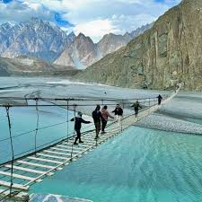

Overview
The Hussaini Suspension Bridge is located in the Hunza Valley of Gilgit-Baltistan, Pakistan. It is one of the most famous and daring suspension bridges in the world, known for its adventurous crossing over the Hunza River. The bridge connects the remote village of Hussaini with Zarabad and other nearby settlements.

History
The Hussaini Suspension Bridge was originally constructed by local villagers to provide a vital connection across the Hunza River. Over time, it has become a major tourist attraction due to its fragile appearance and thrilling experience. Despite its seemingly dangerous design, the bridge is regularly maintained and continues to be used by locals and tourists alike.

Structure and Design
The bridge is made of wooden planks and steel ropes, suspended high above the river. It stretches around 660 feet (200 meters) in length. Many planks are spaced far apart, allowing wind and water to pass through, which increases the thrill for those who cross it. The bridge offers stunning views of the Hunza River and surrounding Karakoram mountain ranges.

Importance
For locals, the Hussaini Bridge remains a crucial link for transportation and access between villages. For visitors, it is a symbol of adventure, resilience, and the breathtaking natural beauty of northern Pakistan. It draws thousands of tourists each year, contributing to the local economy through tourism.

Interesting Facts
- Often referred to as one of the 'most dangerous bridges in the world.'
- Offers panoramic views of the Passu Cones and Hunza River.
- Despite its frightening look, it is relatively safe for cautious travelers.
- Rebuilt and repaired several times after damage from floods and weather.
- A popular spot for photographers and adventure seekers.

